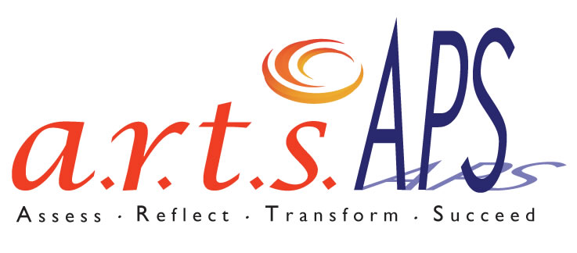
PDAE/Atlanta 2008-2011
How do you transform arts learning across an entire district?
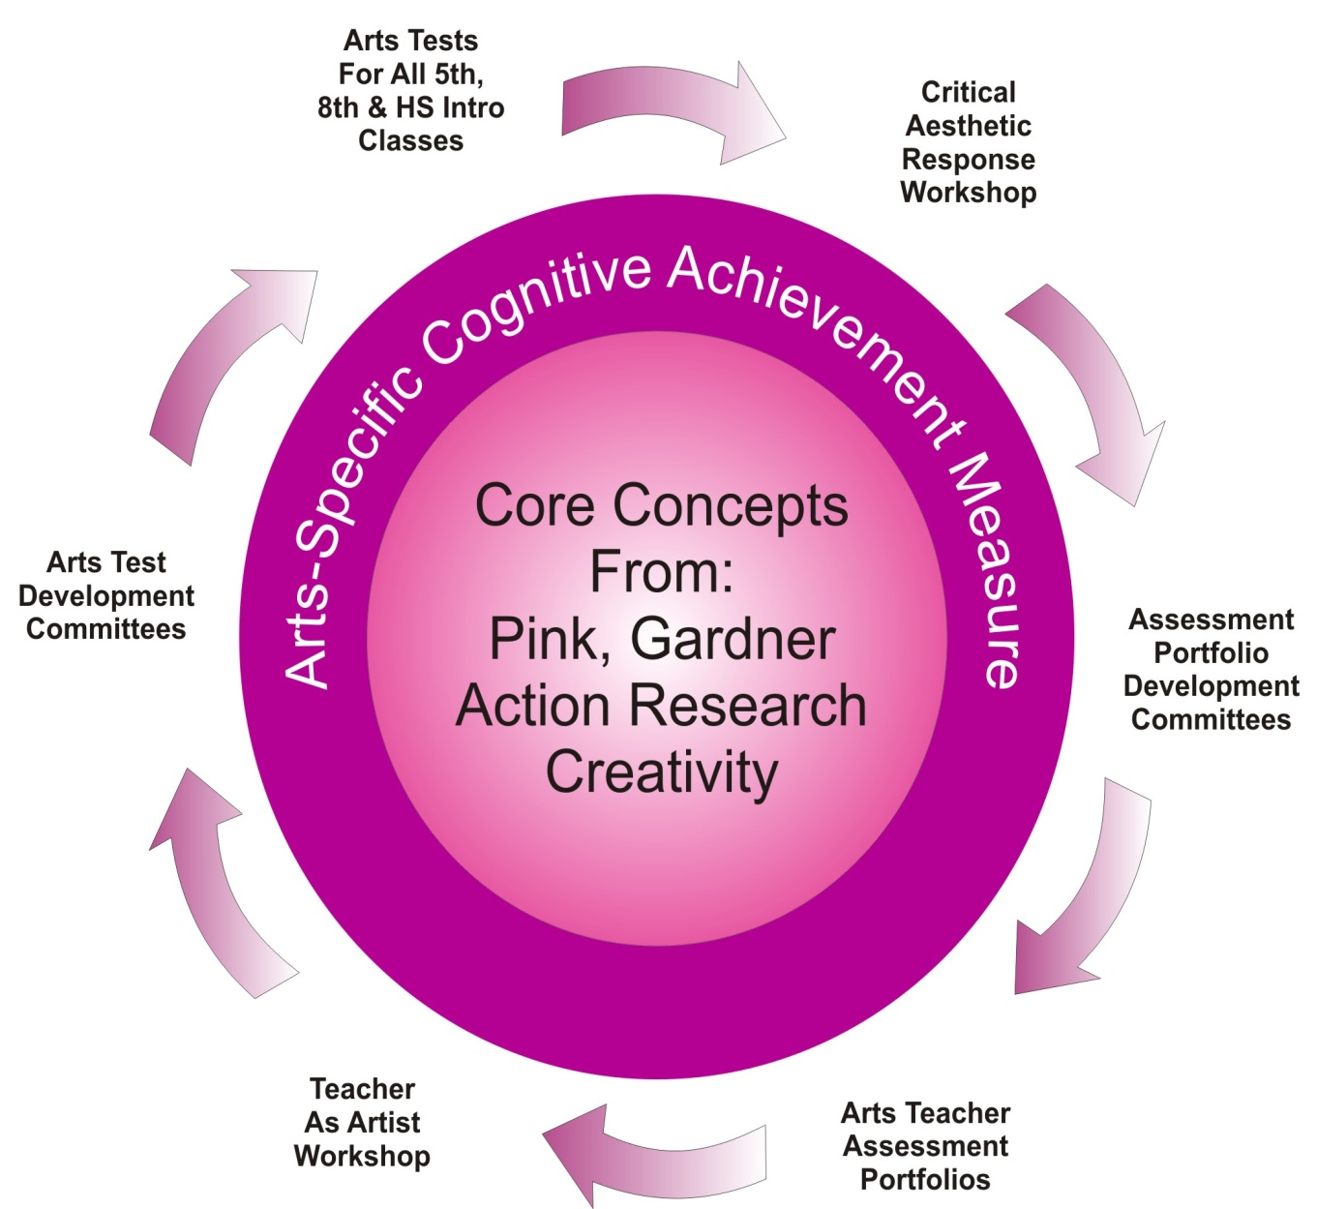
Professional Development
Driven by student assessment data from 5th, 8th, Intro HS courses

Monthly Workshops:
Teacher as artist/performer
Critical Aesthetic Response

Arts Assessments
Online Conceptual Knowledge/Vocabulary
Performance Assessments
Pre/Post VTS writing assessment

http://igniteart.weebly.com/artsaps.html

In 2008, the Atlanta Public Schools received a Professional Development for Arts Educators grant designed to transform arts teaching and learning. This project is unique because it targets arts learning for all teachers and students in the Atlanta Public Schools rather than an individual school, group of schools, or small group of students.

ArtsAPS Model Challenges
- Received grant 8/08; no ED approval until 10/08; told not to start until 1/09
- No in-service time at Principal’s Meeting; can’t support what you don’t know exists
- Disenchanted staff—some have unsupportive, uninformed, unenlightened school leaders
- Theory-Practice gap—habitual response to school pressures trump theory
- Clarifying Objectives, simplifying
- Pass/Fail mentality—staff did not wish to do work
- Master teacher follow through (reporting data), absences; our best are tapped out
- Could not enforce system-wide teacher portfolios; can’t guarantee arts assessments will follow same protocols as standardized testing
- Teacher release time
- Budget process
- New State Arts Standards half way through; delayed curriculum revision and assessments

ArtsAPS Model Successes
- 46 Principals (out of a total 91 schools) participated so far in ArtsAPS Principal Arts Assessment Workshop, “APS Arts Assessments: How They Help You”
  - Strong support and enthusiasm
- Arts Assessments: 5th grade pilot; all targeted grades this year (clarity of the “how to” in relationship to authenticity)—strong promise of “hard” data providing snapshot of achievement on state performance standards
  - http://igniteart.weebly.com/fine-and-performing-arts-on-line-professional-learning-page.html
- ArtsAPS trained staff more receptive to and supportive of arts assessments
- Matrix of Creativity Instructional Objectives
- Staff Cohesion
- Vertically aligned curriculum
  - No education coordinator for 6+ years; fractured curriculum; every teacher an island
  - Pre-curriculum: Same lesson observed at ES, MS and HS levels
  - Small HS reform seems to be eliminating vertical programs at some schools
- Informal support network and problem solving
- Reengagement with art forms; pride in producing/performance
  - 2011 Art Teachers Art Exhibit
  - http://igniteart.weebly.com/2011-artsaps-art-teacher-art-exhibit-at-the-youth-art-connection-gallery.html
- Values. Voice and Vision Conference
- Authentic Assessment as Professional Development: Reports of actual instructional change as the result of arts assessments

On the cusp of:
- Targeted, data-driven changes to instruction

Reporting:
Dr. Melody Milbrandt, Raymond Veon,
ArtsAPS Project Evaluator Int. Director, F&PA/Ed. Coord. VA
Professor, Georgia State University ArtsAPS Project Director
PTI, Georgia State University

