THE VISUAL LANGUAGE OF ART – HOW ART COMMUNICATES TO US
(Art and its Appearance)

-Representational Art (objective/figurative) aims to represent the
appearance of things/people in reality

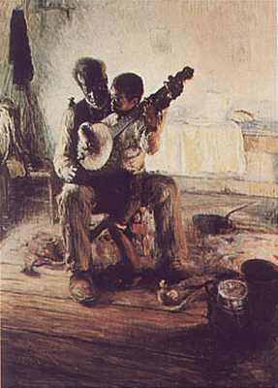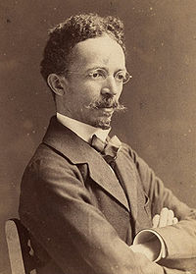
Henry Ossawa Tanner The Banjo Lesson, 1893

-Abstract Art aims to simply the form of an object or idea

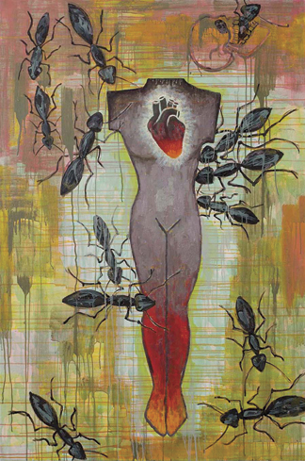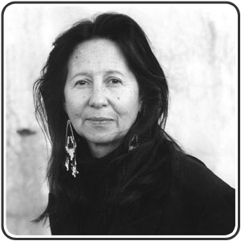
Jaune Quick-to-See Smith Made in America, 2009

-Nonrepresentational Art (nonobjective/nonfigurative) does not aims to represent the appearance of things/people in reality, instead it focuses on pure form

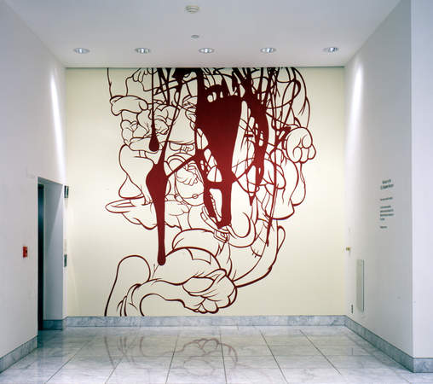

Arturo Herrera, When Alone Again, 2001

