www.igniteart.weebly.com
rveon@atlantapublicschool.us copy micafellow@aol.com

Table 1. K-12 Matrix of Instructional Objectives for Creativity
I = When a skill is introduced (to be developed in subsequent grades).

STAGE 1: IDEA-FORMATION SKILLS  Stage 1 Assessment: Image + Context = Idea  Did you Risk and Reframe?  The student… | K | 1 | 2 | 3 | 4 | 5 | 6-8 | 9-12
Mentally recalls and produces visual images using a variety of materials | I
Explores and states the meaning of visual imagery by critiquing and producing artworks | I
Attends to and follows prompts inherent in the character of art materials when producing artworks | I
Recognizes and discusses how a single visual image can be assigned multiple meanings; Generates multiple interpretations for an object or image |  | I
Demonstrates mental visualization (the ability to mentally manipulate images and meaning) by predicting how changes made to a visual image will changes its meaning(s) |  | I
Improvises in response to unanticipated insights, deviations or teacher-imposed constraints/challenges that reframe experience |  | I
Produces visual images in response to open-ended prompts, themes, and narratives without the teacher providing a visual model |  |  | I
Plans artworks by making preliminary variations; also, makes multiple representations of a single theme/topic using varied media and approaches |  |  | I
Mentally envisions what cannot be directly observed, for example, by producing artworks depicting imaginary worlds, machines with mysterious functions, and embodiments of mythical beings, intangible forces, personal/social values, etc |  |  | I
Produces new images and meaning by using visual analogy and metaphorical thinking (seeing the properties of one thing as representing or standing for the properties, structure, or function of something else) |  |  | I
Recognizes that interpretation relies on context (the implicit and explicit cues/clues that suggest how we should assign meaning to something); combines cues/clues from disparate contexts in planning or producing an artwork to generate unusual meaning |  |  |  | I
Uses strategies to alter and generate visual images, such as SCAMPER (Eberle, 1996) or those found in McKim (1980) and Roukes (1984), to change how they are perceived and interpreted |  |  |  | I
Self-monitors to reflect on and guide the artistic process; identifies what they do not yet know and strategies for discovering/learning it |  |  |  | I
STAGE 2: CONCEPT FORMATION SKILLS  Stage 2 Assessment: Idea + Thinking Framework = Concept  Did you question, intersect, and connect? Did you explore and exploit points of tension?  The student… | K | 1 | 2 | 3 | 4 | 5 | 6-8 | 9-12
Explains/demonstrates how changing the visual language used in an artwork also changes its meaning; see Madden (2005) |  |  |  |  | I
Selects, adapts and uses a visual language/artistic convention to connect one idea to other ideas; seeks/employs visual and conceptual patterns to make connections |  |  |  |  | I
Selects criteria for distinguishing between complete/incomplete artworks and provides reasons for doing so |  |  |  |  | I
Explains and demonstrates how successful artworks convey complex, interconnected ideas (as opposed to conveying a single, simple idea) by critiquing/producing artworks |  |  |  |  |  | I
Researches, reasons about and connects ideas in an artwork using a range of strategies, such as visual analogy, metaphor, visual narrative, symbolism, irony, parody, analogies to other subjects, appropriating historical styles/isms, referencing personal insight, etc.; discusses the reasons for selecting one strategy over another. |  |  |  |  |  | I
Conducts open ends/means analysis by:  - Identifying ambiguous, indeterminate, and conceptually or emotionally dissonant topics as themes for artworks;  - Determining personal strategies and criteria for investigating them artistically. |  |  |  |  |  | I
Develops iterative mindset by consciously forming provisional answers, testing, revising, testing, etc. |  |  |  |  |  | I
Reflects on portfolio to identify ongoing themes and patterns; revises or generates new work as a result |  |  |  |  |  | I
Discusses how different visual languages represent different ways of reasoning about and unifying ideas in artworks |  |  |  |  |  |  | I
STAGE 3: CREATING SKILLS  Stage 3 Assessment: Concept + Stance = Creative Mindset  How does this come out of your own creative stance?  The Student… | K | 1 | 2 | 3 | 4 | 5 | 6 -8 | 9-12
Frames/interprets/generates problems by developing a creative stance:  - Sets personal objectives (themes/topics for investigation)  - Identifies personal standards (adapting/going beyond exemplars)  - Identifies personal rationale (interests/passions);  - Identifies preferred materials and working methods;  - Develops a personal viewpoint/context for working (i.e. develops problem-finding parameters based on personal beliefs, experiences, emotions, social awareness, personality traits, intellectual interests, engagement with media, etc.) |  |  |  |  |  |  | I
Formulates questions, conducts research, and finds/generates new problems based on creative stance, resulting in new artworks |  |  |  |  |  |  |  | I
Revises creative stance in response to unanticipated insights |  |  |  |  |  |  |  | I

Five Questions For The Future:

Following a suggestion by Periklis Pagratis (Savannah College of Art and Design), we might ask: Is there a single set of questions which develop the qualities of a creative mindset that are valid for every grade level—that can serve as a thread through each grade level for developing creativity over the long term? These questions could help students refocus and re-experience what it means to think creatively at each stage of developmental readiness. This suggestion could lead to a useful tool for helping ensure vertical alignment as students spiral upward through the curriculum. The idea is to challenge students by asking them to reframe their experience so they consistently encounter the unfamiliar and the unknown, thereby reconsidering what they know and can do by orchestrating different constellations of skills and concepts. The following list, then, are suggestions—prompts for developing an inquiry-based, creative mindset at each phase of student development.
- What more can you do?
- What else can you connect it to? (What more can you add?)
- What is another way of doing it? (How might someone else do it or see it?)
- What else could it mean?
- What does it lead to (what do you do now)?
Psychomotor Skills
Basic Reasoning Skills
Higher Order Thinking
Affective Domain Skills
Meta-Cognition
Creativity

Copyright © 2009 Raymond E. Veon
A model of the creative process (adapted from Ludvigsen, 1980)

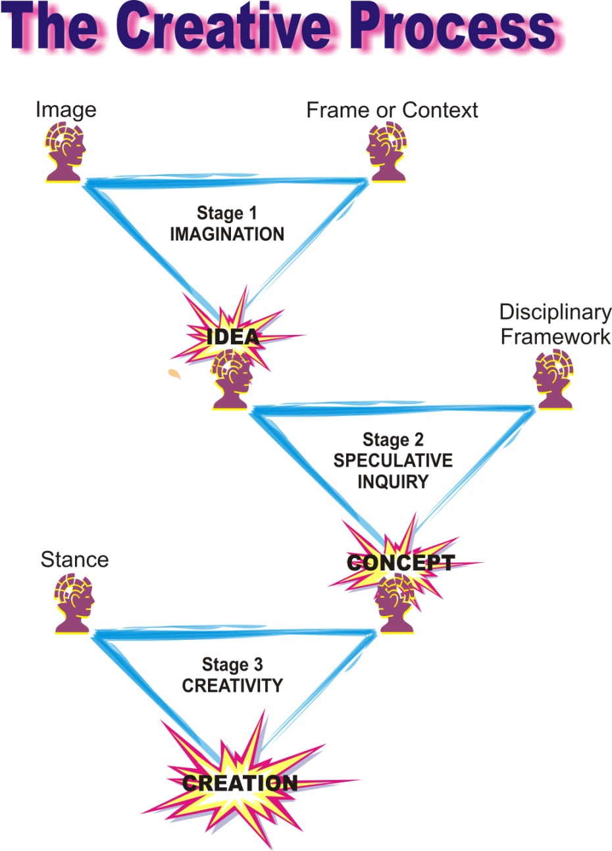

Copyright © 2009 Raymond E. Veon

