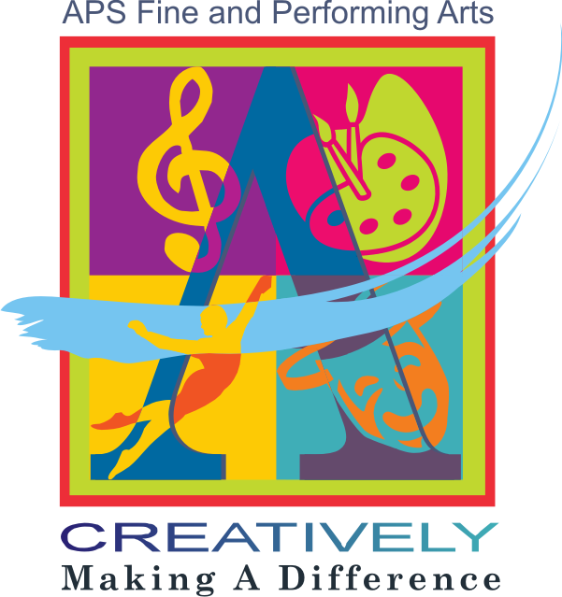

Atlanta Public Schools Visual Arts Curriculum 2010-2011

Grades K-8 and High School Visual Art 1

Acknowledgements
I would like to thank the efforts of the visual art teachers on our advisory team, each of whom contributed substantially in different ways to the evolution of this curriculum and its associated district-wide art assessments:

Debra Jeter
Phil Alexander-Cox
Courtney Bryant
Cynthia Baird-Campbell
Cissy Cohen
Jan Watford

Although many ideas, perspectives, and resources fed the dynamic mix leading to this curriculum, the following require special recognition both for their influence on the process and for their exceptionally high standards, detailed articulation, and clear vision for Visual Arts Education:

- The New York Blueprint for the Arts
- Ontario Ministry of Education: The Ontario Curriculum for the Arts, Grades 1-8 and Grades 9-10
- Think Tank 4 (2009) and Think Tank 5 (2010), Integrative Teaching International (A collaboration between the Lamarr Dodd School of Art, University of Georgia and the School of the Art Institute of Chicago)
- Mary Lazzari, Clarke County Art Educator
- Olivia Gude’s Spiral Workshop Curriculum/The University of Illinois at Chicago
- Art Synectics by Nicholas Roukes
- Confrontationalism: A Foundation of Intellect in Art, Education, and Art Education by Arne Ludvigsen
- Art:21 at http://www.pbs.org/art21/education/

Although inadequate in the company of the exceptional resources above, my own text, Understanding Creativity: A Cognitive Approach, served as a framework for understanding creativity both in the development of the Georgia Performance Standards in the Visual Arts and in the development of this curriculum.

Finally, the insight and wisdom of two key individuals have guided the successful completion of this curriculum, both of whom are exemplars of the very best in arts education leadership: our consultant Denise Jennings, National Art Education Association Art Supervisor of the Year and retired Fulton County Visual Arts Education Supervisor; and Mrs. Cynthia Terry, Director of Fine and Performing Arts in the Atlanta Public Schools.

Raymond Veon
Education Coordinator, Visual Art

Table of Contents

Understanding the Standards………………………..4
Scope and Sequence…………………………………6
Indicators of a Healthy School Arts Program……… 7
Assessments in the Art Classroom ………………… 10
Studio Habits of Mind Template………………….... 11
Students with Special Needs and ELL/ESOL
Students in the Art Classroom…………………....... 12
Museum Based Learning in the Visual Arts……..... 23
The School Art Studio
(Supplies for K-HS Art Rooms)………………… 24
Enduring Understandings………………………….. 29
High School Visual Art 1………………………….. 35
Grade 8 ……………………………………………. 68
Grade 7 ……………………………………………. 85
Grade 6 ……………………………………………. 102
Grade 5 ……………………………………………. 117
Grade 4 ……………………………………………. 140
Grade 3 ……………………………………………. 162
Grade 2 ……………………………………………. 182
Grade 1 ……………………………………………. 198
Kindergarten ………………………………………. 214
Art Learning Plan Template………………………. 219

UNDERSTANDING THE STANDARDS

Through their art, artists reflect the world around them and also construct and project new meaning into the world, allowing us to see and organize the human condition in new ways. Training the minds of students to create new values and insights is one of the primary social and economic contributions that the visual arts make to educating citizens for the 21st Century. Our Meaning and Idea domain emphasizes how the visual arts develop cognitive skills that lead to a life rich with personal value and professional success. In many ways art is the paradigm for intellectual growth because it weaves together personal experience, develops sensory, emotional, and moral responses, and hones high-level conceptual thinking. As educators, we are cognizant of the fact that conceptual models, often utilizing sophisticated empirical research, have become the means by which we organize and manage our world. This means that we need more than personal experience to reason about things like quantum theory, the development of nanotechnology, and the intricate ways that international politics, economics, and social trends merge to affect our lives. One of the most valuable intellectual contributions that the visual arts make to education is that they teach us how to reason, think, and imagine beyond our personal experience. The visual arts are unique because they do this even as they nourish the multiple ways that we are connected to history, culture, and the world around us. Because they combine open inquiry, creativity and critical thinking, the visual arts foster the intellectual leadership needed in both business and society, leadership that is based on the ability to forge and implement a personal vision that shapes a new future.

Throughout history, visual art has served to connect our imaginations with the deepest questions of human existence: Who am I? What must I do? What is valuable? How does everything connect? Where am I going? Our domain for Contextual Understanding involves studying responses to those questions through time and across cultures, as well as acquiring the tools and knowledge to create one's own responses within the context of contemporary life. Students discover who they are by actively engaging artworks and the ideas behind them, both in their everyday lives and from the perspective of diverse times, places, and cultures. The knowledge and skills developed in this standard are essential not only to understanding life but to living it fully and productively.

Our Production domain points to the fact that visual art education is grounded in making artwork according to exacting standards of excellence and craftsmanship. The challenges posed by art making are more like those found in real life than in any other discipline; for instance, in math, problems are pre-defined and point to a correct answer, but in art, like life, you define your own problems and then creatively solve them. There’s no formula, recipe, or dress rehearsal for either life or art. When students successfully orchestrate a creative response to a visual problem, they realize that they are a unique force in the world—that they are individuals capable of marshalling their knowledge, meeting a challenge and enacting change. Through the artistic process, in which they master a wide range of skills and concepts, students develop successful ways of managing their affective and moral lives. They build self-confidence, tenacity, the willingness to risk and explore, and the character that will sustain them in their educational, professional, and personal lives. Accomplished art educators know that developing skill and craft is central to all quality art instruction and that it goes hand-in-hand with the development of meaning. As a result, they ensure that technical expertise for its own sake does not become an isolated end in itself and that skill and meaning are inextricably bound together as students complete finished, compelling artworks.

Through the critical analysis of art, students learn the courage to speculate in the face of not knowing, the wisdom to recognize when to withhold judgment until they have sufficient information for an informed response, and the insight to know when and how to follow up an interpretation with additional research. Not only are these skills crucial to art learning, they are also keys for professional and personal success. Thus, the Assessment and Reflection domain highlights the essentially recursive, metacognitive nature of artistic practice and learning. Students should assess and reflect as a part of every lesson and learn a variety of strategies for doing so. Accomplished art educators select the most appropriate assessment and reflective strategies given the nature, focus, and outcome of a lesson. They ensure that each strategy they select allows students to assess and reflect through the lens of each of our other standards, giving them the opportunity to deepen artistic learning by critically analyzing art in terms of meaning, contextual understanding, mastery of technique and knowledge, and connections to the world around them. While acknowledging the importance of first impressions when engaging art, teachers are expected to push students beyond superficial responses by requiring them to cite specific evidence and to clearly demonstrate a methodical chain of reasoning for their interpretations and assessments.

Quality visual arts instruction that authentically engages students in artistic production creates a need for knowledge and skills from across the curriculum, fueling a desire to learn and grow. Occasionally, and unintentionally, interdisciplinary approaches to art education fail to preserve the unique educational benefits provided by a rigorous and sequential approach based on genuine art learning. Our Connections domain is meant to ensure these educational benefits, preserving an art-centered approach to instructional delivery that strengthens academic learning. High school graduates are better prepared in schools with quality art programs because they have experienced an art curriculum in which they have learned to find and orchestrate knowledge in personally relevant, conceptually rigorous ways. The visual arts are often on the cutting-edge of inquiry because they provide the novel imagery that crystallizes the most intangible and essential aspects of our mental life into discrete ideas. While contemporary art plays a vital role in this process as more artists weave the language of economics, science, technology, sociology, literature and math directly into their practice, it should be recognized that traditional art forms also call on insights and skills used in other disciplines. Thus, students develop life and work skills for envisioning the big picture and for finding and solving new problems in highly effective ways.

Four Units K-HS Visual Art 1

Art Changes Our Way 0f Seeing and Thinking (Always The First Unit)
Art Helps Us Organize Ourselves in Sharing the Planet
Art Helps Us Understand Where We Are In Time And Place
Art Helps Us Understand Who We Are

Aligned GPS for grades K-5

VTS Pre and Post Test Grades 1-HS Visual Art 1

On Line and Performance Assessment Grades: 5, 8, Visual Art 1; program assessment, disaggregate data, establish system-specific levels of achievement (high-medium-low)

Uniform culminating projects across the district: final quarter/weeks of each year/semester/quarter (for auditing purposes; will not serve as assessments; develop with your ideas); teacher determines rest of year

  - Uniform Art History Images K-HS Visual Art 1 (shared visual understanding) TBD
  - Themes/Concepts, Essential Understandings and Essential Questions TBD; In General, currently determined by teacher

From E & P to Creativity, Conceptual Development and Contemporary Practice

As a general rule, no more than 30% of instructional time should focus exclusively on the elements and principles; students should be primarily engaged in the creative process of making meaning, with the elements and principles used as tools to this end and the learning of these tools reinforced in the process itself. Instead of being based on the elements and principles, lessons should be primarily framed using models appropriate to 21st Century learning such as: Pink’s six aptitudes; the Studio Habits of Mind model; of Gude’s Principles of Postmodernism

Scope and Sequence Overview
Kindergarten:
Culminating Project: A Journey in a Vehicle (before, during, after)
Design Focus: Shapes and Line
1st Grade
Culminating Project: A Street in My Neighborhood
Design Focus: Variety
2nd Grade
Culminating Project: My Beautiful Garden
Design Focus: Repetition/Rhythm
3rd Grade
Culminating Project: Installation
Design Focus: Unity and Harmony
4th grade
Culminating Project: Architectural Project
Design Focus: Proportion
5th Grade
Culminating Project: Expressive Portrait
Design Focus: Contrast
6th Grade
Culminating Project: Installation
Design Focus: Unity
Contemporary Focus: Hybridity
7th Grade
Culminating Project: Sculpture/exhibit of endangered species
Design Focus: Emphasis
Contemporary Focus:
8th Grade
Culminating Project: Storyboard/Digital Storytelling—My Journey Until Now
Design Focus: Movement and Sequencing
Contemporary Focus: Appropriation, Recontextualization
High School Visual Art I
Culminating Project: Graphic Design Representing My Community
Design Focus: Harmony
Contemporary Themes: Hybridity, Juxtaposition, Recontextualization

Indicators of a Healthy School Arts Program

In Every School:
- The arts are an important and explicit part of the school’s comprehensive instructional plan;
- Authentic and rigorous assessment methods lead to ongoing improvement in arts programs;
- Parents are meaningfully involved in the school’s arts activities, resulting in advocacy for the school’s arts
programs and support for their children’s arts learning;
- Strategic partnerships are developed with community arts institutions that contribute to realizing the school’s arts goals.

Early Childhood (Pre-Kindergarten-Grade 2):
- Every child experiences a number of different modes of expression in the arts through a sense of play and exploration. Each child has a chance to sing, draw, play, paint, dance, act, listen, look, and think as an artist;
- A weekly minimum of three to five instructional hours in the arts for each child is provided. (This is a combination of instruction by an arts specialist and the general classroom teacher)

Upper Elementary (Grades 3-5):
- Building upon their early childhood experiences, every child is challenged to further develop skills in the arts. Every child continues to have a chance to experiment and think as an artist, with emphasis on more sophisticated creative projects and more challenging techniques and repertoire. Students make richer connections between their work in the arts and other subject areas, and they become more keenly aware of the arts world around them;
- A weekly minimum of two to three instructional hours in the arts for each child is provided. (This could be a
combination of instruction in an arts specialist’s classroom and the general classroom)

Middle School (Grades 6-8):
- Every student has a range of opportunities in the arts that will allow for deeper study in selected disciplines. Students are able to make choices about their artistic pursuits, assisted by parents and teachers. Students are continuing to experiment and think as artists as they delve deeper into a particular discipline;
- A weekly minimum of two to three instructional hours in the arts for each child is provided

High School (Grades 9-12):
- Students take at least one year of one art form or a combination of art forms.
- Arts specialists in music, theater, visual arts, and/or dance work with groups of students throughout the school year to provide a three- to four-year sequential course of study. Schools with fewer available disciplines collaborate with other schools and institutions to provide students access to the discipline of their choice;
- Every student has access to opportunities in the arts that will allow for deeper study in selected disciplines. Students make choices about their artistic pursuits, with a greater sense of independence. Students are continuing to experiment and think as artists, even as they go deeper into a particular discipline;
- Students also have the chance to follow their artistic pursuits to the highest standards as compared to their peers across the nation, including participation in performing arts ensembles, solo and group visual art exhibitions, theatrical and dance performances, and contact with the standards of artistic excellence available in Atlanta.

School leaders can ask some simple, but vital questions:
- What is the place of visual arts in our comprehensive educational plan?
- Do we have the staffing in place to support our visual arts goals? If not, what short- and long-term strategies can we use to implement an infrastructure for effective visual arts education?
- How can we use ongoing assessment to help us improve our visual arts instruction?
- Are parents meaningfully involved? If not, how can we help them become more aware of our students’ learning in visual arts?
- Are we taking advantage of the rich resources that Atlanta has to offer?
- How can strategic arts partnerships help us advance teaching and learning in visual arts?
- Do our art teachers, classroom teachers, and visiting artists have adequate professional development to carry out work that is developmentally appropriate and has artistic integrity? What can we do to support them?
- In every school community, different agendas compete for time and resources. Schools are responsible for helping students learn to read and write, compute, investigate, explore, imagine, and create. Research supports the assertion that authentic work in visual arts serve all of these goals. Effective visual arts education can only be achieved with the commitment of school leaders.

Interdisciplinary Connections

Interdisciplinary education enables students to identify and apply authentic connections between two or more disciplines
and to understand essential concepts that transcend individual disciplines.
—The Consortium of National Arts Education Associations*

Great teachers know the power of the arts to transform, motivate, and inspire. Great arts teachers know the power of connecting their work to the teaching and learning in other subjects. The APS Visual Arts Curriculum provides connections between visual art and other content areas across each grade level. Authentic connections reinforce the power and relevance of the arts, and add depth and dimension to studies in other disciplines. Art teachers and teachers of other subjects can work together to help make this a reality. There are already many exemplary models for how teachers can infuse visual arts into their general classroom work, many through partnerships with cultural institutions and others through school based efforts. Successful collaborations generally involve interdisciplinary education and may take the following forms:

- Parallel Instruction: Teachers agree to focus on a common topic or theme but work on them separately. Example: An elementary classroom teacher and the art teacher focus on community in both their classrooms. Students are able to make connections between these parallel experiences to reinforce learning in social studies and art.
- Cross-Disciplinary Instruction: Teachers agree to focus on a common theme, concept, or problem. They plan together and often engage in team teaching.
Example: A visual arts teacher, a literature teacher, and a visiting museum educator on the middle school level work together to plan a unit of study focusing on Picasso’s Guernica and Paul Gallico’s The Snow Goose, both of which embody artistic responses to violence and war. These collaborative experiences deepen students’ understanding of the content areas;
- Infusion: Teachers focus on the strong relationships among disciplines and commit to a deep and fruitful collaboration.
Example: Art and Social Studies teachers on the high school level plan a semester-long seminar involving both disciplines. They focus on American art–1950-1960’s and primary-source documents from that era so that students can draw shared meaning from both disciplines. The APS Visual Arts Curriculum lists interdisciplinary connections suggesting how visual arts teachers can connect their work to other disciplines. Similarly, teachers of other subject areas can draw on the power of art to help their students delve deeper into the topics they study. General classroom teachers may be especially interested in this section. The APS Visual Arts Curriculum does not include examples of how themes or concepts from other disciplines might initiate joint projects, because its purpose is to demonstrate the power of what happens in visual arts classroom. Joint planning at the local school level will generate many examples of how visual arts teachers and teachers of other subject areas can help create rich learning environments for their students. This APS Visual Arts Curriculum has been designed to encourage such collaborative endeavors in schools.

* Authentic Connections: Interdisciplinary Work in the Arts, The Consortium of National Arts Education Associations
(AATE, MENC, NAEA, NDEO), 2002. The examples given below this citation are also drawn from this article.

For Parents

The arts must also become a rich and vital part of the school experience for every child. Parents and families can help children by being informed about arts education. The APS Visual Arts Curriculum outlines what arts education should look like for students in Kindergarten-Grade 12. In addition to staying informed, there are several areas of arts learning in which parent participation is explicitly suggested, and others where it would be welcome. All the research about successful arts education indicates that parent involvement is crucial. There’s a lot parents can do at home to help children do their best in the arts. Here are just a few ideas:

- Share the rich arts traditions of your family and culture: sing to your child, dance, paint, draw, or tell stories you heard when you were young;
- Attend performances or visit museums with your child, taking advantage of the many family programs offered by Atlanta’s cultural institutions;
- Support your school’s arts programs by attending workshops, exhibitions or performances in the arts;
- Support the arts goals set by the school. Above you will find “Indicators of a Healthy Arts Program in a School,” which lets you know what kind of arts instruction you should expect for your child. If these indicators are not in place at your child’s school at the present time, you can start a conversation with your Parent Coordinator and the school staff by referring to the APS Visual Arts Curriculum. Parents, families, and communities have an important role in contributing to and supporting arts education in the schools. Arts educators and members of the arts community look forward to working with you to give every child in Atlanta equal access to an excellent education in the arts.

Assessments in the Art Classroom
Student Self-  Assessment | FORMATIVE  Preliminary sketches and works-in-progress  Journal reflections/responses  Sketch books  Descriptions of art experiences and processes  Observational notes  Informal student reflection/responses to experimentation  Student analysis of problem-solving strategies  Student-generated “checklist” of goals  Ongoing portfolio review  Written self-assessment of performance task  Creative writing based on a response to an artwork  Records of student’s self-critique of work  Interviews/job shadowing of persons in art-related careers | SUMMATIVE  Completed work  Research papers on artists, art history, works of art  Critical review of a gallery or museum show or installation movements, and related topics  Reflection/evaluation of final portfolio  Student produced skits, plays  Debates  Quiz Bowls  Studio Habits of Mind Assessment
Peer Assessment | FORMATIVE  Peer critiques of student work  Structured group conversations using accountable talk  Peer review of written student work  Student interviews of student artist  Records of peers’ critiques  Student-created questions and surveys  Student-created rubrics and checklists  Small-group discussion and critiques  Co-creating rubrics with peers | SUMMATIVE  Student-curated art exhibits  Peer review of final portfolios  Written reviews of student art exhibits  Student produced skits, plays  Debates  Quiz Bowls  Studio Habits of Mind Assessment
Teacher Assessment of  Student Work | FORMATIVE  Teacher observation of work-in-progress with feedback to student  Conferencing with students  Records of student/teacher conferences  Questioning students during independent work  Charting of class discussions  Documenting art processes in video  Clear teacher expectations, including guidelines, project goals  Quizzes on art vocabulary, materials, techniques, processes of art, principles of art, and elements of design  Review of class notes, observational notes, journals  Review of completed homework | SUMMATIVE  Graded work over time  Student produced skits, plays  Debates  Quiz Bowls  Studio Habits of Mind Assessment\  Final portfolio  End-of-unit or end-of-term exams  Essays comparing or contrasting artists’ work, cultural context of art  5th, 8th, and Visual Art 1 On-Line and Performance Assessments  Advanced Placement Examinations in portfolio and/or art history  International Baccalaureate Examinations

Studio Habits of Mind
A Thinking Grid for Assessing Student Learning

Student Name: Date:
Understand Art World:  Domain: Learning about art history and current practice.  Communities: Learning to interact as an artist with other artists (i.e., in classrooms, in local arts organizations, and across the art field) and within the broader society. | Develop Craft:  Technique: Learning to use tools (e.g., viewfinders, brushes), materials (e.g., charcoal, paint). Learning artistic conventions (e.g., perspective, color mixing).  Studio Practice: Learning to care for tools, materials, and space.
Stretch & Explore:  Learning to reach beyond one's capacities, to explore playfully without a preconceived plan, and to embrace the opportunity to learn from mistakes and accidents. | Engage and Persist:  Learning to embrace problems of relevance within the art world and/or of personal importance, to develop focus and other mental states conducive to working and persevering at art tasks.
Reflect:  Question & Explain: Learning to think and talk with others about an aspect of one’s work or working process.  Evaluate: Learning to judge one’s own work and working process and the work of others in relation to standards of the field. | Express:  Learning to create works that convey an idea, a feeling, or a personal meaning.
Observe:  Learning to attend to visual contexts more closely than ordinary “looking” requires, and thereby to see things that otherwise might not be seen. | Envision:  Learning to picture mentally what cannot be directly observed and imagine possible next steps in making a piece.

Students with Special Needs and ESOL/ELL Students in the Art Classroom

Students with Special Needs in the Art Classroom
What constitutes a child with special needs in the art classroom? Any student with physical, cognitive, or behavioral issues (or any combination) that interfere with or prevent independent functioning within a classroom setting is a student with special needs. In the general education classroom there are inevitably a few students whose needs have not yet been identified but who are known to be either withdrawn and reticent, or acting-out and aggressive. These students often need support to negotiate the learning process and classroom environment. Other students whose needs have been identified include, but are not limited to, the following: students who are deaf or hard of hearing; students who are blind or visually impaired; students who have developmental disabilities (including autism spectrum disorder and mental retardation); students with learning disabilities; students with other health impairments (including attention deficit hyperactivity disorder and child-specific health issues); and students with emotional disturbances. These students may be in a general education classroom, a resource room, a self-contained classroom, or in a cooperative team teaching classroom, or an inclusion program within a public school.
Students with special needs should be stimulated artistically, intellectually, and imaginatively, as should all students. This can be accomplished by making accommodations in the classroom, such as changes in pacing, shifting instructional strategies, factoring in extra support, or involving the larger school community. Indeed, setting clear expectations about learning and behavior will provide youngsters with the guidance and support to achieve, and an educational environment that values self-expression.

Strategies and Modifications to Promote Learning

It is important to plan for each student’s well-being and educational progress. Begin by affirming the student’s strengths, acknowledging the challenges, and then identify the modifications to suit the individual. Discuss the specific needs and abilities of each student with the classroom or special education teacher or other school professional. Refer to the Individualized Education Plan (IEP) which outlines the youngster’s specific needs. Become familiar with this information before meeting the student. Be aware that some students may not yet have had their needs identified or may not have an IEP. Consultations with special education professionals in the school can help devise strategies so that these youngsters can benefit from the art class experience.

Building Skills and Encouraging Participation

- Relate lessons and concepts to the students’ experiences.
- State objectives clearly. Check for understanding.
- Introduce new or abstract ideas with concrete examples.
- Reinforce concepts through repetition and varied applications. Do not assume that all students can transfer learning skills from one situation to another.
- Speak slowly and clearly. Restate or clarify long, complex sentences; idiomatic expressions; or words that may have multiple meanings.
- Present instructions simply and clearly. Students can repeat instructions as they are presented. Post instructions and visual aids throughout the duration of the project.
- Present specific objectives one at a time. Move to the next objective only when the first has been mastered.
- Provide alternative resources so that all students are able to meet curricular goals. For example, when asking students to research a specific artist or technique, ensure that books at varying reading levels are available in the library.
- Communicate with students using multiple modalities: explain assignments orally, display instructions on the wall or blackboard, show examples such as sample projects or artist’s reproductions.
- Work with students to establish individualized goals or rubrics for specific assignments
- Allow students sufficient time to develop and express their thoughts and ideas.
- Be aware of the attention span of students. If attention seems to wane, present tasks at a later date.
- Provide opportunities for students to demonstrate understanding.
- Invite students to discuss their progress in a one-to-one meeting.
- Build students’ confidence by highlighting their achievements. Ask youngsters for permission before displaying their artwork, and then involve parents and community members in a celebration of the work.

Employing Multi-sensory Strategies

- Arrange for visits to cultural institutions to broaden students’ horizons, and provide opportunities for looking at and talking about and examining art as it relates to their own work.
- Encourage students to investigate works of art through many senses. Ask students to imagine themselves in a work of art—what might they hear, feel, or smell? Invite students to assume the pose of a figure depicted in a work of art—how might that figure move?
- Use as many modalities as possible to help students make learning connections. For example, when viewing and discussing Paul Gauguin’s South Pacific paintings, provide examples of
- indigenous fruits and vegetables depicted in the work of art, and locate the islands represented on a map or globe.
- Provide students with a variety of ways to explore new art materials. For example, when using clay, show examples of clay objects. Encourage students to touch finished clay objects and work experimentally with soft clay.
- Encourage students to take inspiration from their own environment. For example, when youngsters are learning about shape and color, take them on a walk around school so that they can make note of, sketch, or photograph the shapes and colors in their surroundings.

Establishing a Safe and Efficient Physical Environment

Routines
- Establish a classroom routine at the start of the school year to provide consistent expectations and a secure environment.
- Post routines, schedules, and lesson instructions on the walls in a format that is clear and easy to read.
- Encourage students to work in pairs or small groups when appropriate; assign peer buddies so that students of varying needs and abilities have an opportunity to work together.

Room Design
- Label all materials and storage locations in the classroom; consistently store materials in the same place.
- Post a map of the classroom on the wall; clearly label areas to promote focused learning.
- Display only a few tools/materials on the table during lesson introductions. It is preferable to set up materials away from the work space until students are ready to use them.
- Configure tables so that all students have ample space to work and can see the teacher and one another.
- Use chairs with backs, if possible.
- Ensure that tables and chairs are at the appropriate height so that students can rest their elbows comfortably on the table.
- Arrange for students requiring additional support to sit close to the teacher. Approach students face to face when assisting them. If the space does not allow for this, negotiate a comfortable approach with the student. Then, announce physical movements prior to making them.

Materials
- Know which materials students can use comfortably and safely. Teachers may need to allot additional time to explore materials with individual students in order to determine this.
- Keep toxic materials out of the classroom or out of reach; label materials accordingly.
- Modify the materials needed for assignments based upon safety and comfort needs.
- Determine whether any students have allergies or adverse reactions to certain art materials. This information can be found on a student’s IEP.
- Adapt tools and media according to student needs. Adaptive tools such as scissors are available through commercial art supply catalogs. Sometimes tools can be easily, quickly, and inexpensively modified by the teacher to suit student needs.

Resources
Printed Materials

Art in the General Education Classroom

Divinyi, Joyce E. Successful Strategies for Working with Difficult Kids. Peachtree City, Georgia: The Wellman Connection, 1997.
- Suggestions for helping children of all ages learn to recognize their feelings and modify their behavior.

Tomlinson, Carol Ann, and McTighe, Jay. 2nd ed. How to Differentiate Instruction in Mixed Ability Classrooms. ASDC, 2001.
- A useful guide that provides practical ideas to help teachers meet the needs of students with diverse learning styles and ability levels.

Art in the Special Education Classroom

Davalos, Sandra R. Making Sense of Art: Sensory-Based Art Activities for Children with Autism, Asperger Syndrome, and Pervasive Developmental Disorders. Shawnee Mission, Kansas: Autism Asperger Publishing Company, 1999.
- Provides practical hands-on activities in the arts that may be useful for children with a variety of developmental disabilities.

Henley, David R. Exceptional Children: Exceptional Art: Teaching Art to Special Needs. Davis Publications,1992.
- A comprehensive text that covers both theory and practice for teaching art to students with special needs.

Ludins-Katz, Florence, and Katz, Elias. 2nd ed. Freedom to Create. National Institute of Art and Disabilities, 1992.
- This book provides practical experiences that enable teachers to stimulate creativity in the visual arts for disabled and non-disabled students.

Majewski, Janice. Part of your general public is disabled: a handbook for guides in museums, zoos, and historic houses. Washington DC: Office of Elementary and Secondary Education by the Smithsonian Institution Press, 1987.
- A guide to working with visitors with disabilities in a cultural setting. Pennsylvania Training and Technical Assistance Network (PaTTAN),

Accommodations and Adaptations for the Art Education Classroom, 1998.
- This booklet provides useful strategies for making accommodations for students with special needs in the art classroom. Special attention is given to making adaptive art-making tools for use with special needs students. Complete PDF file: www.pattan.k12.pa.us/files/Booklets/Arts.pdf

Peter, Melanie. Art for All-II: The Practice: Developing Art in the Curriculum with Pupils with Special Educational Needs. London: David Fulton Publishers, 1996.
- A practical guide for teaching art to children with special needs.

Rodriguez, Susan. Special Artist’s Handbook: Art Activities and Adaptive Aids for Handicapped Students. Palo Alto, CA: Dale Seymore Publications, 1984.
- This book makes specific suggestions for adaptive aids that may be used with children with physical disabilities.

Uhlin, Donald M. Art for Exceptional Children. Dubuque Iowa: WC Brown, 1984.
- A comprehensive book on the topic of art and special education, this text also provides many examples of student artwork.

VSA Arts
www.vsarts.org
A non-profit organization dedicated to providing programming and resources so that all people with disabilities can participate in the arts. The VSA Arts Website contains studies and other documents published by the organization. Below are the links to related articles.

How Students with Disabilities Learn in and Through the Arts
www.vsarts.org/documents/resources/research/arpfinaldraft.pdf
Using the Arts to Help Special Education Students Meet Their Learning Goals
www.vsarts.org/documents/resources/research/VSAarts_Research_Study2004.pdf
VSA Arts Access and Opportunities: A Guide to Disability Awareness
www.vsarts.org/documents/resources/general/DAG.pdf
American Art Therapy Association, Inc.
www.arttherapy.org
The American Art Therapy Association, Inc. is dedicated to the belief that the creative process involved in the making of art is healing and life-enhancing.

Approaches to Inclusive Education

TeacherVision Website
www.teachervision.fen.com/special-education/teaching-methods/2972.html
The Art of Teaching: Keys to Successful Inclusion, including students with disabilities in general education classrooms

The Special Education Service Agency (SESA) Website
www.sesa.org/sesa/agency/docs/incltips.html
Links to inclusion strategies for children with special needs: emotional, cognitive, and physical.

Enabling Education Network
www.eenet.org.uk/theory_practice/theory_practice.shtml
Tips for inclusion settings.

www.uni.edu/coe/inclusion/strategies/index.html
Teaching strategies for inclusion classrooms.

http://curry.edschool.virginia.edu/index.php?option=com_content&task=view&id=1052
Resource for teachers who are looking for ideas to address special education needs.

Lesson Plans for Individuals with Special Needs

Teacher Network
www.teachersnetwork.org/TeachNet/specialed.cfm
Disabilities and Special Education Lesson Plans
www.cloudnet.com/%7Eedrbsass/edexc.htm

Websites dedicated to educating individuals with special needs:

ADDA: National Attention Deficit Disorder Association www.add.org
American Speech-Language-Hearing Association www.asha.org
Art Beyond Sight www.artbeyondsight.org
CH.A.D.D. Children and Adults with ADD www.chadd.org
Education Administration Online (LRP Publications) www.lrp.com/ed
Education Week on the Web www.edweek.org
Education World www.education-world.com
National Center for Learning Disabilities www.ncld.org

ESOL/ELL Students in the Art Classroom
Effective instruction for English Language Learners (ELLs) embodies the same components found in all purposeful, supportive learning environments: clear objectives, scaffolded learning experiences, differentiated strategies, and opportunities for problem solving and expressive
responses. As every youngster brings areas of strength as well as need into the classroom, so does the English Language Learner. And, as in all situations, it takes time and careful planning to uncover what each student knows and has experienced about art—skills; knowledge of materials; recognition of images, artists, and styles; personal vision; and social and historical insights. The less proficient the student is in English, the more essential it is that the teacher provides visual cues and employs strategies such as demonstration and modeling. The sections that follow highlight what should be considered to ensure that the needs of ELLs are met, and that they are successfully integrated in the art class. The activities and strategies offered are appropriate for all students. They reinforce content and learning, as well as provide opportunities for collaboration.

Who Is the English Language Learner?

- English Language Learners can exhibit varying degrees of proficiency in listening, speaking, reading, and writing skills. Many have a high level of proficiency in their native language. Others may not be able to read or write in their native language because of limited or interrupted formal education in their country. Still others may have excellent English-language reading and writing skills but have had little opportunity to converse. Finally, there is a population of ELLs who have been identified as having special needs and are receiving special education services.
- All English Language Learners can participate in classroom activities regardless of their English-language proficiency. They can respond by pointing to words or images, or express themselves in short phrases. As their acquisition of English progresses, so will the quality of their responses. They can contribute to small-group activities by using their native language; they can easily participate in a non-language based activity.
- English Language Learners have much to offer in the art class. The richness of their culture and language can and should be utilized to enhance and contribute to other students’ learning.

Promoting Understanding
- Enunciate clearly and speak in a natural rhythm and tone of voice to foster comprehension.
- Label classroom objects and materials to connect spoken and written word, and to aid students in visualizing what is required for specific tasks.
- Construct lessons that integrate concepts and vocabulary to reinforce both.
- Write on the chalkboard the lesson’s objectives and activities, and provide step-by-step instructions for clarity.
- Present information, restate the question, and explain the task in a different way to assure understanding.
- Ask students to repeat what has been said to encourage careful listening and check comprehension.
- Develop, maintain, and post routines to help students anticipate procedures.
- Avoid using idioms and slang words: they may cause confusion.
- Utilize graphic organizers or other guides to help students organize and categorize new information and notes, and make connections between new learning and prior experiences.
- Use charts, posters, pictures, and symbols to provide visual cues.
- Demonstrate, name, and illustrate processes, materials, and tools to reinforce procedures and key vocabulary.
- Gesture, point directly to objects, or draw pictures, when appropriate, to facilitate comprehension.

Building Confidence and Encouraging Participation

Respond positively to students, even if an answer is incorrect. A response such as “That’s an interesting way to look at it” or “Let’s hear what other students think” encourages students to continue sharing ideas.
Recognize student success publicly and frequently, but also be aware that in some cultures overt individual praise is considered inappropriate and therefore can be embarrassing or confusing to the student.
Create a learning activity that involves the English Language Learners’ native language/culture; encourage students to take the lead in the presentation to demonstrate what they know and can do.
Occasionally pair same-language students to provide a comfort level, and to foster involvement, critical thinking, and creativity that might otherwise be inhibited by a lack of English proficiency
Assign group presentations. Invite students to present their artistic, written, or oral work to the class. After demonstrating a protocol for constructive peer feedback, encourage student comments.
Ask peer tutors to serve as translators at the beginning or end of an activity.
Pair students to share answers/perspectives/opinions. A buddy or small-group interaction may provide a less stressful environment and encourage participation.

Developing Literacy in the Visual Arts
- Rephrase and retell. Describe and explain new concepts in several different ways. Ask students to rephrase and retell to check for comprehension.
- Prepare vocabulary cards for use in class or on a trip. Introduce new words or review with students to prepare for an activity, and again at the conclusion to review and check for understanding.
- Make and use word/picture/object charts to reinforce vocabulary
- Create a visually rich and stimulating environment; have art books and magazines available for student use.
- Provide access to dual-language and picture dictionaries in the art room.
- Encourage students to say the word in their native language; look it up in the native-language dictionary, and see/say the English word with assistance. (Dictionary definitions may sometimes be confusing or not appropriate for the art context.)
- Say the word; write it on the chalkboard for students to copy, spell, and read.
- Create word walls of art terms.
- Highlight cognates and roots of words where appropriate. Spanish and French speakers, for example, may recognize them and quickly grasp meanings: “scissors – les ciseaux,” “style – el estilo,” “painting – la peinture,” “theme – el tema,” “blue – bleu,” etc.
- Make accountable talk an expectation in the class. Prepare question cards. Give each student a card with two or three questions or probes to encourage dialogue. Provide a template for how to share opinions and perspectives about artworks.
- Permit students to take notes by drawing: comprehension can be demonstrated by drawing, as well as by writing.
- Use reproductions of artworks to help students focus on compositional or narrative elements.
- Model reflection techniques to encourage student self-assessments.
- Generate language by asking students to compare and contrast two works of art.
- Chart student responses to provide a framework for later clarification, evaluation, or expansion.
- Invite students to respond to works of art in prose or poetry.

Web Resources for Professional Organizations
The following professional organizations, among others, are a valuable resource for additional information concerning English Language Learners. The Websites provide related links, information on publications, recent research, and effective instructional strategies.
Association for Supervision and Curriculum Development (ASCD) www.ascd.org

Educational Leadership
Teaching English to Speakers of Other Languages (TESOL) www.tesol.org

TESOL Quarterly
New York State Association for Bilingual Education (NYSABE) www.nysabe.org

NYSABE Journal
Center for Applied Linguistics (CAL) www.cal.org
Office of English Language Acquisition www.ed.gov/offices/oela

Museum Based Learning in the Visual Arts
Museum-based learning experiences are integral to units of study in the visual arts:

Art Making
- Museum galleries are optimal settings for investigating the techniques and processes of art making.
Literacy in the Visual Arts
- Discussions in the presence of the art object encourage in-depth explorations of the elements of art and the principles of design.
Making Connections Through Visual Arts
- Study of the context in which artwork is displayed invites students to consider the historical and social aspects of the piece.
Community and Cultural Resources
- Examination of the museum’s architecture and environment leads to an exploration of the museum’s place in the cityscape, its history, and its collecting practices.
Careers and Lifelong Learning in the Visual Arts
- Familiarity with museums and their operation supports a lifelong love of visual art and promotes interest in the museum as a source of career opportunities. A museum trip may be self-guided or conducted by a museum educator. In each case, thoughtful preparation ensures seamless integration into the unit plan.

  - Always review museum etiquette and the behavior expected from students prior to visiting the museum, including: the “stay one arm’s length away from artwork” rule; walking; staying with your group;, and speaking at an appropriate level using respectful language.

The Teacher as Museum Educator:
Conducting a Self-Guided Tour in the Art Museum

Teacher Preparation
Establish the purpose for the museum visit within the context of the classroom work. The motivation for the trip may be the study of a particular art genre, culture, artist, art style, or medium. If making connections to other curricula areas, the purpose may be to view artwork as primary sources. Museums have rich websites. Navigate these sites to become familiar with what the museums offer. Contact the education departments to schedule self-guided tours. Ask if there are specific days and times set aside for these tours, and if there are additional resources available for pre-visit student preparation.

Visit the galleries for a preliminary walk-through, selecting three or four objects most relevant to the theme and goals of
the trip. Decide the order in which they will be introduced. Determine the amount of time needed to view and discuss each artwork.
Check the museum gift shop for images and books related to the visit. Ask the information desk staff for extra floor plans and brochures for students.

Student Preparation
The more informed the students are beforehand, the greater their appreciation of the museum experience.
Discuss the:
purpose for the trip, ensuring that students understand the relationship of the museum visit to the unit of study.
images of artwork students will see. Showing reproductions in advance adds to the pleasure and enthusiasm of viewing the work on site.
facts about the museum, its location, general collection, and history. Use floor plans to explain the general layout of the museum and the areas to be visited.

At the Museum
One important goal of the visit is to encourage a lifelong interest in what museums provide. A successful museum
experience ensures students understand that:
the museum is an environment for the free exchange of ideas and opinions;
reflections and opinions generated by observing works of art relate to universal ideas and promote understanding of one’s culture and those of others;
the museum has relevancy to their lives.

While outside the museum, allow students time to make comparisons with other museums they have visited and to consider the architecture, the size of the building, and how it is integrated into the neighborhood. On entering, allow time for students to experience being in the museum. Examine the interior architectural details, the environment, and the sense of space.

The School Art Studio
When ordering supplies and tools for the art studio, it is best to order the highest quality that the budget allows. Good-quality items are well worth the investment: they facilitate student success and last longer. A clean art room with labeled supplies on shelves or in cabinets signals a welcoming environment to students. It also helps the teacher establish classroom routines, and provides youngsters with independence, accessibility to materials, and a sense of responsibility. These lists for elementary and secondary levels are intended as suggestions for how to initially stock the general studio. A rich variety of visual resources—books, picture files, reproductions, posters, photos—contribute to the art studio. Artifacts and visual references to the surrounding community, announcements of exhibitions, and museum events are also important.

The Elementary Art Studio (For basic materials, order three dozen at a time.)

Painting  - Tempera paints: One gallon each – red, magenta, yellow, blue, turquoise, black; Two gallons – white  - Watercolor sets  - Watercolor paper – student-grade, 12”x18”  - Brushes:  - Flat bristle (1/4”, 1/2”, 1”, and 2”)  - Round sable (small)  - Chubby (for pre-K and K)  - Set-up kit:  - Trays  - Water containers  - Sponges  - Foam egg crates or small plastic cups  - Lidded plastic box  - Popsicle sticks or tongue depressors  - Masking tape | Drawing  - No. 2 pencils  - Ebony drawing pencils  - Color pencil sets  - Oil pastel sets  - Crayons  - Assorted charcoal pencils (black and white)  - Pastel sets  - Woodless color pencils  - Markers (black and colors)  - Paper  - Newsprint, 18” x 24”  - Roll of brown kraft paper  - Roll of white butcher paper  - White sulfite drawing paper, 60-lb. to 80-lb.  - 9”x12”, 12”x18”, 18”x24”  - Charcoal paper (white, black, and gray),  - 18”x24”  - Erasers  - Plastic  - Kneaded  - Hand-held pencil sharpeners  - Small plastic mirrors | Printmaking  - Water-soluble printing inks (cans or large tubes)  - primary colors, black, white, silver, and gold  - Soft brayers  - Paper:  - Block printing paper  - Assorted good-grade color paper  - Oak tag  - Foam plates  - Cardboard and textured materials for  - collograph prints  - 4-ply poster board for mounting
Collage  - Cardboard (textured and corrugated)  - Paper:  - Glossy flint  - Art tissue  - Cellophane  - Sandpaper  - Metallic (plain and embossed)  - Fluorescent  - Velour  - Fabrics, string, yarns, buttons, and alike  items  - Scissors (some left-handed)  - Adhesives:  - White glue  - Glue sticks (purple)  - Glue brushes | Sculpture  - White clay – 50-lb. box  - Clay tools  - Cardboard – flat, boxes, tubes  - Papier mâché materials  Two-Dimensional Applied Design  - Paper:  - Fadeless brilliant colors  - Heavy stock paper for bookmaking  - Premium construction paper  - Rulers  - Stencil shapes  - And suggested materials in drawing,  painting, printmaking, and media  technology | Media Technology  - Computer and monitor  - Color laser printer  - Color flatbed scanner  - Digital still camera and additional memory  card  - LCD projector  - Software: Adobe Creative Suite  - Surge protector  - Lockdown devices for computer and  printer  - Locked storage for peripherals

The Secondary Art Studio (For basic materials, order three dozen at a time.)

Painting  - Tempera paints (ratio of one container of  black, red, and blue for every three of white  and yellow; minimal orders of secondary  and tertiary colors)  - Watercolor sets  - Acrylic paints  - Gesso  - Matte medium  - Heavy-coated stock  - Water color paper – 90-lb. and 140-lb.  - Canvas paper pads; canvas board or  Painting continued  - stretched canvas  - Brushes – sable or sable mix:  - Flat (three sizes)  - Round (five sizes)  - Wash  - Water containers/plastic dishes/plastic  wrap/paper towels  - Masonite clip boards  - Masking tape | Drawing  - Pencil sets (4H–6B) and white  - Pastel sets and tortillons  - Assorted charcoal pencils  - Conte crayons – sanguine, white, gray,  black  - Black India ink and sepia ink; bamboo reed  pens and brushes  - Graphite sticks (square and round)  - Color pencil sets  - Oil pastels  - Drawing pens  Drawing continued  - Watercolor pencils  - Paper  - Newsprint, 18”x24”  - Roll of brown kraft paper  - White sulfite drawing paper (80-lb. or better)  - 9”x12”, 12”x18”, 18”x24”  - Toned color drawing papers  - Pastel paper  - Cold-pressed watercolor paper  - Charcoal paper, 70-lb.  - Bristol paper, 11”x14”  - Erasers  - Plastic  - Vinyl  - Kneaded  - Hand-held pencil sharpeners  - Hand held mirrors
Printmaking  - Water-soluble block printing inks  - Brayers:  - Hard  - Soft  - Block printing paper  - Cardboard and textured materials and  papers for collograph prints  - Unmounted linoleum or linoleum blocks;  - Linoleum gauges*  - Bench hooks  - Foam plates  - *Linoleum printmaking depends on the skill and maturity  level of students to responsibly handle the cutting tools. | Collage  - Cardboard – textured and corrugated  - Paper:  - Textured  - Colored  - Printed  - Tissue  - Fabrics  - String, yarns, and similar items  - Scissors  - Adhesives:  - Rubber cement  - White glue  - Glue sticks
Sculpture  - Cardboard – variety of textures and colors  - Colored card stock  - Assorted wire  - Hot-glue gun and glue sticks | Two- Dimensional Applied Design  - Art papers  - Premium construction papers  - Rulers – 18” with metal edge  - T-squares, triangles, and curves  - And suggested materials in drawing,  painting, printmaking, and media  technology
Media Technology  - Computer and monitor  - Color laser printer  - Color flatbed scanner  - Digital still camera and additional memory  card  - LCD projector  - Software: Adobe Creative Suite  - Surge protector  - Lockdown devices for computer and  printer  - Locked storage for peripherals | Displaying Student Work  - In order to assist students in the making and  displaying of art work, teachers need these  supplies:  - Paper-cutting board, 24”  - Mat knife  - Staple gun and staples  - Metal straightedge, 36”  - Scissors  - Electric pencil sharpener  - Hot-glue gun and glue sticks  - Velcro, double-stick foam  - Stapler and staples  - Labels  - Clothesline and clothes pins  - Fixative  - Gloss medium
\

Enduring Understandings/Suggestions for Visual Art

Enduring Understandings/Contemporary Artistic Practice

- Creating often begins with mental playfulness.
- Artists immerse themselves in a process of making by sensitively interacting with images and ideas as they emerge over time, with no predetermined vision of how their art “has to look.”
- Art helps individuals formulate a sense of who they are and who they might become.
- Art making allows us to explore how our sense of self is constructed within complex family, social, and media experiences.
- In art making we can consider ourselves in new ways by investigating content, themes and “knowledge” that is often taken for granted.
- Great art often engages the most significant issues of a community or society, calling on each of us to bring our deepest understanding and empathy to our shared social experience.
- In today’s interconnected world, learning new skills becomes important for exploring significant life issues. Art brings together thought and action.
- Through art making we can reconsider the inevitability of the status quo (“how things ought to be done,” “how one should look, see and feel,” “what we should value,” and/or “how we should think and reason”).
- Through art making we can reconsider what we think we know.
- Art making can help us to see the world through the eyes of others—understanding the meaning of artworks in terms of the complex aesthetic, social, and historical contexts out of which they emerge.
- Drawing, painting, and photographing natural objects and phenomena helps us see and feel the complexity and beauty of the world around us.
- Through architecture and design we can examine the ways in which the person-made environment shapes the quality of life, the way we see, and the way we think.
- Through art and design, we investigate the psychological impact of spaces on people and the way they interact with each other.
- Through art and design, we can think about the interrelated discourses of design and consumerism.
- Art making develops the skills we need to notice and interpret a wide range of visual practices.
- Such context-based methodologies have the advantage of
- Studying art helps build in an awareness of the environment within which the images or artifacts of other cultures had meaning and significance for those who made them.
- In this increasingly visual world, many people, including those not officially designated as artists, will make and distribute images as part of a wide range of work-related and personal practices.
- In this increasingly visual, media driven world, people in the 21st century need to know how to construct, select, edit, and present visual images.
- We live in a world immersed in local and global cultures of visuality.
- Visual images can have more than one meaning.
- Sometimes a visual image or artwork is more powerful because it suggest many possible meanings rather than only having one meaning.
- We understand how meaning is made through images by analyzing the origins and effects of images.
- A nuanced observer is someone who sees many possible meanings and connections between an artwork and other ideas.
- One aspect of our contemporary aesthetic is the value we place on the practice of making new meaning out of pre-made materials at hand.
- We live in a “Society of the Spectacle” that often frames what we see, do, think and feel and which influences our art making.
- Art making can reveal significant cultural subtexts, assumptions, and hidden values through surprising juxtapositions of imagery, text, and ideas.
- Artists construct new spaces by stepping into worldviews generated outside of our society’s dominant systems of thinking, valuing, and doing.
- Artists and designers can literally reshape their schools and communities through creating murals, mosaics, sculptures, pavements, seating installations, theme-based art shows, magazines, pageants, projections, websites, videos, and countless other art forms.
- Through the artistic process we learn that we do not know many things that we once thought were certain. Artists learn how to play, not just with materials, but also with ideas. Through art making, we learn that reality is constructed through representations in language and images and that these representations can be reconstructed in new ways, helping people to entertain new ideas and new possibilities.
- Contemporary artists use and create hybrid ideas and art forms; this means that they mix-and-match ideas and methods of art making that were kept separate in the past, but are now brought together in ways that make sense in today’s world.
- Contemporary artists explore how choice of materials creates meaning in art by using the unusual juxtaposition of materials—especially non-art materials.
- Contemporary artists recycle imagery by appropriating it to comment on consumer culture.
- Contemporary artists recontextualize images; they make ironic statements and reveal hidden truths by taking an image or meaningful object from one context and putting it into a new context with which it is at odds or does not normally fit.
- Contemporary artists make imagery by building up layers of images (like in Photoshop) to evoke new meaning and suggest ideas.
- Artists develop a creative stance by recognizing personal motivations and interests; identifying a personal viewpoint; developing standards of excellence; identifying objectives and themes to which they are drawn; and identifying preferred working methods and materials.

Enduring Understandings/Contemporary Art Criticism and Interpretation (From Terry Barrett)

- Artworks are always about something.
- Subject Matter+Medium +Form +Content = Meaning.
- To interpret a work of art is to understand it in language.
- Feelings are guides to interpretation.
- The critical activities of describing, analyzing, interpreting, judging, and theorizing about works of art are interrelated and interdependent.
- Artworks attract multiple interpretations and it is not the goal of interpretation to arrive at one single, grand, unified, composite interpretation.
- There is a range of interpretations any artwork will allow.
- Meanings of artworks are not limited to what their artists intended them to mean.
- Interpretations are not so much right but are more or less reasonable, convincing, informative and enlightening.
- Interpretations imply a worldview.
- Good interpretations tell more about the artwork than they tell about the interpreter.
- The objects of interpretation are artworks, not artists.
- All art is in part about the world in which it emerged.
- All art is in part about other art.
- Good interpretations have coherence, correspondence and inclusiveness.
- Interpreting art is an endeavor that is both individual and communal.
- Some interpretations are better than others.
- The admissibility of an interpretation is ultimately determined by a community of interpreters and the community is self-correcting.
- Good interpretations invite us to see for ourselves and continue on our own.

Enduring Understandings/Traditional

- Personal, cultural, and environmental factors affect visual expression and communication.
- Artists use different media and styles to express what they see and feel and think.
- Art is a vehicle with which to address various aesthetic, moral, and political challenges.
- Through the arts, ideas, emotions, events and occurrences are communicated visually and/or spatially.
- Art is expressed in many different incarnations, such as material culture, ideas and actions.
- Appreciation and exposure to the arts of many cultures helps us gain insight into these cultures and the human experience in general.
- While aesthetic interpretations may vary from culture to culture, region to region, and genre to genre, many artists have explored the same human experiences and ideas.
- Personal, cultural, and environmental exposure affects our interpretation of visual expression and communication.
- The evolution of technologies and cultures can stimulate new movements and styles of art.
- Art both reflects and informs the culture that creates it and promotes aesthetic interpretations.
- Artistic production is often influenced by personal experiences, knowledge of materials and established principles.
- Successful creativity can be related to experimental ideas and risk taking.
- Design combines expression with specific needs of form, function and/or communication.
- The Arts reflect and shape culture and history.
- The Arts have content and meaning which are often symbolic and metaphorical.

High School Visual Art 1
Design Focus: Unity and Harmony
• unity and harmony: radial balance (e.g., a mandala); similarity (e.g., consistency and completeness through repetition of colors, shapes, values, textures, or lines); continuity (e.g., treatment of different elements in a similar manner); alignment (e.g., arrangement of shapes to follow an implied axis); proximity (e.g., grouping of related items together)
Contemporary Concepts: Juxtaposition, Recontextualization, Hybridity
Culminating Project: A Graphic Design Representing My Community

By the High School years, a quality instructional program will focus on the continued consolidation and refinement of students’ knowledge, skills, and strategies in the visual arts with an increasing emphasis on learning the unique strategies and concepts employed in contemporary artistic practice. Students continue to need multiple and diverse opportunities to practice independently and demonstrate achievement of art learning. They also need to continue critically interacting with a diverse range of historic and contemporary artworks in ways that illuminate what they value in their own lives. They continue also to discover exemplars of artistic practices that resonate with their own personal and creative concerns, helping them to reflect more deeply on their own art making. By this time, students are well practice in reflecting on their own creative process and the works of others, and they start to consolidate a personal style by explicitly identifying personal objectives, motivations, standards, and preferred methods and materials in art making. They wish to make their own voices heard through their art, using the language of art and visual metaphors to conceptualize personal, social, and aesthetic issues about which they feel deeply. They begin to envision ways of doing things that abide by different sets of rules, conceiving utopias, dystopias, and alternate aesthetic and expressive practices; as 21st century students, they are ready to explore contemporary artistic practices as suitable for their unique intellectual, social, and cultural outlooks. Some young people will be pursuing art as part of their general education while others will be majoring in art and exploring more professional levels of artistic practice. For all 9-12 students continuing experiences with materials, combining observation with imagination, open inquiry and honing expressive skills, offer a repertoire in which to construct personal meaning. While teachers employ guided practice in the use of the creative process, methods and materials, problem solving, and critically responding to art as needed, they also provide significantly increased opportunities for independent practice. They should continue to explicitly teach and model skills to help students identify what is needed to become proficient creators and interpreters of art while requiring students to be self-directed learners.

The visual arts nourish the imagination and develop a sense of beauty, while providing unique ways for students to gain insights into the world around them. All of the arts communicate through complex symbols – verbal, visual, and aural – and help students understand aspects of life in different ways, and contemporary art employs all of these symbolic modalities. It should be noted that while artists employ symbols, these symbols are meaningless outside of the artistic system in which they occur. Consequently, during the high school years attention should be focused on the many living, dynamic, and diverse systems of meaning used by artists; there is no room in a quality art program for blindly “making a symbol” in isolation from a larger context of meaning.

Visual Art 1 lays the foundation to prepare students for a wide range of challenging careers, not only for careers in the arts. Students who aspire to be artists are not the only ones who can benefit from study of the arts. In arts courses, students develop their ability to reason and to think critically as well as creatively; most significantly, they learn flexibility in the exercise of cognitive, affective, and linguistic abilities in discovering, defining, and solving open-ended problems. Students gain insights into the human condition through exposure to works of art. They identify common values, both aesthetic and human, in various genres and works of art, and in doing so, increase their understanding of others and learn that the arts can have a civilizing influence on society. In producing their own works, they communicate their insights while developing artistic skills and aesthetic judgment. Since artistic activities are closely connected to play and human interaction, students experience a sense of wonder and joy when engaged in the arts, which can motivate them to participate more fully in cultural life and in other educational opportunities. Further, they develop their communication and collaborative skills, as well as skills in using different forms of technology. Through studying various works of art, they deepen their appreciation of diverse perspectives and develop the ability to approach others with openness and flexibility. They also learn to approach issues and present ideas in new ways, to teach and persuade, to entertain, and to make designs with attention to aesthetic considerations.

Students should have access to culturally diverse examples that allow them to explore more complex topics or issues and more subtle or abstract themes. The following provide a variety of sources to motivate and engage diverse groups of students: Oral forms such as dramatic presentations, oral reports, think-alouds, commentaries, speeches, monologues, and song lyrics; kinaesthetic forms such as acting out, movement, and dance; concrete forms such as artifacts, garments, and props; print forms such as posters, images, digital and print photographs, stories, biographies, graphic novels, poetry, myths, and legends; and media forms as movie trailers, graphic designs for various products, newspaper or magazine articles, video games, comic books, flyers, websites, and e-mails.

As a general rule, no more than 30% of instructional time should focus exclusively on the elements and principles; students should be primarily engaged in the creative process of making meaning, with the elements and principles used as tools to this end and the learning of these tools reinforced in the process itself. Instead of being based on the elements and principles, lessons should be primarily framed using models appropriate to 21st Century learning such as: Pink’s six aptitudes; the Studio Habits of Mind model; of Gude’s Principles of Postmodernism
Unit I. Art Changes Our Way of Thinking and Seeing
Approximately 6 weeks
Themes and Concepts

Enduring Understandings and Essential Questions
Additional Concepts and Themes determined by specific learning units designed by each art teacher

Georgia Performance Standards in the Visual Arts for Unit 1

VAHSVAMC.1 Engages in the creative process, imagines new ideas by using mental and visual imagery, conceptualizes these ideas by using artistic language and contextual understandings in assessing learning, and develops a personal artistic voice that gives unique form to these concepts.
- Identifies artistic styles of a range of contemporary and past artists.
- Recognizes personal motivations and interests.
- Identifies a personal viewpoint.
- Selects self-assessment standards.
- Identifies themes and interests to which they are drawn.
- Identifies preferred materials and working methods

VAHSVAMC.2 Finds and solves problems through open-ended inquiry, the consideration of multiple options, weighing consequences, and assessing results.
  - Uses sketchbook journal to research and experiment with artistic conventions to communicate ideas.
  - Generates more than one solution to a single artistic problem and assesses merits of each.
  - Analyzes, in both written and oral form, the implications of artistic decisions.
  - Solves artistic problems through discussion and interaction with peers.
  - Supports peers though informal, on-going critique of works in-progress.
  - Recognizes and develops art making as a risk-taking process that incorporates existing knowledge, brainstorming, planning, and discovery of unexpected connections.

VAHSVAMC.4 Analyzes the origins of one’s own ideas in relation to community, culture, and the world.
  - Compares and contrasts the works of a wide range of contemporary and past artists.
  - Identifies values and practices in his or her community culture and world that inform art.
  - Reflects on how his or her personal experience in community, culture, and the world inform his or her work.
  - Identifies the values and contributions of diverse peers, cultures, and communities.

VAHSVACU.1 Articulates ideas and universal themes from diverse cultures of the past and present.
- Discusses the importance of art in daily life (personal significance, social commentary, self-expression, spiritual expression, planning, recording history, for beauty’s sake, and marketing / advertising).
- Supports, with examples from history, the assertion that humanity has an innate need to create or make their world a more beautiful place.

VAHSVACU.2 Demonstrates an understanding of how art history impacts the creative process of art making.
  - Develops a repertoire of contemporary and historical art exemplars.
  - Creates art work that explores ideas, issues, and events from current and past cultures.

VAHSVAPR.1 Uses formal qualities of art (elements and principles) to create unified composition and communicate meaning.
  - Uses a viewfinder to develop compositions.
  - Uses principles of design to organize elements to communicate meaning and unified compositions concepts, such as activating negative space, visual weight, paths of movement, non-centered focal point, dominance and subordination of design elements, and variety within repetition.
  - Uses thumbnail sketches and visual/verbal notes to plan compositions.
  - Discusses and applies concepts, such as activating negative space, visual weight, paths of movement, non-centered focal point, and variety within repetition.

VAHSVAPR.2 Understands and applies media, techniques, and processes in drawing.
  - Creates contour drawings from observation.
  - Uses value to model geometric forms with rendering, hatching/cross-hatching.
  - Combines contour and value in drawing from direct observation.
  - Uses one- and two-point perspective to draw cubes, rectangles, and related objects from observation and analyzes use of one and two-point perspective in famous artwork (landscape, interiors, and still-life).
  - Uses gesture drawing to portray animate / inanimate subjects and to show mass and movement, quick sketches, and expressive mark-making.
  - Uses mark-making in a conscious way in drawing.

VAHSVAPR.3 Understands and applies media, techniques, and processes in color / painting.
  - Applies color theory (hue, value, intensity) and color schemes (monochromatic, analogous, complementary, split-complementary, and triadic) to express emotion and create unity.
  - Reviews primary, secondary, and tertiary hues.
  - Uses color relationships such as monochromatic, warm/cool, complementary, analogous, and spilt-complementary to achieve visual unity and/or intent of work.
  - Demonstrates understanding of the dark/light value quality of specific colors.
  - Demonstrates understanding of the intensity of color.
  - Lightens and darkens color with tints/shades.
  - Understands and applies warm/cool versions of the same hue.
  - Understands and applies impact of juxtaposing various colors.
  - Uses mark-making in a conscious way in painting.
  - Analyzes how color communicates meaning in personal and famous artwork.

VAHSVAPR.5 Creates artwork reflecting a range of concepts, ideas, and subject matter.
  - Keeps a visual/verbal journal.
  - Brainstorms multiple solutions before beginning artwork.
  - Creates sketches/artwork from formalist, emotionalist, and realist approaches.
  - Uses symbolic representation in work.
  - Works to find individual voice (creativity within guidelines); understands that creativity is problem-solving within given parameters.
- Uses concepts / ideas from other disciplines as inspiration for artwork.
- Demonstrates proper care and safe use of tools and materials.

VAHSVAPR.6 Keeps a visual/verbal sketchbook journal, consistently throughout the course, to collect, develop, and preserve ideas in order to produce works of art around themes of personal meaning.
- Creates sketches/artwork from formalist, emotionalist, and realist approaches.
- Writes reflections on work, idea generation, and skills progress.
- Analyzes and critiques works of art – personal, peers, and professional.
- Makes visual/verbal connections.
- Practices direct observation and reactions in words, images, and symbols.
- Records artistic research.
- Collects, develops, and preserves personal ideas and thoughts.
- Records inspirational images, words, thoughts, and ideas.
- Maintains notes and class information.
- Plans artwork.
- Practices technique.
- Experiments with media, technique, and color - uses as a process journal.
- Identifies emerging personal, artistic voice.
VAHSVAPR.7 Develops a portfolio of artwork for the course.
  - Self-evaluates progress and completes work using criteria such as composition, craftsmanship, technical skill, meeting goals of work, and progress over time.
VAHSVAAR.1 Makes written and oral critiques of own works of art.
  - Reflects on the artistic process (through journal-keeping, reflective writing, and discussion).
- Revises artwork based on input from the critique process.

VAHSVAAR.2 Critiques artwork of others individually and in group settings.
- Provides respectful and constructive criticism to peers in formal class critiques.
- Develops skills to provide informal feedback to peers on work in process as part of a community of learners.
- Uses established criteria to analyze specific strengths and weaknesses of art works based on the ways technique and composition are used to convey meaning.
- Analyzes how formal qualities (elements/principles) are used to communicate meaning.
- Discusses the connection between intent and viewer’s interpretation—active participation by viewer to bring personal experience to the interpretation.
- Discusses content in artwork and how it is communicated; “reads” artwork and shares interpretations and personal responses to representational, abstract and non-objective artwork.
- Verbalizes personal reactions to artwork; develops descriptive vocabulary including adjectives, analogies, and metaphors.

VAHSVAAR.3 Develops multiple strategies for responding to and reflecting on artworks.
- Employs specific art vocabulary, accurately and routinely, to critique art in discussion and writing.
- Evaluates artwork using diverse criteria.
- Interprets and evaluates artworks through thoughtful discussion and speculation about the mood, theme, processes, and intentions of those who created the works, such as using “Visual Thinking Strategies” or Feldman’s Art Criticism process.
- Uses a variety of approaches, in his or her visual journal, to explore and find personal connections to artworks.

VAHSVAC.1 Applies information from other disciplines to enhance the understanding and production of artworks.
- Uses inspiration from other disciplines to influence idea development in art.
- Understands how knowledge of art enriches and enhances learning in other core disciplines.
- Makes interdisciplinary connections, applying art skills, knowledge, and habits of mind to improve understanding in other disciplines.
- Develops the ability to integrate visual and verbal skills to communicate.
- Identifies visual choices as a part of life.
- Describes and discusses the importance of aesthetic experiences in daily life.
VAHSVAC.2 Develops 21st century life and work skills and habits of mind for success through the study and production of art.
a. Manages goals and time.
b. Directs own learning.
c. Guides and leads others.
d. Works in diverse teams.
e. Adapts to change.
f. Uses current technology as a tool.

Suggested Activities and Teacher Prompts

VTS Writing Pre-Test: (Required)
Review of 8th Grade End of Year Learning Unit and 8th grade art history images (Required)

Recommended for First Two Weeks: Short activity to break “studio inertia” followed by Gude’s Elements and Principles Panorama Book or similar lesson.
- Introduce the elements and principles as a basic visual vocabulary at the beginning of the course and reinforce within the context of other lessons throughout the semester. Under no circumstances should Visual Art 1 learning units be based on the elements and principles for the entire semester; rather, they should be used as tools used towards authentically meaningful artistic ends.

Next Four Weeks: Introduction to processes, techniques, and concepts that support Creative Thinking and Meaning Making
- Use the Brandhorst Metaphor Worksheet or the Exquisite Corpse Sentence Constructor technique to generate ideas for artworks; employ the Roukes image modification techniques and strategies to develop imagery and creative thinking; further develop visual ideas by producing a variety of thumbnail sketches.

- Develop unpredictable imagery, appreciation for using non-traditional materials and confidence by using Salvador Dali’s Surrealist method of looking for imagery in stains and blots; use old maps, photos of textured surfaces, rubbings, used coffee filters, dirt stained paper, etc

- It is strongly recommended that a graphic design lesson similar to the following lesson be included in Unit 1 as preparation for the Visual Art I Performance Assessment to be given at the end of the semester.

- See sample learning units below; follow the link provided with each unit and note how each addresses the GPS for Visual Art 1 listed above.

Suggested Postmodern Units:
- The following units can be found on the National Art Education Association’s Digication Website. Notice that each unit encourages students to engage critically in a direct and authentic manner with the cultural environment in which they find themselves and to make meaning based on this critical, questioning stance—while at the same time developing technical skill. http://naea.digication.com/Spiral/Spiral_Workshop_Theme_Groups/edit

  - Look Natural: Drawing
  - Chromophobia: Painting in a Culture of Fear
  - Drawing Danger, Making Monsters
  - Drawing “Dirty” Pictures: Post-Neat Art
  - Conflict and Resolution: Pencils and Pixels

Suggested Art:21 Units: (Note possible connections to Social Studies and Language Arts while retaining authentic art-centered focus)

- Looking at Likeness (http://www.pbs.org/art21/education/abstraction/lesson3.html)

  - Defining the Portrait
    - View the video segments and visit the web pages for Art:21 Season Two artists Trenton Doyle Hancock, Eleanor Antin, Kara Walker, and Tim Hawkinson, and Season One artists Kerry James Marshall and Ann Hamilton. Afterwards, have students discuss both literal and symbolic representations of self. Kara Walker presents provocative black silhouetted images that act out dramatic events in scenery reminiscent of the antebellum South. Tim Hawkinson’s work "Emoter" started as a single photographic portrait of the artist which was then broken down into different features and reconfigured as a constantly changing series of facial expressions and configurations. Trenton Doyle Hancock creates an alter-ego for himself in the character Torpedo Boy and represents his real-life foibles in his imagined universe. Eleanor Antin creates personas such as the tragic ballerina Eleanora Antinova and her male alter-ego, The King, that bring together recognizeable features of the artist with a variety of costumes and props. Kerry James Marshall uses emphatically black skin tones to color the characters in his paintings. Ann Hamilton creates photographic portraits in her pinhole camera images taken from inside the artist's mouth, as well as her series of body-object portraits where the artist obscures various parts of her body with a range of different, seemingly random, objects and props.
Discuss with students how each of these “portraits” these artists create represent different aspects of the artists themselves. How do these portraits incorporate both realistic and abstract elements and how do those elements change the way a viewer reads the image or object? (Time: One 45 minute session)

  - Looking at Likeness
    - How would students define the idea of ‘likeness’ in relation to each of the artists’ work? Which is more truly a self-portrait: Tim Hawkinson’s "Emotor " or Bird, the two-inch tall skeleton of a bird made from his own fingernail parings? Could Eleanor Antin’s series of photographs, "100 Boots" represent a self-portrait in any way? How do those images compare with the personas she performs as Eleanora Antinova, The Nurse or The King? How are Walker's and Marshall's imagery similar and different? How are they incorporating portraiture into their imagery? What is the significance of portraiture in their work?
Working in small groups, have students make a list of the physical and more ephemeral attributes represented in the works of these artists. Have students decide how these elements are represented in either abstract or realistic ways. After reviewing these as a group, have students brainstorm a list of attributes that reflect their own personal identity. Again, as a group, review the attributes students have identified and then have each student select several that will become aspects of their own self-portraits. (Time: One 45 minute session)

  - Contour Drawing Techniques
    - Discuss the use of contour drawing to define form and shape. introduce different examples of the use of contour in visual art including Kara Walker's silhouettes and Margaret Kilgallen. While looking in the mirror, and using a modified contour drawing technique, have students draw a number of versions of themselves. Have students look at Kara Walker’s silhouettes and observe the way she accentuates specific features or attributes. The portrait of Dr. Ernst Wagner by Egon Schiele can serve as another model to demonstrate how weighted and modeled lines create volume and emphasis. Encourage students to set up mirrors in such a way that they can comfortably observe themselves from an angle they don’t normally see—in profile, for instance, or from above. (Time: Two 45 minute sessions)

  - Making Meaning
    - Have students list elements of art and principles of design (i.e. color, scale, texture). Discuss how elements of design can add symbolic meaning to a portrait. In many of his paintings, including Our Town and Watts 1963 Kerry James Marshall uses emphatically black skin tones to color the characters in his paintings. Consider how Kara Walker’s silhouettes use exaggerated gestures and features to convey meaning and Eleanor Antin's use of props and costumes to contextualize her characters.
Ask students to return to their lists of objects and attributes that represent aspects of their identity. How can those objects and attributes work with the contour drawings to convey a deeper meaning than any single item alone?
Have each student identify which elements of art and design will help add meaning to his or her contour portrait. Should a gregarious student use huge gesture and exaggeration? Should a shy student work very small? Does color affect the work? Does yellow mean cowardly? Is blue always sad? Have students list ways they can use repetition, texture, and detail to convey meaning in their piece. (Time: One to two 45 minute sessions)

  - The Self-Portrait
    - Students’ final self-portrait should include aspects of both the contour drawing exercise and the objects and attributes they chose as symbolic elements. Choice of medium, scale and composition should support the goals they established. An artists’ statement should explain their intentions and how their portrait establishes both abstract and realistic aspects of their own "likeness." (Time: Three to four 45 minute sessions)

- The Language of Abstraction (http://www.pbs.org/art21/education/abstraction/lesson1-2.html)
  - The work of artists Arturo Herrera, Susan Rothenberg, and Hiroshi Sugimoto relate to the idea of abstraction in unique ways. Through the mediums of collage, painting, and photography these artists appropriate recognizable imagery and abstract it to create unique visual images with particular aesthetic vocabularies and styles. Based on their discussions about abstraction and visual imagery, have students create their own visual language using abstract shapes and colors. Have students design a series of arbitrary or symbolically designed shapes that are differentiated by color using pencil and colored pencil or marker. Encourage students to find shapes in their surroundings or to make up unique shapes from their imagination. For each shape, have students assign a related word—an adjective, noun, or verb that will be used to create a visual and textual narrative or story. Have students create at least 25 shapes with accompanying words. Make multiple copies of each shape and cut them out. Have students create a short narrative or story in an abstract or realistic style using the words they have selected—adding prepositions, conjunctions, and adverbs if they are needed or wanted. Once they have created their story, have students create an accompanying composition with the shapes that reflects the story and can be read as both a visual and text-based narrative.

- Repetition and Meaning:
  - Use the links at http://www.pbs.org/art21/education/technology/lesson1-3.html to introduce students to the work of Bruce Nauman, Paul Pfeiffer, and Ellen Gallagher, paying specific attention to the ways that each artist uses repetition in different ways and to different ends. How does repetition contribute to the meaning and structure of their work? Ask students to consider the significance of the loop in art. Have students select a word, idea, sentence, image or theme that will become the repetitive element in an artwork. Have them consider using visual elements, text, original writing, and video that are repeated for the sake of both providing structure to the artwork while conveying meaning.

- The Body as Creative Machine:
  - Ask students to think of art making as a physical process, one that reflects both the intellectual or thinking process, as well as the physical act of making. What are the physical elements that go into making art and how do they contribute to the final work? Ask student to think of their bodies as creative machines and to list all of the physical elements of their art process, i.e. what tools they need, how they establish their working space, the physical movement of their body as they write. Ask students to produce an artwork that emphasizes or exaggerates their own physical process and movements and that incorporates them as central aspects of the final work. Have students share their final artwork with the class and have other students identify the different physical elements they have used in the work. http://www.pbs.org/art21/education/technology/lesson1-4.html

- Freedom and Constraint:
  - Introduce students to Andrea Zittels work using the link below. Discuss how Zittel's work addresses the two poles of freedom and constraint. Ask students to consider the ways that rules can sometimes offer inspiration and how the freedom of infinite possibilities can often be creatively stifling. Cite specific examples such as homework assignments, chores, and time limitations. Generate a list of examples of when they have experienced freedom to constrictive and rules or regulations to be liberating. Ask students to select one theme, object, or subject and portray it artistically in as many ways as possible by incorporating a new genre, style, perspective, or media in each new version. After sharing their versions, ask students to discuss how the limitations of a single theme, object, or subject affected their art making. This is variation of the lesson found at: http://www.pbs.org/art21/education/technology/lesson1-6.html

- Make a Ritual http://www.pbs.org/art21/education/ritual/lesson3.html
  - What rituals prepare artists to make the work they do? This lesson explores the performative and process-oriented aspects of making art and examines ritual as an act that is given special and sometimes mythological significance. After looking at how ritual affects artistic practice, students will reflect on rituals in daily life, such as cleansing, eating, dressing as well as life rituals births, weddings, or graduations. Students will explore how they affect the consciousness and culture of individuals and communities and create a new ritual based on what they perceive to be missing among the aspects of life that have been ritualized, commemorated, or mythologized in our culture.
Many of the artists featured in Art:21 discuss their working process and the routines and rituals they make part of their art. Janine Antoni makes repetition and ritual one of the central themes of her work in the interest of “bringing you back to the making, the meaning of the making.” Gabriel Orozco takes walks as part of his practice of making art outside of a formal or fixed studio. Bruce Nauman diligently records daily activities on his ranch in New Mexico and reflects on them as a form of meditation and an art practice. After watching the video clips about these artist at the link below, initiate a discussion with your students about specific rituals that mark significant aspects of human activity such as weddings, graduations, or funerals. Ask students how these rituals affect the consciousness and culture of individuals and communities as well as how individuals and culture affect or alter the rituals. Have students identify areas of everyday life that they have not established as a specific ritual but perhaps do repeatedly or often. Ask them how they might turn this action into a ritual and the reasons they would like to give this action more attention. Ask students to perform a specific action at the same time every day for a week. Have students’ record how they feel about each of these new rituals and what the differences are between them after they perform them each day. Do their feelings change over the course of time in which they perform them?
Have students create a ritual for the classroom. Suggest that students can either begin this ritual by themselves or institute it as a practice for others to follow. For example, a student may designate a particular song to be played at the end of every class; through cooperation and participation by the rest of the class, this becomes a ritual.

- Characters and Caricatures: Margaret Kilgallen and Kara Walker http://www.pbs.org/art21/education/individuals/lesson1.html
  - A creative blend of truth and fiction, characters and caricatures allow artists to render what is visible and invisible though a new lens, one that often incorporates suggestive emphasis, pointed exaggeration, or inventive distortion. Frequently humorous, often provocative, potentially offensive, caricatures have been a popular vehicle for political satire, celebrity lampooning, or cartoon commentary.

Have students select a specific personality trait to caricaturize and create a caricature that expresses that trait. Have students consider what features or expressions can be exaggerated to represent this trait? What clothes would this trait wear? What colors, patterns, or symbols can be included to express this trait? How would this trait speak, gesture, and walk? What music would accompany this trait when it enters a room?
Divide students into groups. Bringing each of their individual caricatures together to create a cast of caricatures, have students write a screenplay based on a possible interaction between each of the different caricatures. Have students consider a motivation for each character, how they might come into conflict with each other, and how their internal qualities will be communicated. Have students create costumes, scenery, props, and introduce musical elements to enhance their production. Dramatize the screenplay for class and have students guess the personality trait each caricature represents.

Authentic development of visual symbols, metaphors, critical reflection and analogical thinking in the artistic process (recapitulated from 7th Grade):

• sculpture (symbolic shoe): transform an old shoe into a symbolic monument; take discarded shoe, select a theme (such as “Ode to Napoleon, Ode to Mohammed Ali, Ode to Einstein, Ode to Picasso, etc”), and embellish and transform the shoe to portray the theme (add paper-mache wings, roller skates, miniature toys, transistors, plumbing fixtures, coins) and decorate the surface with bits of mosaic, glitter, yarn, mirror, paint, etc. Mount on a base and affix a name plate.
• sculpture: make a sculptural portrait of a hero or favorite person out of papier mâché or plaster bandage that captures what the person means to them
• sculpture: portray a particular image of Humanity, such as Human as the Inventor, the Artist, the Sportsman, the Magician, the Hunter, etc; interpret the concept with wire to produce a 3-D sculpture; add additional elements to emphasize the theme: clock parts, transistors, rulers, maps, mechanical parts, etc
• sculpture: in “Look who’s coming to dinner,” students plan an imaginary dinner party; they invite celebrities, historical characters, and fictional characters; what kind of dinner would you cook for Joe DiMaggio, Sherlock Holmes, Count Dracula, Mae West, King Henry II, the Buddha, Casanova, Van Gogh, Charlie Chaplin, Sigmund Freud, Cleopatra, Hieronymus Bosch, The Lone Ranger, Johann Guttenberg? Selecting one, let the students imagination dictate the outrageous menu; fashion the dinner on a cardboard plate using Styrofoam, paper, yarn, cellophane, ping-pong balls, sand, glitter, paint, wire, etc.; serve the table on a long table; make a place setting by using 18x24” paper as a placemat and decorate appropriately, including a name card, napkin and cutlery; each class member contributes a “meal” and sits down as their character for a dinner conversation. What will these diverse characters discuss?
• imaginary archive (fantasy case): select a hero or historical figure and portray an “alter ego” for them in three dimensional form; within a plastic, wooden, or shoe box, arrange various objects, photos, drawings, poems, mementos, souvenirs, and other memorabilia that portray the historical personality’s alter ego. Discuss Duchamp’s use of cases as art forms, Cornell’s display boxes.
• mixed media: make a series of small artist trading cards in a variety of media, illustrating a contemporary issue or topic in the styles of the selected artists
• mixed media: use color [analogous, monochromatic] to unify a montage of newspaper and magazine images and text on a social issue

Looking at and discussing art:
- Identify issues raised by a controversial work of art. Recognize the power of art to challenge and provoke the viewer.

Write a review of a gallery or museum exhibition.
- Compare the review with a magazine or newspaper review.

Use postmodern and contemporary techniques to critique artifacts of visual culture
- Research Visual Culture Studies. (See articles by Terry Berrett and Karen Carroll on www.igniteart.weebly.com)

Ongoing throughout the year:

In your verbal-visual sketchbook, identify and explain their strengths, their interests, and areas for improvement as creators, interpreters, and viewers of art (e.g., reflect on challenges and successes in the form of an artist’s statement; maintain in your sketchbook a collection of ideas and images for art works; do peer reviews of each other’s art works, using a checklist of criteria created by the class to help you identify areas that need revision, and provide suggestions)
Teacher prompts: “How did you adapt these new ideas, situations, media, materials, processes, or technologies to help you convey your ideas?” “How did you use imagination, observation, and the study of other art works to help you develop your ideas?” “How did you negotiate designs with other members of the group and agree on the techniques, ideas, and composition you used?” “How did you approach the challenges you faced in making sure your sculpture was interesting to look at from more than one side? What would you do differently next time?”

Demonstrate an understanding of key contributions and functions of visual and media arts in various contexts at both the local and the national levels (e.g., community art schools or programs provide opportunities for creative expression and instruction by and for both amateurs and professionals; a wide variety of workers are employed by arts industries such as advertising, design, movie making, and broadcast media; artists contribute to America’s economy by providing both goods and services)
Teacher prompts: “In what ways do the visual arts contribute to the economies of urban and rural communities?” “In what ways are the visual arts involved in international trade?” “What are the various professions or careers that have a basis in visual arts, and what education is required? How can we find out more about these careers?”

The following skills are introduced to support artistic development, creative thinking, and meaning making in alignment with this unit’s theme and not as ends-in-themselves:

See Georgia Performance Standards for Visual Art 1 listed above.

Assessment
Student self-assessment in visual/verbal journal
Teacher assessment: Studio Habits of Mind rubric (high/medium/low)

Artworks for required VTS: Interspersed throughout semester (see below for images)

Other suggested art criticism models (introduced at discretion of teacher):
Feldman model

Recommended Artists/Artworks:
See learning units listed above

Recommended resources:
Nicholas Roukes, Art Synectics
From Ordinary to Extraordinary
See resources listed above
Advanced students:

UNIT II. Art Helps Us Understand Who We Are: Contemporary Creators
Approximately 6 Weeks
Themes and Concepts

The Creative Stance (Develop personal artistic objectives, identify personal motivations, interests, standards, and working methods)
Enduring Understandings and Essential Questions
Additional Concepts and Themes determined by specific learning units designed by each art teacher

Georgia Performance Standards in the Visual Arts for Unit 2 (Summary)

VAHSVAMC.1 Engages in the creative process, imagines new ideas by using mental and visual imagery, conceptualizes these ideas by using artistic language and contextual understandings in assessing learning, and develops a personal artistic voice that gives unique form to these concepts.
VAHSVAMC.2 Finds and solves problems through open-ended inquiry, the consideration of multiple options, weighing consequences, and assessing results.
VAHSVAMC.3 Cultivates critical thinking and logical argumentation in aesthetics.
VAHSVAMC.4 Analyzes the origins of one’s own ideas in relation to community, culture, and the world.
VAHSVACU.1 Articulates ideas and universal themes from diverse cultures of the past and present.
VAHSVACU.2 Demonstrates an understanding of how art history impacts the creative process of art making.
VAHSVAPR.1 Uses formal qualities of art (elements and principles) to create unified composition and communicate meaning.
VAHSVAPR.2 Understands and applies media, techniques, and processes in drawing.
VAHSVAPR.3 Understands and applies media, techniques, and processes in color / painting.
VAHSVAPR.4 Understands and applies media, techniques, and processes in three-dimensional art.
VAHSVAPR.5 Creates artwork reflecting a range of concepts, ideas, and subject matter.
VAHSVAPR.6 Keeps a visual/verbal sketchbook journal, consistently throughout the course, to collect, develop, and preserve ideas in order to produce works of art around themes of personal meaning.
VAHSVAPR.7 Develops a portfolio of artwork for the course.
VAHSVAPR.8 Plans and presents appropriate exhibition of own artwork.
VAHSVAAR.1 Makes written and oral critiques of own works of art.
VAHSVAAR.2 Critiques artwork of others individually and in group settings.
VAHSVAAR.3 Develops multiple strategies for responding to and reflecting on artworks.
VAHSVAC.1 Applies information from other disciplines to enhance the understanding and production of artworks.
VAHSVAC.2 Develops 21st century life and work skills and habits of mind for success through the study and production of art.
VAHSVAC.3 Utilizes a variety of resources to see how artistic learning extends beyond the walls of the classroom.

Suggested Activities and Teacher Prompts

Visual Art 1 teachers should balance a selection of traditional art lessons and contemporary art lessons with the Visual Art 1 Performance Assessment in mind. The following units of study provide a sample of the concepts and kinds of contemporary artists and artistic challenges to which students are to be introduced. Traditional art lessons are not to be exclusively skill based but are to engage students in creative and critical thinking and meaning making. It is up to the individual teacher to determine the best sequence of instructional units for their students.

Strongly recommended for the end of Unit II to help develop awareness of an individual’s creative stance:
- Systems, Methods and Motivation: In the creative process of writing or making art, systems also become fundamental to how new ideas are conceived and presented. Brainstorm a list of all the different actions or steps that are part of the creative process. For writing, these might include things such as brainstorming, journaling, creating an outline, writing a first draft, editing, reading aloud, re-writing, final edits, formatting, etc. For visual art these might include doodling, sketching, cutting out images or other visual sources from magazines, listening to music, creating a thumbnail drawing, selecting and mixing colors, searching for materials, construction or painting, etc. Are there tools that must be prepared ahead of time? Is there a particular process for creating and editing drafts of the work? How do they know when the work is finished, etc.? Ask students to make a web, chart, or map that depicts their creative process on the last writing or visual art assignment they completed. Have them include how their sources of inspiration fit into their system of creating and whether that comes before, during, or after the finished product? Once they are complete, ask students to present their creative ‘system’ to the class and discuss the ways that each student’s creative process is similar or different from others. http://www.pbs.org/art21/education/technology/lesson1-1.html

Visual & Literary Epic Installation
- Kara Walker’s historical research and interest in melodramas has inspired larger-than-life silhouettes that re-tell a controversial past while Matthew Ritchie incorporates religious narratives, philosophical treatises, and scientific principles into his multi-layered installations, drawings, and sculptures that attempt to describe the breadth of human knowledge. Have students create their own epic narrative based on your discussion of these two artists. Ask students to address issues of scale, time and timelessness, and melodrama. To complement the written narrative, create a temporary, room-sized, temporary installation that represents an existing literary epic or a new epic written by the class. To design the installation, consider using colored paper cut-outs or silhouettes, symbolic or representational objects strung or suspended in different ways, and text. As a group, create a design for each wall, floor and ceiling surface that will determine how the narrative will be read. Divide the students into small working groups to undertake specific sections of the room and/or portions of the narrative. Invite other classrooms to groups to visit the installation and offer their own interpretations of the story. http://www.pbs.org/art21/education/abstraction/lesson1-6.html

In the Landscape: Recording, Integrating, or Imposing?

- Have students discuss art that investigates and records the environment as it exists, art that responds to and is influenced by its setting or environment, and art that imposes itself onto the landscape. What are the similarities and differences between them? Then have students create three different works of art that involve three different processes of interacting with the landscape: 1) art that carefully investigates and records the environment as it exists; 2) an artwork that responds to or is influenced by a particular environment; 3) an artwork that imposes itself upon the landscape. http://www.pbs.org/art21/education/naturalworld/lesson3.html

Teacher prompts: “How does art convey the connections between humans and place or landscape? What are the relationships between (environmental) ethics and aesthetics? Between politics and art? How are conceptions of nature embedded in art forms? What are the ways that art serves as a form of communication and as moral education? How do particular artists and art movements engage in the issue of environmental ethics? What are the visual images we create today that reflect current environmental issues, concerns, and agendas?”

Looking at, thinking about, and discussing art:

- With your students, discuss the traditional categories of visual art: painting, drawing, architecture, and sculpture, as well as categories of performing arts: theater, film, dance, and music. How and why have art disciplines been distinguished from one another throughout history? Who has made the distinction? After discussing traditional categories and hierarchies of the art world, ask your students to brainstorm a preliminary list of all the media used in contemporary art and then expand it by looking at architecture, drawing, performance, sculpture, painting, installation, and printmaking slideshows (see links above) to illustrate and diversify the discussion. How do the pieces included in the slideshows at the following link fit or break with traditional characteristics associated with their medium? http://www.pbs.org/art21/education/labor/lesson3-1.html

Artistic Biodiversity:

- Kiki Smith and Oliver Herring celebrate the biodiversity of the art world by alternating forms like sculpture, video, drawing, photography, performance, and printmaking. Watch the Art:21 video segments on these two artists and refer to their interviews and slideshows (http://www.pbs.org/art21/education/labor/lesson3-2.html). Discuss the reasons why Herring and Smith utilize many art forms rather than specializes in one and how that choice may relate to their early careers or personal background. How is the process they choose for each artwork related to its meaning? Ask your students to select a favorite short story, poem, or play (or write an original) and to keep it secret from the rest of the class. After becoming familiar with the text, ask students to select a character, scene, or main idea to use as the basis for a series of art works. Using a variety of forms, such as video, performance, painting, installation, printmaking, sculpture, textiles, photography, and collage, have students explore their chosen subject from multiple perspectives through three different media, including at least one that they have never used before. On the final day, pair students and ask them to interpret each other’s works (first individually and then collectively). The artist can then reveal the source of inspiration and discuss how each medium changed his or her approach to the subject.

Artistic Cross Fertilization:
- Art21 artists Janine Antoni and Cai Guo-Qiang (http://www.pbs.org/art21/education/labor/lesson3-3.html) both integrate performance with traditional visual art forms, leaving objects that attest to the unique process by which they were created: Antoni uses her body as a sculpting tool, blurring the line between sculpture and performance, and Cai creates huge “drawings” by orchestrating gunpowder explosions on paper. Next, view the video segments on Janine Antoni, and Cai Guo-Qiang and discuss their notions of performance, time, and object making. Antoni’s process is slow and calculated while Cai’s is quick and unpredictable. What purpose does performance serve for each of these artists? Why do Cai and Antoni create and display objects that result from performative acts? How does the evidence of process affect the meaning of the object for viewers? Which aspect is more important to each artist- the process or the record? Who serves as the audience for their performances?

- Activity: Ask students to choose a topic that is important to them personally and brainstorm ideas for a number of related performance pieces that will result in a physical trace or object. Students should then choose one to perform for the class and should be encouraged to consider other aspects of performance art, such as setting and sound. Display the resulting objects, including video or audio recordings if possible.

Recombinants:
- The work of artists Elizabeth Murray and Ida Applebroog is examined as a basis for approaching visual media hybrids. Students will collaborate to create their own hybrid artworks using multiple visual media. http://www.pbs.org/art21/education/labor/lesson3-4.html

Home: Migrating Viewpoints
- Students will create their own visual & written representations of the meaning of home as an idea shaped by personal and social forces. In an age of global travel and migration, many people identify themselves with multiple cultures or cities – those where they have been born as distinct from those that they travel to later in life or those that represent the cultural identities of their family. This lesson will have students investigate the effects of migration versus voluntary movement and how the process of relocation and dislocation can affect the emotional being of a person.

  - Leaving Home – An Oral History Project
Have students collect responses from friends and family who have relocated from a home in another area of the U.S. or from another country. Use the one-minute guide provided at U.C. Berkeley to teach students how to conduct an oral history interview.
Brainstorm interview questions. For example, why did you leave your home? How did you feel about leaving? Did you take anything with you? What did you take? What do you remember about your hometown or home country? What do you miss about your hometown or home country?
  - Understanding Home
How do we define the word home? Is it a building? A feeling? The people close to you? The decoration? Home can be both a physical and a psychological place filled with the complexities of family, identity, culture, and religion. Although not always the same vision, idea, or ideal, we all carry ideas of home with us that are informed by our sense of self and sense of community. This lesson uses the ideas and imagery of contemporary artists to begin a conversation about the meaning of home and community with students, their friends, and their families. http://www.pbs.org/art21/education/home/lesson1.html
  - Design Your Dream Home
How do homes represent a particular idea, philosophy, event, or identity? Have students brainstorm a list of the attributes and elements of their ideal house. Where would it be located? Who would live in it? What would it look like? How big would it be? What would it have inside? What would it say about you? Look at architectural drawings of building plans and elevations, and discuss the process of translating them into physical space. Have students generate a series of drawings and diagrams that explain how their dream home would look and function. Drawings and diagrams could include both drawn and painted elements as well as collage incorporating found images and textures.
(Time: One to two 45 minute sessions) http://www.pbs.org/art21/education/home/lesson3.html
  - Design a Portable, Temporary Home
What if you lost your home to a fire or other catastrophe? Where would you live temporarily until you could find another home? Make a list of the least number of things you would need to live in your temporary home for an indefinite amount of time, anywhere between a week and several months. In a space of no more than 10 feet cubed, how can you design a living space that will meet your needs in this time of transition? Generate sketches and build a three-dimensional model using very thin Styrofoam, which can be easily cut, bent, and glued into both organic and hard-edged forms. Have students compare and contrast the designs and models for their two different versions of a home. Have them present each version to the class and ask them to present how each version might relate to their current home.

Write a reflection about the work compiled in your Visual Art 1 portfolio and explain:
- the process of creating the portfolio
- materials
- influences
- unifying theme
- problems solved/insights gained
- standards of quality that you either selected or conceived and then applied in developing and completing the works

Ongoing throughout the year:

In your verbal-visual sketchbook, identify and explain their strengths, their interests, and areas for improvement as creators, interpreters, and viewers of art (e.g., reflect on challenges and successes in the form of an artist’s statement; maintain in your sketchbook a collection of ideas and images for art works; do peer reviews of each other’s art works, using a checklist of criteria created by the class to help you identify areas that need revision, and provide suggestions)
Teacher prompts: “How did you adapt these new ideas, situations, media, materials, processes, or technologies to help you convey your ideas?” “How did you use imagination, observation, and the study of other art works to help you develop your ideas?” “How did you negotiate designs with other members of the group and agree on the techniques, ideas, and composition you used?” “How did you approach the challenges you faced in making sure your sculpture was interesting to look at from more than one side? What would you do differently next time?”

Demonstrate an understanding of key contributions and functions of visual and media arts in various contexts at both the local and the national levels (e.g., community art schools or programs provide opportunities for creative expression and instruction by and for both amateurs and professionals; a wide variety of workers are employed by arts industries such as advertising, design, movie making, and broadcast media; artists contribute to America’s economy by providing both goods and services)
Teacher prompts: “In what ways do the visual arts contribute to the economies of urban and rural communities?” “In what ways are the visual arts involved in international trade?” “What are the various professions or careers that have a basis in visual arts, and what education is required? How can we find out more about these careers?”

The following skills are introduced to support artistic development, creative thinking, and meaning making in alignment with this unit’s theme and not as ends-in-themselves:

See Georgia Performance Standards for Visual Art 1 listed above for Unit 2

Assessment
Student self-assessment in visual/verbal journal
Teacher assessment: Studio Habits of Mind rubric (high/medium/low)

Artworks for required VTS: Interspersed throughout semester (see below for images)

Other suggested art criticism models (introduced at discretion of teacher):
Feldman model

Recommended Artists/Artworks:
See learning units listed above

Recommended texts:
Nicholas Roukes, Art Synectics
From Ordinary to Extraordinary
See resources listed above

Advanced students:

UNIT III. Art Helps Us Understand Where We Are In Time and Place
Approximately 1-2 weeks (Culminating Project)
Themes and Concepts

Enduring Understandings and Essential Questions
Additional Concepts and Themes determined by specific learning units designed by each art teacher
Layering
Representin’

Georgia Performance Standards in the Visual Arts for Unit 3

VAHSVAMC.1 Engages in the creative process, imagines new ideas by using mental and visual imagery, conceptualizes these ideas by using artistic language and contextual understandings in assessing learning, and develops a personal artistic voice that gives unique form to these concepts.
VAHSVAMC.2 Finds and solves problems through open-ended inquiry, the consideration of multiple options, weighing consequences, and assessing results.
VAHSVAMC.3 Cultivates critical thinking and logical argumentation in aesthetics.
VAHSVAMC.4 Analyzes the origins of one’s own ideas in relation to community, culture, and the world.
VAHSVACU.1 Articulates ideas and universal themes from diverse cultures of the past and present.
VAHSVACU.2 Demonstrates an understanding of how art history impacts the creative process of art making.
VAHSVAPR.1 Uses formal qualities of art (elements and principles) to create unified composition and communicate meaning.
VAHSVAPR.2 Understands and applies media, techniques, and processes in drawing.
VAHSVAPR.3 Understands and applies media, techniques, and processes in color / painting.
VAHSVAPR.4 Understands and applies media, techniques, and processes in three-dimensional art.
VAHSVAPR.5 Creates artwork reflecting a range of concepts, ideas, and subject matter.
VAHSVAPR.6 Keeps a visual/verbal sketchbook journal, consistently throughout the course, to collect, develop, and preserve ideas in order to produce works of art around themes of personal meaning.
VAHSVAPR.7 Develops a portfolio of artwork for the course.
VAHSVAPR.8 Plans and presents appropriate exhibition of own artwork.
VAHSVAAR.1 Makes written and oral critiques of own works of art.
VAHSVAAR.2 Critiques artwork of others individually and in group settings.
VAHSVAAR.3 Develops multiple strategies for responding to and reflecting on artworks.
VAHSVAC.1 Applies information from other disciplines to enhance the understanding and production of artworks.
VAHSVAC.2 Develops 21st century life and work skills and habits of mind for success through the study and production of art.
VAHSVAC.3 Utilizes a variety of resources to see how artistic learning extends beyond the walls of the classroom.

Suggested Activities and Teacher Prompts

Students are to organize an exhibition of Visual Art 1 artwork and invite the school community and family to an opening.
VTS Writing Post-Test: (Required)
On-Line Assessment (Required)

Performance Assessment: (Required; see below)
[Lesson plan with rubric to be provided]

The Task
The task had two components:
– a two-dimensional black-and-white graphic design
– the student’s written commentary of between 75 and 300 words in length explaining his or her artistic judgments

Graphic Design
Through a collection of observational contour line drawings, students record important landmarks in the local school community.
They use their drawings as starting points for developing a concept for designing their two-dimensional graphic images, using the strategies learned over the course of the semester for thinking from multiple viewpoints and making meaning. As they apply elements and principles of design, students produce a two-dimensional black-and-white graphic design on paper.

Written Commentary
The students write explanations of why they chose to include particular imagery in their final designs. They also use a “Class/Student Critique Sheet and Checklist” and a “Checklist for Formative Assessment of the 2D Graphic Design” (to be provided) to reflect on the significance and meaning of the subjects they chose to draw.

Expectations
This task gave students the opportunity to demonstrate their achievement of the following selected expectations from the
Meaning/Creative Thinking, Contextual Understanding, Production, Assessment and Reflection, and Connections domains of the Georgia Performance Standards in the Visual Arts.

Students will:
1. demonstrate appropriate selection of tools, materials, processes, and technologies for use in their art production;
2. apply the creative process (i.e., perception, idea-generation, experimentation, production, and evaluation) in their work;
3. demonstrate an understanding of connections between art and cultural identity or context;
4. explain the organization of visual content in the creation of art works;
5. apply an understanding of the elements and principles of design to personal, historical, and contemporary art works

Prior Knowledge and Skills Required
• an understanding of elements of design (especially line, shape, texture or pattern, tonal value, and positive and negative space) and of the compositional principles of balance and harmony
• previous experience with observational drawing using contour line
• review of cropping
• review of media-specific skills and techniques like drawing with markers or felt pens
• experience with critical viewing
• a knowledge of graphic design

Students must also discuss and determine the most favorable location for a walking tour.

Artworks for required VTS: Interspersed throughout semester (see below for images)

Other suggested art criticism models (introduced at discretion of teacher):
Feldman model

Recommended Artists/Artworks:

Recommended texts:
Nicholas Roukes, Art Synectics
From Ordinary to Extraordinary

Advanced students:

VTS Images: 2 per week (see following pages)

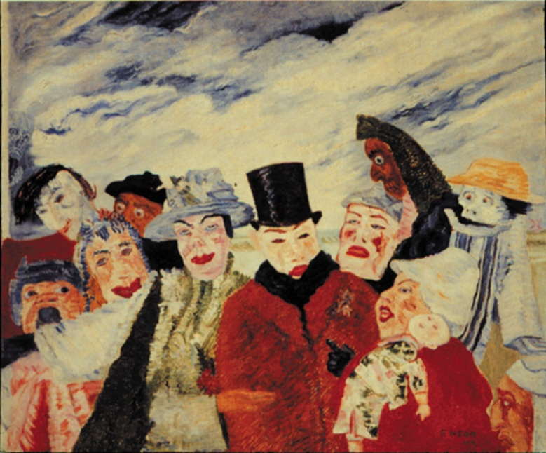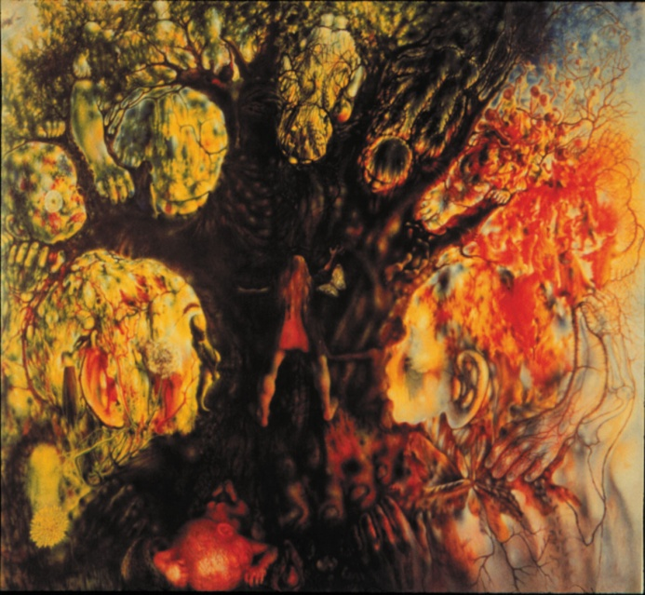

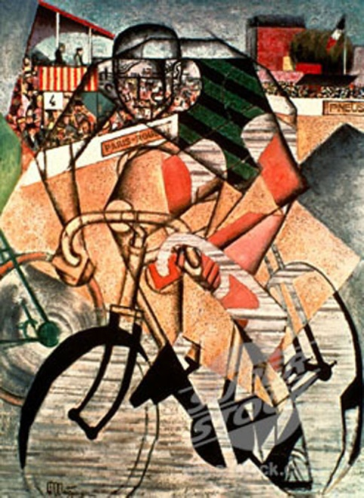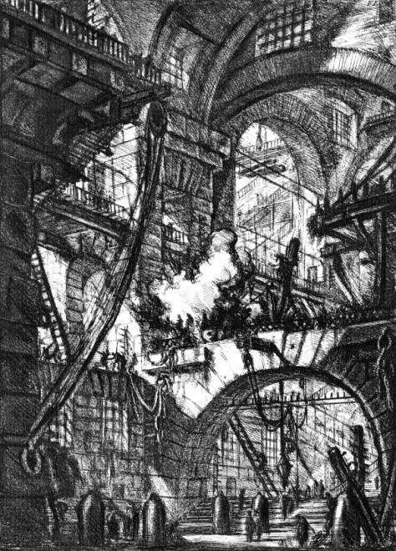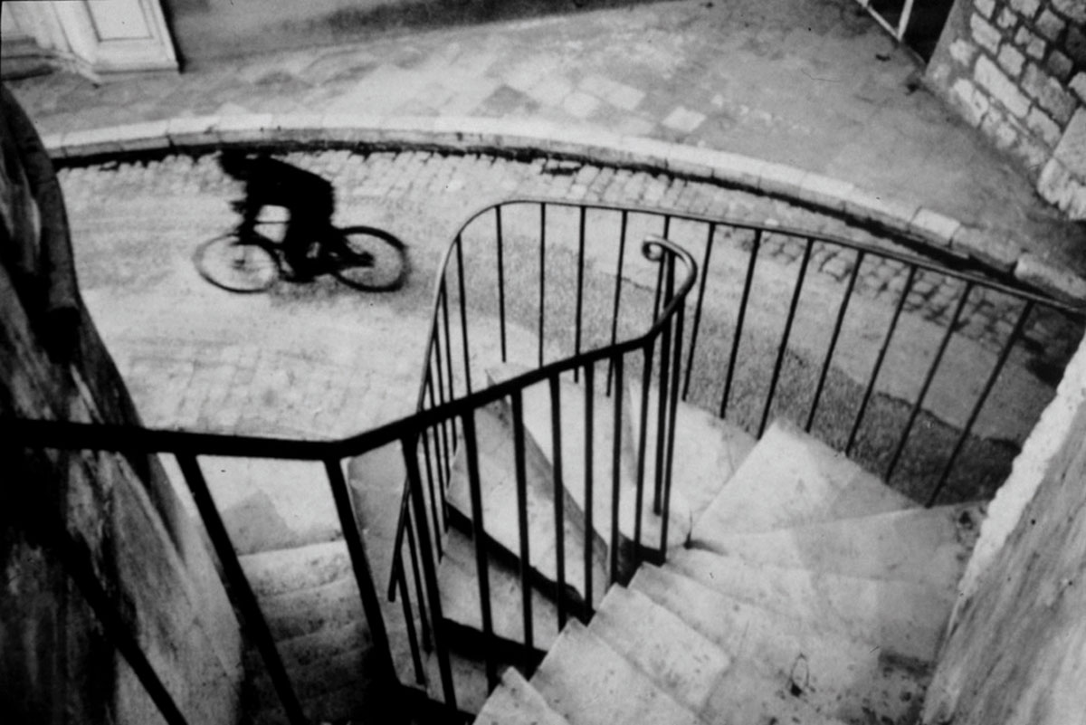

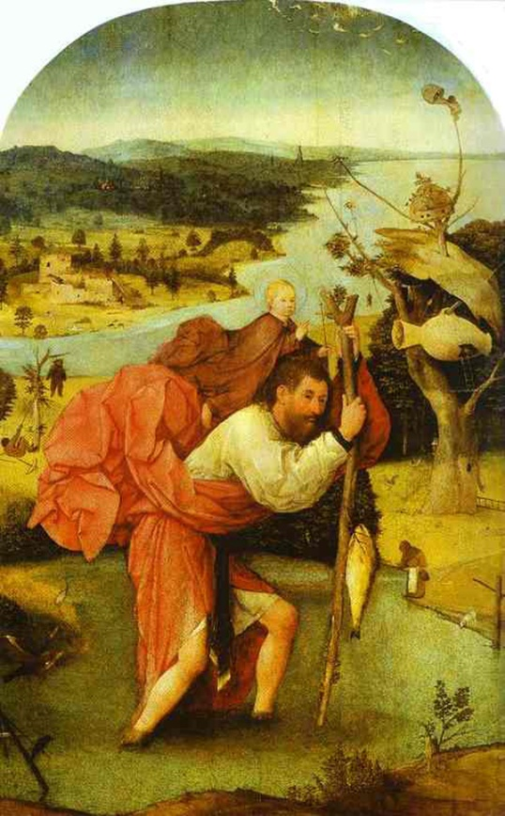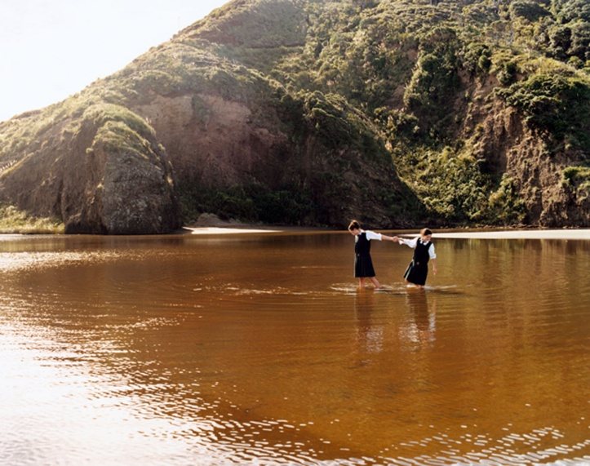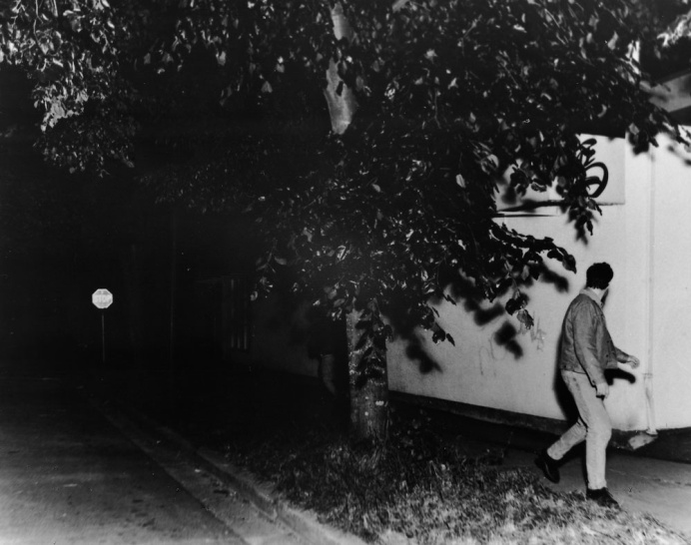
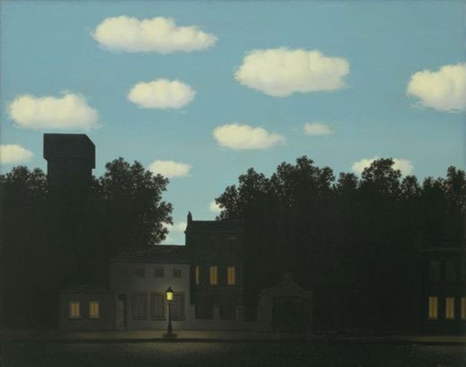
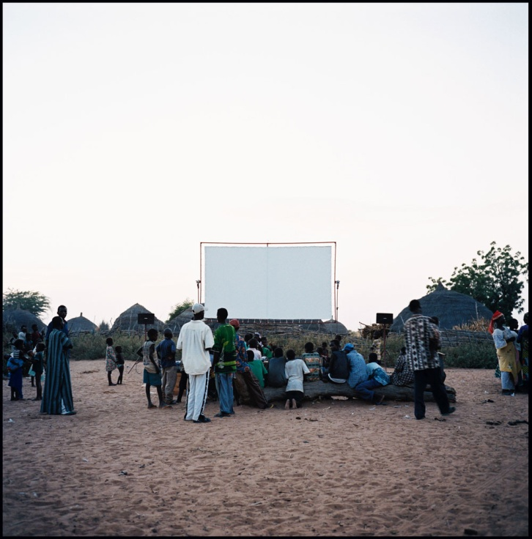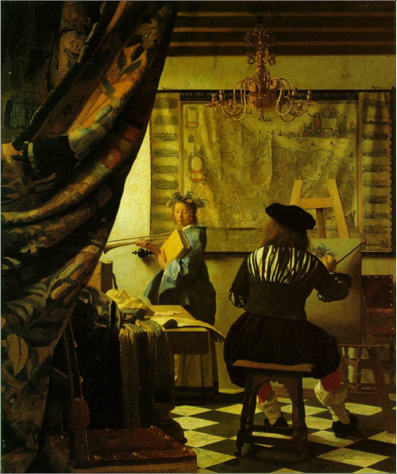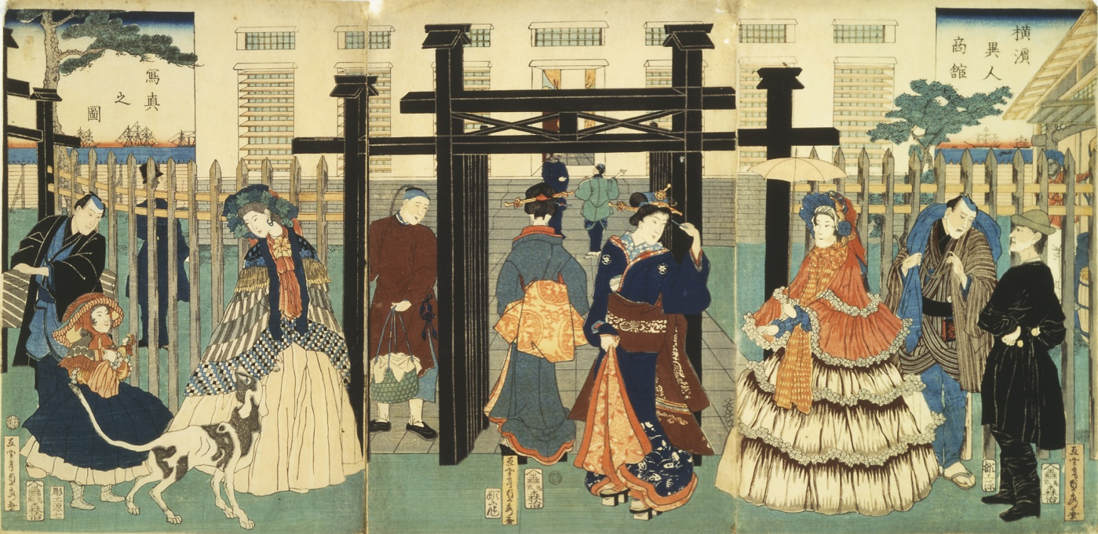

Grade 8 Visual Art
Design Focus: Movement and Sequencing
• movement: actual lines to lead the viewer’s eye (e.g., solid lines, dotted lines); subtle or implied “paths” using shape, value, and/or color (e.g., an invisible path created by leading the eye from large shapes to small shapes, from shapes in dark colors to shapes in lighter colors, from familiar shapes to unfamiliar shapes, from color to no color); actual action (e.g., kinetic sculpture, animation, video); implied action (e.g., an invisible path created by an arrow, a gaze, or a pointing finger; the “freeze frame” effect of an object in motion, such as a bouncing ball suspended in mid-air or a runner about to take
the next step)
Contemporary Focus: Appropriation, Recontextualization
Culminating Project: Storyboard/Digital Story telling—My Journey Until Now

By the Middle School years, a quality instructional program will focus on the consolidation of students’ knowledge, skills, and strategies in the visual arts. They will have acquired foundational knowledge about artistic forms and conventions, the creative process, and critically interacting with a diverse range of artworks. Consequently, students will require multiple and diverse opportunities to practice independently and demonstrate achievement of art learning. To demonstrate mastery, they are ready to apply their abilities to new visual challenges that they have not yet encountered but which are within the range of their skill set. Because they have developed the ability to reflect on, monitor, and take steps to improve their art learning, they use their inquiry and research skills to extend their interpretive and creative abilities. As they start to develop powerful new thoughts and feelings that sometimes challenge established world-views, they use the arts to explore and comment on issues relevant to their daily lives. Art making becomes a safe arena for experimenting in the construction of new relationships between inner and outer realities as young adolescents encounter conflicting and diverse experiences. At the same time that they eagerly incorporate aspects of popular culture into their art they also come to understand the context of historical artworks in more refined and probing ways, leading to greater understanding of what they themselves value. They realize that artists are concerned with issues relevant to their own lives and society and discover exemplars of artistic practices that resonate with their own personal and creative concerns, helping them to reflect more deeply on their own art making. An emerging proficiency in the creative process and critical reflection leads to increasingly confident and informed responses to art while their own art also displays greater expressive confidence and skill. By the end of Grade 8, their technical and conceptual competence in art should result in the first glimmers of a distinctive personal style and pronounced personal aesthetic interests. While teachers should continue employing guided practice in the use of the creative process, methods and materials, problem solving, and critically responding to art, they also provide significantly increased opportunities for independent practice. They should continue to explicitly teach and model skills to help students identify what is needed to become proficient creators and interpreters of art.

Subject matter that is designed to support and challenge students at their individual level of development in the arts will enhance the benefits of appropriately scaffolded instruction. It is important to ensure that students are able to choose from a wide range of topics and activities that are open-ended, provide for multiple, diverse solutions, and which are engaging and relevant to their personal experiences and interests.

Students in the Middle School years continue to generate and develop visual ideas in response to a variety of motivations, using imagination, observation, and a study of artists’ works, and incorporate into their art ideas gained from sources such as independent reading. They also generate and develop visual ideas in response to a variety of artistic challenges and techniques, e.g. the postmodern principles of art and other contemporary “lenses” through which meaning can be created and interpreted. Students explore and describe how different media influence the communication and interpretation of ideas in their own and others’ work. To this end, they look beyond the surface meaning of art works and observe not only what is present but what is missing, in order to analyze and evaluate an artist’s intent. They also analyze and describe how art-making processes and procedures clarify meaning and intentions in their own and others’ work and observe how artists tell stories and create mood in their work. Students use their growing analytical and evaluative skills to investigate the purpose(s) and significance of objects, images, and art works in past and present cultures and to examine the contexts in which they were or are made, viewed, and valued. By the end of 8th grade, should have achieved a significant level of consolidation in their understanding of aesthetics as the emotional and cognitive reaction to the perceived ideas and aspirations that a person or group expresses through the making and display of art.

Students should have access to culturally diverse examples that allow them to explore more complex topics or issues and more subtle or abstract themes. The following provide a variety of sources to motivate and engage diverse groups of students: Oral forms such as dramatic presentations, oral reports, think-alouds, commentaries, speeches, monologues, and song lyrics; kinaesthetic forms such as acting out, movement, and dance; concrete forms such as artifacts, garments, and props; print forms such as posters, images, digital and print photographs, stories, biographies, graphic novels, poetry, myths, and legends; and media forms as movie trailers, graphic designs for various products, newspaper or magazine articles, video games, comic books, flyers, websites, and e-mails.

As a general rule, no more than 30% of instructional time should focus exclusively on the elements and principles; students should be primarily engaged in the creative process of making meaning, with the elements and principles used as tools to this end and the learning of these tools reinforced in the process itself. Instead of being based on the elements and principles framework, lessons should be primarily framed using alternate models appropriate to 21st Century learning such as: Pink’s six aptitudes: story, design, symphony, play, empathy, and meaning; the Studio Habits of Mind model; of Gude’s Principles of Postmodernism.

Unit I. Art Changes Our Way of Thinking and Seeing
Approximately 4 weeks
Themes and Concepts

Enduring Understandings and Essential Questions
Additional Concepts and Themes determined by specific learning units designed by each art teacher
Movement
Appropriation
Recontextualization
Image modification and transformation exercises

Georgia Performance Standards in the Visual Arts for Unit 1

VA8MC.1 Engages in the creative process to generate and visualize ideas.
VA8MC.2 Identifies and works to solves problems through authentic engagement (thinking, planning, and experimenting) with art methods and materials, exploring the nature of creativity.
VA8MC.3 Demonstrates how artists create and communicate meaning in artworks.
VA8CU.1 Discovers how the creative process relates to art history.
VA8PR.1 Engages in art making process with care and craftsmanship.
VA8PR.2 Creates artwork reflecting a range of concepts, ideas, subject matter.
VA8PR.3 Produces an array of two-dimensional and three-dimensional artistic processes and techniques using a variety of media and technology.
VA8PR.4 Keeps a visual/verbal sketchbook journal, consistently throughout the course, to collect, develop and preserve ideas in order to produce works of art.
VA8PR.5 Develops and maintains an individual portfolio of artworks.
VA8AR.1 Critiques personal artworks as well as artwork of others using visual and verbal approaches.
VA8AR.2 Reflects and expands the use of visual language throughout the artistic process.
VA8AR.3 Plans and presents appropriate exhibition(s) for work(s) of art.
VA8C.2 Develops fluency in visual communication.

Suggested Activities and Teacher Prompts

VTS Writing Pre-Test: (Required)
Review of 7th Grade End of Year Learning Unit and 7th grade art history images (Required)

Use the Brandhorst Metaphor Worksheet or the Exquisite Corpse Sentence Constructor technique to generate ideas for artworks; employ the Roukes image modification techniques and strategies to develop imagery and creative thinking; further develop visual ideas by producing a variety of thumbnail sketches.

Develop unpredictable imagery, appreciation for using non-traditional materials and confidence by using Salvador Dali’s Surrealist method of looking for imagery in stains and blots; use old maps, photos of textured surfaces, rubbings, used coffee filters, dirt stained paper, etc

Use a variety of materials, tools, techniques, and technologies to determine solutions to increasingly complex artistic challenges

• drawing: create a pastel composition or flipbook that combines or contrasts styles of two artists or styles from two cultures or that appropriates an image from culture and recontextualizes it in terms of another culture
• painting: make an acrylic painting of a magnified section of a sketch or an image that is seen through a viewfinder or frame, then make changes to the painted surface with oil pastels to create a personal or make a cityscape that will serve as a background in an animated short movie, using experimental watercolor techniques such as wet on wet or salt resist interpretation of the image
• printmaking: make a series of two-color softoleum, linoleum, or block prints that are variations on a social theme and that are printed on papers of different colors and textures [magazine paper, colored bond paper, newsprint, tissue paper, handmade paper]
• digital: produce a work of art using a computer that includes a scanned image or digital photo and that demonstrates experimentation with compositional elements; paintbrush, drawing, selection and contrast tools; layering; and 1-2 filters. Advanced: “cut out” a figure from one image using the selection tool and paste it into a new digital composition, thereby recontextualizing it. Suggested theme: a digital drawing of an animal using paint brush and drawing tool features that includes at least 2 layers and use of 1-2 filters that significantly alters the original image. Select a student to demonstrate use of the computer program. Discuss the range of artistic options.

Teacher prompt: “How would the feeling and message of the print change if you printed it on a magazine advertisement rather than on colored paper? Which one serves your purpose better?” “How can you use storyboards to plan a variety of shots and camera angles?” “Does the meaning change when you magnify, repeat, or appropriate an image for a different use? How?”

Ongoing throughout the year:

In your verbal-visual sketchbook, identify and explain their strengths, their interests, and areas for improvement as creators, interpreters, and viewers of art (e.g., reflect on challenges and successes in the form of an artist’s statement; maintain in your sketchbook a collection of ideas and images for art works; do peer reviews of each other’s art works, using a checklist of criteria created by the class to help you identify areas that need revision, and provide suggestions)
Teacher prompts: “How did you adapt these new ideas, situations, media, materials, processes, or technologies to help you convey your ideas?” “How did you use imagination, observation, and the study of other art works to help you develop your ideas?” “How did you negotiate designs with other members of the group and agree on the techniques, ideas, and composition you used?” “How did you approach the challenges you faced in making sure your sculpture was interesting to look at from more than one side? What would you do differently next time?”

Demonstrate an understanding of key contributions and functions of visual and media arts in various contexts at both the local and the national levels (e.g., community art schools or programs provide opportunities for creative expression and instruction by and for both amateurs and professionals; a wide variety of workers are employed by arts industries such as advertising, design, movie making, and broadcast media; artists contribute to America’s economy by providing both goods and services)
Teacher prompts: “In what ways do the visual arts contribute to the economies of urban and rural communities?” “In what ways are the visual arts involved in international trade?” “What are the various professions or careers that have a basis in visual arts, and what education is required? How can we find out more about these careers?”

The following skills are introduced to support artistic development, creative thinking, and meaning making in alignment with this unit’s theme and not as ends-in-themselves:

Assessment
Student self-assessment in visual/verbal journal
Teacher assessment: Studio Habits of Mind rubric (high/medium/low)

Artworks for required VTS: 2 per week (see below for images)

Other suggested art criticism models (introduced at discretion of teacher):
Feldman model

Recommended Artists/Artworks:

Recommended texts:
Nicholas Roukes, Art Synectics
From Ordinary to Extraordinary

Advanced students:

UNIT II. Art Helps Us Understand Where We Are in Time and Place
Approximately 3-4 weeks
Themes and Concepts

Enduring Understandings and Essential Questions
Additional Concepts and Themes determined by specific learning units designed by each art teacher
Artists interpret nature, people, & culture/society by selecting, editing, emphasizing, ordering/reordering, and by questioning hierarchies of values and logic
Juxtaposition

Georgia Performance Standards in the Visual Arts for Unit 2

VA8MC.3 Demonstrates how artists create and communicate meaning in artworks.
VA8MC.4 Participates in aesthetic dialogue about his or her artwork and artwork of others.
VA8CU.2 Investigates and discovers personal relationship to community, culture, and world through making and studying art.
VA8PR.1 Engages in art making process with care and craftsmanship.
VA8PR.3 Produces an array of two-dimensional and three-dimensional artistic processes and techniques using a variety of media and technology.
VA8AR.2 Reflects and expands the use of visual language throughout the artistic process.
VA8C.1 Applies information from other disciplines to enhance the understanding and production of artworks.
VA8C.2 Develops fluency in visual communication.
VA8C.3 Expands knowledge of art as a profession and/or avocation and develops personal life-skills through artistic endeavor.

Suggested Activities and Teacher Prompts

Create art works, using a variety of traditional forms and current media technologies, that express feelings, ideas, and issues and that demonstrate an awareness of multiple points of view

- produce a collage that shows contrast between two points of view or a cause-and-effect relationship
- create an art work on a current event or issue, using the conventions of sequential art or comics, or using found images and text to express a point of view in the style of a contemporary artist such as Martin Firrel, Jenny Holzer, or Barbara Kruger

Teacher prompts: “How can you juxtapose text and images to create a message that challenges
what the text is saying?” “In your monochromatic comic layout, how will you use angle of view, images, and text to show two sides of the story?” “How can stereotypes be reinforced or challenged in art works?”

Demonstrate an understanding of composition, using multiple principles of design and other layout considerations such as compositional triangles to create narrative art works or art works on a theme or topic

- a figure drawing of a historically influential person that makes use of the whole paper or space to create a sense of unity and balance, with a single word or motif in the background
- a stop-motion animation that tells a simple story and that demonstrates the principle of movement through sequential images in which the character or object moves in relation to the frame

Teacher prompts: “How would your image be different if your figure took up only one side of the paper?” “How can you use color and variation in value, like Mary Pratt, to capture light in a still-life composition that leads the viewer’s eye throughout the art work?” “How can you use implied action through a technique such as automotion or through the gaze or gestures of the figures?”

Ongoing throughout the year:

In your verbal-visual sketchbook, identify and explain their strengths, their interests, and areas for improvement as creators, interpreters, and viewers of art (e.g., reflect on challenges and successes in the form of an artist’s statement; maintain in your sketchbook a collection of ideas and images for art works; do peer reviews of each other’s art works, using a checklist of criteria created by the class to help you identify areas that need revision, and provide suggestions)
Teacher prompts: “How did you adapt these new ideas, situations, media, materials, processes, or technologies to help you convey your ideas?” “How did you use imagination, observation, and the study of other art works to help you develop your ideas?” “How did you negotiate designs with other members of the group and agree on the techniques, ideas, and composition you used?” “How did you approach the challenges you faced in making sure your sculpture was interesting to look at from more than one side? What would you do differently next time?”

Demonstrate an understanding of key contributions and functions of visual and media arts in various contexts at both the local and the national levels (e.g., community art schools or programs provide opportunities for creative expression and instruction by and for both amateurs and professionals; a wide variety of workers are employed by arts industries such as advertising, design, movie making, and broadcast media; artists contribute to America’s economy by providing both goods and services)
Teacher prompts: “In what ways do the visual arts contribute to the economies of urban and rural communities?” “In what ways are the visual arts involved in international trade?” “What are the various professions or careers that have a basis in visual arts, and what education is required? How can we find out more about these careers?”

The following skills are introduced to support artistic development, creative thinking, and meaning making in alignment with this unit’s theme and not as ends-in-themselves:

Assessment
Student self-assessment in visual/verbal journal
Teacher assessment: Studio Habits of Mind rubric (high/medium/low)
Artworks for required VTS: 2 per week (see below for images)

Other suggested art criticism models (introduced at discretion of teacher):
Feldman model

Recommended Artists/Artworks:

Recommended texts:
Nicholas Roukes, Art Synectics
From Ordinary to Extraordinary

Advanced students:

UNIT III. Art Helps Us Understand Who We Are
Approximately 1-2 weeks (Culminating Project)
Themes and Concepts

Enduring Understandings and Essential Questions
Additional Concepts and Themes determined by specific learning units designed by each art teacher
Layering
Representin’

Georgia Performance Standards in the Visual Arts for Unit 3

VA8MC.1 Engages in the creative process to generate and visualize ideas.
VA8MC.3 Demonstrates how artists create and communicate meaning in artworks.
VA8MC.4 Participates in aesthetic dialogue about his or her artwork and artwork of others.
VA8CU.1 Discovers how the creative process relates to art history.
VA8PR.3 Produces an array of two-dimensional and three-dimensional artistic processes and techniques using a variety of media and technology.
VA8PR.4 Keeps a visual/verbal sketchbook journal, consistently throughout the course, to collect, develop and preserve ideas in order to produce works of art.
VA8AR.1 Critiques personal artworks as well as artwork of others using visual and verbal approaches.
VA8AR.2 Reflects and expands the use of visual language throughout the artistic process.
VA8AR.3 Plans and presents appropriate exhibition(s) for work(s) of art.
VA8C.1 Applies information from other disciplines to enhance the understanding and production of artworks.

Suggested Activities and Teacher Prompts

VTS Writing Post-Test: (Required)
On-Line Assessment (Required)

Performance Assessment: (Required; see below)
[Lesson plan with rubric to be provided]

Produce a series of related images that demonstrates:

• narrative
• compelling visual metaphor to communicate the meaning of the narrative
• integration of various media and materials, including layering, recontextualizing, appropriation, image modification, etc.
• expressive use of art elements; shape, color, line, texture

Consider using a pictorial sequence demonstrating imaginative combination of drawn, painted, photocopied, scanned, and/or digital images. Consider Jacob Lawrence’s Great Migration series, Parthenon friezes, Chinese scrolls and picture books with little or no text. Examine the techniques used to move the narrative along.

Theme: You have been asked to artistically portray the journey that a student takes from elementary school to 8th grade through a video. Your digital story will be shown to rising 5th graders who will enter middle school next year. What challenges, joys, issues, ups and downs will you share with them? What visual metaphors will you employ to depict the journey visually, without narration or text? (Appropriate music may be included).

Artworks for required VTS: 2 per week (see below for images)

Other suggested art criticism models (introduced at discretion of teacher):
Feldman model

Recommended Artists/Artworks:

Recommended texts:
Nicholas Roukes, Art Synectics
From Ordinary to Extraordinary

Advanced students:

VTS Images: 2 per week (see following pages)

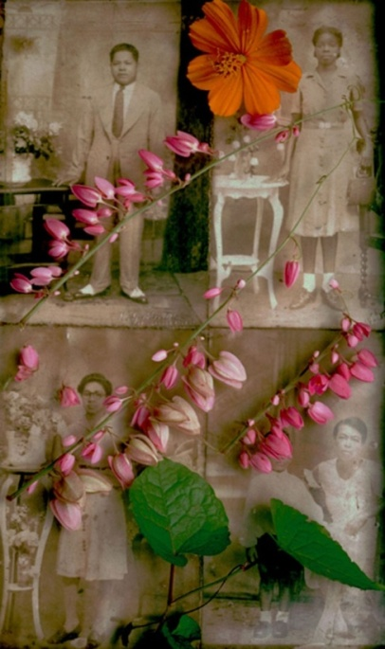
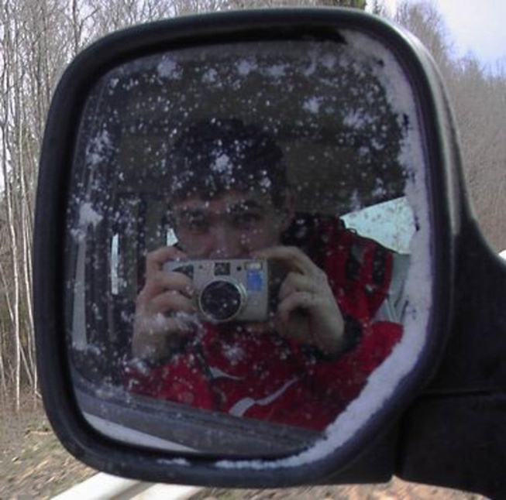
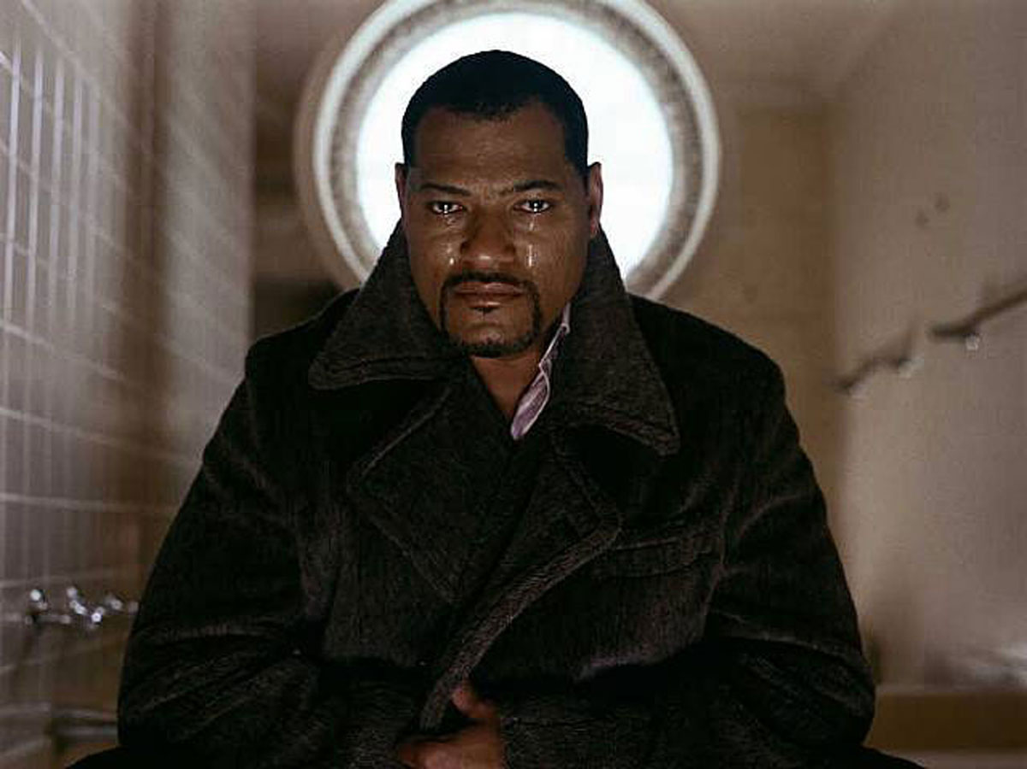
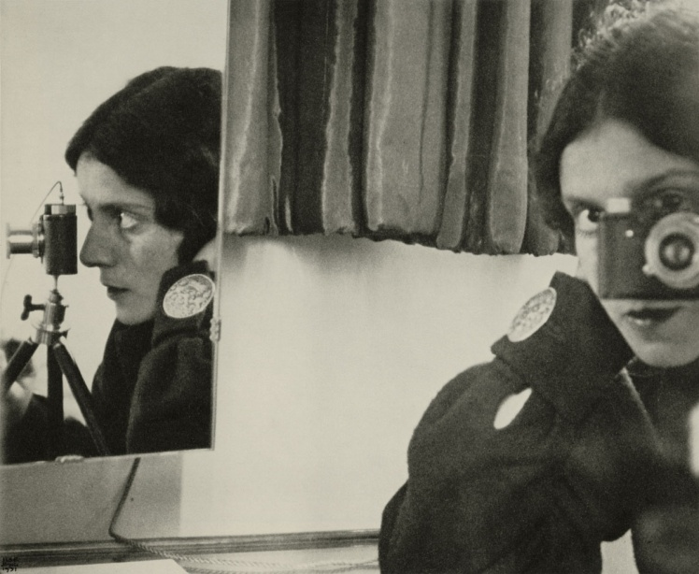

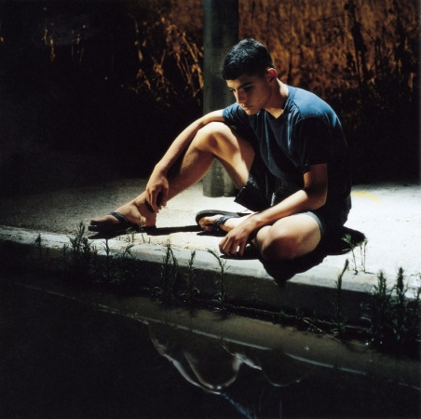
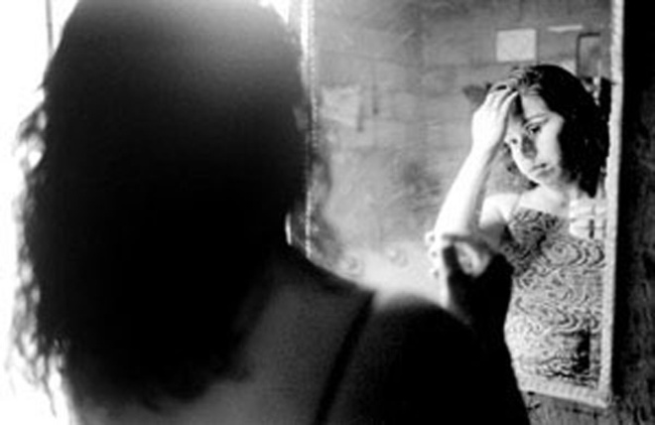

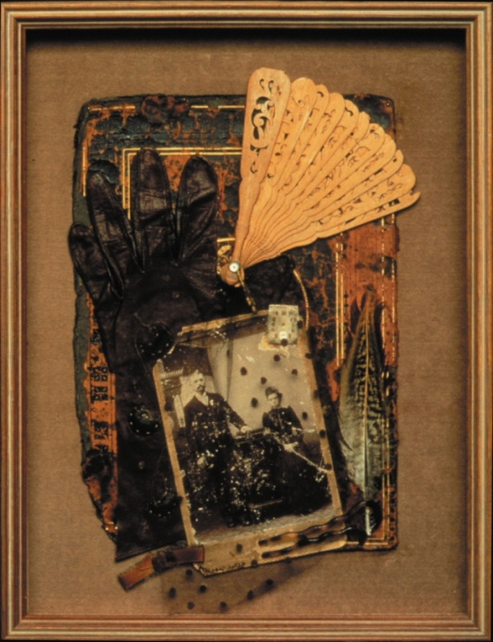
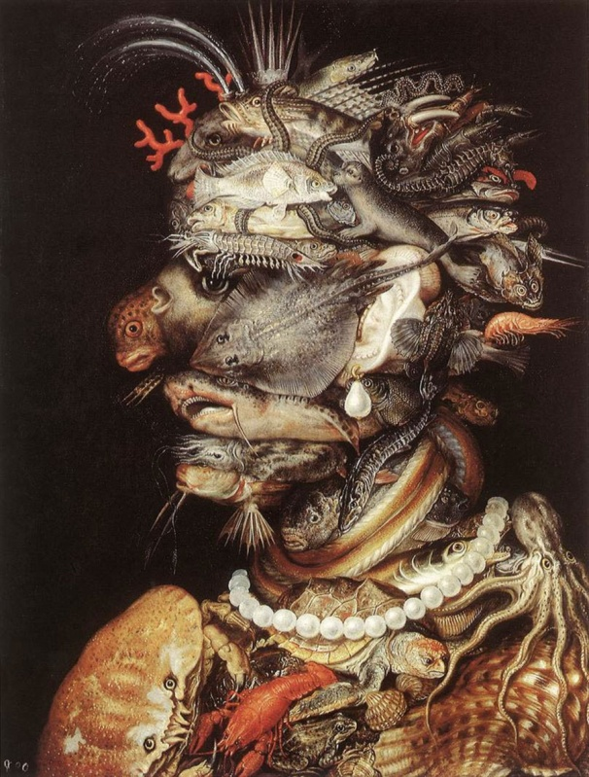

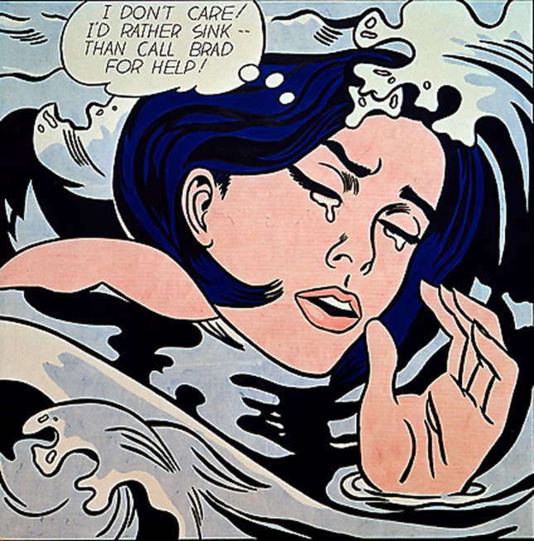
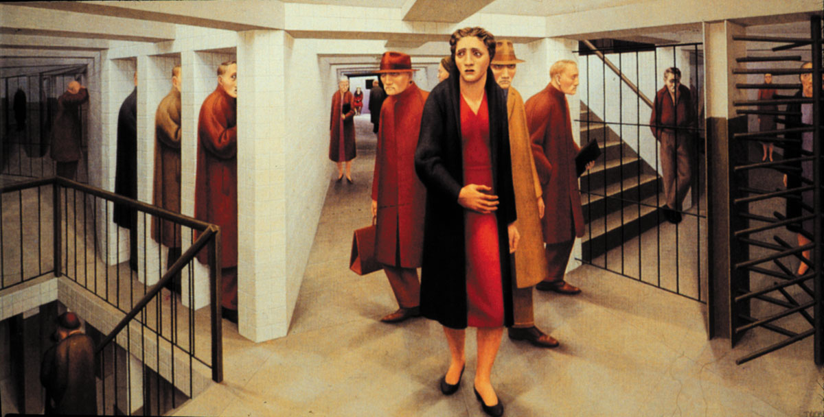
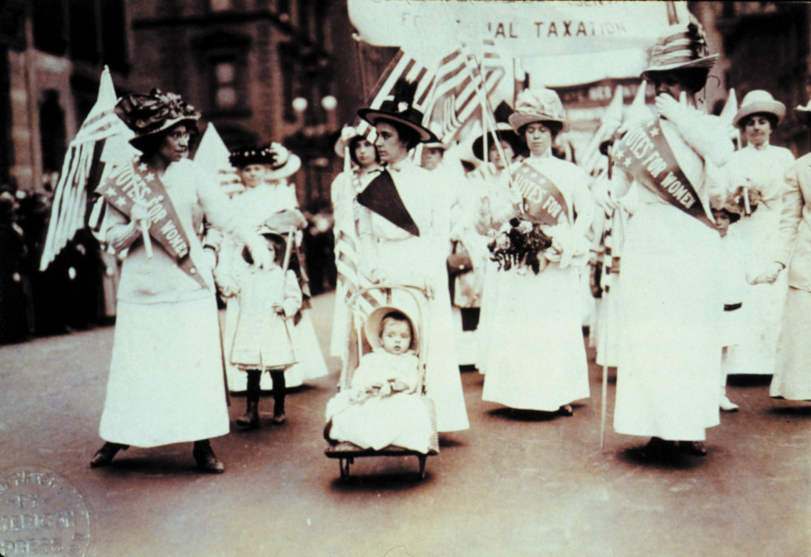
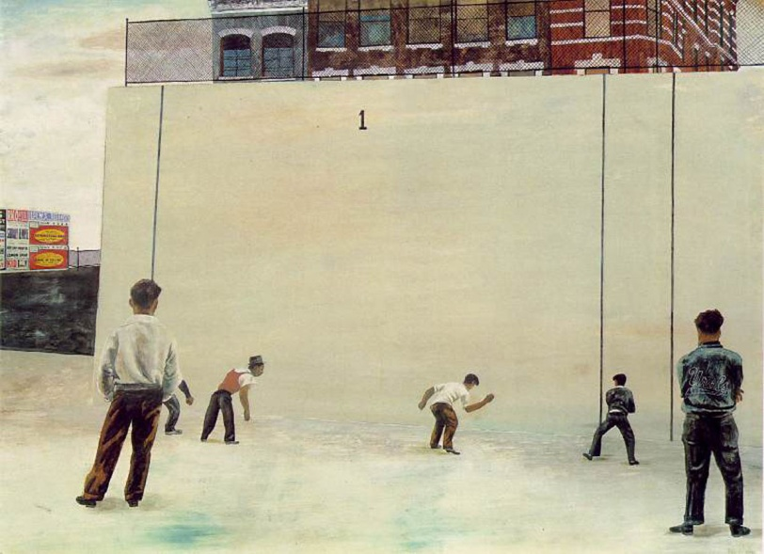

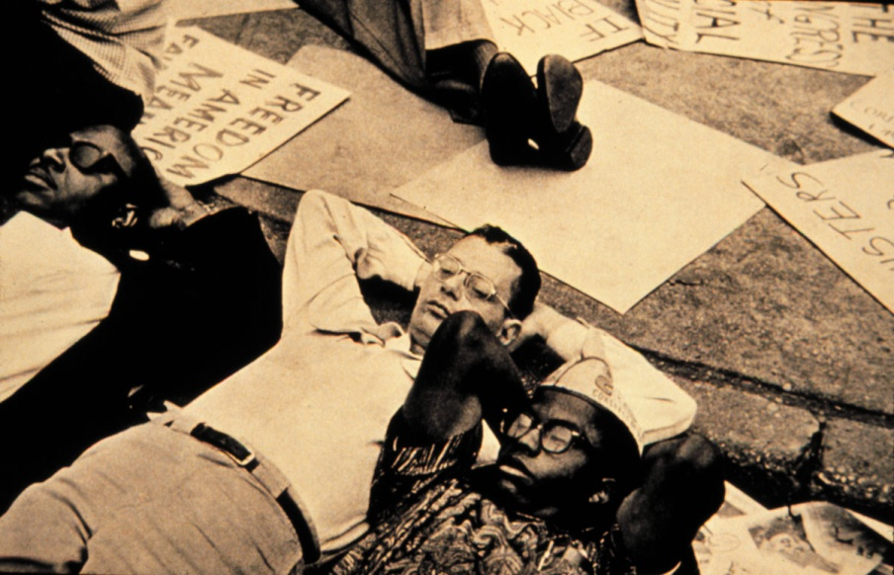
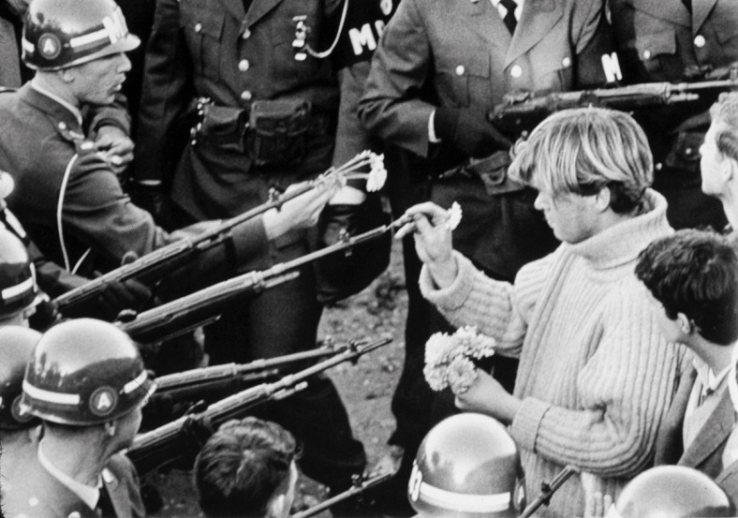

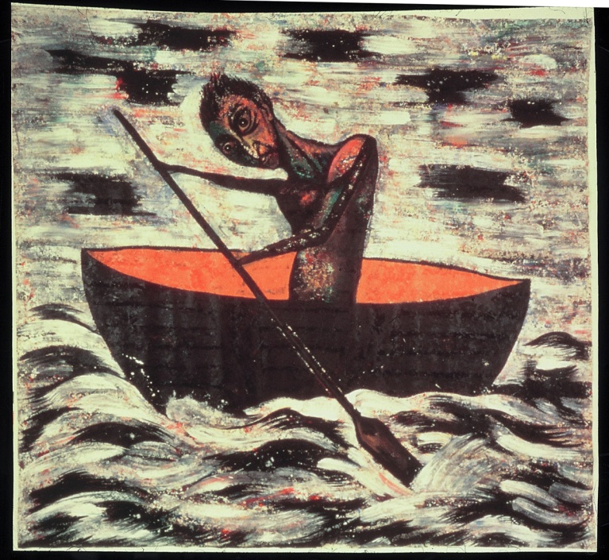

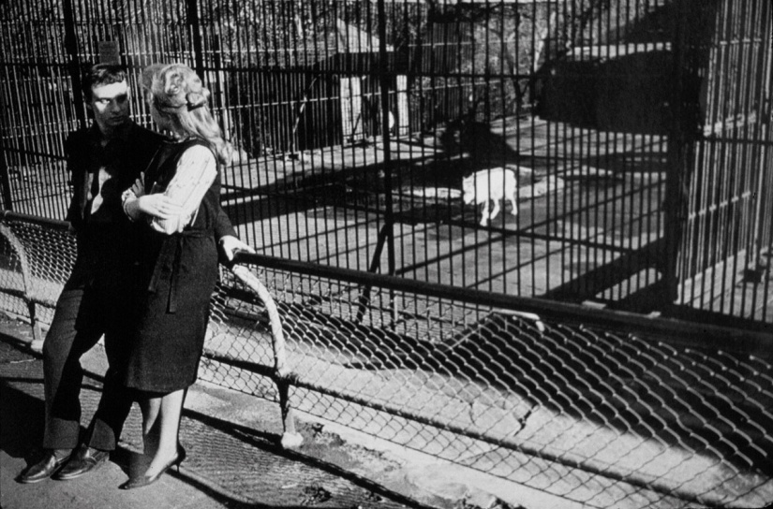
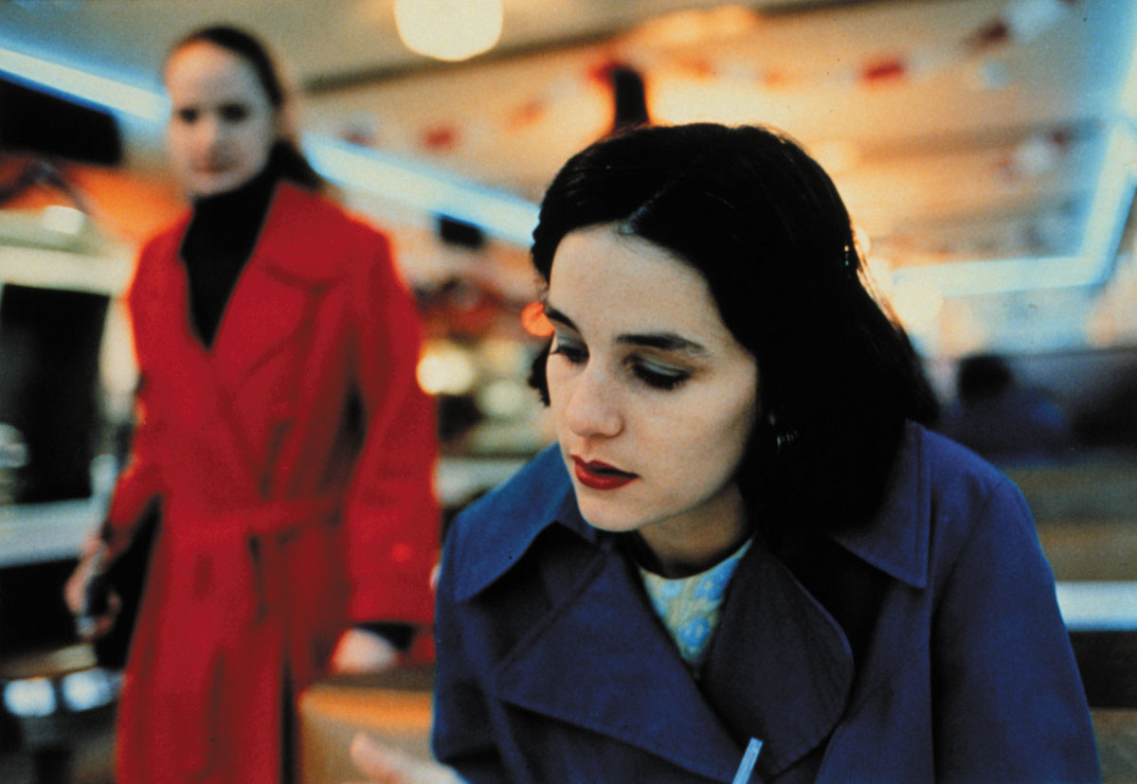

Grade 7 Visual Art
Design Focus: Emphasis
• emphasis: use of color intensity, contrast in value, placement and size of shapes, and/or weight of line to create a particular focal point
Contemporary Focus:
Culminating Project: Sculpture/exhibit of endangered species
Art History:

By the Middle School years, a quality instructional program will focus on the consolidation of students’ knowledge, skills, and strategies in the visual arts. They will have acquired foundational knowledge about artistic forms and conventions, the creative process, and critically interacting with a diverse range of artworks. Consequently, students will require multiple and diverse opportunities to practice independently and demonstrate achievement of art learning. To demonstrate mastery, they are ready to apply their abilities to new visual challenges that they have not yet encountered but which are within the range of their skill set. Because they have developed the ability to reflect on, monitor, and take steps to improve their art learning, they use their inquiry and research skills to extend their interpretive and creative abilities. As they start to develop powerful new thoughts and feelings that sometimes challenge established world-views, they use the arts to explore and comment on issues relevant to their daily lives. Art making becomes a safe arena for experimenting in the construction of new relationships between inner and outer realities as young adolescents encounter conflicting and diverse experiences. At the same time that they eagerly incorporate aspects of popular culture into their art they also come to understand the context of historical artworks in more refined and probing ways, leading to greater understanding of what they themselves value. They realize that artists are concerned with issues relevant to their own lives and society and discover exemplars of artistic practices that resonate with their own personal and creative concerns, helping them to reflect more deeply on their own art making. An emerging proficiency in the creative process and critical reflection leads to increasingly confident and informed responses to art while their own art also displays greater expressive confidence and skill. By the end of Grade 8, their technical and conceptual competence in art should result in the first glimmers of a distinctive personal style and pronounced personal aesthetic interests. While teachers should continue employing guided practice in the use of the creative process, methods and materials, problem solving, and critically responding to art, they also provide significantly increased opportunities for independent practice. They should continue to explicitly teach and model skills to help students identify what is needed to become proficient creators and interpreters of art.

Subject matter that is designed to support and challenge students at their individual level of development in the arts will enhance the benefits of appropriately scaffolded instruction. It is important to ensure that students are able to choose from a wide range of topics and activities that are open-ended, provide for multiple, diverse solutions, and which are engaging and relevant to their personal experiences and interests.

Students in the Middle School years continue to generate and develop visual ideas in response to a variety of motivations, using imagination, observation, and a study of artists’ works, and incorporate into their art ideas gained from sources such as independent reading. They also generate and develop visual ideas in response to a variety of artistic challenges and techniques, e.g. the postmodern principles of art and other contemporary “lenses” through which meaning can be created and interpreted. Students explore and describe how different media influence the communication and interpretation of ideas in their own and others’ work. To this end, they look beyond the surface meaning of art works and observe not only what is present but what is missing, in order to analyze and evaluate an artist’s intent. They also analyze and describe how art-making processes and procedures clarify meaning and intentions in their own and others’ work and observe how artists tell stories and create mood in their work. Students use their growing analytical and evaluative skills to investigate the purpose(s) and significance of objects, images, and art works in past and present cultures and to examine the contexts in which they were or are made, viewed, and valued. By the end of 8th grade, should have achieved a significant level of consolidation in their understanding of aesthetics as the emotional and cognitive reaction to the perceived ideas and aspirations that a person or group expresses through the making and display of art.

Students should have access to culturally diverse examples that allow them to explore more complex topics or issues and more subtle or abstract themes. The following provide a variety of sources to motivate and engage diverse groups of students: Oral forms such as dramatic presentations, oral reports, think-alouds, commentaries, speeches, monologues, and song lyrics; kinaesthetic forms such as acting out, movement, and dance; concrete forms such as artifacts, garments, and props; print forms such as posters, images, digital and print photographs, stories, biographies, graphic novels, poetry, myths, and legends; and media forms as movie trailers, graphic designs for various products, newspaper or magazine articles, video games, comic books, flyers, websites, and e-mails.

As a general rule, no more than 30% of instructional time should focus exclusively on the elements and principles; students should be primarily engaged in the creative process of making meaning, with the elements and principles used as tools to this end and the learning of these tools reinforced in the process itself. Instead of being based on the elements and principles framework, lessons should be primarily framed using alternate models appropriate to 21st Century learning such as: Pink’s six aptitudes: story, design, symphony, play, empathy, and meaning; the Studio Habits of Mind model; of Gude’s Principles of Postmodernism.

Unit 1. Art Changes Our Way of Thinking and Seeing
Approximately 4 weeks
Themes and Concepts

Enduring Understandings and Essential Questions
Additional Concepts and Themes determined by specific learning units designed by each art teacher
Metaphor
Modification and transformation of imagery
Inquiry based development of imagery…

Georgia Performance Standards in the Visual Arts for Unit 1

VA7MC.1 Engages in the creative process to generate and visualize ideas.
VA7MC.2 Identifies and works to solve problems through creative thinking, planning, and/or experimenting with art methods and materials.
VA7CU.1 Discovers how the creative process relates to art history.
VA7PR.1 Understands and applies media, techniques, and processes with care and craftsmanship.
VA7PR.2 Creates artwork reflecting a range of concepts, ideas, and subject matter.
VA7PR.3 Uses the elements and principles of design along with a variety of media, techniques and skills to produce two-dimensional and three-dimensional works of art.
VA7PR.4 Keeps a visual/verbal sketchbook journal, consistently throughout the course, to collect, develop, and preserve ideas in order to produce works of art.
VA7AR.1 Develops and maintains an individual portfolio of artworks.
VA7AR.2 Critiques personal artworks as well as artwork of others using visual the and verbal approaches.
VA7AR.3 Reflects and expands the use of visual language throughout the artistic process.
VA7C.2 Develops fluency in visual communication.
VA7C.3 Expands knowledge of art as a profession and/or avocation and increases personal life-skills through artistic endeavor.

Suggested Activities and Teacher Prompts

VTS Writing Pre-Test: (Required)
Review of 6th Grade End of Year Learning Unit and 6th grade art history images (Required)

Use the Brandhorst Metaphor Worksheet or the Exquisite Corpse Sentence Constructor technique to generate ideas for artworks; employ the Roukes image modification techniques and strategies to develop imagery and creative thinking; further develop visual ideas by producing a variety of thumbnail sketches.

Develop unpredictable imagery, appreciation for using non-traditional materials and confidence by using Salvador Dali’s Surrealist method of looking for imagery in stains and blots; use old maps, photos of textured surfaces, rubbings, used coffee filters, dirt stained paper, etc

Develop skills in symbolic understanding and transformation through:
- symbolization: make a list of processes such as open, shut, lift, drop, turn, recycle, destruct, do not enter, etc; design an appropriate, original graphic symbol for each.
- symbolic doodles: divide paper into six compartments; in each, create a symbolic doodle that portrays each of the following: Yesterday-Today-Tomorrow; Restraint-Reaction-Freedom; Sleep-Awakening-Action; Compression-Ignition-Exhaust; Nonbeing-Birth-Transformation; Stimulus-response-Result

Use elements of design in art works to communicate ideas, messages, and understandings for a specific audience and purpose

- produce balance in positive and negative space in a personal logo design, using drawing or paper cut-outs of black-and-white shapes on a grey background. Variation: produce a personal digital logo using a computer that demonstrates experimentation with compositional elements, computer program icons, layering, and 1-2 filters. Select a student to demonstrate use of the computer program. Discuss the range of artistic options.
- selectively manipulate the color, values, and text in a digital composition to change the message of a print advertisement)

Teacher prompts: “How could you elaborate on the visual metaphor in your logo? How could you simplify the design of the logo and still retain a balance between positive and negative shapes?” “How could you change the colors, values, and symbols used in a print advertisement for a popular soft drink to convey an objection to consumerism?”

Ongoing throughout the year:

In your verbal-visual sketchbook, identify and explain their strengths, their interests, and areas for improvement as creators, interpreters, and viewers of art (e.g., reflect on challenges and successes in the form of an artist’s statement; maintain in your sketchbook a collection of ideas and images for art works; do peer reviews of each other’s art works, using a checklist of criteria created by the class to help you identify areas that need revision, and provide suggestions)
Teacher prompts: “How did you adapt these new ideas, situations, media, materials, processes, or technologies to help you convey your ideas?” “How did you use imagination, observation, and the study of other art works to help you develop your ideas?” “How did you negotiate designs with other members of the group and agree on the techniques, ideas, and composition you used?” “How did you approach the challenges you faced in making sure your sculpture was interesting to look at from more than one side? What would you do differently next time?”

Demonstrate an understanding of key contributions and functions of visual and media arts in various contexts at both the local and the national levels (e.g., community art schools or programs provide opportunities for creative expression and instruction by and for both amateurs and professionals; a wide variety of workers are employed by arts industries such as advertising, design, movie making, and broadcast media; artists contribute to America’s economy by providing both goods and services)
Teacher prompts: “In what ways do the visual arts contribute to the economies of urban and rural communities?” “In what ways are the visual arts involved in international trade?” “What are the various professions or careers that have a basis in visual arts, and what education is required? How can we find out more about these careers?”

The following skills are introduced to support artistic development, creative thinking, and meaning making in alignment with this unit’s theme and not as ends-in-themselves:

Assessment
Student self-assessment in visual/verbal journal
Teacher assessment: Studio Habits of Mind rubric (high/medium/low)

Artworks for required VTS: 2 images per week (see below)

Other suggested art criticism models (introduced at discretion of teacher):
Feldman model

Recommended Artists/Artworks:

Recommended texts:

Advanced students:

II. Art Helps Us Understand Where We Are in Time and Place
Approximately 3-4weeks
Themes and Concepts

Enduring Understandings and Essential Questions
Additional Concepts and Themes determined by specific learning units designed by each art teacher

Georgia Performance Standards in the Visual Arts for Unit 2

VA7MC.3 Interprets how artists create and communicate meaning in and through their work.
VA7MC.4 Participates in dialogue about his or her artwork and the artwork of others.
VA7CU.2 Investigates and discovers personal relationship to community, culture, and world through creating and studying art.
VA7PR.1 Understands and applies media, techniques, and processes with care and craftsmanship.
VA7PR.2 Creates artwork reflecting a range of concepts, ideas, and subject matter.
VA7PR.3 Uses the elements and principles of design along with a variety of media, techniques and skills to produce two-dimensional and three-dimensional works of art.
VA7PR.4 Keeps a visual/verbal sketchbook journal, consistently throughout the course, to collect, develop, and preserve ideas in order to produce works of art.
VA7AR.1 Develops and maintains an individual portfolio of artworks.
VA7AR.2 Critiques personal artworks as well as artwork of others using visual the and verbal approaches.
VA7AR.3 Reflects and expands the use of visual language throughout the artistic process.
VA7C.2 Develops fluency in visual communication.
VA7C.3 Expands knowledge of art as a profession and/or avocation and increases personal life-skills through artistic endeavor.

Suggested Activities and Teacher Prompts

Download Olivia Gude’s Spiral Workshop lesson units that employ the “principles of possibility” and principles of postmodernism (e.g. Chromophobia, Conflict and Resolution, Pencils and Pixels, Painting—So Cute and Creepy, etc.)

Authentic development of visual symbols, metaphors, critical reflection and analogical thinking in the artistic process:

• graphic design (symbolic message): produce a symbolic message using graphic designs and images to be put on board a spaceship and directed to other forms of intelligence in the universe (such as was put on the Voyager spacecraft); use the symbols to tell such things as who we are, what we look like, what we do, the things we have created, the places we live in, the technology , science, games, inventions, sports, transportation systems, dances, and so on that are part of our world
• sculpture (symbolic shoe): transform an old shoe into a symbolic monument; take discarded shoe, select a theme (such as “Ode to Napoleon, Ode to Mohammed Ali, Ode to Einstein, Ode to Picasso, etc”), and embellish and transform the shoe to portray the theme (add paper-mache wings, roller skates, miniature toys, transistors, plumbing fixtures, coins) and decorate the surface with bits of mosaic, glitter, yarn, mirror, paint, etc. Mount on a base and affix a name plate.
• sculpture: make a sculptural portrait of a hero or favorite person out of papier mâché or plaster bandage that captures what the person means to them
• sculpture: portray a particular image of Humanity, such as Human as the Inventor, the Artist, the Sportsman, the Magician, the Hunter, etc; interpret the concept with wire to produce a 3-D sculpture; add additional elements to emphasize the theme: clock parts, transistors, rulers, maps, mechanical parts, etc
• sculpture: in “Look who’s coming to dinner,” students plan an imaginary dinner party; they invite celebrities, historical characters, and fictional characters; what kind of dinner would you cook for Joe DiMaggio, Sherlock Holmes, Count Dracula, Mae West, King Henry II, the Buddha, Casanova, Van Gogh, Charlie Chaplin, Sigmund Freud, Cleopatra, Hieronymus Bosch, The Lone Ranger, Johann Guttenberg? Selecting one, let the students imagination dictate the outrageous menu; fashion the dinner on a cardboard plate using Styrofoam, paper, yarn, cellophane, ping-pong balls, sand, glitter, paint, wire, etc.; serve the table on a long table; make a place setting by using 18x24” paper as a placemat and decorate appropriately, including a name card, napkin and cutlery; each class member contributes a “meal” and sits down as their character for a dinner conversation. What will these diverse characters discuss?
• imaginary archive (fantasy case): select a hero or historical figure and portray an “alter ego” for them in three dimensional form; within a plastic, wooden, or shoe box, arrange various objects, photos, drawings, poems, mementos, souvenirs, and other memorabilia that portray the historical personality’s alter ego. Discuss Duchamp’s use of cases as art forms, Cornell’s display boxes.
• mixed media: make a series of small artist trading cards in a variety of media, illustrating a contemporary issue or topic in the styles of the selected artists
• mixed media: use color [analogous, monochromatic] to unify a montage of newspaper and magazine images and text on a social issue

Identify and describe some of the ways in which art forms and styles reflect the beliefs and traditions of a variety of communities, times, and places
- art can represent ways in which people view their personal identity
- contemporary Aboriginal artists use their artistic traditions to comment on identity, society, and the world
- art can be a record of human experience
- differences in style among different artists can be associated with a specific reason, intent, or motivation
Teacher prompts: “How do contemporary artists use the influences of various global and/or historical art forms to explore ideas and themes that have personal relevance?” “How does Jane Ash Poitras’ combining of autobiographical elements, traditional Cree iconography, text, photographs, newspaper clippings, and painted elements address ideas about identity and acculturation?” “Describe some of the differences and similarities between the depictions of men and the depictions of women in historical and contemporary art works.”

Ongoing throughout the year:

In your verbal-visual sketchbook, identify and explain their strengths, their interests, and areas for improvement as creators, interpreters, and viewers of art (e.g., reflect on challenges and successes in the form of an artist’s statement; maintain in your sketchbook a collection of ideas and images for art works; do peer reviews of each other’s art works, using a checklist of criteria created by the class to help you identify areas that need revision, and provide suggestions)
Teacher prompts: “How did you adapt these new ideas, situations, media, materials, processes, or technologies to help you convey your ideas?” “How did you use imagination, observation, and the study of other art works to help you develop your ideas?” “How did you negotiate designs with other members of the group and agree on the techniques, ideas, and composition you used?” “How did you approach the challenges you faced in making sure your sculpture was interesting to look at from more than one side? What would you do differently next time?”

Demonstrate an understanding of key contributions and functions of visual and media arts in various contexts at both the local and the national levels (e.g., community art schools or programs provide opportunities for creative expression and instruction by and for both amateurs and professionals; a wide variety of workers are employed by arts industries such as advertising, design, movie making, and broadcast media; artists contribute to America’s economy by providing both goods and services)
Teacher prompts: “In what ways do the visual arts contribute to the economies of urban and rural communities?” “In what ways are the visual arts involved in international trade?” “What are the various professions or careers that have a basis in visual arts, and what education is required? How can we find out more about these careers?”

The following skills are introduced to support artistic development, creative thinking, and meaning making in alignment with this unit’s theme and not as ends-in-themselves:

Assessment
Student self-assessment in visual/verbal journal
Teacher assessment: Studio Habits of Mind rubric (high/medium/low)

Artworks for required VTS: 2 images per week (see below)

Other suggested art criticism models (introduced at discretion of teacher):
Feldman model

Recommended Artists/Artworks:

Recommended texts:

Advanced students:

III. Art Helps Us Organize Ourselves in Sharing The Planet
(Culminating Project) Approximately 1-2 weeks
Themes and Concepts

Enduring Understandings and Essential Questions
Additional Concepts and Themes determined by specific learning units designed by each art teacher

Georgia Performance Standards in the Visual Arts for Unit 2

VA7MC.1 Engages in the creative process to generate and visualize ideas.
VA7MC.2 Identifies and works to solve problems through creative thinking, planning, and/or experimenting with art methods and materials.
VA7CU.2 Investigates and discovers personal relationship to community, culture, and world through creating and studying art.
VA7PR.1 Understands and applies media, techniques, and processes with care and craftsmanship.
VA7PR.2 Creates artwork reflecting a range of concepts, ideas, and subject matter.
VA7PR.3 Uses the elements and principles of design along with a variety of media, techniques and skills to produce two-dimensional and three-dimensional works of art.
VA7PR.4 Keeps a visual/verbal sketchbook journal, consistently throughout the course, to collect, develop, and preserve ideas in order to produce works of art.
VA7AR.1 Develops and maintains an individual portfolio of artworks.
VA7AR.2 Critiques personal artworks as well as artwork of others using visual the and verbal approaches.
VA7AR.3 Reflects and expands the use of visual language throughout the artistic process.
VA7AR.4 Plans and presents appropriate exhibition(s) for work(s) of art.
VA7C.1 Applies information from other disciplines to enhance the understanding and production of artworks.
VA7C.2 Develops fluency in visual communication.
VA7C.3 Expands knowledge of art as a profession and/or avocation and increases personal life-skills through artistic endeavor.

Suggested Activities and Teacher Prompts

VTS Writing Post-Test (Required)

Culminating Project (Required): Create sculpture constructed from material such as boxes and tubes, cardboard, papier mâchè, and paint that demonstrates:
• gesture
• movement
• expression
• attention to three-dimensionality
Theme: a free standing figure of an endangered species or a species that has become extinct in the last 20 years; with your class, discuss and develop an installation that uses all of the class’ endangered species sculptures and which communicates a message without words. Examine the sculpture of Barry Wilson (?), Joel Shapiro for gesture and movement; Red Grooms and Tom
Otterness for a sense of whimsy.
Artworks for required VTS: 2 images per week (see below)

Other suggested art criticism models (introduced at discretion of teacher):
Feldman model

Recommended Artists/Artworks:

Recommended texts:

Advanced students:

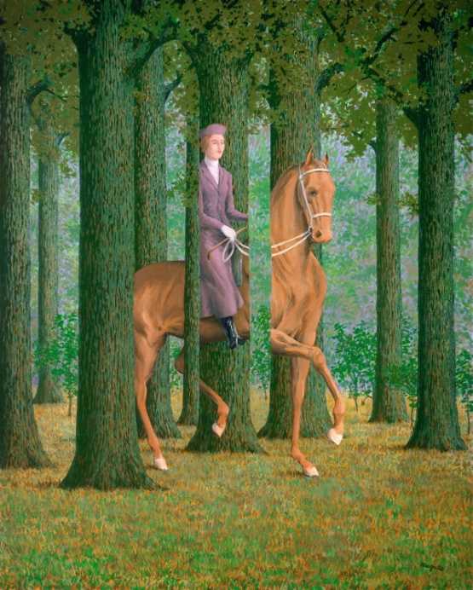
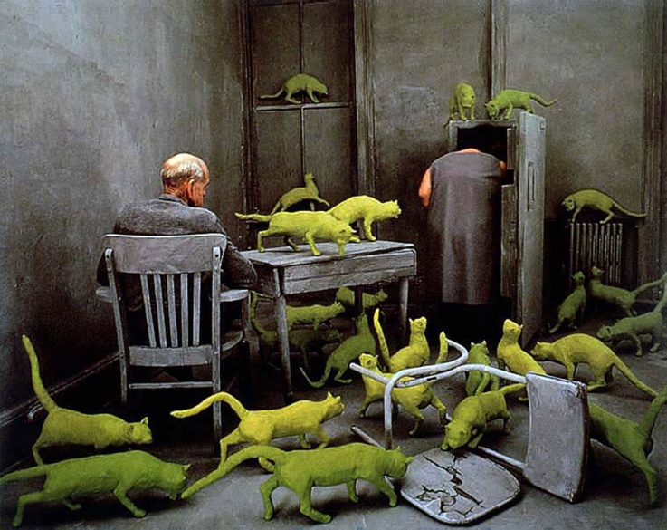
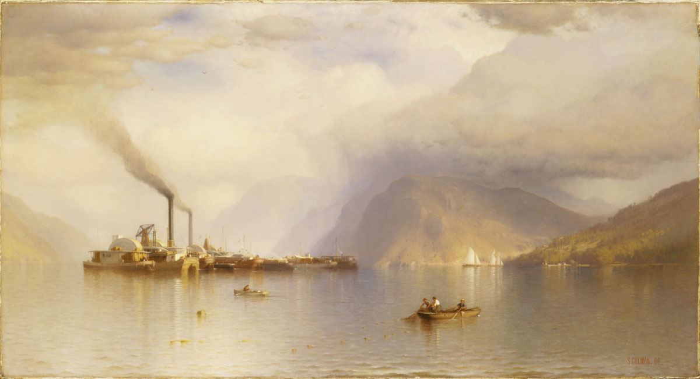

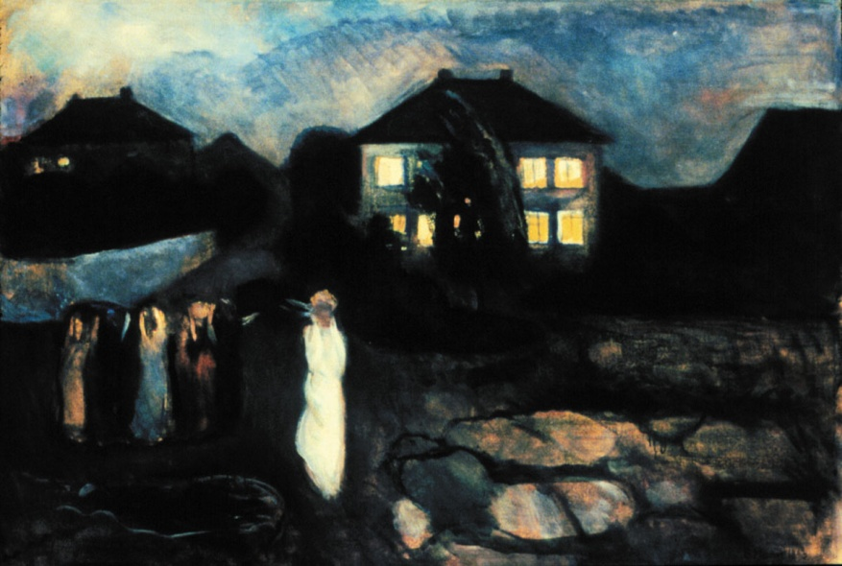

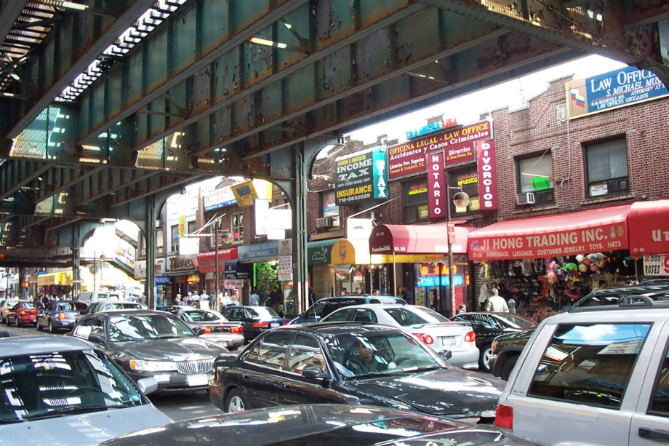
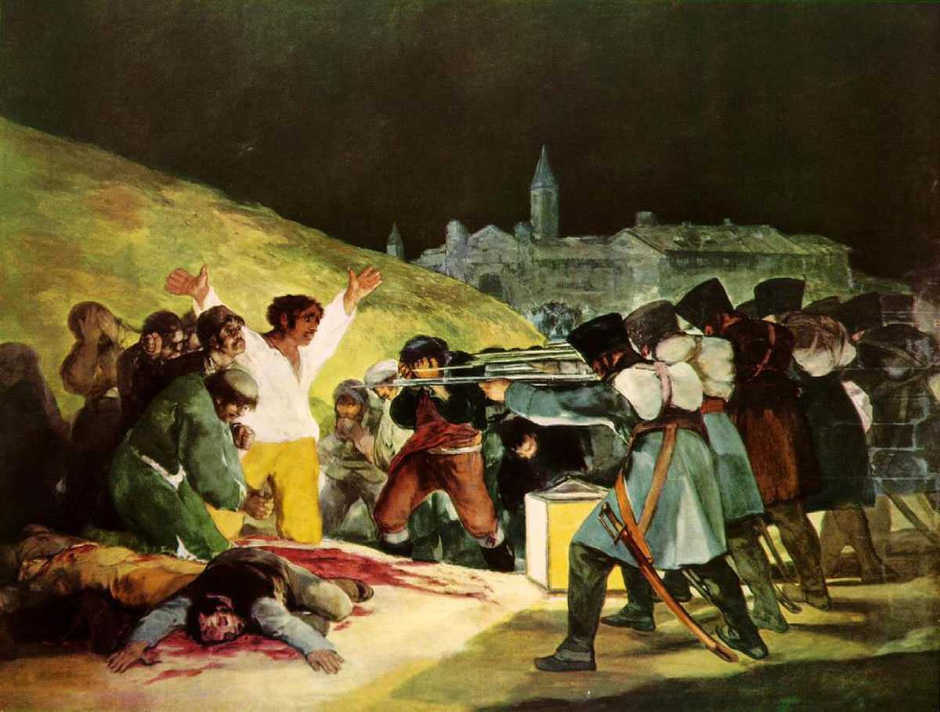
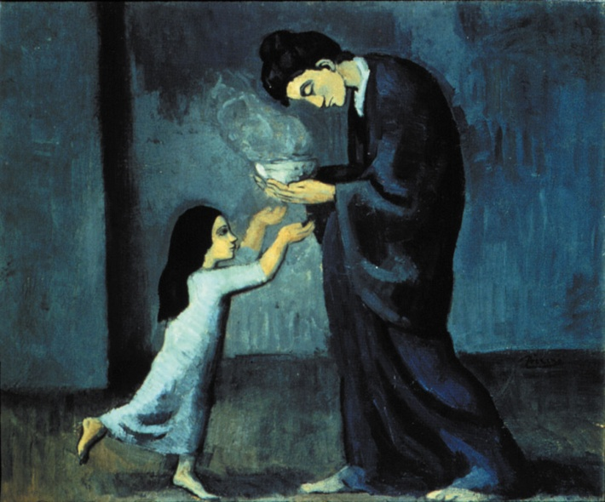
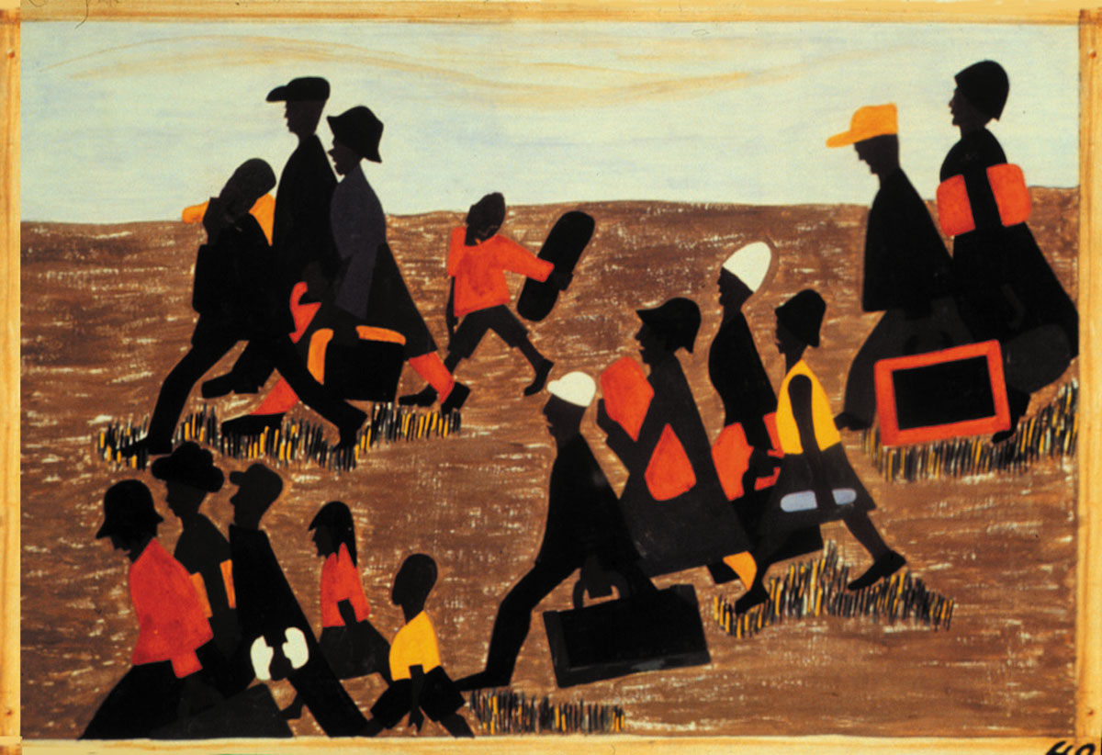

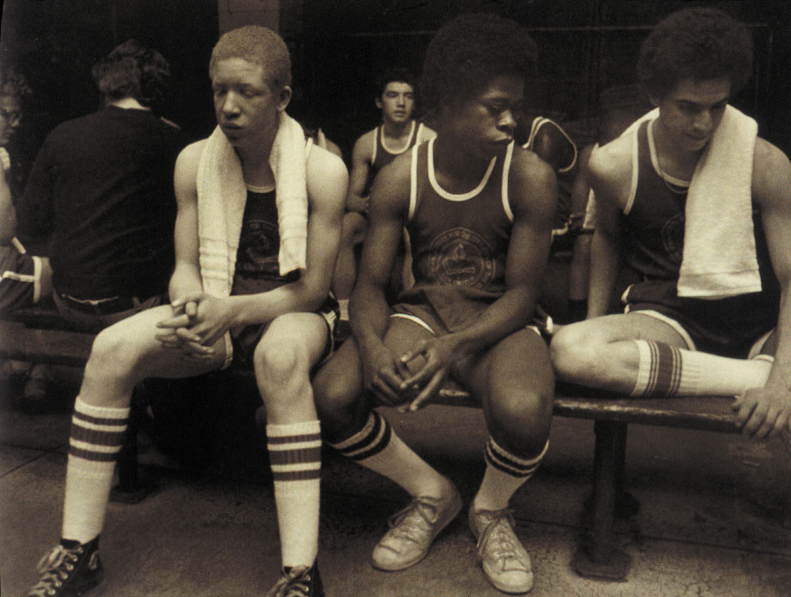
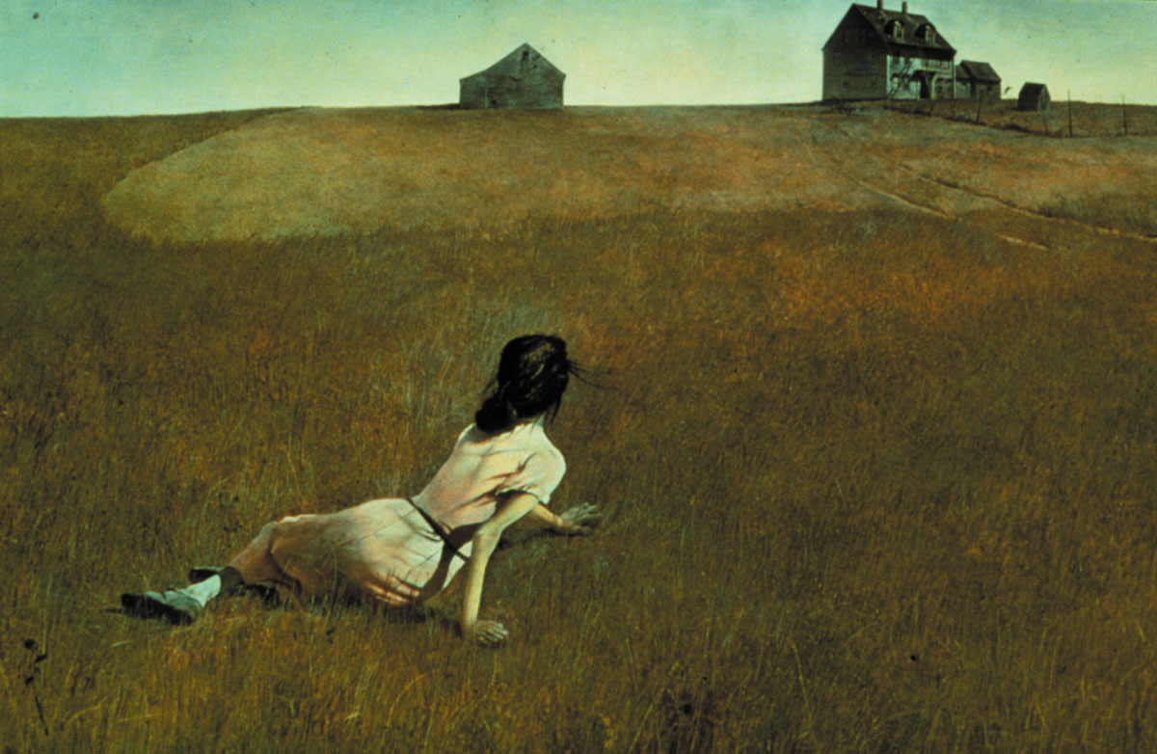
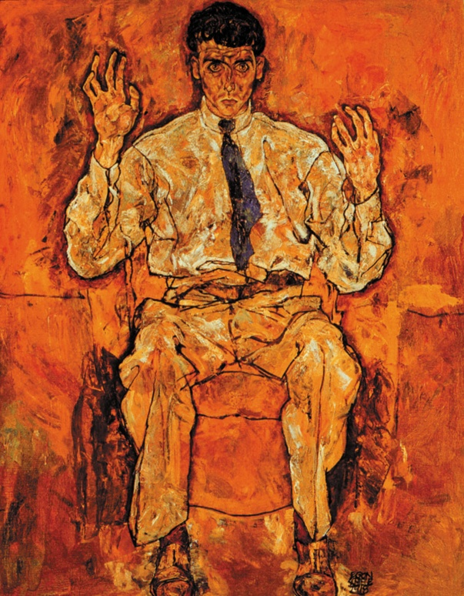
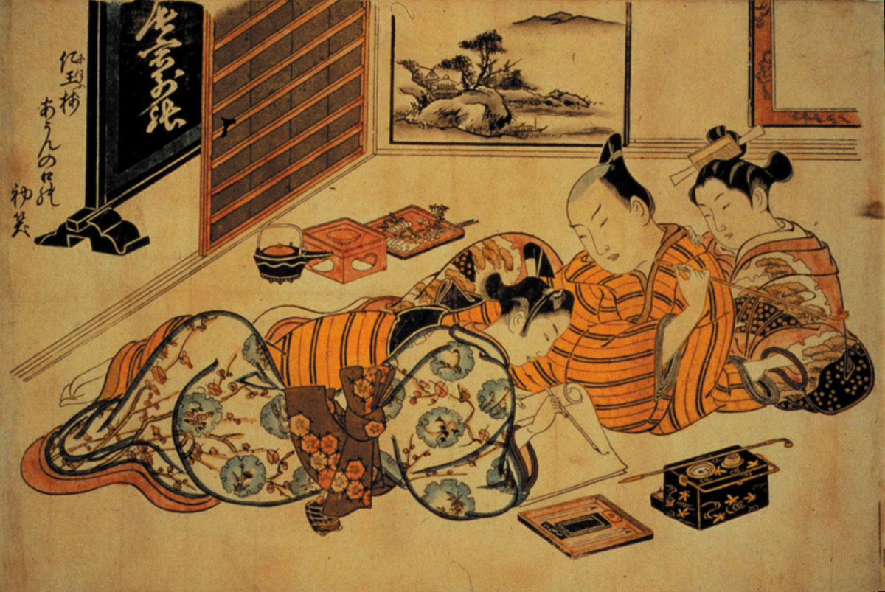

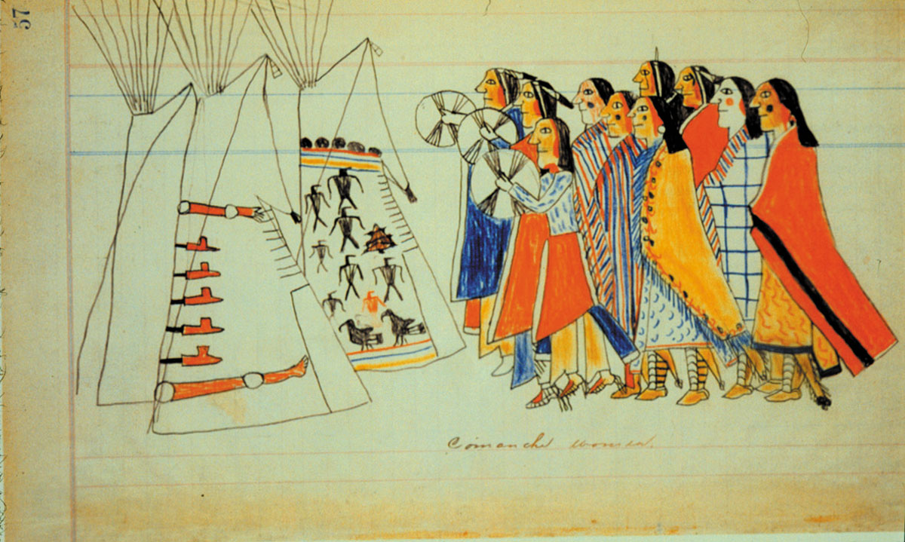
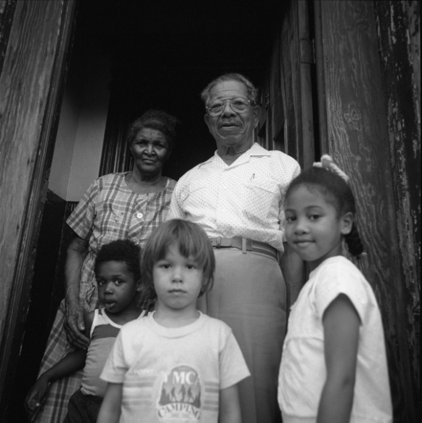

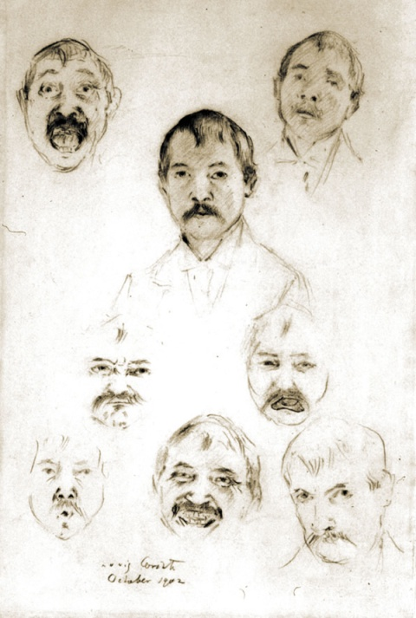
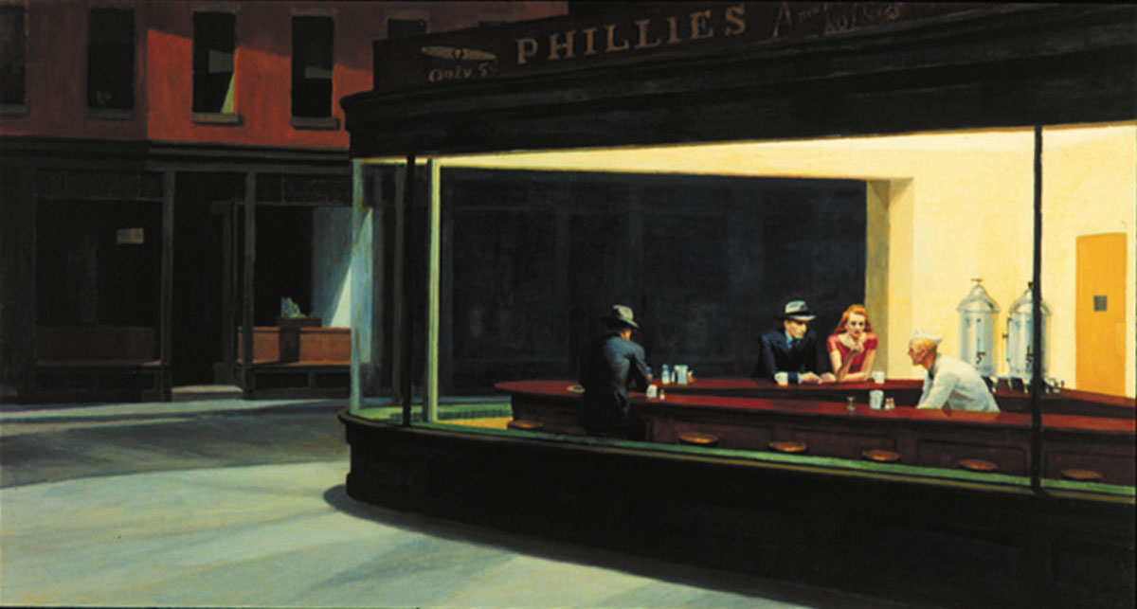

Grade 6 Visual Art
Design Focus: Unity and Harmony
• unity and harmony: radial balance (e.g., a mandala); similarity (e.g., consistency and completeness through repetition of colors, shapes, values, textures, or lines); continuity (e.g., treatment of different elements in a similar manner); alignment (e.g., arrangement of shapes to follow an implied axis); proximity (e.g., grouping of related items together)
Contemporary Focus: Hybridity
Culminating Project: Installation based on research into student selected topic
Art History:
VTS Images: 2 per week

By the Middle School years, a quality instructional program will focus on the consolidation of students’ knowledge, skills, and strategies in the visual arts. They will have acquired foundational knowledge about artistic forms and conventions, the creative process, and critically interacting with a diverse range of artworks. Consequently, students will require multiple and diverse opportunities to practice independently and demonstrate achievement of art learning. To demonstrate mastery, they are ready to apply their abilities to new visual challenges that they have not yet encountered but which are within the range of their skill set. Because they have developed the ability to reflect on, monitor, and take steps to improve their art learning, they use their inquiry and research skills to extend their interpretive and creative abilities. As they start to develop powerful new thoughts and feelings that sometimes challenge established world-views, they use the arts to explore and comment on issues relevant to their daily lives. Art making becomes a safe arena for experimenting in the construction of new relationships between inner and outer realities as young adolescents encounter conflicting and diverse experiences. At the same time that they eagerly incorporate aspects of popular culture into their art they also come to understand the context of historical artworks in more refined and probing ways, leading to greater understanding of what they themselves value. They realize that artists are concerned with issues relevant to their own lives and society and discover exemplars of artistic practices that resonate with their own personal and creative concerns, helping them to reflect more deeply on their own art making. An emerging proficiency in the creative process and critical reflection leads to increasingly confident and informed responses to art while their own art also displays greater expressive confidence and skill. By the end of Grade 8, their technical and conceptual competence in art should result in the first glimmers of a distinctive personal style and pronounced personal aesthetic interests. While teachers should continue employing guided practice in the use of the creative process, methods and materials, problem solving, and critically responding to art, they also provide significantly increased opportunities for independent practice. They should continue to explicitly teach and model skills to help students identify what is needed to become proficient creators and interpreters of art.

Subject matter that is designed to support and challenge students at their individual level of development in the arts will enhance the benefits of appropriately scaffolded instruction. It is important to ensure that students are able to choose from a wide range of topics and activities that are open-ended, provide for multiple, diverse solutions, and which are engaging and relevant to their personal experiences and interests.

Students in the Middle School years continue to generate and develop visual ideas in response to a variety of motivations, using imagination, observation, and a study of artists’ works, and incorporate into their art ideas gained from sources such as independent reading. They also generate and develop visual ideas in response to a variety of artistic challenges and techniques, e.g. the postmodern principles of art and other contemporary “lenses” through which meaning can be created and interpreted. Students explore and describe how different media influence the communication and interpretation of ideas in their own and others’ work. To this end, they look beyond the surface meaning of art works and observe not only what is present but what is missing, in order to analyze and evaluate an artist’s intent. They also analyze and describe how art-making processes and procedures clarify meaning and intentions in their own and others’ work and observe how artists tell stories and create mood in their work. Students use their growing analytical and evaluative skills to investigate the purpose(s) and significance of objects, images, and art works in past and present cultures and to examine the contexts in which they were or are made, viewed, and valued. By the end of 8th grade, should have achieved a significant level of consolidation in their understanding of aesthetics as the emotional and cognitive reaction to the perceived ideas and aspirations that a person or group expresses through the making and display of art.

Students should have access to culturally diverse examples that allow them to explore more complex topics or issues and more subtle or abstract themes. The following provide a variety of sources to motivate and engage diverse groups of students: Oral forms such as dramatic presentations, oral reports, think-alouds, commentaries, speeches, monologues, and song lyrics; kinaesthetic forms such as acting out, movement, and dance; concrete forms such as artifacts, garments, and props; print forms such as posters, images, digital and print photographs, stories, biographies, graphic novels, poetry, myths, and legends; and media forms as movie trailers, graphic designs for various products, newspaper or magazine articles, video games, comic books, flyers, websites, and e-mails.

As a general rule, no more than 30% of instructional time should focus exclusively on the elements and principles; students should be primarily engaged in the creative process of making meaning, with the elements and principles used as tools to this end and the learning of these tools reinforced in the process itself. Instead of being based on the elements and principles framework, lessons should be primarily framed using alternate models appropriate to 21st Century learning such as: Pink’s six aptitudes: story, design, symphony, play, empathy, and meaning; the Studio Habits of Mind model; of Gude’s Principles of Postmodernism.

Unit I. Art Changes Our Way of Thinking and Seeing
Approximately 3-4weeks
Themes and Concepts

Enduring Understandings and Essential Questions
Additional Concepts and Themes determined by specific learning units designed by each art teacher
Metaphor
Modification and transformation of imagery
Inquiry based development of imagery…

Georgia Performance Standards in the Visual Arts for Unit 1

VA6MC.1 Engages in the creative process to generate and visualize ideas.
VA6MC.2 Identifies and works to solve visual problems through creative thinking, planning, and/or experimenting with art materials, tools and techniques. VA6MC.3 Interprets how artists communicate meaning in their work.
VA6MC.4 Engages in dialogue about his or her artwork and the artwork of others.
VA6CU.1 Discovers how the creative process relates to art history.
VA6PR.1 Understands and applies media, techniques, and processes.
VA6PR.2 Creates artwork reflecting a range of concepts, ideas, and subject matter.
VA6PR.3 Incorporates an understanding of the language of art (elements and principles of design) to develop and organize own ideas, resolve specific visual arts problems, and create works of art.
VA6PR.4 Keeps a visual/verbal sketchbook journal to collect, develop and preserve ideas in order to produce works of art.
VA6AR.1 Develops and maintains an individual portfolio of artworks.
VA6AR.2 Critiques personal artworks as well as artwork of others using visual and verbal approaches.
VA6AR.3 Reflects and expands the use of visual language throughout the artistic process.
VA6C.1 Applies information from other disciplines to enhance the understanding and production of artworks.
VA6C.2 Develops fluency in visual communication.

Suggested Activities and Teacher Prompts

VTS Writing Pre-Test: (Required)
Review of 5th Grade End of Year Learning Unit and 5th grade art history images (Required)

Use the Brandhorst Metaphor Worksheet or the Exquisite Corpse Sentence Constructor technique to generate ideas for artworks; employ the Roukes image modification techniques and strategies to develop imagery and creative thinking; further develop visual ideas by producing a variety of thumbnail sketches.

Use Olivia Gude’s “Dirty Pictures” strategy: develop unpredictable imagery and confidence by “toning” or preparing paper surface with mud, dirt, charcoal, ink, dust, pollen, coffee grounds, and organic matter in a random, playful way, then use Salvador Dali’s Surrealist method of looking for imagery in stains and blots to rework the surfaces using oil pastels, charcoal, and chalk to draw out images that they see “hiding” in the muck.

Produce art works, using a variety of traditional forms and current media technologies, that express feelings, ideas, and issues, including opposing points of view

• digital: produce a work of art using a computer that demonstrates experimentation with compositional elements, computer program icons, layering, and 1-2 filters. Suggested theme: a digital drawing of an animal using paint brush and drawing tool features that includes at least 2 layers and use of 1-2 filters that significantly alters the original image. Select a student to demonstrate use of the computer program. Discuss the range of artistic options.
• sculpture: based on an image found in the Dali’s Surrealist method, sculpt a figure or an imaginary creature made from clay, using basic hand building methods such as making the piece with coils or slabs of clay or by pinching and pulling the clay
• printmaking: a relief print transferred from a textured surface, made with glue lines, craft foam, cardboard, paper, or string glued to board, using shapes to create a graphic design that explores pattern in a non-objective op art style; using colored pencils, take one of the resulting prints and use the Surrealist technique of finding images in non-representational forms to produce a Surrealist image
• drawing: a colored line drawing of an underwater setting or the view from an airplane that addresses environmental awareness by showing the interconnectedness of ecosystems (or social awareness of the interconnectedness of cultures, social systems, or economic systems; use Google Earth to zoom in on aerial views of the world’s major cities showing the availability of green space, building density, the proximity of shanty towns or the desert to highly developed areas (such as in Dubai))

Teacher prompts: “How does our impression of the world change when we look at it from a bird’s-eye view rather than a worm’s-eye view onto fields near a wetland, a cityscape showing building density and limited green space? (Do you think wealthy, middle class, or poor people live near the green spaces? How can you use a particular point of view in your painting (not necessarily these) to create a particular impression?”

- an acrylic painting that uses symbols to represent conflict and resolution
- performance art or an installation that portrays both sides of the struggle between humankind and nature
- a mixed-media or digital composition of a personal mandala that shows both unity and opposing forces

Teacher prompts: “How will your art work convey opposing perspectives on an issue that you have chosen to explore (e.g., consumerism versus sustainability, land development versus conservation, global warming, poverty)?” “With the symbols you have chosen, how can you show resolution as clearly as you have shown conflict?” “How does your installation or sculpture communicate the benefits and challenges of environmental stewardship?”

Ongoing throughout the year:

In your verbal-visual sketchbook, identify and explain their strengths, their interests, and areas for improvement as creators, interpreters, and viewers of art (e.g., reflect on challenges and successes in the form of an artist’s statement; maintain in your sketchbook a collection of ideas and images for art works; do peer reviews of each other’s art works, using a checklist of criteria created by the class to help you identify areas that need revision, and provide suggestions)
Teacher prompts: “How did you adapt these new ideas, situations, media, materials, processes, or technologies to help you convey your ideas?” “How did you use imagination, observation, and the study of other art works to help you develop your ideas?” “How did you negotiate designs with other members of the group and agree on the techniques, ideas, and composition you used?” “How did you approach the challenges you faced in making sure your sculpture was interesting to look at from more than one side? What would you do differently next time?”

Demonstrate an understanding of key contributions and functions of visual and media arts in various contexts at both the local and the national levels (e.g., community art schools or programs provide opportunities for creative expression and instruction by and for both amateurs and professionals; a wide variety of workers are employed by arts industries such as advertising, design, movie making, and broadcast media; artists contribute to America’s economy by providing both goods and services)
Teacher prompts: “In what ways do the visual arts contribute to the economies of urban and rural communities?” “In what ways are the visual arts involved in international trade?” “What are the various professions or careers that have a basis in visual arts, and what education is required? How can we find out more about these careers?”

The following skills are introduced to support artistic development, creative thinking, and meaning making in alignment with this unit’s theme and not as ends-in-themselves:

Assessment
Student self-assessment in visual/verbal journal
Teacher assessment: Studio Habits of Mind rubric (high/medium/low)

Artworks for required VTS:
(See images below)

Other suggested art criticism models (introduced at discretion of teacher):
Feldman model

Recommended Artists/Artworks:

Recommended texts:

Advanced students:

II. Art Helps Us Understand Where We Are in Time and Place
Approximately 3-4weeks
Themes and Concepts

Enduring Understandings and Essential Questions
Additional Concepts and Themes determined by specific learning units designed by each art teacher

Georgia Performance Standards in the Visual Arts for Unit 2

VA6MC.1 Engages in the creative process to generate and visualize ideas.VA6MC.2 Identifies and works to solve visual problems through creative thinking, planning, and/or experimenting with art materials, tools and techniques. VA6MC.3 Interprets how artists communicate meaning in their work.
VA6MC.4 Engages in dialogue about his or her artwork and the artwork of others.
VA6CU.1 Discovers how the creative process relates to art history.
VA6CU.2 Investigates and discovers personal relationship to community, culture, and the world through making and studying art.
VA6PR.2 Creates artwork reflecting a range of concepts, ideas, and subject matter.
VA6PR.3 Incorporates an understanding of the language of art (elements and principles of design) to develop and organize own ideas, resolve specific visual arts problems, and create works of art.
VA6PR.4 Keeps a visual/verbal sketchbook journal to collect, develop and preserve ideas in order to produce works of art.
VA6AR.1 Develops and maintains an individual portfolio of artworks.
VA6AR.2 Critiques personal artworks as well as artwork of others using visual and verbal approaches.
VA6AR.3 Reflects and expands the use of visual language throughout the artistic process.
VA6C.1 Applies information from other disciplines to enhance the understanding and production of artworks.
VA6C.2 Develops fluency in visual communication.
VA6C.3 Expands knowledge of art as a profession and/or avocation.

Suggested Activities and Teacher Prompts

• graphic design: Produce a graphic design that demonstrates integration of text and image, vivid use of color, line and shape, and clarity of message. Suggested theme: a poster that communicates an opinion about a current event. Refer to posters by artists such as Lorenzo Homar, Rafael Tufiño, James Montgomery Flagg, Ester Hernandez, Russian Constructivists.
• painting: Produce a painting that demonstrates observation of detail, use of primary and secondary colors, use of tints and shades, and a balanced composition. Suggested theme: a neighborhood scene. Examine works of artists such as Faith Ringgold, Edward Hopper, and Ralph Fasanella, and authors/illustrators Ezra Jack Keats and Vera B. Williams. Discuss how the artists use detail, color, and balance to evoke a sense of place.
• printmaking: make a collograph or chine collé that communicates a personal experience through the use of shape and analogous color; produce a foam engraving that demonstrates the application of a variety of textures and lines and that expresses emotion. Suggested theme: a simple etching of a person or landscape on a foam plate. Refer to the etchings of artists such as Albrecht Dürer, Rembrandt van Rijn, and Jose Posada. After close observation, discuss the ways in which texture and line are used to create shading, rhythm, and variety of surface design.
• sculpture: make clay or papier mâché gargoyles or “crossed creatures” that have exaggerated features, using open and closed forms
• technology: make a high-contrast self-portrait or caricature with software, using techniques such as blurring, cloning, cropping, distortion, layering, rotation, and selection)
Teacher prompts: “What aspects of your subject’s personality will you emphasize or exaggerate in your gargoyle or portrait?” “How do different printmaking techniques limit or change

Interpret a variety of art works and identify the feelings, issues, themes, and social concerns that they convey (e.g., describe Ted Harrison’s use of line, color, brushstrokes, and rhythm to create a feeling of movement and excitement; compare the themes and the emotions conveyed in selected Western animations and in Japanese animations such as those by Hayao Miyazaki)
Teacher prompts: “How does the artist convey a particular emotion through this art work?” “How does each comic style use facial expression, body language, and color to express emotion? How have current media technologies influenced the expression of ideas in animations and comics?”

Explain how the elements and principles of design are used in their own and others’ art work to communicate meaning or understanding (e.g., identify the point of view or gaze of the main subject, and explain how it is used to influence an intended audience of an art work or a media work; explain how Kenojuak Ashevak’s use of formal balance (symmetry) in The World Around Me conveys a sense of harmony in nature; explain how a rough texture can be used to represent strength, anger, or something unpleasant)
Teacher prompts: “How could you show the same message in another art form, such as a sculpture, a digital medium, or a painting?” “How does Bill Reid’s The Raven and the First Men depict the relationship of form to its surroundings through the use of positive and negative space?”

Demonstrate an understanding of how to read and interpret signs, symbols, and style in art works (e.g., symbolism for sending messages and telling stories in Egyptian hieroglyphs, Agawa rock paintings, or graffiti art; symbols on currency or in advertisements that have specific national or other connotations; meanings associated with color in different cultures [white dresses symbolize purity in Western culture but mourning and death in some Asian cultures])
Teacher prompts: “What are some of the feelings and ideas associated with American symbols, and what are some of the things that they say about us as a nation?” “What assumptions do you make about a product when its advertisement shows a man and woman holding hands? How can designers change the image to manipulate those assumptions?”

Ongoing throughout the year:

In your verbal-visual sketchbook, identify and explain their strengths, their interests, and areas for improvement as creators, interpreters, and viewers of art (e.g., reflect on challenges and successes in the form of an artist’s statement; maintain in your sketchbook a collection of ideas and images for art works; do peer reviews of each other’s art works, using a checklist of criteria created by the class to help you identify areas that need revision, and provide suggestions)
Teacher prompts: “How did you adapt these new ideas, situations, media, materials, processes, or technologies to help you convey your ideas?” “How did you use imagination, observation, and the study of other art works to help you develop your ideas?” “How did you negotiate designs with other members of the group and agree on the techniques, ideas, and composition you used?” “How did you approach the challenges you faced in making sure your sculpture was interesting to look at from more than one side? What would you do differently next time?”

Demonstrate an understanding of key contributions and functions of visual and media arts in various contexts at both the local and the national levels (e.g., community art schools or programs provide opportunities for creative expression and instruction by and for both amateurs and professionals; a wide variety of workers are employed by arts industries such as advertising, design, movie making, and broadcast media; artists contribute to America’s economy by providing both goods and services)
Teacher prompts: “In what ways do the visual arts contribute to the economies of urban and rural communities?” “In what ways are the visual arts involved in international trade?” “What are the various professions or careers that have a basis in visual arts, and what education is required? How can we find out more about these careers?”

The following skills are introduced to support artistic development, creative thinking, and meaning making in alignment with this unit’s theme and not as ends-in-themselves:

Assessment
Student self-assessment in visual/verbal journal
Teacher assessment: Studio Habits of Mind rubric (high/medium/low)

Images for required VTS:

UNIT 3. Art Helps Us Understand Who We Are
Approximately 1-2 weeks (Culminating Project)
Themes and Concepts

Enduring Understandings and Essential Questions
Additional Concepts and Themes determined by specific learning units designed by each art teacher
Hybridity

Georgia Performance Standards in the Visual Arts for Unit 3

VA6MC.1 Engages in the creative process to generate and visualize ideas.VA6MC.2 Identifies and works to solve visual problems through creative thinking, planning, and/or experimenting with art materials, tools and techniques. VA6MC.3 Interprets how artists communicate meaning in their work.
VA6MC.4 Engages in dialogue about his or her artwork and the artwork of others.
VA6CU.1 Discovers how the creative process relates to art history.
VA6CU.2 Investigates and discovers personal relationship to community, culture, and the world through making and studying art.
VA6PR.2 Creates artwork reflecting a range of concepts, ideas, and subject matter.
VA6PR.3 Incorporates an understanding of the language of art (elements and principles of design) to develop and organize own ideas, resolve specific visual arts problems, and create works of art.
VA6PR.4 Keeps a visual/verbal sketchbook journal to collect, develop and preserve ideas in order to produce works of art.
VA6AR.1 Develops and maintains an individual portfolio of artworks.
VA6AR.2 Critiques personal artworks as well as artwork of others using visual and verbal approaches.
VA6AR.3 Reflects and expands the use of visual language throughout the artistic process.
VA6PR.4 Plans and participates in appropriate exhibition(s) of artworks.
VA6C.1 Applies information from other disciplines to enhance the understanding and production of artworks.
VA6C.2 Develops fluency in visual communication.
VA6C.3 Expands knowledge of art as a profession and/or avocation.

VTS Post-Test
Culminating Project [Lesson plan with rubric to be provided]
Dividing the class into groups; each group selects, discusses, and researches a “burning issue” topic around which they will create an interactive installation.

Images for Required VTS:

Grade 5 Visual Art
Design Focus: Contrast and Balance
• contrast: light/dark; large/small; pure/mixed color
• balance: arrangement of the elements of design to create the impression of equality in weight or importance (e.g., a formal or symmetrical arrangement produced through distribution of shapes; an informal or asymmetrical arrangement produced through use of color); color concepts to be used in creating balance (e.g., light or neutral colors appear lighter in “weight” than dark or brilliant colors; warm colors seem to expand, cool colors seem to contract; transparent areas seem to “weigh” less than opaque areas)
Contemporary Focus:
Culminating Project: Expressive Portrait
Art History:

The knowledge that students in 4th and 5th grade have in the arts comes from their life experiences and prior knowledge and from the foundational arts knowledge and skills acquired in the primary school years. The expectations for 4th and 5th grade build upon this foundation. Because the base of arts knowledge, experience, and skills varies from student to student, it is important for instruction to be differentiated to meet the needs of individuals and small groups of students.

Arts instruction in these grades is designed to engage students in meaningful interactions with a wide variety of forms and strategies in the visual arts, with an increasing emphasis placed on contemporary practices. At this level, students learn to identify and explore multiple perspectives, question the messages in artworks and consider the issues raised in them, including issues related to fairness, equity, and justice. They analyze the structure and elements of a variety of art forms, explore a range of interpretations, and communicate their own ideas and opinions for a variety of purposes and audiences. Students at this level develop their ability to monitor their own learning and select appropriate strategies to help them make sense of and create increasingly complex and/or challenging works for personally and socially relevant purposes. They reflect on and talk about the strategies that have helped them construct and communicate meaning and identify steps they can take to improve.

Visual art teachers should employ an inquiry-based approach to instruction that does not sacrifice the need to explicitly teach and model the use of the knowledge, skills, and strategies targeted in the Georgia Performance Standards. Explicit teaching and modeling help students to identify the skills and strategies they need in order to become proficient creators and interpreters and move towards achievement of the expectations. Modeled, shared, and guided learning experiences provide the instructional support 4th and 5th grade students need to communicate increasingly complex ideas and information using a greater variety of forms. Subject matter that is designed to support and challenge students at their individual level of development in the arts will enhance the benefits of appropriately scaffolded instruction. It is important to ensure that students are able to choose from a wide range of topics and activities that are open-ended, provide for multiple, diverse solutions, and which are engaging and relevant to their personal experiences and interests.

Students should have access to culturally diverse examples that allow them to explore more complex topics or issues and more subtle or abstract themes. The following provide a variety of sources to motivate and engage diverse groups of students: Oral forms such as dramatic presentations, oral reports, think-alouds, commentaries, speeches, monologues, and song lyrics; kinaesthetic forms such as acting out, movement, and dance; concrete forms such as artifacts, garments, and props; print forms such as posters, images, digital and print photographs, stories, biographies, graphic novels, poetry, myths, and legends; and media forms as movie trailers, graphic designs for various products, newspaper or magazine articles, video games, comic books, flyers, websites, and e-mails.

In Grades 4 and 5, students apply the elements of design to communicate for a variety of purposes and on a variety of themes. However, as a general rule, no more than 30% of instructional time should focus exclusively on the elements and principles; students should be primarily engaged in the creative process of making meaning, with the elements and principles used as tools to this end and the learning of these tools reinforced in the process itself. Instead of being based on the elements and principles framework, lessons should be primarily framed using alternate models appropriate to 21st Century learning such as: Pink’s six aptitudes: story, design, symphony, play, empathy, and meaning; the Studio Habits of Mind model; of Gude’s Principles of Postmodernism.

The focus of visual arts in these grades is to help students extend their exploration of relationships and personal experience in their own world. Students use a broader range of subject matter and media (tools, materials, processes, and techniques) to produce works of art. They grow more sophisticated in depicting movement, spatial relationships, and emotions. Students at this age display increased manual dexterity; however, their skills may not keep pace with their desire for increasingly elaborate work. This may lead to self-consciousness and insecurity about their artistic ability. The teacher’s role at this stage is to provide a positive working environment, facilitate the growth of technical skills and observational skills, and help students recognize that mistakes can be turned into creative opportunities.

They generate and develop visual ideas in response to a variety of motivations, using imagination, observation, and a study of artists’ works, and incorporate into their art ideas gained from sources such as independent reading. They also generate and develop visual ideas in response to a variety of artistic challenges and techniques, e.g. the postmodern principles of art and other contemporary “lenses” through which meaning can be created and interpreted. Students explore and describe how different media influence the communication and interpretation of ideas in their own and others’ work. To this end, they look beyond the surface meaning of art works and observe not only what is present but what is missing, in order to analyze and evaluate an artist’s intent. They also analyze and describe how art-making processes and procedures clarify meaning and intentions in their own and others’ work and observe how artists tell stories and create mood in their work. Students use their growing analytical and evaluative skills to investigate the purpose(s) and significance of objects, images, and art works in past and present cultures and to examine the contexts in which they were or are made, viewed, and valued. Students begin to develop an understanding of aesthetics as the emotional and cognitive reaction to the perceived ideas and aspirations that a person or group expresses through the making and display of art.

Unit 1: Art Changes our Way of Thinking and Seeing
August/September/October 8-10 class sessions
Themes and Concepts

Enduring Understandings and Essential Questions
Additional Concepts and Themes determined by specific learning units designed by each art teacher
Image modification: Roukes
Metaphor
Conceptual skills
Psychomotor skills

Georgia Performance Standards in the Visual Arts for Unit 1

VA5MC.1 Engages in the creative process to generate and visualize ideas.
- Creates a series of thumbnail sketches to alter visual images (e.g., magnifying, reducing, repeating or combining them in a variety of ways) to change how they are perceived and interpreted.
VA5MC.2 Formulates personal responses to visual imagery.
- Uses a sketchbook for planning and self-reflection.
VA5MC.3 Selects and uses subject matter, symbols, and/or ideas to communicate meaning.
- Generates different viewpoints for making and interpreting a visual image.
- Develops visual images by combining or modifying open-ended themes/topics in unique and innovative ways.
- Observes how the visual relationship of objects and ideas (juxtaposition) affects contrast and/or proportion and how the placement may affect meaning and/or significance.
VA5PR.1 Creates artworks based on personal experience and selected themes.
- Interprets visually the big ideas (community, identity, nature, justice, conflict) and broad themes (mother and child, love, war, loss, family) in open-ended ways that resonate with personal meaning.
VA5PR.2 Understands and applies media, techniques, and processes of two-dimensional art processes (drawing, painting, printmaking, mixed-media) using tools and materials in a safe and appropriate manner to develop skills.
- Creates an edition of prints.
- Creates art works using available technology (e.g., computers, cameras, digital/video recorder).

Suggested Activities and Teacher Prompts

VTS Writing Pre-Test: (required)
Image 5.2.3 Remedios Varo (Spain 1908-Mexico 1963). Creation of the Birds. 1957. Oil on masonite, 20 3/5 x 24 7/10 in. Private Collection.
Review of 4th Grade End of Year Learning Unit and 4th grade art history images (required)

Use the Brandhorst Metaphor Worksheet or the Exquisite Corpse Sentence Constructor technique to generate ideas for artworks; employ the Roukes image modification techniques and strategies to develop imagery and creative thinking; further develop visual ideas by producing a variety of thumbnail sketches

Produce artwork that express feelings and ideas inspired by their own and others’ points of view
- a painting based on a students’ photo montages about children’s rights and responsibilities
- a painting of someone in a particular situation in which empathy for him or her is created through characterization

Teacher prompts: “How can you use size and shape in your painting to express your feelings or point of view about the importance of the different images in your montage?” “How does our impression of the world change when we look at it from a bird’s-eye view rather than a worm’s-eye view? How can you use a particular point of view in your painting (not necessarily these) to create a particular impression?”

Use a variety of materials, tools, and techniques to determine solutions to artistic challenges

• drawing: draw an object, person or scene from observation; selecting part of the drawing and do several more by applying Roukes’ image modification techniques or SCAMPER; how does altering the image change the meaning?
• painting: tempera paint or watercolor pencils using unusual colors or perspectives to suggest a fantasy world
• digital: produce a work of art using a computer that demonstrates experimentation with compositional elements, computer program icons, layering, and 1-2 filters. Suggested theme: a digital drawing of an animal using paint brush and drawing tool features that includes at least 2 layers and use of 1-2 filters that significantly alters the original image. Select a student to demonstrate use of the computer program. Discuss the range of artistic options.
• printmaking: a relief print transferred from a textured surface, made with glue lines, craft foam, cardboard, paper, or string glued to board, using shapes to create a graphic design that explores pattern in a non-objective op art style; using colored pencils, take one of the resulting prints and use the Surrealist technique of finding images in non-representational forms to produce a Surrealist image

Teacher prompts: “How could you make the lines in your caricature more fluid and the shapes more expressive?” “How are the images you used in your art work and their placement and composition symbolic of how you see yourself?”

Interpret a variety of art works and identify the feelings, issues, themes, and social concerns that they convey
- use an image round-table technique to compare interpretations of emotions suggested by abstract forms or figures in art work
- sort and classify a variety of art images, such as Nigerian, Egyptian, Mayan, and Chinese sculptures, to determine common subjects or theme
Teacher prompts: “When you look at how Constantin Brancusi makes the human form abstract in his sculptures, what do the shapes remind you of?” “What different emotions does the pose of this art work suggest to you? If the figure in the art work could come to life, what would it say to you?” “How is proportion used to convey importance?”

Ongoing throughout the year:

In your verbal-visual sketchbook, identify and explain your strengths, interests, and areas for improvement as creators, interpreters, and viewers of art (e.g., use of appropriate terminology in talking about their own art work; discussion of others’ ideas with sensitivity and respect; provision of reasons for their artistic choices in a diary entry in their art journal or sketchbook)
Teacher prompts: “Why is the medium you have picked the best choice for your narrative line drawing?” “How does the choice of media and tools change how the same subject matter is perceived?” “Do you think good art needs to take a long time to make? Why or why not?” “What did you find when you compared your work with the ways in which different artists have expressed ideas about themselves in self-portraits (e.g., self-portraits by Vincent Van Gogh, Frida Kahlo, Andy Warhol)?”

Demonstrate an awareness of ways in which visual arts reflect the beliefs and traditions of a variety of peoples and of people in different times and places (e.g., the use of contemporary Aboriginal art to support cultural revitalization; the use of images on ancient Greek vases to reflect narratives of daily life, legends, and war; the relationship between public art and its location; exhibitions of the art of local artists in local festivals; displays and exhibitions of art works in galleries and museums)
Teacher prompts: “How does the work of Baffin Island printmakers reflect ways in which Inuit life has changed over time and how they preserve stories?” “How is art a reflection of personal, local, or cultural identity?” “Whose voices or beliefs are not represented in this exhibition?” “How can community groups advocate for the arts?”

The following skills are introduced to support artistic development, creative thinking, and meaning making in alignment with this unit’s theme and not as ends-in-themselves:

- Produces textures that are real or implied.
- Texture is vital to printing and printmaking.
- Uses adjectives to describe texture are smooth, rough, bumpy, scratchy, slick, etc.
- Produces patterns with textures.
- Understand that there are two types of shapes: geometric & organic.
- Produces contrast with positive and negative shapes.
- Uses warm & cool colors to create space (warm colors appear to advance; cool colors to recede).
- Mixes tints and shades of colors
- Produces 2-D art emphasizing contrast.
- Uses colors to show how they feel.
- Uses light and dark values to suggest locations in space.
- Drawings emphasizing proportion, distortion and exaggeration
- Uses line can be used to show shape, movement, and space.
- Uses contour lines describe the edges of an object
- Uses gesture lines to show movement
- Produces aerial perspective by modifying the lightness, darkness, and depth of lines, using more/less detail, bright/dull color

Assessment

Student self-assessment in visual/verbal journal
Teacher assessment: Studio Habits of Mind rubric (high/medium/low)

Images for required VTS:

- Image 5.1.1 Probably by Mirza Ali. Hawking Party. About 1575. Gold, silver and opaque watercolor on paper, 14 11/16 x 9 3/4 in.
- Museum of Fine Arts, Boston; Francis Bartlett Donation of 1912 and Picture Fund; 14.624. © 2002 Museum of Fine Art, Boston.
- Image 5.1.2 Diego Rivera. Agrarian Leader Zapata. 1931. Fresco, 7ft 9 3/4 x 74 in. Museum of Modern Art, New York, NY. Abby Aldrich Rockefeller Fund. (1631.1940). © The Museum of Modern Art/Licensed by SCALA/Art Resource, NY. © 2002 Banco de México Diego Rivera & Frida Kahlo Museums Trust. Av. Cinco de Mayo No. 2, Col. Centro, Del. Cuauhtémoc 06059, México, D.F.
- Image 5.1.3 Eastern Tibet, Artist Unknown. Bodhisattva– Akashagarbha. 1700 – 1799. Ground mineral pigment on cotton, 14 3/4 x 9 1/4 in. Collection of Shelley & Donald Rubin Foundation, New York.
- Image 5.2.1 Ruth Russell Williams. First Art Lesson. Open edition, painted/released in print, 1992. Acrylic. Courtesy of renowned folk artist Ruth Russell Williams of North Carolina.
- Image 5.2.2 Giovanni Boccaccio. Marcia Painting her Self-Portrait. c. 1470. Vellum. Ms.33, f.37v. France. Astor, Lenox, and Tilden Foundations. Spencer Collection, The New York Public Library, New York, NY. © The New York Public Library/Art Resource, NY.
- Image 5.3.1 Joanna B. Pinneo. LeAnne age 12, June 1996, Zephyr Hills, Florida. 1996. Black and white photograph, 35 mm. © Joanna B. Pinneo 1996, All Rights Reserved.

Recommended Resources:

Advanced students:

Unit 2: Art Helps Us Organize Ourselves in Sharing the Planet
October/November/December 8-10 class sessions
Themes and Concepts

Enduring Understandings and Essential Questions
Additional Concepts and Themes determined by specific learning units designed by each art teacher

Georgia Performance Standards in the Visual Arts for Unit 2

VA5MC.1b Engages in the creative process to generate and visualize ideas.
VA5CU.1 Investigates and discovers personal relationship to community, culture, and the world through creating and studying art.
VA5CU.2 Views and discusses selected artworks.
VA5PR.1 Creates artworks based on personal experience and selected themes.
VA5PR.2 Understands and applies media, techniques, and processes of two-dimensional art processes (drawing, painting, printmaking, mixed-media) using tools and materials in a safe and appropriate manner to develop skills.
VA5PR.3 Understands and applies media, techniques, and processes of three-dimensional works of art (e.g., ceramics, sculpture, crafts, mixed-media) using tools and materials in a safe and appropriate manner to develop skills.
VA5AR.1 Develops and maintains an individual portfolio of artworks.
VA5AR.2 Uses a variety of approaches to understand and critique works of art.
VA5AR.3 Explains how selected principles of design are used in an artwork to convey meaning and how they affect personal responses to and evaluation of the artwork.
VA5C.1 Applies information and processes from other disciplines to enhance the understanding and production of artworks.
VA5C.2 Develops life skills through the study and production of art.

Suggested Activities and Teacher Prompts

Use elements of design in art works to communicate ideas, messages, and understandings
- a series of three relief prints that use a glue line relief print process to illustrate the beginning, middle, and end of a story about a moral or environmental dilemma
- a poster that presents solutions to stereotyping, bias, or bullying, using angle of view
- a graffiti-style mural that addresses a community issue, using convex shapes that lead the eye with implied lines
- a clay sculpture that portrays the process of transformation undergone by a living organism as a result of exposure to toxins, pollution, or an imagined alteration in the environment
- an installation addressing the “water wars” issue between states in the Southeastern part of the United States

Teacher prompts: “How did you use asymmetrical geometric shapes to simplify the text and image? How did the use of proportion and scale change your message when your poster had faces that were larger than life?” “Which elements and principles of design did you use to focus and simplify the text and image in the mural? How did you use gradations of value to create the illusion of depth in your designs?”

Ongoing throughout the year:

In your verbal-visual sketchbook, identify and explain your strengths, interests, and areas for improvement as creators, interpreters, and viewers of art (e.g., use of appropriate terminology in talking about their own art work; discussion of others’ ideas with sensitivity and respect; provision of reasons for their artistic choices in a diary entry in their art journal or sketchbook)
Teacher prompts: “Why is the medium you have picked the best choice for your narrative line drawing?” “How does the choice of media and tools change how the same subject matter is perceived?” “Do you think good art needs to take a long time to make? Why or why not?” “What did you find when you compared your work with the ways in which different artists have expressed ideas about themselves in self-portraits (e.g., self-portraits by Vincent Van Gogh, Frida Kahlo, Andy Warhol)?”

Demonstrate an awareness of ways in which visual arts reflect the beliefs and traditions of a variety of peoples and of people in different times and places (e.g., the use of contemporary Aboriginal art to support cultural revitalization; the use of images on ancient Greek vases to reflect narratives of daily life, legends, and war; the relationship between public art and its location; exhibitions of the art of local artists in local festivals; displays and exhibitions of art works in galleries and museums)
Teacher prompts: “How does the work of Baffin Island printmakers reflect ways in which Inuit life has changed over time and how they preserve stories?” “How is art a reflection of personal, local, or cultural identity?” “Whose voices or beliefs are not represented in this exhibition?” “How can community groups advocate for the arts?”

The following skills are introduced to support artistic development, creative thinking, and meaning making in alignment with this unit’s theme and not as ends-in-themselves:

- Refines skills in additive and subtractive sculpture to create subjective works.
- Uses one and two point perspective to produce drawings to imply depth.
- Compares Oriental (e.g. Chinese) aerial and Western linear perspective; discusses differences in aesthetic values and cultural approaches to art
- Represent form in a drawing through the use of a minimum of three values (light, medium, dark)..
- Produces depth by overlapping shapes, adjusting size relationships (big to small), & placement of shapes on the page.
- Identify color schemes: analogous, complementary, monochromatic.
- Use a combination of 2 or more clay methods to construct ceramic artwork (i.e. pinch method, coil method, slip and score, wedging, slab method, surface texture).
- Define characteristics of form as open or closed. ( 5.8)
- Create a form which is either open or closed.
- Describe relief as the raised area on a flat surface and use it in a work of art.

Assessment

Student self-assessment in visual/verbal journal
Teacher assessment: Studio Habits of Mind rubric (high/medium/low)

Images for required VTS:
- Image 5.3.2 Edgar Degas. Danseuse au Bouquet. c. 1878-80. Pastel over monotype, 15 7/8 x 19 7/8 in. Museum of Art, Rhode Island School of Design, Gift of Mrs. Murray S. Danforth.
- Image 5.3.3 Father Castiglione. The Tartar envoys presenting their horses to Emperor Qianlong (detail). 1757. Painting on paper, 17 7/10 x 105 in. Scroll, detail 2/7. Inv.: MG 17033. Photo: Michel Urtado. Musee des Arts Asiatiques-Guimet, Paris, France. © Réunion des Musées Nationaux/Art Resource, NY.
- Image 5.4.1 Edvard Munch. The Storm. 1893. Oil on canvas, 36 1/8 x 51 1/2 in. Museum of Modern Art, New York, NY. Gift of Mr. and Mrs. H. Irgens Larsen and acquired through the Lillie P. Bliss and Abby Aldrich Rockefeller Funds (1351.1974). Digital Image © The Museum of Modern Art/Licensed by SCALA/Art Resource, NY. © 2002 The Munch Museum/The Munch-Ellingsen Group/Artists Rights Society (ARS), NY.

Recommended Resources:

Advanced students:

Unit 3: Art Helps Us Understand Where We Are in Time and Place
January/February/March 8-10 class Sessions
Themes and Concepts

Enduring Understandings and Essential Questions
Additional Concepts and Themes determined by specific learning units designed by each art teacher

Georgia Performance Standards in the Visual Arts for Unit 3

VA5MC.1b Formulates visual ideas by using a variety of resources (e.g., books, magazines, Internet).
VA5CU.1b Explores and articulates ideas, themes, and events from diverse cultures of the past and present.
VACU.2c Discusses how social events inspire art from a given time period.
VA5PR.3 Understands and applies media, techniques, and processes of three-dimensional works of art (e.g., ceramics, sculpture, crafts, mixed-media) using tools and materials in a safe and appropriate manner to develop skills.
VA5AR.2c Distinguishes between representational, abstract art and non-objective forms.

Suggested Activities and Teacher Prompts

Demonstrate an understanding of composition, using selected principles of design to create narrative art works or art works on a theme or topic (e.g.,

- create an abstract painting using different proportions of complementary colors
- create a simple sculpture of a human form that depicts an emotional response to a social issue and shows awareness of proportion and negative space [such as seen in the style of sculptor Barbara Hepworth]
- create an impression of depth and space by neutralizing color intensity and brightness in a landscape painting based on a theme relating to Earth Day [atmospheric perspective]--compare your landscape to those of other artists past and present, articulating any similar or divergent meanings you find)

Teacher prompts: “How have you used color to create a point of emphasis and a sense of space?” “How will you use your in-class sketches of student poses to help you decide on the emotion to express with the position of the figure?” “How did you dull the colors to show things that are in the distance?”

Ongoing throughout the year:

In your verbal-visual sketchbook, identify and explain your strengths, interests, and areas for improvement as creators, interpreters, and viewers of art (e.g., use of appropriate terminology in talking about their own art work; discussion of others’ ideas with sensitivity and respect; provision of reasons for their artistic choices in a diary entry in their art journal or sketchbook)
Teacher prompts: “Why is the medium you have picked the best choice for your narrative line drawing?” “How does the choice of media and tools change how the same subject matter is perceived?” “Do you think good art needs to take a long time to make? Why or why not?” “What did you find when you compared your work with the ways in which different artists have expressed ideas about themselves in self-portraits (e.g., self-portraits by Vincent Van Gogh, Frida Kahlo, Andy Warhol)?”

Demonstrate an awareness of ways in which visual arts reflect the beliefs and traditions of a variety of peoples and of people in different times and places (e.g., the use of contemporary Aboriginal art to support cultural revitalization; the use of images on ancient Greek vases to reflect narratives of daily life, legends, and war; the relationship between public art and its location; exhibitions of the art of local artists in local festivals; displays and exhibitions of art works in galleries and museums)
Teacher prompts: “How does the work of Baffin Island printmakers reflect ways in which Inuit life has changed over time and how they preserve stories?” “How is art a reflection of personal, local, or cultural identity?” “Whose voices or beliefs are not represented in this exhibition?” “How can community groups advocate for the arts?”

The following skills are introduced to support artistic development, creative thinking, and meaning making in alignment with this unit’s theme and not as ends-in-themselves:

- Describes how a prism bends light to produce the spectrum.
- Identifies the use of light to show texture, shape and form (e.g. light source, how cast shadow depicts texture (e.g. grass vs. bark))
- Describes how changes in light affect the perception of color and distance
- Produces artwork using color schemes to express specific emotions.
- Mixes tertiary colors.
- Shows emphasis or dominance in a composition by the amount of contrasts in: hues (colors), intensity (brightness), and value (dark-light).
- Analyzes proportion in artworks as the relationship of one part to another or in the whole. ( 5.10)
- Uses contrasting shapes to produce interest or emphasis in a work of art
- Uses repeated colors, lines, shapes, forms, or textures to make a pattern in an artwork.
- Arranges shapes to create balance.
- Understands that shapes are flat, (2-D) and forms are flat (3-D).

Assessment

Student self-assessment in visual/verbal journal
Teacher assessment: Studio Habits of Mind rubric (high/medium/low)

Images for required VTS:

- Image 5.4.2 Frederic Edwin Church. Cotopaxi. 1862. Oil on canvas, 48 x 85 in. Founders Society Purchase, Robert H. Tannahill Foundation Fund, Gibbs-Williams Fund, Dexter M. Ferry, Jr., Fund, Merrill Fund, Beatrice W. Rogers Fund, and Richard A. Manoogian Fund. Photograph © 1985 The Detroit Institute of Arts.
- Image 5.4.3 Martina Lopez. Heirs come to Pass 1. 1991. Cibachrome, 30 x 50 in. © 1991 Courtesy of the artist, Martina Lopez.
- Image 5.5.1 Walter Rosenblum. Friends. 1952. Black and white photograph. Courtesy of the artist, Walter Rosenblum.
- Image 5.5.2 Winslow Homer. Eagle Head, Manchester, Massachusetts, High Tide. 1870. Oil on canvas, 26 x 38 in. The Metropolitan Museum of Art, Gift of Mrs. William F. Milton, 1923. (23.77.2) Photograph © 1992 The Metropolitan Museum of Art.
- Image 5.5.3 Henry Ossawa Tanner. The Banjo Lesson. 1893. Oil on canvas, 47 7/10 x 35 in. Hampton University Museum, Hampton, Virginia.
- Image 5.6.1 Frida Kahlo. The Bus (El Camion). 1929. Oil on canvas, 10 1/5 x 21 7/10 in. Fundacion Dolores Olmedo, Mexico City, D.F., Mexico © Schalkwijk/Art Resource, NY. © 2002 Banco de México Diego Rivera & Frida Kahlo Museums Trust. Av. Cinco de Mayo No. 2, Col. Centro, Del. Cuauhtémoc 06059, México, D.F.

Recommended Resources:

Advanced students:

Unit 4: Art Helps Us Understand Who We Are March/April/May 8-10 class sessions
(End of Course Performance Assessment)
THEMES/CONCEPTS

Enduring Understandings and Essential Questions
Additional Concepts and Themes determined by specific learning units designed by each art teacher

Georgia Performance Standards in the Visual Arts for Unit 4

VA5MC.2 Formulates personal responses to visual imagery.
Responds to big ideas, universal themes, and symbolic images to produce images with richer, more personal meaning.
Applies images from a variety of sources (e.g., personal experience, social and/or academic interests, books, visual resources, popular culture) and transforms them in free and open-ended ways.
Explores and invents artistic conventions (styles, techniques) to connect and express visual ideas.
VA5MC.3 Selects and uses subject matter, symbols, and/or ideas to communicate meaning.
Observes how the visual relationship of objects and ideas (juxtaposition) affects contrast and/or proportion and how the placement may affect meaning and/or significance.
VA5CU.1 Investigates and discovers personal relationship to community, culture, and the world through creating and studying art.
Recognizes the unique contributions of contemporary and historical artists and art forms.
VA5CU.2 Views and discusses selected artworks.
Identifies elements, principle, themes, and/ or time period in a work of art.
VA5PR.1 Creates artworks based on personal experience and selected themes.
VA5PR.2 Understands and applies media, techniques, and processes of two-dimensional art processes (drawing, painting, printmaking, mixed-media) using tools and materials in a safe and appropriate manner to develop skills.
Creates drawings with a variety of media (e.g., pencils, crayons, pastels, and charcoal).
Produces drawings that emphasize proportion and/or distortion.
Creates paintings with a variety of media (e.g., acrylic, tempera, watercolor).
Uses color schemes in a work of art (analogous, monochromatic, complementary, neutral, tertiary).
VA5PR.4 Plans and participates in appropriate exhibition(s) of artworks.
Prepares artwork for exhibition by writing a title, statement and signature on his or her finished work of art.
VA5AR.2 Uses a variety of approaches to understand and critique works of art.
Analyzes and assesses an artist’s intent by looking past the superficial and readily apparent meaning in an artwork and scrutinizing not only what is present but what is missing.
Interprets and evaluates artworks through thoughtful discussion and speculation about the mood, theme, and intentions of those who created a work of art.
Writes about art for an audience and captures the feelings represented in words.
VA5AR.3 Explains how selected principles of design are used in an artwork to convey meaning and how they affect personal responses to and evaluation of the artwork.
Uses art terms with emphasis on the elements of art: line, shape, form, color, space, value, texture.
Uses art terms with emphasis on the principles of design: balance, proportion, rhythm, emphasis, unity, contrast.
Describes how line can be used to show shape, movement, and space.
Discusses the effect of color properties (hue, intensity, and value) and color schemes (analogous, monochromatic, complementary) on the composition.
Explains that negative space is the area that surrounds an object.
VA5C.1 Applies information and processes from other disciplines to enhance the understanding and production of artworks.
Makes interdisciplinary connections applying art skills, knowledge, and ideas to improve understanding in other disciplines.
VA5C.2 Develops life skills through the study and production of art.
Manages goals and time.
Directs own learning.
Demonstrates persistence.

VTS Writing Post-Test: (required)

Image 5.2.3 Remedios Varo (Spain 1908-Mexico 1963). Creation of the Birds. 1957. Oil on masonite, 20 3/5 x 24 7/10 in. Private Collection.

On-Line Assessment
Performance Assessment: (required) Expressive Self Portrait
Teacher’s packet will be provided

Images for required VTS:
- Image 5.6.2 Frida Kahlo. Frida and Diego Rivera. 1931. Oil on canvas, 39 3/8 x 31 in. San Francisco Museum of Modern Art, Albert M. Bender Collection, Gift of Albert M. Bender.
- Image 5.6.3 Frida Kahlo. The Two Fridas. 1939. Oil on canvas, 68 3/8 x 68 1/8 in. Museo Nacional de Arte Moderno, Instituto Nacional de Bellas Artes, Mexico City, D.F., Mexico. © Schalkwijk/Art Resource, NY. © 2002 Banco de México Diego Rivera
- & Frida Kahlo Museums Trust. Av. Cinco de Mayo No. 2, Col. Centro, Del. Cuauhtémoc 06059, México, D.F.
- Image 5.7.1 Rembrandt van Rijn. Jacob Blessing the Sons of Joseph. Oil on canvas, 68 x 82 in. Staatliche Museen Kassel, Kassel, Germany.
- Image 5.7.2 Rembrandt van Rijn. The Sampling-Officials of the Amsterdam Draper’s Guild (‘De Staalmeesters’). 1662. Oil on canvas, 75 1/2 x 110 in. Rijksmuseum, Amsterdam, The Netherlands.

INTERDISCIPLINARY CONNECTIONS
Math GPS
Geometric Solids
M5M4 Students will understand and compute the volume of a simple geometric solid.
a. Understand a cubic unit (u3) is represented by a cube in which each edge has the length of 1 unit.
e. Estimate the volume of a simple geometric solid.
f. Understand the similarities and differences between volume and capacity.

Art & Math Connections
M5P4 Students will make connections among mathematical ideas and to other disciplines.
- Recognize and use connections among mathematical ideas.
b. Understand how mathematical ideas interconnect and build on one another to produce a coherent whole.
c. Recognize and apply mathematics in contexts outside of mathematics.

Science GPS
Observing Nature
S5CS1 Students will be aware of the importance of curiosity, honesty, openness, and skepticism in science and will exhibit these traits in their own efforts to understand how the world works.
a. Keep records of investigations and observations and do not alter the records later.
b. Carefully distinguish observations from ideas and speculation about those observations.
c. Offer reasons for findings and consider reasons suggested by others.
d. Take responsibility for understanding the importance of being safety conscious.

Art Inspired by Nature (Dynamic Landscapes)
S5E1 Students will identify surface features of the Earth caused by constructive and destructive processes.
a. Identify surface features caused by constructive processes.
- Deposition (deltas, sand dunes, etc.)
- Earthquakes
- Volcanoes
- Faults
b. Identify and find examples of surface features caused by destructive processes.
- Erosion (water—rivers and oceans, wind)
- Weathering
- Impact of organisms
- Earthquake
- Volcano
Illustrating Plants & Animals
S5L1 Students will classify organisms into groups and relate how they determined the groups with how and why scientists use classification.
Elements:
a. Demonstrate how animals are sorted into groups (vertebrate and invertebrate) and how vertebrates are sorted into groups (fish, amphibian, reptile, bird, and mammal).
b. Demonstrate how plants are sorted into groups.
Family Portraits
S5L2 Students will recognize that offspring can resemble parents in inherited traits and learned behaviors.

Social Studies GPS
American Landscapes
SS5G1 The student will locate important places in the United States.
a. Locate important physical features; include the Grand Canyon, Salton Sea, Great Salt Lake, and the Mojave Desert.
b. Locate important man-made places; include the Chisholm Trail; Pittsburgh, PA; Gettysburg, PA; Kitty Hawk, NC; Pearl Harbor, HI; and Montgomery, AL.

Civil War
SS5H1 The student will explain the causes, major events, and consequences of the Civil War.
a. Identify Uncle Tom's Cabin and John Brown's raid on Harper's Ferry and explain how each of these events was related to the Civil War.
b. Discuss how the issues of states' rights and slavery increased tensions between the North and South.
c. Identify major battles and campaigns: Fort Sumter, Gettysburg, the Atlanta Campaign, Sherman’s March to the Sea, and Appomattox Court House.
d. Describe the roles of Abraham Lincoln, Robert E. Lee, Ulysses S. Grant, Jefferson Davis, and Thomas "Stonewall" Jackson.
e. Describe the effects of war on the North and South.
SS5H2 The student will analyze the effects of Reconstruction on American life.
a. Describe the purpose of the 13th, 14th, and 15th Amendments.
b. Explain the work of the Freedmen’s Bureau.
c. Explain how slavery was replaced by sharecropping and how African- Americans were prevented from exercising their newly won rights; include a discussion of Jim Crow laws and customs.

American History
SS5H3 The student will describe how life changed in America at the turn of the century.
a. Describe the role of the cattle trails in the late 19th century; include the Black Cowboys of Texas, the Great Western Cattle Trail, and the Chisholm Trail.
b. Describe the impact on American life of the Wright brothers (flight), George Washington Carver (science), Alexander Graham Bell (communication), and Thomas Edison (electricity).
c. Explain how William McKinley and Theodore Roosevelt expanded America’s role in the world; include the Spanish-American War and the building of the Panama Canal.
d. Describe the reasons people emigrated to the United States, from where they emigrated, and where they settled.

20th Century American Art (Harlem Renaissance & WPA)
SS5H4 The student will describe U.S. involvement in World War I and post-World War I America.
b. Describe the cultural developments and individual contributions in the 1920s of the Jazz Age (Louis Armstrong), the Harlem Renaissance (Langston Hughes), baseball (Babe Ruth), the automobile (Henry Ford), and the airplane (Charles Lindbergh).
SS5H5 The student will explain how the Great Depression and New Deal affected the lives of millions of Americans. :
a. Discuss the Stock Market Crash of 1929, Herbert Hoover, Franklin Roosevelt, the Dust Bowl, and soup kitchens.
b. Analyze the main features of the New Deal; include the significance of the Civilian Conservation Corps, Works Progress Administration, and the Tennessee Valley Authority.
c. Discuss important cultural elements of the 1930s; include Duke Ellington, Margaret Mitchell, and Jesse Owens.

African American Artists
SS5H6 The student will explain the reasons for America’s involvement in World War II.
e. Describe the effects of rationing and the changing role of women and African-Americans; include "Rosie the Riveter" and the Tuskegee Airmen.
Civil Right & Modern Art
SS5H8 The student will describe the importance of key people, events, and developments between 1950-1975.
Discuss the importance of the Cuban Missile Crisis and the Vietnam War.
b. Explain the key events and people of the Civil Rights movement; include Brown v. Board of Education (1954), Montgomery Bus Boycott, the March on Washington, Civil Rights Act, Voting Rights Act, and civil rights activities of Thurgood Marshall, Rosa Parks, and Martin Luther King, Jr.
c. Describe the impact on American society of the assassinations of President John F. Kennedy, Robert F. Kennedy, and Martin Luther King, Jr.
d. Discuss the significance of the technologies of television and space exploration.

Modern Technology & Art
SS5H9 The student will trace important developments in America since 1975.
a. Describe U. S. involvement in world events; include efforts to bring peace to the Middle East, the collapse of the Soviet Union, Persian Gulf War, and the War on Terrorism in response to September 11, 2001.
b. Explain the impact the development of the personal computer and Internet has had on American life.

Language Arts GPS
Looking At & Talking About Works of Art
ELA5LSV1 The student participates in student-to-teacher, student-to-student, and group verbal interactions. The student
a. Initiates new topics in addition to responding to adult-initiated topics.
b. Asks relevant questions.
c. Responds to questions with appropriate information.
d. Uses language cues to indicate different levels of certainty or hypothesizing (e.g., “What if. . .”; “Very likely. . .”; “I’m unsure whether. . .”).
e. Confirms understanding by paraphrasing the adult’s directions or suggestions.
f. Displays appropriate turn-taking behaviors.
g. Actively solicits another person’s comments or opinions.
h. Offers own opinion forcefully without domineering.
i. Responds appropriately to comments and questions.
j. Volunteers contributions and responds when directly solicited by teacher or discussion leader.
k. Gives reasons in support of opinions expressed.
l. Clarifies, illustrates, or expands on a response when asked to do so; asks classmates for similar expansions.

ELA5LSV2 The student listens to and views various forms of text and media in order to gather and share information, persuade others, and express and understand ideas.
Critical Component: When responding to visual and oral texts and media (e.g., television, radio, film productions, and electronic media), the student:
a. Demonstrates an awareness of the presence of the media in the daily lives of most people.
b. Evaluates the role of the media in focusing attention and in forming an opinion.
c. Judges the extent to which media provide a source of entertainment as well as a source of information.
Critical Component: When delivering or responding to presentations, the student:
a. Shapes information to achieve a particular purpose and to appeal to the interests and background knowledge of audience members.
c. Engages the audience with appropriate verbal cues and eye contact.
d. Projects a sense of individuality and personality in selecting and organizing content and in delivery.
ELA5R1 The student demonstrates comprehension and shows evidence of a warranted and responsible explanation of a variety of literary and informational texts.
Elements:
Critical Component: For literary texts, the student identifies the characteristics of various genres and produces evidence of a reading that:
a. Identifies and analyzes the elements of setting, characterization, and conflict in plot.
c. Identifies and analyzes the similarities and differences between a narrative text and its film or play version.
d. Relates a literary work to information about its setting (historically or culturally).
g. Applies knowledge of the concept that theme refers to the message either implied or stated, that the author wants us to derive from a selection.
i. Makes judgments and inferences about setting, characters, and events and supports them with elaborating and convincing evidence from the text.
j. Identifies similarities and differences between the characters or events and theme in a literary work and the actual experiences in an author’s life.
Creating Illustrations & Narrative Artwork
ELA5W1 The student produces writing that establishes an appropriate organizational structure, sets a context and engages the reader, maintains a coherent focus throughout, and signals a satisfying closure. The student
a. Selects a focus, an organizational structure, and a point of view based on purpose, genre expectations, audience, length, and format requirements.
c. Uses traditional structures for conveying information (e.g., chronological order, cause and effect, similarity and difference, and posing and answering a question).
Critical Component: The student produces informational writing (e.g., report, procedures, correspondence) that:
b. Develops a controlling idea that conveys a perspective on a subject.
c. Creates an organizing structure appropriate to a specific purpose, audience, and context.
d. Includes appropriate facts and details.
e. Excludes extraneous details and inappropriate information.
Researching Art & Artists
ELA5W3 The student uses research and technology to support writing. The student
a. Acknowledges information from sources.
b. Uses organizational features of printed text (i.e., citations, end notes, bibliographic references, appendices) to locate relevant information.
c. Uses various reference materials (i.e., dictionary, thesaurus, encyclopedia, electronic information, almanac, atlas, magazines, newspapers) as aids to writing.

Grade 4 Visual Art
Focusing on Elements: Space and Form
Design Principle: Proportion
• proportion: the relationship of the size and shape of the parts of a figure to the whole figure; the scale of one object compared to its surroundings, with indications of how close and how large the object is (e.g., figures with childlike proportions that are approximately “five heads high” and adult figures that are approximately “seven or eight heads high”; caricature; use of improbable scale for imaginary settings and creatures)
Culminating Project:
Art History:

The knowledge that students in 4th and 5th grade have in the arts comes from their life experiences and prior knowledge and from the foundational arts knowledge and skills acquired in the primary school years. The expectations for 4th and 5th grade build upon this foundation. Because the base of arts knowledge, experience, and skills varies from student to student, it is important for instruction to be differentiated to meet the needs of individuals and small groups of students.

Arts instruction in these grades is designed to engage students in meaningful interactions with a wide variety of forms and strategies in the visual arts, with an increasing emphasis placed on contemporary practices. At this level, students learn to identify and explore multiple perspectives, question the messages in artworks and consider the issues raised in them, including issues related to fairness, equity, and justice. They analyze the structure and elements of a variety of art forms, explore a range of interpretations, and communicate their own ideas and opinions for a variety of purposes and audiences. Students at this level develop their ability to monitor their own learning and select appropriate strategies to help them make sense of and create increasingly complex and/or challenging works for personally and socially relevant purposes. They reflect on and talk about the strategies that have helped them construct and communicate meaning and identify steps they can take to improve.

Visual art teachers should employ an inquiry-based approach to instruction that does not sacrifice the need to explicitly teach and model the use of the knowledge, skills, and strategies targeted in the Georgia Performance Standards. Explicit teaching and modeling help students to identify the skills and strategies they need in order to become proficient creators and interpreters and move towards achievement of the expectations. Modeled, shared, and guided learning experiences provide the instructional support 4th and 5th grade students need to communicate increasingly complex ideas and information using a greater variety of forms. Subject matter that is designed to support and challenge students at their individual level of development in the arts will enhance the benefits of appropriately scaffolded instruction. It is important to ensure that students are able to choose from a wide range of topics and activities that are open-ended, provide for multiple, diverse solutions, and which are engaging and relevant to their personal experiences and interests.

Students should have access to culturally diverse examples that allow them to explore more complex topics or issues and more subtle or abstract themes. The following provide a variety of sources to motivate and engage diverse groups of students: Oral forms such as dramatic presentations, oral reports, think-alouds, commentaries, speeches, monologues, and song lyrics; kinaesthetic forms such as acting out, movement, and dance; concrete forms such as artifacts, garments, and props; print forms such as posters, images, digital and print photographs, stories, biographies, graphic novels, poetry, myths, and legends; and media forms as movie trailers, graphic designs for various products, newspaper or magazine articles, video games, comic books, flyers, websites, and e-mails.

In Grades 4 and 5, students apply the elements of design to communicate for a variety of purposes and on a variety of themes. However, as a general rule, no more than 30% of instructional time should focus exclusively on the elements and principles; students should be primarily engaged in the creative process of making meaning, with the elements and principles used as tools to this end and the learning of these tools reinforced in the process itself. Instead of being based on the elements and principles framework, lessons should be primarily framed using alternate models appropriate to 21st Century learning such as: Pink’s six aptitudes: story, design, symphony, play, empathy, and meaning; the Studio Habits of Mind model; of Gude’s Principles of Postmodernism.

The focus of visual arts in these grades is to help students extend their exploration of relationships and personal experience in their own world. Students use a broader range of subject matter and media (tools, materials, processes, and techniques) to produce works of art. They grow more sophisticated in depicting movement, spatial relationships, and emotions. Students at this age display increased manual dexterity; however, their skills may not keep pace with their desire for increasingly elaborate work. This may lead to self-consciousness and insecurity about their artistic ability. The teacher’s role at this stage is to provide a positive working environment, facilitate the growth of technical skills and observational skills, and help students recognize that mistakes can be turned into creative opportunities.

They generate and develop visual ideas in response to a variety of motivations, using imagination, observation, and a study of artists’ works, and incorporate into their art ideas gained from sources such as independent reading. They also generate and develop visual ideas in response to a variety of artistic challenges and techniques, e.g. the postmodern principles of art and other contemporary “lenses” through which meaning can be created and interpreted. Students explore and describe how different media influence the communication and interpretation of ideas in their own and others’ work. To this end, they look beyond the surface meaning of art works and observe not only what is present but what is missing, in order to analyze and evaluate an artist’s intent. They also analyze and describe how art-making processes and procedures clarify meaning and intentions in their own and others’ work and observe how artists tell stories and create mood in their work. Students use their growing analytical and evaluative skills to investigate the purpose(s) and significance of objects, images, and art works in past and present cultures and to examine the contexts in which they were or are made, viewed, and valued. Students begin to develop an understanding of aesthetics as the emotional and cognitive reaction to the perceived ideas and aspirations that a person or group expresses through the making and display of art.

Unit 1.) Art Changes Our Way of Thinking and Seeing
August/September/October 8 -10 Class Sessions
Themes and Concepts

A sketchbook helps plan, reflect and develop visual ideas
Drawing from observation
Spatial concepts in art: proportion, perspective through composition (see Molly Bang)
Built vs. Natural environment
Abstracting organic and geometric shapes from nature
Enduring Understandings and Essential Questions
Additional Concepts and Themes determined by specific learning units designed by each art teacher

Georgia Performance Standards in the Visual Arts for Unit 1

VA4MC.1 Engages in the creative process to generate and visualize ideas.
VA4MC.2 Formulates personal responses to visual imagery.
VA4PR.1 Creates artworks based on personal experience and selected themes.
VA4PR.2 Understands and applies media, techniques, and processes of two-dimensional art processes (drawing, painting, printmaking, mixed-media) using tools and materials in a safe and appropriate manner to develop skills.
VA4AR.2 Uses a variety of approaches to understand and critique works of art.
VA4AR.3 Explains how selected elements and principles of design are used in an artwork to convey meaning and how they affect personal responses to and evaluation of the artwork.

Suggested Activities and Teacher Prompts

VTS Writing Pre-test (required):
Image 4.1.2 David Bradley. Chippewa Family. 1987. Acrylic on canvas, 24 x 36 in. Plains Art Museum, Fargo, North Dakota.
Grade 3 review of learning exemplar and 3rd grade art history images (required)

Use the Brandhorst Metaphor Worksheet or the Exquisite Corpse Sentence Constructor technique to generate ideas for artworks; employ the Roukes image modification techniques and strategies to develop imagery and creative thinking

Produce works of art that express feelings and ideas inspired by their interests and experiences
- a comic strip or a storyboard featuring a space voyage
- an oil pastel drawing of peers in sports or dance poses showing proportion and movement
Teacher prompts: “How can you make your classmates look as if they are participating in a sport? Can you ’freeze’ them in a dynamic sports pose? How can you position them to show them in action?” “How can you arrange and cluster the objects to create a focal point with the emphasis on the most important ones?”

Demonstrate an understanding of composition, using selected principles of design to create narrative art works or art works on a theme or topic
- a collaborative mural depicting a historical or an imaginary landscape in which objects and figures placed in the foreground create areas of emphasis, and objects
- placed in the background show diminishing size
- a relief print of a seascape in which shapes that are similar, but are different in size or color, give the work both unity and variety
Teacher prompts: “How can you create emphasis in your art work by varying the value, width, and weight of your lines? In what other ways could you show emphasis?” “How can you repeat values of a color in several places in your image to create unity?”

Use a variety of materials, tools, and techniques to determine solutions to artistic challenges
• drawing: make contour drawings of overlapping objects that are easily recognizable [e.g., a piece of fruit, a shoe, a glove, a pitcher], using soft graphite drawing pencils [e.g., primary printers] and depicting the objects from different points of view [e.g., from the front, the back, the side]
• mixed media: make a collage to depict a dream, using cut and torn paper, tissue paper, and found objects in contrasting shapes with a focus on positive and negative space
• painting: use tempera paint and a range of monochromatic color values to represent the emotional state of a character at a critical moment in a story that they have written or read
• printmaking: use low-relief found objects [e.g., lace, textured leaves, and tin foil] to make a collograph in which texture and shape are used to create the composition, and embellish the final inked print with oil-pastel drawing
• sculpture: make a clay or papier mâché mask featuring exaggeration for dramatic effect and textures made by embossing, piercing, pinching, pressing, and/or scraping)
Teacher prompts: “From which point of view was it most challenging to draw that object? Why?” “How have you used monochromatic color to create a mood in your painting?” “How can you increase the number of different textures that you can apply to the mask to give the surface more variety?”

Ongoing throughout the year:

In your verbal-visual sketchbook, Identify and document strengths, their interests, and areas for improvement as creators and viewers of art (e.g., review notes and sketches they have made during a visit to a public gallery, and summarize what tends to interest them when they look at art; after a classroom gallery walk, identify what they think are the most useful of the comments and suggestions that their classmates had written on sticky notes and placed on their art work)
Teacher prompts: “Reflecting on what you have learned, what would you do differently if you were to use a similar medium, process, or theme?” “What do you notice first when you look at works of art? What do you consider when you give yourself time to think before deciding whether you like an art work?”

Demonstrate an awareness of a variety of works of art and artistic traditions from diverse communities, times, and places
Teacher prompts: “Why do you think people create art work about their communities?” “What is the difference between telling a story in a painting and telling a story with words?” “What stands out for you in this art work?” “Which image do you relate to most? Why?” “What other art works are you reminded of?” “How would the image and message change if they were shown from a different point of view or in another style?”

The following skills are introduced to support artistic development, creative thinking, and meaning making in alignment with this unit’s theme and not as ends-in-themselves:

- Creates contour drawing
- Uses shading/value to create depth
- Achieves distance through diminishing sizes and placement of objects higher on the page.
- Draws lines with varied weights and in varied ways.
- Captures movement through gesture drawings; uses gesture lines to create action or movement; discusses an artist's purpose for using line, shape, and color to capture movement in artworks, such as gesture drawings, action painting, and mobiles.
- Describes how movement is created by repetition of lines, shapes and colors.
- Establishes a point of view in an artwork (e.g., close-up, below, and above).

Assessment
Student self-assessment in visual/verbal journal
Teacher assessment: Studio Habits of Mind rubric (high/medium/low)

Artworks for required VTS:

- Image 4.1.1 Persia, unknown. Building of the Fort of Khwarnag. 1494. Manuscript, 9 1/2 x 6 3/4 in. British Museum, London, Great Britain.
- Image 4.1.3 Katushika Hokusai. Timberyard by the Tate River. 1835. Woodblock print, 10 1/16 x 15 in. The Metropolitan Museum of Art, New York, New York.
- Image 4.2.1 Winslow Homer. The Watermelon Boys. 1876. Oil on canvas, 24 1/8 x 38 1/8 in. Cooper-Hewitt Museum, National Design Museum, Smithsonian Institution, New York, New York.
- Image 4.2.2 Kent Baker. Untitled. 1999. Color photograph. Collection of the artist.
- Image 4.2.3 John Sloan. Backyards, Greenwich Village. 1914. Oil on canvas, 26 x 32 in. Whitney Museum of American Art, New York, New York.
- Image 4.3.1 Edward Loper. Woman by the Window. c. 1941 Oil on canvas, 24 x 30 in. Michael Rosenfeld Gallery, New York, New York.
Other suggested art criticism models (introduced at discretion of teacher):
Feldman model

Recommended Artists/Artworks:
Mondrian’s tree paintings (from organic to abstract)
Theo van Doesburg, Composition studies for “The Cow” (from organic to abstract)

Recommended texts:
Molly Bang, “Picture This”

Advanced students: Digital media

UNIT 2.) Art Helps Us Understand Who We Are
October/November/December 8 -10 Class Sessions
Theme and Concepts

Self-portrait and proposition
Proportions in figures: Real vs Superheroes vs Cartoon (manga)
Projecting yourself into another time
Scale: Ruler and measurement skills: grids; enlarging
Enduring Understandings and Essential Questions
Additional Concepts and Themes determined by specific learning units designed by each art teacher

Georgia Performance Standards in the Visual Arts for Unit 2

VA4MC.1 Engages in the creative process to generate and visualize ideas.
VA4MC.2 Formulates personal responses to visual imagery.
VA4MC.3 Selects and uses subject matter, symbols, and/or ideas to communicate meaning.
VA4PR.1 Creates artworks based on personal experience and selected themes.
VA4PR.2 Understands and applies media, techniques, and processes of two-dimensional art processes (drawing, painting, printmaking, mixed-media) using tools and materials in a safe and appropriate manner to develop skills.
VA4C.1 Applies information from other disciplines to enhance the understanding and production of artworks.
VA4C.2 Develops life skills through the study and production of art.

Suggested Activities and Teacher Prompts

Styrofoam Relief or Collograph Printmaking

Use digital photos of architectural examples, including one’s home, and manipulation the scale and proportion of images on the computer

Describe how visual art forms and styles represent various messages and contexts in the past and present
- images that promote businesses, events, or festivals
- paintings in art galleries that enrich, challenge, and engage viewers
- picture books and graphic novels that inform and entertain
- traditional and contemporary purposes of Aboriginal sculpture
Teacher prompts: “What is the role of visual arts in our community? How can this role be expanded?” “What is the difference between the role of the artist and the role of the viewer?” “Where in our community do people see works of art?”

Interpret a variety of art works, and identify the feelings, issues, themes, and social concerns that they convey
- express their response to student drawings on a classroom gallery walk
- identify artistic techniques that are used to influence the viewer
- in role as a famous artist, write a journal entry or letter identifying the artist’s compositional choices and intentions
Teacher prompts: “If an artist such as David Blackwood changed the contrast and value in his prints, how might they suggest a different mood or feeling?” “How might different people experience and interpret the same object or image?”

Ongoing throughout the year:

In your verbal-visual sketchbook, Identify and document strengths, their interests, and areas for improvement as creators and viewers of art (e.g., review notes and sketches they have made during a visit to a public gallery, and summarize what tends to interest them when they look at art; after a classroom gallery walk, identify what they think are the most useful of the comments and suggestions that their classmates had written on sticky notes and placed on their art work)
Teacher prompts: “Reflecting on what you have learned, what would you do differently if you were to use a similar medium, process, or theme?” “What do you notice first when you look at works of art? What do you consider when you give yourself time to think before deciding whether you like an art work?”

Demonstrate an awareness of a variety of works of art and artistic traditions from diverse communities, times, and places
Teacher prompts: “Why do you think people create art work about their communities?” “What is the difference between telling a story in a painting and telling a story with words?” “What stands out for you in this art work?” “Which image do you relate to most? Why?” “What other art works are you reminded of?” “How would the image and message change if they were shown from a different point of view or in another style?”

The following skills are introduced to support artistic development, creative thinking, and meaning making in alignment with this unit’s theme and not as ends-in-themselves:

- Discuss the following properties of color: neutral, complementary intensity, value, hue and use them in a work of art; identify and discusses color schemes (e.g., complementary and neutrals).
- Explain how contrast can be used in a work of art to create emphasis.
- Mixes tints and shades of colors
- Identify and discuss the properties of color (e.g., hue, intensity, and value).
- Classifies shapes as geometric and organic,
- ID space as positive or negative ;understands that shapes are two-dimensional and they occupy two-dimensional space
- Creates pattern with repeated colors, lines, shapes, forms, or textures in an artwork.
- ID visual and tactile qualities of texture
- Produces textures that are real and implied.
- Understands that texture and pattern are very closely related.
- Uses adjectives used to describe texture are smooth, rough, bumpy, scratchy, slick, etc.
- Produces a 3-D art work emphasizing proportion.

Artworks for required VTS:
- Image 4.3.2 India, unknown. Krsna Points out to Balarama the Descent from the Sky of Two Chariots Carrying Celestial Weapons. 1769. Opaque watercolor with gold on paper, 11 3/4 x 16 in. Philadelphia Museum of Art, Philadelphia, Pennsylvania.
- Image 4.3.3 Diego Velazquez. Las Meniñas. 1656. Oil on canvas, 124 1/4 x 108 3/4 in. The Prado, Madrid, Spain.
- Image 4.4.1 Edward Hopper. Night Shadows. 1921. Etching, 7 x 8 5/16 in. Weisman Art Museum, Minneapolis, Minnesota.
- Image 4.4.2 David Graham. Xina Graham-Vannais, Tyler State Park, Newton Pennsylvania. 1994. Color Photograph. Collection of the artist.

Introduce Aesthetic Stances:
Naturalistic/Representational
Expressionistic
Formal
Functional
Postmodern

Other suggested art criticism models (introduced at discretion of teacher):
Feldman model

Recommended texts:

Recommended artists/artworks:
Chuck Close
Da Vinci
Warhol

Advanced students: use of grids in image software; manipulate proportions on computer

UNIT 3.) Art Helps Us Understand Where We Are in Time and Place
January/February/March 8 -10 Class Sessions
Themes and Concepts
Makes artwork based on the design process of collaborating with a client
Enduring Understandings and Essential Questions
Additional Concepts and Themes determined by specific learning units designed by each art teacher

Georgia Performance Standards in the Visual Arts for Unit 3

VA4MC.1 Engages in the creative process to generate and visualize ideas.
VA4CU.1 Investigates and discovers the personal relationship of artist to the community, the culture, and world through making and studying art.
VA4CU.2 Views and discusses selected artworks.
VA4PR.1 Creates artworks based on personal experience and selected themes.
VA4PR.2 Understands and applies media, techniques, and processes of two-dimensional art processes (drawing, painting, printmaking, mixed-media) using tools and materials in a safe and appropriate manner to develop skills.
VA4PR.3 Understands and applies media, techniques, and processes of three-dimensional works of art (ceramics, sculpture, crafts, and mixed-media) using tools and materials in a safe and appropriate manner to develop skills.
VA4AR.2 Uses a variety of approaches to understand and critique works of art.
VA4AR.3 Explains how selected elements and principles of design are used in an artwork to convey meaning and how they affect personal responses to and evaluation of the artwork.
VA4C.1 Applies information from other disciplines to enhance the understanding and production of artworks.
VA4C.2 Develops life skills through the study and production of art.

Suggested Activities and Teacher Prompts

- Design a mask for a client/design a Native American mask designed to perform specific function in a ceremony
- Design pottery or sculpture for a client
- Mythological beasts and architecture (Gargoyles and cathedrals; Castles and dragons)
- Collaborative, temporary site-specific work on school grounds
- Articulates ideas and themes from historical and contemporary art and architecture; discusses large scale art and architecture in terms of proportion and scale
- Produces 3-D artwork with proportion as a design focus (suggested: theme related to the environment and Earth Day in April, i.e.: recycle materials sculpture)

Analyze the use of elements and principles of design in a variety of art works, and explain how they are used to communicate meaning or understanding
- the use of texture and negative space in Henry Moore’s abstract forms to suggest natural objects or figures
- the use of tints and shades to explore vivid color in Alma Thomas’s aerial view paintings
- the use of bright colors and rounded shapes in children’s advertising to get their attention and convey a friendly feeling
Teacher prompts: “How important are negative shapes in an art work? Why?” “What message is the artist conveying by distorting and abstracting the subject?” “Who is the poster directed towards? How has the artist used different elements to appeal to his or her audience?”

Demonstrate awareness of the meaning of signs, symbols, and styles in works of art
- symbols representing luck
- fonts typically used in marketing
- heraldic symbols
- aboriginal totems around the world
- Egyptian hieroglyphics
Teacher prompts: “How many good luck symbols can we list?” “What symbols are used in ’Good Luck’ greeting cards?” “Why do some fonts attract your attention to products and messages more than other fonts?” “What does this Old English font make you think of?” “Why did knights put symbols on their shields?”

Demonstrate an awareness of a variety of art forms, styles, and traditions, and describe how they reflect the diverse cultures, times, and places in which they were made
- wax-resist batik as a national art form in Indonesia
- masks used in the celebrations of various cultures
- symbols, motifs, and designs on totem poles
- radial symmetry in patterns in Islamic art
- contemporary and historical oil paintings in an art gallery
Teacher prompts: “Where do they hold arts and crafts festivals in our community? What new art forms and art ideas did you see there that you’d never seen before?” “Why do people make masks? How were they used in the past and how are they used today?”

Ongoing throughout the year:

In your verbal-visual sketchbook, Identify and document strengths, their interests, and areas for improvement as creators and viewers of art (e.g., review notes and sketches they have made during a visit to a public gallery, and summarize what tends to interest them when they look at art; after a classroom gallery walk, identify what they think are the most useful of the comments and suggestions that their classmates had written on sticky notes and placed on their art work)
Teacher prompts: “Reflecting on what you have learned, what would you do differently if you were to use a similar medium, process, or theme?” “What do you notice first when you look at works of art? What do you consider when you give yourself time to think before deciding whether you like an art work?”

Demonstrate an awareness of a variety of works of art and artistic traditions from diverse communities, times, and places
Teacher prompts: “Why do you think people create art work about their communities?” “What is the difference between telling a story in a painting and telling a story with words?” “What stands out for you in this art work?” “Which image do you relate to most? Why?” “What other art works are you reminded of?” “How would the image and message change if they were shown from a different point of view or in another style?”

The following skills are introduced to support artistic development, creative thinking, and meaning making in alignment with this unit’s theme and not as ends-in-themselves:

- Students use a combination of 2 or more clay methods to construct ceramic artwork.
- Students execute a more advanced project using coil or slab method.
- Produces 3-D artwork that demonstrates a design concept: open or closed form, proportion, balance, color scheme, movement.
- Explain the use of positive and negative space in composition.
- Recognize spatial concepts that show depth in art works: overlapping, placement, size, color, detail and use them in a work of art.
- Produces representational art works of landscape, still life and portrait from direct observation.
- Explains how artists use a variety of lines and color values within an artwork to achieve three-dimensional effects (dimensional line and shading techniques).
- Compare spatial concepts that show depth in artworks (e.g., overlapping, placement (scale), color intensity, and detail [atmospheric perspective]).

Assessment
Student self-assessment in visual/verbal journal
Teacher assessment: Studio Habits of Mind rubric (high/medium/low)

Artworks for required VTS:

- Image 4.4.3 Janet Fish. Flying Kites. 1986. Oil on canvas, 95 x 80 in. Robert Miller Gallery, New York, New York.
- Image 4.5.1 Gordon Parks. Willie Causey and Family, Shady Grove, Alabama. 1956. Collection of the artist.
- Image 4.5.2 Anonymous. Guest at Dinner. c. 1869. Oil on canvas, 33 1/2 x 43 1/2 in. Howard University Gallery of Art, Howard University, Washington DC.
- Image 4.5.3 Edgar Degas. The Bellini Family. 1858-67. Oil on canvas, 78 4/5 x 98 ½ in. Musée D’Orsay, Paris, France.
- Image 4.6.1 Edouard Vuillard. Mother and Sister of the Artist. 1893. Oil on canvas, 18 1/4 x 22 1/4 in. Museum of Modern Art, New York, New York.
- Image 4.6.2 Gertrude Kasebier. Blessed Art Thou Among Women. 1899. Platinum print, 9 1/2 x 5 3/16 in. The Clarence H. White Collection, Princeton University, Princeton, New Jersey.

Other suggested art criticism models (introduced at discretion of teacher):
Feldman model

Recommended Artists/Artworks:
Christo’s Running Fences
James Turrell
Sprial Jetty
Andy Goldsworthy
“Earth Art” from Georgia’s Indigenous Mound Builders, Rock Eagle, Etowah Mounds to Spiral Jetty
Picturing America Resources from The National Endowment for the Humanities

Recommended resources:

Advanced students: Digital media

UNIT 4.) Art Helps Us Organize Ourselves in Sharing the Planet.
March/April/May 8 -10 Class Sessions
Themes and Concepts

End of Year Learning Exemplar Unit provided by Office of Fine and Professional Arts

Georgia Performance Standards in the Visual Arts for Unit 4

VA4MC.1 Engages in the creative process to generate and visualize ideas.
VA4MC.2 Formulates personal responses to visual imagery.
VA4MC.3 Selects and uses subject matter, symbols, and/or ideas to communicate meaning.
VA4PR.1 Creates artworks based on personal experience and selected themes.
VA4PR.2 Understands and applies media, techniques, and processes of two-dimensional art processes (drawing, painting, printmaking, mixed-media) using tools and materials in a safe and appropriate manner to develop skills.
VA4PR.3 Understands and applies media, techniques, and processes of three-dimensional works of art (ceramics, sculpture, crafts, and mixed-media) using tools and materials in a safe and appropriate manner to develop skills.
VA4PR.4 Plans and participates in appropriate exhibition(s) of artworks.
VA4AR.1 Develops and maintains an individual portfolio of artworks.
VA4AR.3 Explains how selected elements and principles of design are used in an artwork to convey meaning and how they affect personal responses to and evaluation of the artwork.
VA4C.1 Applies information from other disciplines to enhance the understanding and production of artworks.
VA4C.2 Develops life skills through the study and production of art.

VTS Writing Post-test: (required)
Image 4.1.2 David Bradley. Chippewa Family. 1987. Acrylic on canvas, 24 x 36 in. Plains Art Museum, Fargo, North Dakota. (Turned into F&PA with Pre-test)

Culminating Project (required)
Adapting “A Special Structure for a Special Client” activity from Architecture Foundation of Oregon’s “Architects-in-Schools” Curriculum, p. 257-262)
- Given the opportunity to plan and complete a project, students will apply artistic elements, principles, and technical skills to create, present, and exhibit a finished model structure for a specific client.
- Students will be able to reflect, respond, and analyze works of art using their knowledge of technical, organizational, and aesthetic qualities.

See Culminating Project Packet for Recommended Resources and Artists

Artworks for required VTS:
- Image 4.6.3 Hughie Lee-Smith. Girl with Portfolio. 1987. Oil on canvas, 28 x 22 in. Michael Rosenfeld Gallery, New York, New York.
- Image 4.7.1 Paul Gauguin. The Meal. 1891. Oil on paper mounted on canvas, 28 5/8 x 36 1/4 in. Musée D’Orsay, Paris, France.
- Image 4.7.2 M. C. Escher. Inside St. Peter’s. 1935. Wood engraving, 9 1/3 x 12 1/2 in. Gemeentemuseum, The Hague, The Netherlands.
- Image 4.7.3 Meindert Hobbema. The Avenue, Middelharnis.1689. Oil on canvas, 40 4/5 x 55 1/2 in. National Gallery, London, Great Britain.

Other suggested art criticism models (introduced at discretion of teacher):
Feldman model

Recommended Artists/Artworks:
Frank Gehry
Frank Loyd Wright
Local architects and buildings:
Renzo Piano (High Musuem)
“Green” buildings
Postmodern architecture
Minimal sculpture and architecture

INTERDISCIPLINARY CONNECTIONS
Math GPS
Geometric Figures
M4G2 Students will understand fundamental solid figures.
a. Compare and contrast a cube and a rectangular prism in terms of the number and shape of their faces, edges, and vertices.
b. Describe parallel and perpendicular lines and planes in connection with rectangular prisms.
c. Construct/collect models for solid geometric figures (cubes, prisms, cylinders, etc.)

Art & Math Connection
M4P4 Students will make connections among mathematical ideas and to other disciplines.
- Recognize and use connections among mathematical ideas.
b. Understand how mathematical ideas interconnect and build on one another to produce a coherent whole.
c. Recognize and apply mathematics in contexts outside of mathematics.

Science GPS
Observing Nature
S4CS1 Students will be aware of the importance of curiosity, honesty, openness, and skepticism in science and will exhibit these traits in their own efforts to understand how the world works.
a. Keep records of investigations and observations and do not alter the records later.
b. Carefully distinguish observations from ideas and speculation about those observations.
c. Offer reasons for findings and consider reasons suggested by others.
d. Take responsibility for understanding the importance of being safety conscious.
S4CS4 Students will use ideas of system, model, change, and scale in exploring scientific and technological matters.
a. Observe and describe how parts influence one another in things with many parts.
b. Use geometric figures, number sequences, graphs, diagrams, sketches, number lines, maps, and stories to represent corresponding features of objects, events, and processes in the real world. Identify ways in which the representations do not match their original counterparts.
c. Identify patterns of change in things—such as steady, repetitive, or irregular change—using records, tables, or graphs of measurements where appropriate.

Art Inspired By Nature (Solar Systems & the Night Sky)
S4E1 Students will compare and contrast the physical attributes of stars, star patterns, and planets.
a. Recognize the physical attributes of stars in the night sky such as number, size, color and patterns.
b. Compare the similarities and differences of planets to the stars in appearance, position, and number in the night sky.
c. Explain why the pattern of stars in a constellation stays the same, but a planet can be seen in different locations at different times.
d. Identify how technology is used to observe distant objects in the sky.
S4E2 Students will model the position and motion of the earth in the solar system and will explain the role of relative position and motion in determining sequence of the phases of the moon.
a. Explain the day/night cycle of the earth using a model.
b. Explain the sequence of the phases of the moon.
c. Demonstrate the revolution of the earth around the sun and the earth’s tilt to explain the seasonal changes.
d. Demonstrate the relative size and order from the sun of the planets in the solar system.

Art Inspired By Nature (Landscapes & Clouds)
S4E3 Students will differentiate between the states of water and how they relate to the water cycle and weather.
a. Demonstrate how water changes states from solid (ice) to liquid (water) to gas (water vapor/steam) and changes from gas to liquid to solid.
b. Identify the temperatures at which water becomes a solid and at which water becomes a gas.
c. Investigate how clouds are formed.
d. Explain the water cycle (evaporation, condensation, and precipitation).
e. Investigate different forms of precipitation and sky conditions (rain, snow, sleet, hail, clouds, and fog).

Animals & Nature’s Camouflage
S4L2 Students will identify factors that affect the survival or extinction of organisms such as adaptation, variation of behaviors (hibernation), and external features (camouflage and protection).
a. Identify external features of organisms that allow them to survive or reproduce better than organisms that do not have these features (for example: camouflage, use of hibernation, protection, etc.).
Painting with Light
S4P1 Students will investigate the nature of light using tools such as mirrors, lenses, and prisms.
a. Identify materials that are transparent, opaque, and translucent.
b. Investigate the reflection of light using a mirror and a light source.
c. Identify the physical attributes of a convex lens, a concave lens, and a prism and where each is used.

Social Studies GPS
Historical Portraits
SS4CG5 The student will name positive character traits of key historic figures and government leaders (honesty, patriotism, courage, trustworthiness).

American Landscapes & Cityscapes
SS4G1 The student will be able to locate important physical and man-made features in the United States.
a. Locate major physical features of the United States; include the Atlantic Coastal Plain, Great Plains, Continental Divide, the Great Basin, Death Valley, Gulf of Mexico, St. Lawrence River, and the Great Lakes.
b. Locate major man-made features; include New York City, NY; Boston, MA; Philadelphia, PA; and the Erie Canal.

Native American Culture
SS4H1 The student will describe how early Native American cultures developed in North America.
a. Locate where the American Indians settled with emphasis on Arctic (Inuit), Northwest (Kwakiutl), Plateau (Nez Perce), Southwest (Hopi), Plains (Pawnee), and Southeastern (Seminole).
b. Describe how the American Indians used their environment to obtain food, clothing, and shelter.
SS4H2 The student will describe European exploration in North America.
a. Describe the reasons for, obstacles to, and accomplishments of the Spanish, French, and English explorations of John Cabot, Vasco Nunez Balboa, Juan Ponce de Leon, Christopher Columbus, Henry Hudson, and Jacques Cartier.
b. Describe examples of cooperation and conflict between Europeans and Native Americans.

Colonial America
SS4H3 The student will explain the factors that shaped British colonial America.
a. Compare and contrast life in the New England, Mid-Atlantic, and Southern colonies.
b. Describe colonial life in America as experienced by various people, including large landowners, farmers, artisans, women, indentured servants, slaves, and Native Americans.
SS4H4 The student will explain the causes, events, and results of the American Revolution.
a. Trace the events that shaped the revolutionary movement in America, including the French and Indian War, British Imperial Policy that led to the 1765 Stamp Act, the slogan “no taxation without representation,” the activities of the Sons of Liberty, and the Boston Tea Party.
b. Explain the writing of the Declaration of Independence; include who wrote it, how it was written, why it was necessary, and how it was a response to tyranny and the abuse of power.
c. Describe the major events of the Revolution and explain the factors leading to American victory and British defeat; include the Battles of Lexington and Concord and Yorktown.
d. Describe key individuals in the American Revolution with emphasis on King George III, George Washington, Benjamin Franklin, Thomas Jefferson, Benedict Arnold, Patrick Henry, and John Adams.

American West
SS4H6 The student will explain westward expansion of America between 1801 and 1861.
a. Describe territorial expansion with emphasis on the Louisiana Purchase, the Lewis and Clark expedition, and the acquisitions of Texas (the Alamo and independence), Oregon (Oregon Trail), and California (Gold Rush and the development of mining towns).
b. Describe the impact of the steamboat, the steam locomotive, and the telegraph on life in America.

Famous Americans
SS4H7 The student will examine the main ideas of the abolitionist and suffrage movements.
- Discuss biographies of Harriet Tubman and Elizabeth Cady Stanton.
b. Explain the significance of Sojourner Truth’s address ("Ain’t I a Woman?" 1851) to the Ohio Women’s Rights Convention.

Language Arts GPS
Looking At & Talking About Works of Art
ELA4LSV1 The student participates in student-to-teacher, student-to-student, and group verbal interactions. The student
a. Initiates new topics in addition to responding to adult-initiated topics.
b. Asks relevant questions.
c. Responds to questions with appropriate information.
d. Uses language cues to indicate different levels of certainty or hypothesizing (e.g., “What if. . .”; “Very likely. . .”; “I’m unsure whether. . .”).
e. Confirms understanding by paraphrasing the adult’s directions or suggestions.
f. Displays appropriate turn-taking behaviors.
g. Actively solicits another person’s comments or opinions.
h. Offers own opinion forcefully without domineering.
i. Responds appropriately to comments and questions.
j. Volunteers contributions and responds when directly solicited by teacher or discussion leader.
k. Gives reasons in support of opinions expressed.
l. Clarifies, illustrates, or expands on a response when asked to do so; asks classmates for similar expansions.

ELA4LSV2 The student listens to and views various forms of text and media in order to gather and share information, persuade others, and express and understand ideas.
Critical Component: When responding to visual and oral texts and media (e.g., television, radio, film productions, and electronic media), the student:
a. Demonstrates an awareness of the presence of the media in the daily lives of most people.
b. Evaluates the role of the media in focusing attention and in forming an opinion.
c. Judges the extent to which the media provides a source of entertainment as well as a source of information.

Creating Illustrations & Narrative Artwork
ELA4R1 The student demonstrates comprehension and shows evidence of a warranted and responsible explanation of a variety of literary and informational texts.
Critical Component: For literary texts, the student identifies the characteristics of various genres and produces evidence of reading that:
a. Relates theme in works of fiction to personal experience.
b. Identifies and analyzes the elements of plot, character, and setting in stories read, written, viewed, or performed.
d. Identifies sensory details and figurative language.
e. Identifies and shows the relevance of foreshadowing clues.
f. Makes judgments and inferences about setting, characters, and events and supports them with elaborating and convincing evidence from the text.
g. Identifies similarities and differences between the characters or events and theme in a literary work and the actual experiences in an author’s life.
h. Identifies themes and lessons in folktales, tall tales, and fables.
Critical Component: For informational texts, the student reads and comprehends in order to develop understanding and expertise and produces evidence of reading that:
h. Distinguishes fact from opinion or fiction.

ELA4W2 The student demonstrates competence in a variety of genres.
Critical Component: The student produces a narrative that:
a. Engages the reader by establishing a context, creating a speaker’s voice, and otherwise developing reader interest.
b. Establishes a plot, setting, and conflict, and/or the significance of events.
e. Excludes extraneous details and inconsistencies.
Critical Component: The student produces informational writing (e.g., report, procedures, correspondence) that:
b. Frames a central question about an issue or situation.
d. Includes appropriate facts and details.
e. Excludes extraneous details and inappropriate information.
f. Uses a range of appropriate strategies, such as providing facts and details, describing or analyzing the subject, and narrating a relevant anecdote.
Critical Component: The student produces a response to literature that:
a. Engages the reader by establishing a context, creating a speaker’s voice, and otherwise developing reader interest.
d. Demonstrates an understanding of the literary work (e.g., a summary that contains the main idea and most significant details of the reading selection).
e. Excludes extraneous details and inappropriate information.

Researching Art & Artists
ELA4W3 The student uses research and technology to support writing. The student
a. Acknowledges information from sources.
b. Locates information in reference texts by using organizational features (i.e. prefaces, appendices, index, glossary, and table of contents).
c. Uses various reference materials (i.e. dictionary, thesaurus, encyclopedia, electronic information, almanac, atlas, magazines, newspapers, and key words).
d. Demonstrates basic keyboarding skills and familiarity with computer terminology (e.g., software, memory, disk drive, hard drive).

GRADE 3 VISUAL ARTS
Culminating Project: Installation
Design Focus: Unity and Harmony
• unity and harmony: radial balance (e.g., a mandala); similarity (e.g., consistency and completeness through repetition of colors, shapes, values, textures, or lines); continuity (e.g., treatment of different elements in a similar manner); alignment (e.g., arrangement of shapes to follow an implied axis); proximity (e.g., grouping of related items together)

During the upper elementary years, students become increasingly curious and observant about the world around them. They learn to identify and explore multiple perspectives and interpretations, and to question and consider the issues raised by diverse types of art, including issues of fairness and justice. They should be guided to look past the superficial and readily apparent meaning in an artwork and scrutinize not only what is present but what is missing, thereby analyzing and assessing an artist’s intent. They reason about and express how art concepts and processes are used to clarify meaning in their own work and the work of others. Their growing analytic and evaluative skills are used to examine the contexts in which past and present cultures have made art and investigating how such artworks were made, viewed, and valued. They are prepared to analyze the structure and elements used in a broad range of art forms, and to convey their own ideas and opinions for a variety of purposes and audiences. Making art stimulates thoughtful inquiry and sharpens careful perception, and it becomes increasingly important for students to capture the details that make each thing, event or place both unique in the world and personally relevant to them. Imagination and observation are used to explore and express new ways of thinking and feeling. They continue to routinely reflect on their art making to verbally capture the important parts of their artistic insights. They are encouraged to intermittently revise projects rather than engage in a string of unconnected, one-time art experiences. At this level, there is also an increased interest in technical mastery of various media, and they use a broader range of subject matter and media to make art. Teachers should continue employing guided practice in the use of the creative process, methods and materials, problem solving, and critically responding to art, but also provide increased opportunities for independent practice. Open-ended questions and inquiry should be at the heart of instruction with the explicit teaching and modeling of skills introduced in ways that do not short-circuit the process of inquiry but rather help students identify what is needed to become proficient creators and interpreters of art. Lessons should embody Pink’s six aptitudes: story, design, symphony, play, empathy, and meaning. As a general rule, no more than 30% of instructional time should focus exclusively on the elements and principles; students should be primarily engaged in the creative process of making meaning, with the elements and principles used as tools to this end and the learning of these tools reinforced in the process itself.

Unit 1. Art Changes Our Way of Thinking and Seeing (9 Weeks)
Themes and Concepts
Enduring Understandings and Essential Questions
Additional Concepts and Themes determined by specific learning units designed by each art teacher
Metaphor
Modification and transformation of imagery

Georgia Performance Standards in the Visual Arts for Unit 1

VA3MC.1 Engages in the creative process to generate and visualize ideas.
VA3MC.2 Formulates personal responses to visual imagery.
VA3MC.3 Selects and uses subject matter, symbols, and ideas to communicate meaning.
VA3CU.2 Views and discusses selected artworks.
VA3PR.1 Creates artworks based on personal experience and selected themes.
VA3PR.2 Understands and applies media, techniques, and processes of two-dimensional art processes (drawing, painting, printmaking, mixed-media) using tools and materials in a safe and appropriate manner to develop skills.
VA3PR.3 Understands and applies media, techniques, and processes of three-dimensional works of art (ceramics, sculpture, crafts, and mixed-media) using tools and materials in a safe and appropriate manner to develop skills.
VA3AR.1 Discusses his or her artwork and the artwork of others.
VA3AR.2 Uses a variety of approaches to understand and critique works of art.
VA3C.1 Applies information from other disciplines to enhance the understanding and production of artworks.
VA3C.2 Develops life skills through the study and production of art.

Suggested Activities and Teacher Prompts

Week 1:

- Review of 2nd Grade End of Year Learning Unit and 2nd Grade art history images (required)
- VTS Writing Pre-Test (required):
Image 1.2 David Turnley. Father and Daughter Playing Guitar. 1986. Color photograph. © David Turnley/CORBIS.

Use a variety of materials, tools, and techniques to respond to artistic challenges

- drawing: use a variety of lines and shapes, drawn with pencil and marker, to show transformation of an object from one thing to another in a flipbook; employ one or more techniques from Roukes or SCAMPER to modify and transform an image, discussing how its meaning changes
- mixed media: use wax crayons, oil pastels, paint resist, and materials of various textures [e.g. yarn, found objects] to depict a tree or plant above ground, and use the technique of elaboration to depict what is hidden below ground; use the Brandhorst Metaphor Development Worksheet or the Exquisite Corpse Sentence Constructor to generate unusual ideas and depict them in a mixed media artwork
- painting: create a watercolor or tempera painting of animals, using color in a non-representational and expressive way
- sculpture: use modeling clay to create a series of organic forms that are inspired by nature, such as shells, seed pods, and water-worn stones, and that shows metamorphosis or transformation into another form or figure; decide how to exhibit the final work (on a pedestal, as an installation, below eye level, above eye level, suspend from the ceiling, exhibit by itself or with other artworks made by the class?)
- produce a work of art using a computer that demonstrates experimentation with:
  - compositional elements
  - computer program icons
  - Suggested theme: a drawing using paint brush and drawing tool features; select a student to demonstrate use of the computer program; discuss the range of artistic options

Teacher prompts: “How can you make the shapes move more smoothly in your flipbook? Would small or big changes in movement between one page and the next work better to create smoothness?” “What do the roots of a tree or plant look like below the ground? How could you draw a plant and show its roots?”

Ongoing throughout the year:

In your verbal-visual sketchbook, identify and document strengths, interests, and areas for improvement as creators of art (e.g., keep an art journal to record what they think they have done well in their art works, or learned about in their art works, as they complete them; use the strategy of matching word and image to share their feelings about an art work or its creation)
Teacher prompts: “What did you most enjoy doing when making your mask?” “What do you think is the most important thing in your painting?” “How can you explain to a partner why you chose to place that descriptive word or expressive emoticon on the art work?”

Demonstrate an awareness of a variety of works of art and artistic traditions from diverse communities, times, and places
Teacher prompts: “Why do you think people create art work about their communities?” “What is the difference between telling a story in a painting and telling a story with words?” “What stands out for you in this art work?” “Which image do you relate to most? Why?” “What other art works are you reminded of?” “How would the image and message change if they were shown from a different point of view or in another style?”

The following skills are introduced to support artistic development, creative thinking, and meaning making in alignment with this unit’s theme and not as ends-in-themselves:

- Uses pattern to imply texture.
- Achieves distance through diminishing sizes and placement of objects higher on the page.
- Draws lines with varied weights and in varied ways
- Uses color to express thoughts feeling and ideas.
- Produces prints using mono-printing techniques.
- Adapts to change.
- Directs own learning.
- Demonstrates persistence.

Assessment

Student self-assessment in visual/verbal journal
Teacher assessment: Studio Habits of Mind rubric (high/medium/low)

Artworks for required VTS:

- Image 1.1 Carmen Lomas Garza. Curandera (faith healer). Oil on linen mounted on wood, 24 x 32 in. Collection of the Mexican Museum, San Francisco, CA. © 1989 Carmen Lomas Garza. Photo: Wolfgang Dietze.
- Image 1.3 David Siqueiros. Peasant Mother. 1962. Museo Nacional de Arte Moderno, Instituto Nacional de Bellas Artes, Mexico City, D.F., Mexico. Photo: Giraudon/Art Resource, NY. © Est. David Alfaro Siqueiros/VAGA, NY, NY.
- Image 2.1 Cadzi Cody. Hide Painting depicting the Sun Dance. c. 1880. Elk hide and pigments, 68 x 79 in. The Minneapolis Institute of Arts, Minneapolis. Gift of Bruce B. Dayton.
- Image 2.2 Assyria, unknown. Figure of a Tribute Bearer. 8th cent. B.C. Ivory, 5 5/16 x 2 13/16 in. The Metropolitan Museum of Art, Rogers Fund, 1960. (60.145.11) © 1987 The Metropolitan Museum of Art.

Recommended Artists/Artworks:

Recommended Resources:

Advanced students:

Unit II. Art Helps Us Understand Where We Are in Time and Place (9 Weeks)
Themes and Concepts

Enduring Understandings and Essential Questions
Additional Concepts and Themes determined by specific learning units designed by each art teacher

Georgia Performance Standards in the Visual Arts for Unit 2

VA3MC.1 Engages in the creative process to generate and visualize ideas.
VA3MC.2 Formulates personal responses to visual imagery.
VA3MC.3 Selects and uses subject matter, symbols, and ideas to communicate meaning.
VA3CU.1 Investigates and discovers the personal relationship of artist to community, culture, and world through making and studying art.
VA3CU.2 Views and discusses selected artworks.
VA3PR.1 Creates artworks based on personal experience and selected themes.
VA3PR.2 Understands and applies media, techniques, and processes of two-dimensional art processes (drawing, painting, printmaking, mixed-media) using tools and materials in a safe and appropriate manner to develop skills.
VA3PR.3 Understands and applies media, techniques, and processes of three-dimensional works of art (ceramics, sculpture, crafts, and mixed-media) using tools and materials in a safe and appropriate manner to develop skills.
VA3AR.1 Discusses his or her artwork and the artwork of others.
VA3AR.2 Uses a variety of approaches to understand and critique works of art.
VA3C.1 Applies information from other disciplines to enhance the understanding and production of artworks.
VA3C.2 Develops life skills through the study and production of art.

Suggested Activities and Teacher Prompts

Produce two- and three-dimensional works of art that express personal feelings and ideas inspired by the environment or that have the community as their subject

- make a symmetrical sculpture of an insect or a flower, using natural materials such as wood, pebbles, dry seedpods, feathers—compare/contrast to images of flora/fauna past and present; collect authentic and/or make “fake” artifacts and display as an archive installation, asking fellow students to experience the installation and discuss how the format of a presentation influences whether we interpret it as fact or fiction
- draw a picture depicting a solution to the problem of litter in the community
- make a painting of nature, focusing on a feature of personal interest or meaning to themselves
- make a picture book that tells a story about people and the time and place in which they work, play, and build their community research classical Greek sculptures of sports figures and contemporary sports sculptures, or the influence of Ancient Greek architecture on buildings in history and in American architecture

Teacher prompt: “Let’s look at how artist Andy Goldsworthy uses natural materials in his art. How can you use the textures and shapes of sticks, leaves, or stones to express your ideas about the natural environment?”

In class discussions or written reports, students identify and describe a variety of visual art forms that they see in their home, at school, in the community, and in visual arts experiences

- Examples: original paintings at a community gallery, sculptures in a local park, art reproductions in offices, murals or sculptural monuments in the community, mixed media art works at arts festivals

Teacher prompts: “Where do you see art in our community? Where could you imagine there to be more? What are some of the different roles that the visual arts play in the community?” “What is the difference between original art
works and reproductions?” “Where have you seen art exhibitions in our community? What did you find there? Why do people go to museums and art galleries?”

Ongoing throughout the year:

In your verbal-visual sketchbook, identify and document strengths, interests, and areas for improvement as creators of art (e.g., keep an art journal to record what they think they have done well in their art works, or learned about in their art works, as they complete them; use the strategy of matching word and image to share their feelings about an art work or its creation)
Teacher prompts: “What did you most enjoy doing when making your mask?” “What do you think is the most important thing in your painting?” “How can you explain to a partner why you chose to place that descriptive word or expressive emoticon on the art work?”

Demonstrate an awareness of a variety of works of art and artistic traditions from diverse communities, times, and places
Teacher prompts: “Why do you think people create art work about their communities?” “What is the difference between telling a story in a painting and telling a story with words?” “What stands out for you in this art work?” “Which image do you relate to most? Why?” “What other art works are you reminded of?” “How would the image and message change if they were shown from a different point of view or in another style?”

The following skills are introduced to support artistic development, creative thinking, and meaning making in alignment with this unit’s theme and not as ends-in-themselves:

- Demonstrates the additive method using slip and score.
- Demonstrates use of the slab method to construct ceramic artwork (uses rollers to make slabs)
- Combines constructions skills to create subjective sculpture.
- Makes decisions about surface treatment of sculpture.
- Produces a textile composition from a variety of methods (weaving, stitchery, batik).
- Creates a collage composition from a variety of methods (fiber, paper, found object).
- Lines can be used to suggest movement, feelings, sounds, and ideas.
- ID the direction of lines: vertical, horizontal, diagonal.
- Produces 2-D art work illustrating unity.
- Compares and explain descriptive, directional, and expressive lines in artworks.
- Explains how texture (implied and actual) is used in art works.
- Uses texture to produce contrast
- Understands that shapes can make positive or negative space.
- Distinguishes between 2-D shapes and 3-D forms
- Explain how texture (implied and actual) is used in two-dimensional shapes and three-dimensional forms.

Assessment
Student self-assessment in visual/verbal journal
Teacher assessment: Studio Habits of Mind rubric (high/medium/low)

Artworks for required VTS:

- Image 2.3 Limbourg Brothers. November: Acorn Harvest. Très Riches Heures du Duc de Berry. 15th cent. Musée Condé, Chantilly, France. Photo: Giraudon/Art Resource, NY.
- Image 3.1 Gabriel Metsu. The Sick Child. c. 1660. Oil on canvas, 13 1/16 x 10 11/16 in. Rijksmuseum, Amsterdam.
- Image 3.2 Jacques Emile Blanche. The Painter Thaulow and his children, also known as “The Thaulow Family”. 1885. Oil on canvas, 70 9/10 x 78 4/5 in. Musée d’Orsay, Paris, France. Photo: Giraudon/Art Resource, NY.
- Image 3.3 Marisol. The Family. 1962. Painted wood and other materials, overall 6 ft. 10 5/8 x 65 1/2 x 15 1/2 in. The Museum of Modern Art, New York. Advisory Committee Fund. Photograph © 2000 The Museum of Modern Art, New York. ©Marisol/VAGA, NY, NY.
- Image 4.1 Walter Rosenblum. Family, Waiting Room, South Bronx. 1980. Black and white photograph. Photograph by Walter Rosenblum.
- Image 4.2 Togyokuko. Man in a black robe, lady with child in her lap, before a standing screen. 5 1/4 x 13 3/4 in. Collection of The Newark Museum, George T. Rockwell Collection. Inv.:9.1456. The Newark Museum, Newark, New Jersey. Photo: The Newark
- Museum/Art Resource, NY.

Recommended Artists/Artworks:

Recommended Resources:

Advanced students:

III. Art Helps Us Understand Who We Are ( 9 Weeks)
Themes and Concepts
Enduring Understandings and Essential Questions
Additional Concepts and Themes determined by specific learning units designed by each art teacher

Georgia Performance Standards in the Visual Arts for Unit 3

VA3MC.1 Engages in the creative process to generate and visualize ideas.
VA3MC.2 Formulates personal responses to visual imagery.
VA3MC.3 Selects and uses subject matter, symbols, and ideas to communicate meaning.
VA3CU.1 Investigates and discovers the personal relationship of artist to community, culture, and world through making and studying art.
VA3CU.2 Views and discusses selected artworks.
VA3PR.1 Creates artworks based on personal experience and selected themes.
VA3PR.2 Understands and applies media, techniques, and processes of two-dimensional art processes (drawing, painting, printmaking, mixed-media) using tools and materials in a safe and appropriate manner to develop skills.
VA3PR.3 Understands and applies media, techniques, and processes of three-dimensional works of art (ceramics, sculpture, crafts, and mixed-media) using tools and materials in a safe and appropriate manner to develop skills.
VA3AR.1 Discusses his or her artwork and the artwork of others.
VA3AR.2 Uses a variety of approaches to understand and critique works of art.
VA3C.1 Applies information from other disciplines to enhance the understanding and production of artworks.
VA3C.2 Develops life skills through the study and production of art.

Suggested Activities and Teacher Prompts

Express personal feelings and ideas about society, community, art experiences and images

- mixed media: a composite image that uses photographs, photocopies, transfers, images, and selected opaque and transparent materials to reflect their self-identity WITHOUT actually depicting themselves (alternative: a mixed-media artwork that shows who they are NOT)
- drawing: colored pencils to create a caricature of a celebrity that exaggerates facial features and uses linear shading and cast shadows in a way that makes clear why people are attracted (or not) to this person; produce a mural to express a response to a community celebration, using a variety of lines and shapes; create a poster for an exhibition, using words of different sizes and colors to show their excitement about the event; express thoughts and ideas about an art work while in role as the artist in a peer artist interview

Teacher prompts: “How can you vary the thickness of lines to make your characters stand out from the background?” “How can you use colors to show your feelings about the places in your mural?” “What words will you choose to express your feelings about the exhibition in your poster?” “Using what you know about the artist, and looking carefully at the art work, what might the artist have said about his or her artistic choices?”

Explain how elements and principles of design are used to communicate meaning or understanding in their own and others’ art work

- use Molly Bang’s Picture This
- organic shapes to make the monsters look less frightening and more like stuffed animals in Where the Wild Things Are by Maurice Sendak)

Teacher prompts: “What do you think this painting is about? What elements has the artist used to make the painting’s message clear?” “What design elements has Sendak used on this book’s cover? How have images, shapes, colors, and the letters of words been arranged on the cover to send a clear message?”

Demonstrate an awareness of the meaning of signs and symbols encountered in their daily lives and in works of art

- fonts or logos that remind them of specific companies, messages, or moods
- the meaning of animals such as the orca in Aboriginal clan symbols or the Inukshuk in Aboriginal art, or the use of an animal in different ad campaigns

Teacher prompts: “Where have you seen this symbol before? What makes it eye-catching?” “Why do companies create logos?” “How many examples can you think of where the same animal represents different ideas or emotions?” “How can you draw letters that suggest the mood or content of a story or movie?”

Ongoing throughout the year:

In your verbal-visual sketchbook, identify and document strengths, interests, and areas for improvement as creators of art (e.g., keep an art journal to record what they think they have done well in their art works, or learned about in their art works, as they complete them; use the strategy of matching word and image to share their feelings about an art work or its creation)
Teacher prompts: “What did you most enjoy doing when making your mask?” “What do you think is the most important thing in your painting?” “How can you explain to a partner why you chose to place that descriptive word or expressive emoticon on the art work?”

Demonstrate an awareness of a variety of works of art and artistic traditions from diverse communities, times, and places
Teacher prompts: “Why do you think people create art work about their communities?” “What is the difference between telling a story in a painting and telling a story with words?” “What stands out for you in this art work?” “Which image do you relate to most? Why?” “What other art works are you reminded of?” “How would the image and message change if they were shown from a different point of view or in another style?”

The following skills are introduced to support artistic development, creative thinking, and meaning making in alignment with this unit’s theme and not as ends-in-themselves:

- Describes intermediate colors as red-orange, yellow-orange, yellow-green, blue-green, blue-violet, and red-violet.
- Mixes and use secondary and intermediate colors in art work.
- Identifies complementary colors.
- Identifies tints and shades of colors and use them in a work of art.
- Recognizes value as the lightness and darkness of a color
- Recognizes the division of pictures as foreground, middle ground and background and use it in a work of art.
- Recognize and compare symmetrical and asymmetrical balance in artworks.

Assessment
Student self-assessment in visual/verbal journal
Teacher assessment: Studio Habits of Mind rubric (high/medium/low)

Artworks for required VTS:

- Image 4.3 Egypt, unknown. The Royal Family (Akhenaten). From Tell el-Amarna. c. 1345 B.C. Limestone, 12 3/4 x 15 1/4 x 1 9/16 in. Aegyptisches Museum, Staatliche Museen, Berlin, Germany. Photo: Vanni/Art Resource, NY.
- Image 5.1 Paul Gauguin. Breton Girls Dancing, Pont-Aven. 1888. Oil on canvas, 28 3/4 x 36 1/2 in. National Gallery of Art, Washington DC. Collection of Mr. and Mrs. Paul Mellon. © 2000 Board of Trustees, National Gallery of Art, Washington DC.
- Image 5.2 Lewis Watts. Martin Luther King Way, West Oakland. 1993. Photograph. © Lewis Watts. Reproduction of this image in any form is prohibited without permission of the photographer.
- Image 5.3 Ben Shahn. Liberation. 1945. Tempera on cardboard mounted on composition board, 29 3/4 x 40 in. The Museum of Modern Art, New York. James Thrall Soby Bequest. Photograph © 2000 The Museum of Modern Art, New York. © Est. Ben Shahn/VAGA, NY, NY.
- Image 6.1Doris Ulmann. Cheevers Meadows and His Daughters. c. 1933. Photograph. Doris Ulmann Collection, Division of Special Collections and University Archives, University of Oregon Library System.
- Image 6.2 Maria Bashkirtseff. A Meeting. 1884. Oil on canvas, 74 15/16 x 68 15/16 in. Musée d’Orsay, Paris, France. Photo: Giraudon/Art Resource, NY.

Recommended Artists/Artworks:

Recommended Resources:

Advanced students:

IV. Art helps us organize ourselves in sharing the planet (Culminating Project) March/April/May 8 -10 Class Sessions
Themes and Concepts
Enduring Understandings and Essential Questions
Additional Concepts and Themes determined by specific learning units designed by each art teacher

Georgia Performance Standards in the Visual Arts for Unit 4

VA3MC.1 Engages in the creative process to generate and visualize ideas.
VA3MC.2 Formulates personal responses to visual imagery.
VA3MC.3 Selects and uses subject matter, symbols, and ideas to communicate meaning.
VA3CU.1 Investigates and discovers the personal relationship of artist to community, culture, and world through making and studying art.
VA3CU.2 Views and discusses selected artworks.
VA3PR.1 Creates artworks based on personal experience and selected themes.
VA3PR.2 Understands and applies media, techniques, and processes of two-dimensional art processes (drawing, painting, printmaking, mixed-media) using tools and materials in a safe and appropriate manner to develop skills.
VA3PR.3 Understands and applies media, techniques, and processes of three-dimensional works of art (ceramics, sculpture, crafts, and mixed-media) using tools and materials in a safe and appropriate manner to develop skills.
VA3PR.4 Participates in appropriate exhibition(s) of artworks.
VA3AR.1 Discusses his or her artwork and the artwork of others.
VA3AR.2 Uses a variety of approaches to understand and critique works of art.
VA3C.1 Applies information from other disciplines to enhance the understanding and production of artworks.
VA3C.2 Develops life skills through the study and production of art.

VTS Writing Post-Test (required)
Image 1.2 David Turnley. Father and Daughter Playing Guitar. 1986. Color photograph.
© David Turnley/CORBIS.

Culminating Project (required) ( April/May; see below; Lesson plan with rubric to be provided)

Dividing the class into groups; each group selects, discusses, researches an important topic around which they will create an interactive installation that addresses environmental awareness by showing the interconnectedness of ecosystems, cultures, etc.

See Culminating Project Packet for Recommended Resources and Artists

Targeted Life Skills
- Manages goals and time.
- Works in teams.
- Guides and leads others.

Artworks for required VTS:

- Image 6.3 Flip Schulke. Martin Luther King Jr. Eating with his Family. Black and white photograph. © Flip Schulke/CORBIS.
- Image 7.1 Greece, unknown. Two Boxers. Fresco from Thera (Santorini). Minoan, 13th cent. B.C. National Archaeological Museum, Athens, Greece. Photo: Nimatallah/Art Resource, NY.
- Image 7.2 Gordon Parks. Children on Harlem Street. 1943. Photograph. © Corbis.
- Image 7.3 Unidentified. The Stephens Children. Oil on canvas, 63 1/4 x 51 1/8 in. Smithsonian American Art Museum, Gift of Amelia R. Lowther.

Interdisciplinary Connections by GPS
Math GPS
Geometric Figures
M3G1 Students will further develop their understanding of geometric figures by drawing them. They will also state and explain their properties.
a. Draw and classify previously learned fundamental geometric figures as well as scalene, isosceles, and equilateral triangles.
b. Identify and explain the properties of fundamental geometric figures.
c. Examine and compare angles of fundamental geometric figures.
d. Identify the center, diameter, and radius of a circle.

Art & Math Connection
M3P4 Students will make connections among mathematical ideas and to other disciplines.
- Recognize and use connections among mathematical ideas.
b. Understand how mathematical ideas interconnect and build on one another to produce a coherent whole.
c. Recognize and apply mathematics in contexts outside of mathematics.

Language Arts GPS
Looking At & Talking About Works of Art
ELA3LSV1 The student uses oral and visual strategies to communicate. The student
a. Adapts oral language to fit the situation by following the rules of conversation with peers and adults.
b. Recalls, interprets, and summarizes information presented orally.
c. Uses oral language for different purposes: to inform, persuade, or entertain.
ELA3R3 The student uses a variety of strategies to gain meaning from grade-level text. The student
a. Reads a variety of texts for information and pleasure.
b. Makes predictions from text content.
c. Generates questions to improve comprehension.
d. Distinguishes fact from opinion.
e. Recognizes plot, setting, and character within text, and compares and contrasts these elements between texts.
f. Makes judgments and inferences about setting, characters, and events and supports them with evidence from the text.
g. Summarizes text content.
h. Interprets information from illustrations, diagrams, charts, graphs, and graphic organizers.
i. Makes connections between texts and/or personal experiences.
j. Identifies and infers main idea and supporting details.
k. Self-monitors comprehension to clarify meaning.
l. Identifies and infers cause-and-effect relationships and draws conclusions.
m. Recalls explicit facts and infers implicit facts.
n. Identifies the basic elements of a variety of genres (fiction, non-fiction, drama, and poetry).
o. Uses titles, table of contents, and chapter headings to locate information quickly and accurately and to preview text.
p. Recognizes the author’s purpose.
q. Formulates and defends an opinion about a text.
r. Applies dictionary, thesaurus, and glossary skills to determine word meanings.

ELA3W1 The student demonstrates competency in the writing process. The student
a. Captures a reader’s interest by setting a purpose and developing a point of view.
b. Begins to select a focus and an organizational pattern based on purpose, genre, expectations, audience, and length.
d. Uses organizational patterns for conveying information (e.g., chronological order, cause and effect, similarity and difference, questions and answers).
f. Begins to use specific sensory details (e.g., strong verbs, adjectives) to enhance descriptive effect.
g. Begins to develop characters through action and dialogue.
h. Begins to use descriptive adjectives and verbs to communicate setting, character, and plot.
i. Begins to include relevant examples, facts, anecdotes, and details appropriate to the audience.
j. Uses a variety of resources to research and share information on a topic.
k. Writes a response to literature that demonstrates understanding of the text, formulates an opinion, and supports a judgment.
l. Writes a persuasive piece that states a clear position.
Creating Illustrations & Narrative Artwork
ELA3W2 The student begins to write in a variety genres, including narrative, informational, persuasive, and response to literature.
Critical Component: The student produces a narrative that:
a. Captures a reader's interest by writing both personal and fantasy/imaginary stories, setting a purpose, and developing a point of view.
b. Sustains a focus.
c. Includes the appropriate purpose, expectations, and length for the audience and genre.
d. Uses sensory details and other literary language to communicate setting, characters, and plot.
e. Uses appropriate organizational structures to ensure coherence (well developed beginning, middle, and end, and sequence of events) and strategies (transition words/phrases, time cue words, and sequence of events).
f. Develops characters through action and dialogue.
g. Provides a sense of closure.
Critical Component: The student produces informational writing (e.g., procedures, report, correspondence) that:
a. Captures a reader's interest by setting a purpose and developing a point of view.
b. Sustains a focused topic.
c. Includes the appropriate purpose, expectations, and length for the audience and the genre.
d. Includes relevant examples, facts, anecdotes, and details.
e. Uses organizational structures for conveying information (chronological order, cause and effect, similarities and differences, questions and answers).
f. Uses a variety of resources (encyclopedia, Internet, books) to research and share information on a topic.
g. Provides a sense of closure.
Critical Component: The student produces a persuasive piece of writing that:
a. Captures a reader's interest by stating a clear position/opinion and developing a point of view.
b. Sustains a focus.
c. Includes the appropriate purpose, expectations, and length for audience and the genre.
d. Adds supportive details throughout the paper that may include relevant examples, facts, and anecdotes.
e. Uses appropriate organizational structures to ensure coherence (introduction, body, conclusion) and appropriate formats (speech, brochure, advertisement, movie and book reviews).
f. Provides a sense of closure. .
Critical Component: The student produces a response to literature that:
a. Captures a reader's interest by developing a point of view.
b. Demonstrates understanding of the text, formulates an opinion, and supports a judgment.
c. Makes connections: text-to-self, text-to-text, text-to-world connections using significant details from the reading selection.
d. Uses appropriate organizational structures to ensure coherence (T-charts, compare and contrast, letter to author, rewrite the ending, beginning, middle, and end with details from the text).
e. Provides a sense of closure.
Social Studies GPS
Symbols of Democracy
SS3CG1 The student will explain the importance of the basic principles that provide the foundation of a republican form of government.
a. Explain why in the United States there is a separation of power between branches of government and levels of government.
b. Name the three levels of government (national, state, local) and the three branches in each (executive, legislative, judicial), including the names of the legislative branch (Congress, General Assembly, city commission or city council).
c. State an example of the responsibilities of each level and branch of government.

Historical Portraits
SS3CG2 The student will describe how the historical figures in SS3H2a display positive character traits of cooperation, diligence, liberty, justice, tolerance, freedom of conscience and expression, and respect for and acceptance of authority.

Landscapes in America
SS3G1 The student will locate major topographical features of the United States of America.
a. Identify major rivers of the United States of America: Mississippi, Ohio, Rio Grande, Colorado, Hudson.
b. Identify major mountain ranges of the United States of America: Appalachian, Rocky.
SS3G2 The student will describe the cultural and geographic systems associated with the historical figures in SS3H2a.
Greek History
SS3H1 The student will explain the political roots of our modern democracy in the United States of America.
a. Identify the influence of Greek architecture (Parthenon, U. S. Supreme Court building), law, and the Olympic Games on the present.
Historical Portraits
SS3H2 The student will discuss the lives of Americans who expanded people's rights and freedoms in a democracy.
- Paul Revere (independence), Frederick Douglass (civil rights), Susan B. Anthony (women's rights), Mary McLeod Bethune (education), Franklin D. Roosevelt (New Deal and World War II), Eleanor Roosevelt (United Nations and human rights), Thurgood Marshall (civil rights), Lyndon B. Johnson (Great Society and voting rights), and Cesar Chavez (workers' rights).

Science GPS

Observing the World
S3CS1 Students will be aware of the importance of curiosity, honesty, openness, and skepticism in science and will exhibit these traits in their own efforts to understand how the world works.
a. Keep records of investigations and observations and do not alter the records later.
b. Offer reasons for findings and consider reasons suggested by others.
c. Take responsibility for understanding the importance of being safety conscious.

Clay as an Art Medium
S3E1 Students will investigate the physical attributes of rocks and soils.
a. Explain the difference between a rock and a mineral.
b. Recognize the physical attributes of rocks and minerals using observation (shape, color, texture), measurement, and simple tests (hardness).
c. Use observation to compare the similarities and differences of texture, particle size, and color in top soils (such as clay, loam or potting soil, and sand).
d. Determine how water and wind can change rocks and soil over time using observation and research.

Georgia Landscapes
S3L1 Students will investigate the habitats of different organisms and the dependence of organisms on their habitat.
a. Differentiate between habitats of Georgia (mountains, marsh/swamp, coast, Piedmont, Atlantic Ocean) and the organisms that live there.
b. Identify features of green plants that allow them to live and thrive in different regions of Georgia.
c. Identify features of animals that allow them to live and thrive in different regions of Georgia.
d. Explain what will happen to an organism if the habitat is changed.

Recycled Art
S3L2 Students will recognize the effects of pollution and humans on the environment.
a. Explain the effects of pollution (such as littering) to the habitats of plants and animals.
b. Identify ways to protect the environment.
- Conservation of resources
Recycling of materials

Grade 2 Visual Arts
Design Principle: Repetition and Rhythm
• repetition and rhythm: repetition of color and shape in patterns; random, alternating, and regular patterns in everyday objects (e.g., textiles, ceramics) and in art (e.g., works by M. C. Escher)
Culminating Project, ”My Beautiful Garden”
Required Art History: Monet’s haystacks and water lilies; Van Gogh’s sunflowers, landscapes

Early Elementary (Grade K-2):
Young children are lively, enthusiastic explorers and it is especially important to engage them in open-ended, hands on activities that allow them to handle and experiment with a variety of materials. During this period, they are introduced to the foundational knowledge and skills that they will need to learn in and through the visual arts. Their environment should be safe and inviting, one that rewards risk and unanticipated discovery and that provides plentiful opportunities for child-initiated individual expression. It should engage them in a wide range of art activities allowing them the freedom to make independent choices based on personal observations, preference, experiences, and background knowledge. As part of their artistic development, they are encouraged to intermittently revise projects rather than engage in a string of unconnected, one-time art experiences. Their artwork captures the sensory and physical aspects of their insights, expressing the movement, feeling and tactile qualities of animals, places and people. They form ideas by telling visual stories through their art. They often combine observations with inner worlds of fantasy, an important source of inspiration and imaginative inquiry. They begin forming complex visual ideas by the end of Grade 2, by which time they should be well practiced in ongoing reflection to verbally capture the important qualities of the stories, thoughts, feelings, and insights expressed in their artwork. Materials which limit students to assembling stereotyped images by following rote, unvarying procedures, such as coloring-in activities or assembling pre-cut turkeys at Thanksgiving, have no place in a quality visual arts program; they limit opportunities for genuine self-expression, choice-making, skill-development, problem solving, and creative inquiry. Teachers should employ guided practice in the use of the creative process, methods and materials, and critical thinking, which includes explicitly modeling not just motor skills and procedures (the “how to”) but also publically displaying both the rationale and mental process of choice making, problem solving, inquiry, etc. (the “know-how” and the “know-why”). Lessons should embody Pink’s six aptitudes: story, design, symphony, play, empathy, and meaning.

Unit 1.) Art Changes Our Way of Thinking and Seeing.
August/September/October 8 -10 Class Sessions
THEMES/CONCEPTS

Enduring Understandings and Essential Questions
Additional Concepts and Themes determined by specific learning units designed by each art teacher

Georgia Performance Standards in the Visual Arts for Unit 1

VA2MC.1 Engages in the creative process to generate and visualize ideas.
VA2MC.2 Formulates personal responses.
VA2MC.3 Selects and uses subject matter, symbols, and ideas to communicate meaning.
VA2CU.2 Views and discusses selected artworks.
VA2PR.1 Creates artworks based on personal experience and selected themes.
VA2PR.2 Understands and applies media, techniques, and processes of two-dimensional art processes (drawing, painting, printmaking, mixed-media) using tools and materials in a safe and appropriate manner to develop skills.
VA2PR.3 Understands and applies media, techniques, and processes of three-dimensional works of art (ceramics, sculpture, crafts, and mixed-media) using tools and materials in a safe and appropriate manner to develop skills.
VA2AR.1 Discusses his or her artwork and the artwork of others.
VA2AR.2 Uses a variety of approaches to understand and critique works of art.
VA2C.1 Applies information from other disciplines to enhance the understanding and production of artworks.
VA2C.2 Develops life skills through the study and production of art.

Suggested Activities and Teacher Prompts

VTS Writing Pre-Test (required)
Image 2.1 Winslow Homer. Snap the Whip. 1872. Oil on canvas, 22 x 36 in. The Butler Institute of American Art, Youngstown, Ohio.

Review of 1st Grade End of Year Learning Unit and 1st grade art history images; Review identification of primary and secondary colors (required)

Produce works of art that express feelings and that encourage experimentation with media and ideas
• painting: Produce a painting that demonstrates personal observations about a place while also demonstrating control of paint media using various Brushes, basic organization of space, and experimentation with mixing colors. Suggested theme: an experience in the community. Refer to artists such as Jacob Lawrence, John Sloan, and Carmen Lomas Garza, and picture-book illustrator Jerry Pinkney. Demonstrate the various ways that paints and brushes can be used:
- paint – thick, thin
- strokes – long, short, curved
- colors – light, dark, dull, bright
- shapes – big, small, layered
• drawing: produce a drawing that demonstrates experimentation with various drawing tools such as, oil pastels, pencils, colored pencils, crayons in the drawing, and that uses of varied lines and colors to convey expression. Suggested theme: a family portrait with attention to physical features. Share the work of artists such as Käthe Kollwitz and illustrator Trina Schart Hyman. Discuss how artists express themselves; note the use of different mediums, and the effects of black and white, and color.
• printmaking: produce a print that demonstrates a basic technique such as stamping, rubbing, and collograph printing that shows textures, colors and shapes; repeat the print technique to make an imaginary person, place or animal; discuss the use of textured surfaces in the work of Sam Gilliam. Examine Jasper John’s and Robert Rauschenberg’s use of rubbings with regard to texture and materials.
• mixed media: use acrylic paint over textured materials [e.g., burlap, cardboard] to make expressive organic shapes, using a combination of traditional techniques [blending, glazing, sgraffito, scumbling, impasto] and experimental techniques [use of sponges, fingers, sticks, twigs, feathers, masking tape]

Demonstrate an understanding of composition, using principles of design to create narrative art works or art works on a theme or topic

- use repetition of color throughout an image that communicates a story
- create a painting or series of stamp prints, showing depth, perspective, and contrast of pattern by overlapping fish and vegetation of different sizes and shapes

Teacher prompt: “When you overlap these shapes, which one looks farthest away? How can you arrange and place shapes of different sizes throughout your pattern to make a more varied image?”

Use elements of design in art works to communicate ideas, messages, and understandings
- use tints of a color to create light areas for emphasis in a collaborative mural of favorite places in the neighborhood
- use a simple action pose to modify form in a sculpture of a pet or other animal made with modeling clay

Teacher prompts: “How can you use color and arrangement in the images and pictures in the mural to emphasize the most important personal landmarks along the way to school?” “If you want to make this painting ’feel’ like a hot summer day, what kinds of colors would you need to repeat?” “How could you use squeezing, pinching, and pulling techniques to make the legs and head of the sculpture of the pet look as if they were moving?”

The following skills are introduced to support artistic development, creative thinking, and meaning making in alignment with this unit’s theme and not as ends-in-themselves:

- Produces landscape with foreground, middle ground, background.
- Creates landscape with use of horizon line
- Uses overlapping
- Achieving distance through diminishing sizes and placement of objects higher on the page
- Cuts shapes with scissors without drawing them first
- Draw objects from direct observation
- Uses color to express thoughts feeling and ideas.
- Mixes tints and shades
- Produces prints using stamps and stamping techniques.
- Produces prints using mono-printing.
- Constructs prints using relief techniques

Assessment
Student self-assessment in visual/verbal journal
Teacher assessment: Studio Habits of Mind rubric (high/medium/low)

Images for required VTS:

- Image 1.1 Mary Cassatt. The Child’s Bath. 1893. Oil on canvas, 39 1/2 x 26 in. The Art Institute of Chicago. Robert A. Waller Fund, 1910.2. © 2000 The Art Institute of Chicago. All Rights Reserved.
- Image 1.2 Maria Izquierdo. Family Portrait (Mis Sobrinos). Museo Nacional de Arte Moderno, Instituto National de Bellas Artes, Mexico City, D.F., Mexico. Photo: Schalkwijk/Art Resource, NY.
- Image 2.2 Philip Evergood. Sunny Side of the Street. 1950. Egg-oil varnish emulsion with marble dust and glass on canvas, 50 x 36 1/4 in. In the Collection of the Corcoran Gallery of Art, Washington, DC. Museum Purchase, Anna E. Clark Fund. 51.17.
- Image 3.1 Norman Rockwell. The Stay at Homes (Outward Bound). 1927. Oil on canvas, 39 1/4 x 32 1/2 in. The Norman Rockwell Museum at Stockbridge. Printed by permission of the Norman Rockwell Family Trust. ©2000 the Norman Rockwell Family Trust. Photo courtesy of The Norman Rockwell Museum at Stockbridge.
- Image 3.2 Garin Baker. Waiting for the Train. 1986. Oil on linen, 30 x 40 in. © Garin Baker.
- Image 4.1 Diego Rodriguez Velazquez. Prince Balthasar Carlos on Horseback. 1635. Oil on canvas, 82 1/16 x 68 1/16 in. Museo del Prado, Madrid, Spain. Photo: Scala/Art Resource, NY.

2.) Art Helps Us Organize Ourselves in Sharing the Planet.
October/November/December 8 -10 Class Sessions
Themes and Concepts

Enduring Understandings and Essential Questions
Additional Concepts and Themes determined by specific learning units designed by each art teacher

Georgia Performance Standards in the Visual Arts for Unit 2

VA2MC.1 Engages in the creative process to generate and visualize ideas.
VA2MC.2 Formulates personal responses.
VA2MC.3 Selects and uses subject matter, symbols, and ideas to communicate meaning.
VA2CU.2 Views and discusses selected artworks.
VA2PR.1 Creates artworks based on personal experience and selected themes.
VA2PR.2 Understands and applies media, techniques, and processes of two-dimensional art processes (drawing, painting, printmaking, mixed-media) using tools and materials in a safe and appropriate manner to develop skills.
VA2PR.3 Understands and applies media, techniques, and processes of three-dimensional works of art (ceramics, sculpture, crafts, and mixed-media) using tools and materials in a safe and appropriate manner to develop skills.
VA2AR.1 Discusses his or her artwork and the artwork of others.
VA2AR.2 Uses a variety of approaches to understand and critique works of art.
VA2C.1 Applies information from other disciplines to enhance the understanding and production of artworks.
VA2C.2 Develops life skills through the study and production of art.

Suggested Activities and Teacher Prompts

Produce two- and three-dimensional works of art that express feelings and ideas inspired by activities in their community or observations of nature

- collage: a streetscape collage with children playing, made with paint, pastel, and various kinds of paper [newspaper, magazines]
- print making: small glue-line prints in which a variety of curvy and pointy lines show illusory texture or represent a pattern they have seen on insects in the schoolyard or garden
- drawing: make marker or colored-pencil drawings of trees that are close and far away, using contrasts in size and placement on the paper to show depth of space, and basing the drawings on observations of real trees and trees in a variety of art works [e.g., works by Emily Carr or Tom Thomson]
- diorama: after brainstorming, produce a diorama that depicts an different ways people interact with nature and the environment

Teacher prompts: “Let’s look at how collage is used to show aspects of community in Snowballs by Lois Ehlert, The Snowy Day by Ezra Keats, or The Block by Romare Bearden. What kinds of details can you see? What materials in these images might you like to use in your neighborhood collage?” “How can you use a variety of diagonal, vertical, and horizontal lines to show the patterns and body parts on the insect?”

The following skills are introduced to support artistic development, creative thinking, and meaning making in alignment with this unit’s theme and not as ends-in-themselves:

- Demonstrates the additive method using slip and score.
- Demonstrates use of the slab method to construct ceramic artwork (use rollers to make slabs)
- Wedges clay
- Constructs by cutting folding, inserting with or without glue
- Produces relief sculpture with paper mache or tissue paper and glue.
- Uses a variety of art materials and techniques to model, construct, and compose original artworks.
- Produces a textile composition from a variety of methods (weaving, stitchery, batik)..
- Produces a collage composition from a variety of methods (fiber, paper, found object).
- Lines can move diagonally, vertically, horizontally or in a circular path. Differentiates horizontal, vertical, diagonal, and curving/circular lines; understands curved lines are more often found in nature; straight lines in the human environment.
- Uses lines to show rhythm and movement.

Assessment
Student self-assessment in visual/verbal journal
Teacher assessment: Studio Habits of Mind rubric (high/medium/low)

Images for required VTS:

- Image 4.2 Francis Blackbear Bosin. Prairie Fire. c. 1953. Gouache on brown paper. Museum Purchase, The Philbrook Museum of Art, Tulsa, Oklahoma. Museum Purchase.
- Image 5.1 Georges Seurat. The Circus. 1891. Oil on canvas. Musée d’Orsay, Paris, France. Photo: Giraudon/Art Resource, NY.
- Image 5.2 Allan Rohan Crite. Parade on Hammond Street. 1935. Oil on canvas board, 17 7/8 x 23 7/8 in. The Phillips Collection, Washington, DC.
- Image 6.1 Nik Wheeler. Children Playing on a Slide. Color photograph. © Nik Wheeler/CORBIS.

Recommended Artists/Artworks:

Recommended Resources:

Advanced students:

3.) Art Helps Us Understand Where We Are in Time and Place.
January/February/March 8 -10 Class Sessions
THEMES/CONCEPTS

Enduring Understandings and Essential Questions
Additional Concepts and Themes determined by specific learning units designed by each art teacher

Georgia Performance Standards in the Visual Arts for Unit 3

VA2MC.1 Engages in the creative process to generate and visualize ideas.
VA2MC.2 Formulates personal responses.
VA2MC.3 Selects and uses subject matter, symbols, and ideas to communicate meaning.
VA2CU.1 Identifies artists as creative thinkers who make art and share their ideas.
VA2CU.2 Views and discusses selected artworks.
VA2PR.1 Creates artworks based on personal experience and selected themes.
VA2PR.2 Understands and applies media, techniques, and processes of two-dimensional art processes (drawing, painting, printmaking, mixed-media) using tools and materials in a safe and appropriate manner to develop skills.
VA2PR.3 Understands and applies media, techniques, and processes of three-dimensional works of art (ceramics, sculpture, crafts, and mixed-media) using tools and materials in a safe and appropriate manner to develop skills.
VA2AR.1 Discusses his or her artwork and the artwork of others.
VA2AR.2 Uses a variety of approaches to understand and critique works of art.
VA2C.1 Applies information from other disciplines to enhance the understanding and production of artworks.
VA2C.2 Develops life skills through the study and production of art.

Suggested Activities and Teacher Prompts

- painting: make a tempera painting depicting friends playing playground games, using a limited palette of colors
- printmaking: make a print of a motif for a storybook about dinosaurs, using polystyrene plate stamps or modeling-clay imprints of dinosaurs and plants
- sculpture: make insect shapes and habitat features, using wood, twigs, raffia, corn husks, and other natural materials, to explore science concepts; discuss the artwork of Mark Dion
- bookmaking: Produce an accordion book composed of letters, numbers, and simple geometric shapes that demonstrates experimentation with primary and secondary colors, rectilinear and curved shapes, a variety of lines and textures, and contrast through rhythmic patterns. Examine the work of artists such as Robert Indiana and Jasper Johns that incorporates numbers and letters. Discuss the design

Teacher prompts: “What materials could you use for building your bugs? How could you hold the parts together?” “How will the mood of the print change if you print it on different kinds of paper (bond, construction, newspaper, giftwrap) or colors of paper (warm, cool)?”

The following skills are introduced to support artistic development, creative thinking, and meaning making in alignment with this unit’s theme and not as ends-in-themselves:

- Distinguished between the textures of materials such as fabric, yarn, paper, clay, and found objects
- Produces actual (tactile) and implied (visual) textures
- Uses warm/cool colors
- Understands color is always surrounded by other color and that color can affect the mood of a work of art.
- Mixes colors to create specific new ones (Tints/shades) and recognizes them in other artists’ work.
- Identifies value as the lightness or darkness of a color.
- Explores a variety of media such as paper, clay, wood and found objects to create sculpture and 3-D art.
- Repeats shapes to make a pattern.
- Balances shapes/forms radially, symmetrically and asymmetrically; identifies types of balance in artworks and in nature.
- Uses geometric and non-geometric shapes and forms in artwork
- Demonstrate how artists use spatial techniques such as overlapping, size, and placement of shapes to produce visual depth

Assessment
Student self-assessment in visual/verbal journal
Teacher assessment: Studio Habits of Mind rubric (high/medium/low)

Images for required VTS:

- Image 6.2 Faith Ringgold. Dancing at the Louvre. 73 1/2 x 80 1/2 in. Private Collection. Faith Ringgold © 1991.
- Image 7.1 Norman Rockwell. Triple Self-Portrait. 1960. From The Saturday Evening Post, February 1960. Oil on canvas, 44 1/2 x 34 3/4 in. The Norman Rockwell Museum at Stockbridge. © 1960 The Curtis Publishing Company. Photo courtesy of The Norman Rockwell
- Museum at Stockbridge.
- Image 7.2 Palmer Hayden. The Janitor Who Paints. c. 1937. Oil on canvas, 39 1/8 x 32 7/8 in. Smithsonian American Art Museum, Gift of the Harmon Foundation. © Miriam A. Hayden Estate.
- Image 8.1 Adelaide Labille Guiard. Self-Portrait with Two Pupils, Mademoiselle Marie Gabrielle Capet and Mademoiselle Carreaux de Rosemond. Oil on canvas, 83 x 59 1/2 in. The Metropolitan Museum of Art, Gift of Julie A. Berwind, 1953. (53.225.5) Photograph ©
- 1980 The Metropolitan Museum of Art.
- Image 8.2 Okajuma Toyohiro. Four Accomplishments No. 1. 19th cent. Oil on canvas. Courtesy of the Freer Gallery of Art, Smithsonian Institution, Washington, DC. F1903.57.
- Image 9.1 Gaston Phébus. Hunter and Dogs Pursuing Fallow Deer, from Livre de la Chasse, Ms. 27, fol. 81v (detail). about 1430 - 1440. Tempera colors, gold paint, silver paint, and gold leaf on parchment bound between pasteboard covered with red morocco, 10 3/8 x 7 1/4 in. The J. Paul Getty Museum, Los Angeles.

Recommended Artists/Artworks:

Recommended Resources:

Advanced students:

4.) Art Helps Us Understand Who We Are. (Culminating Project)
March/April/May 8 -10 Class Sessions
Themes/Concepts

Enduring Understandings and Essential Questions
Additional Concepts and Themes determined by specific learning units designed by each art teacher

Georgia Performance Standards in the Visual Arts for Unit 4

VA2MC.1 Engages in the creative process to generate and visualize ideas.
VA2MC.2 Formulates personal responses.
VA2MC.3 Selects and uses subject matter, symbols, and ideas to communicate meaning.
VA2CU.2 Views and discusses selected artworks.
VA2PR.1 Creates artworks based on personal experience and selected themes.
VA2PR.2 Understands and applies media, techniques, and processes of two-dimensional art processes (drawing, painting, printmaking, mixed-media) using tools and materials in a safe and appropriate manner to develop skills.
VA2PR.3 Understands and applies media, techniques, and processes of three-dimensional works of art (ceramics, sculpture, crafts, and mixed-media) using tools and materials in a safe and appropriate manner to develop skills.
VA2PR.4 Participates in appropriate exhibition(s) of artworks.
VA2AR.1 Discusses his or her artwork and the artwork of others.
VA2AR.2 Uses a variety of approaches to understand and critique works of art.
VA2C.1 Applies information from other disciplines to enhance the understanding and production of artworks.
VA2C.2 Develops life skills through the study and production of art.

VTS Writing Post-Test (required)
Image 2.1 Winslow Homer. Snap the Whip. 1872. Oil on canvas, 22 x 36 in. The Butler Institute of American Art, Youngstown, Ohio.

Culminating Project (required)
- Given the opportunity to plan and complete a project, students will apply artistic elements, principles, and technical skills to create a painting that conveys feelings.
- Students will be able to analyze and provide a written response to their painting, describing how colors are mixed and the moods and feelings colors can express.
- Students will demonstrate an understanding of repetition of color and shape in patterns

See Culminating Project Packet for Recommended Resources and Artists

Images for required VTS:

- Image 9.2 Tibet, unknown. Arhat - Upasaka Dharmatala. 1500-1599. Ground mineral pigment, fine gold line on cotton, 32 x 21 3/4 in. Collection of Shelley & Donald Rubin Foundation, New York.
- Image 10.1 Edgar Degas. School of Ballet. 1873. Oil on canvas, 18 3/4 x 24 1/2 in. In the Collection of The Corcoran Gallery of Art, Washington, DC. William A. Clark Collection. 26.74.
- Image 10.2 Henri Rousseau. The Football Players (Les Jouers de football). 1908. Oil on canvas, 39 1/2 x 31 5/8 in. The Solomon R. Guggenheim Museum, New York. Photograph by David Heald © The Solomon R. Guggenheim Foundation, New York.

Interdisciplinary Connections by GPS
Math GPS
Venn Diagrams
M2D1 Students will create simple tables and graphs and interpret their meaning.
a. Organize and display data using picture graphs, Venn diagrams, bar graphs, and simple charts/tables to record results.
b. Know how to interpret picture graphs, Venn diagrams, and bar graphs.

Plane and Solid Geometric Figures
M2G2 Students will describe and classify solid geometric figures (prisms, cylinders, cones, and spheres) according to such things as the number of edges and vertices and the number and shape of faces and angles.
- Recognize the (plane) shapes of the faces of a geometric solid and count the number of faces of each type.
b. Recognize the shape of an angle as a right angle, an obtuse angle, or an acute angle.

Science GPS
Observing Nature
S2CS1 Students will be aware of the importance of curiosity, honesty, openness, and skepticism in science and will exhibit these traits in their own efforts to understand how the world works.
a. Raise questions about the world around them and be willing to seek answers to some of the questions by making careful observations and measurements and trying to figure things out.
S2E1 Students will understand that stars have different sizes, brightness, and patterns.
a. Describe the physical attributes of stars—size, brightness, and patterns.

Observing Nature (Landscapes)
S2E2 Students will investigate the position of sun and moon to show patterns throughout the year.
a. Investigate the position of the sun in relation to a fixed object on earth at various times of the day.
b. Determine how the shadows change through the day by making a shadow stick or using a sundial.
c. Relate the length of the day and night to the change in seasons (for example: Days are longer than the night in the summer.)
d. Use observations and charts to record the shape of the moon for a period of time.

Animals in Art
S2E3 Students will observe and record changes in their surroundings and infer the causes of the changes.
a. Recognize effects that occur in a specific area caused by weather, plants, animals, and/or people.
S2L1 Students will investigate the life cycles of different living organisms. Teacher note: Instruct students not to touch wild plants and animals when they observe them. Always wash hands after handling any plants or animals. Caution students not to eat wild plants they find.
- Determine the sequence of the life cycle of common animals in your area: a mammal such as a cat or dog or classroom pet, a bird such as a chicken, an amphibian such as a frog, and an insect such as a butterfly.
b. Relate seasonal changes to observations of how a tree changes throughout a school year.
c. Investigate the life cycle of a plant by growing a plant from a seed and by recording changes over a period of time.
d. Identify fungi (mushrooms) as living organisms
Social Studies GPS
Portraits
The student will identify the roles of the following elected officials:
a. President (leader of our nation)
b. Governor (leader of our state)
c. Mayor (leader of a city)

Historical Places
SS2CG4 The student will demonstrate knowledge of the state and national capitol buildings by identifying them from pictures and capitals of the United States of America (Washington, D.C.) and the state of Georgia (Atlanta) by locating them on appropriate maps.

Georgia Landscapes
SS2G1 The student will locate major topographical features of Georgia and will describe how these features define Georgia’s surface.
a. Locate all the geographic regions of Georgia: Blue Ridge Mountains, Piedmont, Coastal Plain, Valley and Ridge, and Appalachian Plateau.
b. Locate the major rivers: Ocmulgee, Oconee, Altamaha, Savannah, St. Mary’s, Chattahoochee, and Flint.

Cherokee Culture
The student will describe the cultural and geographic systems associated with the historical figures in SS2H1 and Georgia’s Creeks and Cherokees.
a. Identify specific locations significant to the life and times of each historic figure on a political map.
b. Describe how place (physical and human characteristics) had an impact on the lives of each historic figure.
c. Describe how each historic figure adapted to and was influenced by his/her environment.
d. Trace examples of travel and movement of these historic figures and their ideas across time.
e. Describe how the region in which these historic figures lived affected their lives and compare these regions to the region in which the students live.

Georgia History
SS2H1 The student will read about and describe the lives of historical figures in Georgia history.
a. Identify the contributions made by these historic figures: James Oglethorpe, Tomochichi, and Mary Musgrove (founding of Georgia); Sequoyah (development of a Cherokee alphabet); Jackie Robinson (sports); Martin Luther King, Jr. (civil rights); Jimmy Carter (leadership and human rights).
b. Describe how everyday life of these historical figures is similar to and different from everyday life in the present (food, clothing, homes, transportation, communication, recreation, rights, and freedoms).

Creek & Cherokee Culture
SS2H2 The student will describe the Georgia Creek and Cherokee cultures of the past in terms of tools, clothing, homes, ways of making a living, and accomplishments.
a. Describe the regions in Georgia where the Creeks and Cherokees lived and how the people used their local resources.
b. Compare and contrast the Georgia Creek and Cherokee cultures of the past to Georgians today.

Language Arts GPS
Looking At & Talking About Works of Art
ELA1LSV1 The student uses oral and visual strategies to communicate. The student
a. Follows three-part oral directions.
b. Recalls information presented orally.
c. Responds appropriately to orally presented questions.
d. Increases vocabulary to reflect a growing range of interests and knowledge.
f. Uses complete sentences when speaking.

ELA1R6 The student uses a variety of strategies to understand and gain meaning from grade-level text. The student
Elements:
a. Reads and listens to a variety of texts for information and pleasure.
b. Makes predictions using prior knowledge.
c. Asks and answers questions about essential narrative elements (e.g., beginning middle- end, setting, characters, problems, events, resolution) of a read-aloud or independently read text.
e. Distinguishes fact from fiction in a text.
f. Makes connections between texts and/or personal experiences.
g. Identifies the main idea and supporting details of informational text read or heard.
k. Begins to use dictionary and glossary skills to determine word meanings.
l. Recognizes plot, setting, and character within texts, and compares and contrasts these elements among texts.
m. Recognizes and uses graphic features and graphic organizers to understand text.
Creating Illustrations & Narrative Artwork
ELA1W1 The student begins to demonstrate competency in the writing process. The student
a. Writes texts of a length appropriate to address a topic and tell a story.
b. Describes an experience in writing.
ELA1W2 The student writes in a variety of genres, including narrative, informational, persuasive and response to literature.
Elements:
Critical Component: The student produces a narrative that:
a. Begins to capture a reader's interest by writing a personal story.
b. Begins to maintain a focus.
c. Adds details to expand a story.
e. Begins to develop characters and setting through dialogue and descriptive adjectives.
f. Begins to develop a sense of closure.
Critical Component: The student produces informational writing that:
a. Begins to capture a reader's interest.
b. Stays on one topic and begins to maintain a focus.
c. Adds details to expand a topic.
d. Begins to use organizational structures (steps , chronological order) and strategies (description).
Critical Component: The student produces a response to literature that:
a. Captures a reader's interest by stating a position/opinion about a text.
b. Begins to demonstrate an understanding of the text through oral retelling, pictures, or in writing.
c. Makes connections: text-to-self, text-to-text, text-to-world.
d. Begins to use organizational structures (beginning, middle, and end with details from the text).
e. May have a sense of closure.

Grade 1 Visual Arts
Design Principle: Variety
Culminating Project: A Street in My Neighborhood
Required Art History: Monet’s haystacks and water lilies; Van Gogh’s sunflowers, landscapes

Early Elementary (Grade K-2):
Young children are lively, enthusiastic explorers and it is especially important to engage them in open-ended, hands on activities that allow them to handle and experiment with a variety of materials. During this period, they are introduced to the foundational knowledge and skills that they will need to learn in and through the visual arts. Their environment should be safe and inviting, one that rewards risk and unanticipated discovery and that provides plentiful opportunities for child-initiated individual expression. It should engage them in a wide range of art activities allowing them the freedom to make independent choices based on personal observations, preference, experiences, and background knowledge. As part of their artistic development, they are encouraged to intermittently revise projects rather than engage in a string of unconnected, one-time art experiences. Their artwork captures the sensory and physical aspects of their insights, expressing the movement, feeling and tactile qualities of animals, places and people. They form ideas by telling visual stories through their art. They often combine observations with inner worlds of fantasy, an important source of inspiration and imaginative inquiry. They begin forming complex visual ideas by the end of Grade 2, by which time they should be well practiced in ongoing reflection to verbally capture the important qualities of the stories, thoughts, feelings, and insights expressed in their artwork. Materials which limit students to assembling stereotyped images by following rote, unvarying procedures, such as coloring-in activities or assembling pre-cut turkeys at Thanksgiving, have no place in a quality visual arts program; they limit opportunities for genuine self-expression, choice-making, skill-development, problem solving, and creative inquiry. Teachers should employ guided practice in the use of the creative process, methods and materials, and critical thinking, which includes explicitly modeling not just motor skills and procedures (the “how to”) but also publically displaying both the rationale and mental process of choice making, problem solving, inquiry, etc. (the “know-how” and the “know-why”). Lessons should embody Pink’s six aptitudes: story, design, symphony, play, empathy, and meaning.

Unit 1.) Art Changes Our Way of Thinking and Seeing.
August/September/October 8 -10 Class Sessions
THEMES/CONCEPTS

Enduring Understandings and Essential Questions
Additional Concepts and Themes determined by specific learning units designed by each art teacher

Georgia Performance Standards in the Visual Arts for Unit 1

Suggested Activities and Teacher Prompts

VTS Writing Pre-Test (required):
Image 1.1 Edward Hicks. The Peaceable Kingdom. c. 1840-45. Oil on canvas, 18 x 24 1/8
in. Brooklyn Museum of Art, Dick S. Ramsay Fund

Produce works of art that express feelings and that encourage experimentation with media and ideas use a variety of materials, tools, and techniques to respond to artistic challenges
• drawing: use wax crayon or oil pastel lines on colored paper to express their responses to different kinds of music or rhythm
• mixed media: use torn paper and textured materials to create a landscape collage of a playground that includes a horizon line
• painting: create paint resists that are made with wax crayon on paper, using rubbing plates that have a variety of textures [e.g., bumpy, wavy] to create imaginary creatures inspired by the artistic style of Eric Carle
• printmaking: use cut sponge or cardboard and paint stamping to make a pattern of geometric and organic shapes
• sculpture: use glued or taped scrap wood to build a wood block sculpture of an imaginary geometric machine)
Teacher prompts: “When you hear the drumbeat in the music, think about how you could show the beat with different kinds of lines.” “What techniques or tools can you use to make the texture (e.g., wood bark) look real on your paper?” “How can you move the pieces in your sculpture to make different openings or spaces in it?”

Express their feelings and ideas about art works and art experiences
- describe feelings evoked by the use of colors in the painting Inside the Sugar Shack by Miyuki Tanobe or The Starry Night by Vincent van Gogh
- use drama to respond to a community art work viewed during a neighborhood walk
- describe the ways in which an artist’s representation of an event relates to their own experiences
Teacher prompts: “Why might someone want to visit this place? If you could take a walk in this picture, where would you go?” “Where would you place yourself if you were in this picture? Who might live or work here?” “What story does this art work tell?”

Ongoing throughout the year

Identify and document their strengths, their interests, and areas for improvement as creators of art (e.g., discuss what they think is good about works in their art folder during conferences with their teacher; do a think-pair-share on their favorite part of one of their art works)
Teacher prompts: “Tell me something you like about your art work. What did you want to express in it?” “Close your eyes. When you open them, tell me the first place your eye goes. What did you put in that part of the image so your eye will go there? What part would you change if you could?” “What other details can you add to your sculpture to make it look as if it is moving? What did you learn from your work?”

The following skills are introduced to support artistic development, creative thinking, and meaning making in alignment with this unit’s theme and not as ends-in-themselves:

- Draw from memory, imagination and observation.
- Uses overlapping to create depth.
- Identify lines as outlines or edges of shapes and forms.
- Identify line quality: straight, curved, dotted, broken, wavy, scallop, spiral, zig-zag
- Lines can be made from different materials: draw, cut, sew, glue.
- Identify primary colors & secondary colors
- Mix two primary colors to make a secondary color
- Identify black, white brown and gray are neutral colors
- Mixes with black and/or white to make all other colors
- Describes colors as bright, dull, light and dark
- Shapes are made when a line touches or closes itself.
- Shapes have two dimensions: height and width. Identify shapes as flat and forms as not flat.
- Shapes can be found in nature or made by humans. Differentiate between geometric shapes and organic shapes.
- Identify patterns that repeat.
- Explores printmaking using a variety of stamping techniques.
- Uses an awareness of form, pattern and texture to create a variety of print art.

Assessment
Student self-assessment in visual/verbal journal
Teacher assessment: Studio Habits of Mind rubric (high/medium/low)

Images for required VTS:

- Image 1.2 France, unknown. The Hunt of the Unicorn. VII, The Unicorn in Captivity. c. 1500. Silk, wool, silver and silver-gilt threads, 145 x 99 in. The Metropolitan Museum of Art, Gift of John D. Rockefeller, Jr., The Cloisters Collection, 1937. (37.80.6) Photograph © 1988 The Metropolitan Museum of Art.
- Image 2.1 Mary Cassatt. Alexander Cassatt and His Son Robert. 1884-85. Oil on canvas, 39 x 32 in. Philadelphia Museum of Art: Purchased with the W.P. Wilstach Fund and Funds contributed by Mrs. William Coxe Wright.
- Image 2.2 William Frank Gentile. Sandinista Policeman with his family, Managua. 1988. Color photograph. Collection of the artist. © William Frank Gentile.
- Image 3.1 W.H. Brown. Bareback Riders. 1886. Oil on cardboard mounted on wood, 18 1/2 x 24 1/2 in. National Gallery of Art, Washington, DC. Gift of Edgar William and Bernice Chrysler Garbisch. © 2000 Board of Trustees, National Gallery of Art, Washington DC.
- Image 3.2 Pierre Auguste Renoir. Acrobats at the Cirque Fernando (Francisca and Angelina Wartenberg). 1879. Oil on canvas, 51 4/5 x 39 1/5 in. The Art Institute of Chicago. Potter Palmer Collection, 1922.440. © 2000 The Art Institute of Chicago. All Rights Reserved.
- Image 4.1 William H. Johnson. Soapbox Racing. c. 1939-40. Tempera, pen and ink on paper, 14 1/8 x 17 7/8 in. National Museum of American Art, Smithsonian Institution, Washington DC. Photo: National Museum of American Art, Washington, DC/Art Resource, NY.

2.) Art Helps Us Organize Ourselves in Sharing the Planet.
October/November/December 8 -10 Class Sessions
Themes and Concepts

EU EQ

Georgia Performance Standards in the Visual Arts for Unit 2

VA2MC.1 Engages in the creative process to generate and visualize ideas.
VA2MC.2 Formulates personal responses.
VA2MC.3 Selects and uses subject matter, symbols, and ideas to communicate meaning.
VA2CU.2 Views and discusses selected artworks.
VA2PR.1 Creates artworks based on personal experience and selected themes.
VA2PR.2 Understands and applies media, techniques, and processes of two-dimensional art processes (drawing, painting, printmaking, mixed-media) using tools and materials in a safe and appropriate manner to develop skills.
VA2PR.3 Understands and applies media, techniques, and processes of three-dimensional works of art (ceramics, sculpture, crafts, and mixed-media) using tools and materials in a safe and appropriate manner to develop skills.
VA2AR.1 Discusses his or her artwork and the artwork of others.
VA2AR.2 Uses a variety of approaches to understand and critique works of art.
VA2C.1 Applies information from other disciplines to enhance the understanding and production of artworks.
VA2C.2 Develops life skills through the study and production of art.

Suggested Activities and Teacher Prompts

Produce two- and three-dimensional works of art that express feelings and ideas inspired by personal experiences
- a tempera painting that communicates their feelings about a special occasion or event such as a fair or a parade
- a sculpture of a favorite musical instrument made with found objects
- a watercolor painting of a favorite part of the schoolyard
- an assemblage in which images and objects from home and school are used to represent special memories
Teacher prompts: “How does your art work reflect your feelings? Which colors could you use to show happiness or excitement?” “Why did you choose to paint this part of the schoolyard?”

Explain how elements and principles of design are used to communicate meaning or understanding in their own and others’ art work
- explain how repeated lines and shapes are used to depict the texture of snake, lizard, leopard, or dinosaur skin
- classify images on a topic, and, focusing on a dominant element, use the images to explain that there are many different ways of approaching the same subject
Teacher prompts: “What did you do in your drawing to help people understand what you mean or what you are thinking here?” “What kinds of shapes do you see? How can you use some of these shapes to make a collage that depicts the music, a musical instrument, and the mood of the music?”

Demonstrate an awareness of signs and symbols encountered in their daily lives and in works of art
- green is associated with nature and sometimes with envy or illness in the West
- red is associated with stopping [traffic lights]in the West, luck in China, success in Cherokee culture, mourning in South Africa
Teacher prompts: “What are some examples of special colors used for different festivals?” “Does our school have its own colors or a symbol? Why do you think the school chose those colors or that symbol?”

Ongoing throughout the year

Identify and document their strengths, their interests, and areas for improvement as creators of art (e.g., discuss what they think is good about works in their art folder during conferences with their teacher; do a think-pair-share on their favorite part of one of their art works)
Teacher prompts: “Tell me something you like about your art work. What did you want to express in it?” “Close your eyes. When you open them, tell me the first place your eye goes. What did you put in that part of the image so your eye will go there? What part would you change if you could?” “What other details can you add to your sculpture to make it look as if it is moving? What did you learn from your work?”

The following skills are introduced to support artistic development, creative thinking, and meaning making in alignment with this unit’s theme and not as ends-in-themselves:

- Students make pinch forms (pinch pots, pinch pot animals).
- Students show actual texture in their ceramic artwork.
- Use tools to create textures and patterns clay.
- Texture can be seen as well as touched. Differentiates textures by sight and by touch.
- Names a variety of textures (smooth, rough, hard, soft, bumpy, etc.)
- Use a variety of materials to create a texture.
- Forms have three dimensions: height, width and depth.
- Forms have many sides and occupy space.
- Use clay techniques to create forms (modeling, rolling, pinching).
- Identify positive and negative space
- Space can be enclosed, empty, filled or crowded.

Assessment
Student self-assessment in visual/verbal journal
Teacher assessment: Studio Habits of Mind rubric (high/medium/low)

Images for required VTS:

- Image 4.2 Francisco Jose de Goya y Lucientes. The Seesaw. 1791-92. Oil on canvas, 32 7/16 x 64 1/4 in. Philadelphia Museum of Art: Given by Anna Warren Ingersoll.
- Image 5.1 Attributed to Su Hanchen. Children Playing with a Balance Toy. 12th cent. Square album leaf; ink and color on silk, 8 7/8 x 9 13/16 in. Museum of Fine Arts, Boston. John Ware Willard Fund, 1956. Courtesy, Museum of Fine Arts, Boston. Reproduced with
- permission. © 2000 Museum of Fine Arts, Boston.
- Image 5.2 India, unknown. Musical Mode Todi (Todi Ragini) from a “Ragamala (Garland of Musical Modes)”. c. 1760. Opaque watercolor on paper, 7 1/8 x 4 3/4 in. Museum of Fine Arts, Boston. Gift of John Goelet. Courtesy, Museum of Fine Arts, Boston.
- Reproduced with permission. © 2000 Museum of Fine Arts, Boston.
- Image 6.1 China, unknown. Sorting of the Cocoons. Book of the Silk Industry. Qing Dynasty, early 19th cent. Ms. 202, f.6. Bibliotheque Municipale, Poitiers, France. Photo: Giraudon/Art Resource, NY.

Recommended Artists/Artworks:

Recommended Resources:

Advanced students:

3.) Art Helps Us Understand Where We Are in Time and Place.
January/February/March 8 -10 Class Sessions
THEMES/CONCEPTS

Enduring Understandings and Essential Questions
Additional Concepts and Themes determined by specific learning units designed by each art teacher

Georgia Performance Standards in the Visual Arts for Unit 3

VA2MC.1 Engages in the creative process to generate and visualize ideas.
VA2MC.2 Formulates personal responses.
VA2MC.3 Selects and uses subject matter, symbols, and ideas to communicate meaning.
VA2CU.1 Identifies artists as creative thinkers who make art and share their ideas.
VA2CU.2 Views and discusses selected artworks.
VA2PR.1 Creates artworks based on personal experience and selected themes.
VA2PR.2 Understands and applies media, techniques, and processes of two-dimensional art processes (drawing, painting, printmaking, mixed-media) using tools and materials in a safe and appropriate manner to develop skills.
VA2PR.3 Understands and applies media, techniques, and processes of three-dimensional works of art (ceramics, sculpture, crafts, and mixed-media) using tools and materials in a safe and appropriate manner to develop skills.
VA2AR.1 Discusses his or her artwork and the artwork of others.
VA2AR.2 Uses a variety of approaches to understand and critique works of art.
VA2C.1 Applies information from other disciplines to enhance the understanding and production of artworks.
VA2C.2 Develops life skills through the study and production of art.

Suggested Activities and Teacher Prompts

Use elements of design in art works to communicate ideas, messages, and personal understandings
- a pattern of broken, wavy, and zigzag lines to make the bark of a tree look rough in a drawing;
- size and arrangement of organic shapes in a painting of flowers to create the impression that the various flowers are at different distances from the viewer
Teacher prompts: “What kinds of lines would you use to show this texture?” “Look carefully at the arrangement of these flowers. How do you have to place them and change their shapes in a painting to show that some of them are closer and some farther away?”

Identify and describe visual art forms that they see in their home, at school, in their community, and in visual arts experiences
- illustrations in picture books, designs of various toys, patterns on clothing or other textiles, classroom visits by artists, student displays at their school, visits to galleries
Teacher prompts: “What do you think about having art on display in the classroom?” “Why do people have art in their homes?” “What reaction do you get from others when you display your art works?” “Who is an artist? What do artists do? What everyday objects do they make or design?

Demonstrate an awareness of a variety of works of art from diverse communities, times, and places
- iconic architecture they have seen either in pictures or in real life, such as the CNN Tower, the Eiffel Tower, the Taj Mahal; comics from different countries
- decorations or patterns on crafts or old artifacts
- contemporary and ancient clay sculptures
- paintings of family or community events from different cultures or from previous eras
Teacher prompts: “How does the artist show that people in the past played games, had families, and made things that had personal meaning to them?” “What kinds of art have you made to remember a special time, person, or place?” “How can you use some of the ideas that have been used in these objects and images in your own art work?” “How do these art works relate to your own experience and to other works you have studied?”

Ongoing throughout the Year

Identify and document their strengths, their interests, and areas for improvement as creators of art (e.g., discuss what they think is good about works in their art folder during conferences with their teacher; do a think-pair-share on their favorite part of one of their art works)
Teacher prompts: “Tell me something you like about your art work. What did you want to express in it?” “Close your eyes. When you open them, tell me the first place your eye goes. What did you put in that part of the image so your eye will go there? What part would you change if you could?” “What other details can you add to your sculpture to make it look as if it is moving? What did you learn from your work?”

The following skills are introduced to support artistic development, creative thinking, and meaning making in alignment with this unit’s theme and not as ends-in-themselves:

Continue to reinforce skills introduced during first two units.

Assessment
Student self-assessment in visual/verbal journal
Teacher assessment: Studio Habits of Mind rubric (high/medium/low)

Images for required VTS:

- Image 6.2 Pieter Bruegel. The Harvesters. Oil on wood, 46 1/2 x 63 1/4 in. The Metropolitan Museum of Art, Rogers Fund, 1919. (19.164) Photograph © 1998 The Metropolitan Museum of Art.
- Image 7.1 Frederic Remington. “Turn Him Loose, Bill”. Oil on canvas, 25 x 33 in. Courtesy of The Anschutz Collection. Photo: William J.
- O’Connor.
- Image 7.2 Attributed to Big Cloud, Cheyenne (Tsistsistas). Counting Coup. c. 1880. Graphite and colored pencil on ruled paper, 7 11/16 x 12 5/16 in. The Minneapolis Institute of Arts, Gift of Jud and Lisa Dayton.
- Image 8.1 Miguel Covarrubais. Three Women Rowing a Boat on Lake Patzcuaro. 1930s. Gouache on paper. Philadelphia Museum of Art: Anonymous Gift.
- Image 8.2 Winslow Homer. The Turtle Pound. 1898. Watercolor over pencil, 14 15/16 x 21 3/8 in. Brooklyn Museum
- of Art, Sustaining Membership Fund; A.T. White Memorial Fund; Augustus Healy Fund 23.98.
- Image 9.1 Micius Stephane. Sunday Morning Relaxation. 20th cent. The Detroit Institute of Arts, Detroit. Gift of Mr. and Mrs. Marvin Barasch. Photograph © 1988 The Detroit Institute of Arts.

Recommended Artists/Artworks:

Recommended Resources:

Advanced students:

4.) Art Helps Us Understand Who We Are. (Culminating Project)
March/April/May 8 -10 Class Sessions
Themes/Concepts

Enduring Understandings and Essential Questions
Additional Concepts and Themes determined by specific learning units designed by each art teacher

Georgia Performance Standards in the Visual Arts for Unit 4

VA2MC.1 Engages in the creative process to generate and visualize ideas.
VA2MC.2 Formulates personal responses.
VA2MC.3 Selects and uses subject matter, symbols, and ideas to communicate meaning.
VA2CU.2 Views and discusses selected artworks.
VA2PR.1 Creates artworks based on personal experience and selected themes.
VA2PR.2 Understands and applies media, techniques, and processes of two-dimensional art processes (drawing, painting, printmaking, mixed-media) using tools and materials in a safe and appropriate manner to develop skills.
VA2PR.3 Understands and applies media, techniques, and processes of three-dimensional works of art (ceramics, sculpture, crafts, and mixed-media) using tools and materials in a safe and appropriate manner to develop skills.
VA2PR.4 Participates in appropriate exhibition(s) of artworks.
VA2AR.1 Discusses his or her artwork and the artwork of others.
VA2AR.2 Uses a variety of approaches to understand and critique works of art.
VA2C.1 Applies information from other disciplines to enhance the understanding and production of artworks.
VA2C.2 Develops life skills through the study and production of art.

VTS Writing Post-Test (required)
Image 1.1 Edward Hicks. The Peaceable Kingdom. c. 1840-45. Oil on canvas, 18 x 24 1/8
in. Brooklyn Museum of Art, Dick S. Ramsay Fund

Culminating Project (required)

A Street in My Neighborhood; details forthcoming

See Culminating Project Packet for Recommended Resources and Artists

Images for required VTS:

- Image 9.2 Berthe Morisot. Interior at the Isle of Wight. 1875. Private Collection, Paris, France. Photo: Giraudon/Art Resource, NY.
- Image 10.1 Li Lin. Polo Game. 1635. Handscroll; watercolor on silk, 11 1/16 x 36 1/16 in. Victoria and Albert Museum, London, Great Britain. Photo: Victoria & Albert Museum, London/Art Resource, NY.
- Image 10.2 Franz Marc. Die grossen blauen Pferde (The Large Blue Horses). 1911. Oil on canvas, 41 5/8 x 71 5/16 in. Collection Walker Art Center, Gift of the T.B. Walker Foundation, Gilbert M. Walker Fund, 1942.

Interdisciplinary Connections by GPS
Math GPS
Shapes: 2-D & 3-D; Space & Overlapping
M1G1 Students will study and create various two and three-dimensional figures and identify basic figures (squares, circles, triangles, and rectangles) within them.
- Build, draw, name, and describe triangles, rectangles, pentagons, and hexagons.
b. Build, represent, name, and describe cylinders, cones, and rectangular prisms (objects that have the shape of a box).
c. Create pictures and designs using shapes, including overlapping shapes.

Science GPS
Science GPS
Observing the World
S1CS1 Students will be aware of the importance of curiosity, honesty, openness, and skepticism in science and will exhibit these traits in their own efforts to understand how the world works.
a. Raise questions about the world around them and be willing to seek answers to some of the questions by making careful observations and measurements and trying to figure things out.
Drawing from Observation
S1CS5 Students will communicate scientific ideas and activities clearly.
b. Draw pictures (grade level appropriate) that correctly portray features of the thing being described.
c. Use simple pictographs and bar graphs to communicate data.

Art & Nature (Weather)
S1E1 Students will observe, measure, and communicate weather data to see patterns in weather and climate.
a. Identify different types of weather and the characteristics of each type.
Nature in Art (Plants & Animals)
S1L1 Students will investigate the characteristics and basic needs of plants and animals.
c. Identify the parts of a plant—root, stem, leaf, and flower.
d. Compare and describe various animals—appearance, motion, growth, basic needs.

Light & Shadow in Art
S1P1 Students will investigate light and sound.
- Recognize sources of light.
b. Explain how shadows are made.

Social Studies GPS
Appreciating Ourselves and Others
SS1CG1 The student will describe how the historical figures in SS1H1a display positive character traits of fairness, respect for others, respect for the environment, conservation, courage, equality, tolerance, perseverance, and commitment.

Patriotic Symbols
SS1CG2 The student will explain the meaning of the patriotic words to America (My Country 'Tis of Thee) and America the Beautiful.
SS1G1 The student will describe the cultural and geographic systems associated with the historical figures in SS1H1a.

Appreciating Nature (Landscapes)
SS1G3 The student will locate major topographical features of the earth’s surface.
c. Identify and describe landforms (mountains, deserts, valleys, plains, plateaus, and coasts).

Historical Portraits
The student will read about and describe the life of historical figures in American history.
a. Identify the contributions made by these figures: Benjamin Franklin (inventor/author/statesman),Thomas Jefferson (Declaration of Independence), Meriwether Lewis and William Clark with Sacagawea (exploration), Harriet Tubman (Underground Railroad), Theodore Roosevelt (National Parks and the environment), George Washington Carver (science).
b. Describe how everyday life of these historical figures is similar to and different from everyday life in the present (food, clothing, homes, transportation, communication, recreation).
SS1H2 The student will read or listen to American folktales and explain how they characterize our national heritage. The study will include John Henry, Johnny Appleseed, Davy Crockett, Paul Bunyan, and Annie Oakley.

Language Arts GPS
Looking At & Talking About Works of Art
ELA1LSV1 The student uses oral and visual strategies to communicate. The student
a. Follows three-part oral directions.
b. Recalls information presented orally.
c. Responds appropriately to orally presented questions.
d. Increases vocabulary to reflect a growing range of interests and knowledge.
e. Communicates effectively when relating experiences and retelling stories read, heard, or viewed.
f. Uses complete sentences when speaking.

ELA1R6 The student uses a variety of strategies to understand and gain meaning from grade-level text. The student
Elements:
a. Reads and listens to a variety of texts for information and pleasure.
b. Makes predictions using prior knowledge.
c. Asks and answers questions about essential narrative elements (e.g., beginning middle- end, setting, characters, problems, events, resolution) of a read-aloud or independently read text.
e. Distinguishes fact from fiction in a text.
f. Makes connections between texts and/or personal experiences.
g. Identifies the main idea and supporting details of informational text read or heard.
k. Begins to use dictionary and glossary skills to determine word meanings.
l. Recognizes plot, setting, and character within texts, and compares and contrasts these elements among texts.
Creating Illustrations & Narrative Artwork
ELA1W1 The student begins to demonstrate competency in the writing process. The student
a. Writes texts of a length appropriate to address a topic and tell a story.
b. Describes an experience in writing.
ELA1W2 The student writes in a variety of genres, including narrative, informational, persuasive and response to literature.
Elements:
Critical Component: The student produces a narrative that:
a. Begins to capture a reader's interest by writing a personal story.
b. Begins to maintain a focus.
c. Adds details to expand a story.
d. Begins to use organizational structures ( beginning, middle, end, and sequence of events) and strategies (transition words and time cue words).
e. Begins to develop characters and setting through dialogue and descriptive adjectives.
f. Begins to develop a sense of closure.
Critical Component: The student produces informational writing that:
a. Begins to capture a reader's interest.
b. Stays on one topic and begins to maintain a focus.
c. Add details to expand a topic.
d. Begins to use organizational structures (steps, chronological order) and strategies (description).

Kindergarten Visual Art
In Progress
Culminating Project: A Journey in a Vehicle (Movement0

Images for VTS:

AUGUST
Image 1.1 Pablo Picasso. Child with a Dove. 1901. Oil on canvas, 28 3/4 x 21 1/4 in. On
loan to the National Gallery, London. © National Gallery, London. © 2000 Estate of Pablo
Picasso/Artists Rights Society (ARS), New York.
Image 1.2 Mary Cassatt. Mother and Child. c. 1890. Oil on canvas. The Roland P.
Murdock Collection, Wichita Art Museum, Wichita, Kansas
SEPTEMBER
Image 2.2 Francois Gerard. The Miniaturist Jean-Baptiste Isabey with his Daughter. Oil
on canvas, 76 5/8 x 51 1/4 in. Louvre, Paris, France. Photo: Scala/Art Resource, NY.
Image 3.1 Paul Manship. Group of Bears. 1939. Bronze, 33 1/2 x 27 x 19 in. From the
Collection of the Minnesota Museum of American Art, St. Paul. © John Manship.
OCTOBER
Image 3.2 Matsumura Keibun, Okamoto Toyohiko and Azuma Toyo. Bat, Deer and Pine.
19th cent. Two-panel folding screen; ink and light color paper, 72 x 65 5/16 in. Fenollosa-
Weld Collection, 1911. Courtesy, Museum of Fine Arts, Boston. Reproduced with
permission. © 2000 Museum of Fine Arts, Boston. All Rights Reserved.
Image 4.1 Gustave Baumann. Plum and Peach Blossom. 1915. Color woodcut, 19 13/16 x
26 11/16 in. Smithsonian American Art Museum.
NOVEMBER
Image 4.2 Edvard Munch. Springtime on the Karl Johann Street. Foundation Rasmus
Meyers, Bergen, Norway. Photo: Scala/Art Resource, NY. © 2000 The Munch
Museum/The Munch- Ellingsen Group/Artists Rights Society (ARS), New York.
Image 5.1 William H. Johnson. Boy’s Sunday Trip. 1939-42. Tempera and ink on paper, 14
1/4 x 17 7/8 in. Smithsonian American Art Museum, Gift of the Harmon Foundation.
DECEMBER
Image 5.2 Ambrogio Lorenzetti. Effects of Good Government in the City, detail of shops.
Palazzo Pubblico, Siena, Italy. Photo: Scala/Art Resource, NY.
Image 6.1 Camille Pissarro. In the Garden. Oil on canvas. National Gallery, Prague,
Czech Republic.
Photo: Giraudon/Art Resource, NY.
JANUARY
Image 6.2 Paul D’Amato. Girl Reaching for Rose, Boston. 1986. Ektacolor print, 23 x 35 in.
The Reader’s Digest Art Collection. © Paul D’Amato.
Image 7.1 Probably by Mirza Ali. Hawking Party. About 1775. Gold, silver and opaque
watercolor on paper, 18 7/8 x 12 15/16 in. Francis Bartlett Donation and Picture Fund,
1914. Courtesy, Museum of Fine Arts, Boston. Reproduced with permission. © 2000
Museum of Fine Arts, Boston. All Rights Reserved.
FEBRUARY
Image 7.2 India, unknown. Dhanashri Ragini. c. 1790 or earlier. Opaque watercolor and
gold on paper, 8 x 5 in. Brooklyn Museum of Art, Anonymous Gift 80.277.9.
Image 8.1 Henri Rousseau. The Carriage of Pere Junier. 1908. Oil on canvas, 32 3/16 x 50
11/16 in. Musée de l’Orangerie, Paris, France. Photo: Erich Lessing/Art Resource, NY.
MARCH
Image 8.2 Paul Gauguin. The Swineherd. 1888. Oil on canvas, 28 3/4 x 36 5/8 in. Los
Angeles County Museum of Art, Gift of Lucille Ellis Simon and family in honor of the
museum’s twenty-fifth anniversary. M.19.256. Photograph © 2000 Museum
Associates/LACMA.
Image 9.1 Winslow Homer. The Bridle Path, White Mountains. 1868. Oil on canvas, 24
1/8 x 38 in. Sterling and Francine Clark Art Institute, Williamstown, Massachusetts. ©
Sterling and Francine Clark Art Institute, Williamstown, Massachusetts.
APRIL
Image 9.2 Horace Pippin. Holy Mountain III. 1945. Oil on canvas, 25 1/4 x 30 1/4 in.
Hirschhorn Museum and Sculpture Garden, Smithsonian Institution, Gift of Joseph H.
Hirschhorn, 1966. Photo: Lee Stalsworth.
Image 10.1 Frida Kahlo. Self-Portrait with Monkey. 1938. Oil on Masonite, 16 x 12 in.
Collection Albright-Knox Art Gallery, Buffalo, New York. Bequest of A. Conger
Goodyear, 1966.
MAY
Image 10.2 China, unknown. Chinese Civilization: Women’s occupations. Bernisches
Historisches Museum, Bern, Switzerland. Photo: SEF/Art Resource, NY.
Plus image of teacher’s choice

Interdisciplinary Connections
Math GPS  Shapes  MKG1 Students will correctly name simple two and three dimensional figures, and recognize them in the environment.  a. Recognize and name the following basic two-dimensional figures: triangles, rectangles, squares, and circles.  b. Recognize and name the following three-dimensional figures: spheres (balls) and cubes.  c. Observe concrete objects in the environment and represent the objects using basic shapes, such as drawing a representation of a house using a square together with a triangle for the roof.  d. Combine basic shapes into basic and more complicated shapes, and will decompose basic shapes into combinations of basic shapes.  Space & Overlapping Shapes  MKG2 Students will understand basic spatial relationships.  a. Identify when an object is beside another object, above another object, or below another object.  b. Identify when an object is in front of another object, behind another object, inside another object, or outside it.  Patterns  MKG3 Students will identify, create, extend, and transfer patterns from one representation to another using actions, objects, and geometric shapes.  a. Identify a missing shape within a given pattern of geometric shapes.  b. Extend a given pattern, and recognize similarities (such as color, shape, texture, or number) in different patterns. | Social Studies GPS  Community Helpers  SSKE1 The student will describe the work that people do (police officer, fire fighter, soldier, mail carrier, baker, farmer, doctor, and teacher).  Family Celebrations  SSKG1 The student will describe American culture by explaining diverse community and family celebrations and customs.  Holidays  SSKH1 The student will identify the purpose of national holidays and describe the people or events celebrated.  a. Labor Day  b. Columbus Day (Christopher Columbus)  c. Veterans Day  d. Thanksgiving Day  e. Martin Luther King, Jr. Day  f. Presidents Day (George Washington, Abraham Lincoln, and the current President)  g. Memorial Day  h. Flag Day  i. Independence Day  Symbols of America  SSKH2 The student will identify important American symbols and explain their meaning.  a. The national and state flags (United States and Georgia flags)  b. The bald eagle  c. The Statue of Liberty  d. Lincoln Memorial  e. Washington Monument  f. White House  Depicting Time in Art  SSKH3 The student will correctly use words and phrases related to chronology and time to explain how things change.  a. Now, long ago  c. Morning, afternoon, night  g. Past, present, future
Science GPS  Drawing from Observation  SKCS5 Students will communicate scientific ideas and activities clearly.  a. Describe and compare things in terms of number, shape, texture, size, weight, color, and motion.  b. Begin to draw pictures that portray features of the thing being described.  SKCS6 Students will understand the important features of the process of scientific inquiry. Students will apply the following to inquiry learning practices:  c. Much can be learned about plants and animals by observing them closely, but care must be taken to know the needs of living things and how to provide for them (classroom pets).  Art Inspired By Nature (Day & Night in Works of Art)  SKE1 Students will describe time patterns (such as day to night and night to day) and objects (such as sun, moon, stars) in the day and night sky.  a. Describe changes that occur in the sky during the day, as day turns into night, during the night, and as night turns into day.  b. Classify objects according to those seen in the day sky and those seen in the night sky.  c. Recognize that the Sun supplies heat and light to the Earth.  Working with Clay  SKE2 Students will describe the physical attributes of rocks and soils.  a. Use senses to observe and group rocks by physical attributes such as large/small, heavy/light, smooth/rough, dark/light, etc.  b. Use senses to observe soils by physical attributes such as smell, texture, color, particle/grain size.  c. Recognize earth materials— soil, rocks, water, air, etc.  Art Inspired By Nature (Animals & Plants)  SKL2 Students will compare the similarities and differences in groups of organisms.  a. Explain the similarities and differences in animals (color, size, appearance, etc.).  b. Explain the similarities and differences in plants (color, size, appearance, etc.).  c. Recognize the similarities and differences between a parent and a baby.  d. Match pictures of animal parents and their offspring explaining your reasoning (for example: dog/puppy; cat/kitten; cow/calf; duck/ducklings, etc.).  e. Recognize that you are similar to and different from other students (senses, appearance).  Teacher note: Be sensitive to the fact that some children have parents who are not their biological parents.  Textures in Art  SKP1 Students will describe objects in terms of the materials they are made of and their physical properties.  a. Compare and sort materials of different composition (common materials include clay, cloth, paper, plastic, etc.).  b. Use senses to classify common materials, such as buttons or swatches of cloth, according to their physical attributes (color, size, shape, weight, texture, buoyancy, flexibility). | Language Arts GPS  Looking At & Talking About Works of Art  ELAKR1 The student demonstrates knowledge of concepts of print. The student  a. Recognizes that print and pictures (signs and labels, newspapers, and informational books) can inform, entertain, and persuade.  Creating Illustrations & Narrative Artwork  ELAKR6 The student gains meaning from orally presented text. The student  b. Makes predictions from pictures and titles.  c. Asks and answers questions about essential narrative elements (e.g., beginning-middle-end, setting, characters, problems, events, resolution) of a read-aloud text.  d. Begins to distinguish fact from fiction in a read-aloud text.  e. Retells familiar events and stories to include beginning, middle, and end.  f. Uses prior knowledge, graphic features (illustrations), and graphic organizers to understand text.  g. Connects life experiences to read-aloud text.  h. Retells important facts in the student’s own words.  ELAKW2 The student writes in a variety of genres, including narrative, informational, persuasive and response to literature.  Critical Component: The student produces a narrative that:  a. Involves one event.  b. Uses drawings, letters, and phonetically spelled words to describe a personal experience.

ART Learning Plan
Kindergarten
Cynthia Campbell
Lesson Focus: |  |  | Week Start: |  | # Sessions:
Media |  | Strategies | Evaluation | Vocabulary | Materials
Assemblage |  | Teacher Directed | Art Work
Clay |  | Student Directed | Class Participation
Collage |  | Group Work | Oral Response
Drawing |  | Visual Resources | Rubric
Multi-Media |  | Text | Test
Painting |  | Discussion | Written Work
Printmaking |  | Demonstration | Home Work
Sculpture |  | Production
Textile |  | Interrelated
Essential Question:
X | GPS | Description
 | VAKMC.1 | Engages in the creative process to generate and visualize ideas.
 | VAKMC.2 | Formulates personal responses.
 | VAKMC.3 | Selects and uses subject matter, symbols, and/or ideas to communicate meaning.
 | VAKCU.1 | Identifies artists and offers ideas about what art is and who artists are.
 | VAKCU.2 | Views and discusses selected artworks.
 | VAKPR.1 | Creates artworks based on personal experience and selected themes.
 | VAKPR.2 | Understands and applies media, techniques, and processes of two-dimensional works of art (e.g., drawing, painting, printmaking, mixed media) using tools and materials in a safe and appropriate manner to develop skills.
 | VAKPR.3 | Understands and applies media, techniques, and processes of three-dimensional works of art (e.g., ceramics, sculpture, crafts, and mixed-media) using tools and materials in a safe and appropriate manner to develop skills.
 | VAKPR.4 | Participates in appropriate exhibition(s) of artworks.
 | VAKAR.1 | Discusses his or her own artwork and the artwork of others.
 | VAKAR.2 | Utilizes a variety of approaches to understand and critique works of art.
 | VAKC.1 | Applies information from other disciplines to enhance the understanding and production of artworks.
 | VAKC.2 | Develops life skills through the study and production of art.

Procedures:

ART Learning Plan
Grade 1
Cynthia Campbell
Lesson Focus: |  |  | Week Start: |  | # Sessions:
Media |  | Strategies | Evaluation | Vocabulary | Materials
Assemblage |  | Teacher Directed | Art Work
Clay |  | Student Directed | Class Participation
Collage |  | Group Work | Oral Response
Drawing |  | Visual Resources | Rubric
Multi-Media |  | Text | Test
Painting |  | Discussion | Written Work
Printmaking |  | Demonstration | Home Work
Sculpture |  | Production
Textile |  | Interrelated
Essential Question:
X | GPS | Description
 | VA1MC.1 | Engages in the creative process to generate and visualize ideas.
 | VA1MC.2 | Formulates personal responses.
 | VA1MC.3 | Selects and uses subject matter, symbols, and/or ideas to communicate meaning.
 | VA1CU.1 | Identifies artists as creative thinkers who make art and share ideas.
 | VA1CU.2 | Views and discusses selected artworks.
 | VA1PR.1 | Creates artworks based on personal experience and selected themes.
 | VA1PR.2 | Understands and applies media, techniques, and processes of two-dimensional works of art (drawing, painting, printmaking, mixed-media) using tools and materials in a safe and appropriate manner to develop skills..
 | VA1PR.3 | Understands and applies media, techniques, and processes of three-dimensional works of art (ceramics, sculpture, crafts, and mixed-media) using tools and materials in a safe and appropriate manner to develop skills.
 | VA1PR.4 | Participates in appropriate exhibition(s) of artworks.
 | VA1AR.1 | Discusses his or her artwork and the artwork of others.
 | VA1AR.2 | Uses a variety of approaches to understand and critique works of art.
 | VA1C.1 | Applies information from other disciplines to enhance the understanding and production of artworks.
 | VA1C.2 | Develops life skills through the study and production of art.

Procedures:

ART Learning Plan
Grade 2
Cynthia Campbell
Lesson Focus: |  |  | Week Start: |  | # Sessions:
Media |  | Strategies | Evaluation | Vocabulary | Materials
Assemblage |  | Teacher Directed | Art Work
Clay |  | Student Directed | Class Participation
Collage |  | Group Work | Oral Response
Drawing |  | Visual Resources | Rubric
Multi-Media |  | Text | Test
Painting |  | Discussion | Written Work
Printmaking |  | Demonstration | Home Work
Sculpture |  | Production
Textile |  | Interrelated
Essential Question:
X | GPS | Description
 | VA2MC.1 | Engages in the creative process to generate and visualize ideas.
 | VA2MC.2 | Formulates personal responses.
 | VA2MC.3 | Selects and uses subject matter, symbols, and/or ideas to communicate meaning.
 | VA2CU.1 | Identifies artists as creative thinkers who make art and share ideas.
 | VA2CU.2 | Views and discusses selected artworks.
 | VA2PR.1 | Creates artworks based on personal experience and selected themes.
 | VA2PR.2 | Understands and applies media, techniques, and processes of two-dimensional art processes (drawing, painting, printmaking, mixed-media) using tools and materials in a safe and appropriate manner to develop skills.
 | VA2PR.3 | Understands and applies media, techniques, and processes of three-dimensional works of art (ceramics, sculpture, crafts, and mixed-media) using tools and materials in a safe and appropriate manner to develop skills.
 | VA2PR.4 | Participates in appropriate exhibition(s) of artworks.
 | VA2AR.1 | Discusses his or her artwork and the artwork of others.
 | VA2AR.2 | Uses a variety of approaches to understand and critique works of art.
 | VA2C.1 | Applies information from other disciplines to enhance the understanding and production of artworks.
 | VA2C.2 | Develops life skills through the study and production of art.

Procedures:

ART Learning Plan
Grade 3
Cynthia Campbell
Lesson Focus: |  |  | Week Start: |  | # Sessions:
Media |  | Strategies | Evaluation | Vocabulary | Materials
Assemblage |  | Teacher Directed | Art Work
Clay |  | Student Directed | Class Participation
Collage |  | Group Work | Oral Response
Drawing |  | Visual Resources | Rubric
Multi-Media |  | Text | Test
Painting |  | Discussion | Written Work
Printmaking |  | Demonstration | Home Work
Sculpture |  | Production
Textile |  | Interrelated
Essential Question:
X | GPS | Description
 | VA3MC.1 | Engages in the creative process to generate and visualize ideas.
 | VA3MC.2 | Formulates personal responses.
 | VA3MC.3 | Selects and uses subject matter, symbols, and/or ideas to communicate meaning.
 | VA3CU.1 | Identifies artists as creative thinkers who make art and share ideas.
 | VA3CU.2 | Views and discusses selected artworks.
 | VA3PR.1 | Creates artworks based on personal experience and selected themes.
 | VA3PR.2 | Understands and applies media, techniques, and processes of two-dimensional art processes (drawing, painting, printmaking, mixed-media) using tools and materials in a safe and appropriate manner to develop skills.
 | VA3PR.3 | Understands and applies media, techniques, and processes of three-dimensional works of art (ceramics, sculpture, crafts, and mixed-media) using tools and materials in a safe and appropriate manner to develop skills.
 | VA3PR.4 | Participates in appropriate exhibition(s) of artworks.
 | VA3AR.1 | Discusses his or her artwork and the artwork of others.
 | VA3AR.2 | Uses a variety of approaches to understand and critique works of art.
 | VA3C.1 | Applies information from other disciplines to enhance the understanding and production of artworks.
 | VA3C.2 | Develops life skills through the study and production of art.

Procedures:

ART Learning Plan
Grade 4
Cynthia Campbell
Lesson Focus: |  |  | Week Start: |  | # Sessions:
Media |  | Strategies | Evaluation | Vocabulary | Materials
Assemblage |  | Teacher Directed | Art Work
Clay |  | Student Directed | Class Participation
Collage |  | Group Work | Oral Response
Drawing |  | Visual Resources | Rubric
Multi-Media |  | Text | Test
Painting |  | Discussion | Written Work
Printmaking |  | Demonstration | Home Work
Sculpture |  | Production
Textile |  | Interrelated
Essential Question:
X | GPS | Description
 | VA4MC.1 | Engages in the creative process to generate and visualize ideas.
 | VA4MC.2 | Formulates personal responses to visual imagery.
 | VA4MC.3 | Selects and uses subject matter, symbols, and/or ideas to communicate meaning.
 | VA4CU.1 | Investigates and discovers the personal relationship of artist to the community, the culture, and world through making and studying art.
 | VA4CU.2 | Views and discusses selected artworks.
 | VA4PR.1 | Creates artworks based on personal experience and selected themes.
 | VA4PR.2 | Understands and applies media, techniques, and processes of two-dimensional art processes (drawing, painting, printmaking, mixed-media) using tools and materials in a safe and appropriate manner to develop skills.
 | VA4PR.3 | Understands and applies media, techniques, and processes of three-dimensional works of art (ceramics, sculpture, crafts, and mixed-media) using tools and materials in a safe and appropriate manner to develop skills.
 | VA4PR.4 | Participates in appropriate exhibition(s) of artworks.
 | VA4AR.1 | Develops and maintains an individual portfolio of artworks.
 | VA4AR.2 | Uses a variety of approaches to understand and critique works of art.
 | VA4AR.3 | Explains how selected elements and principles of design are used in an artwork to convey meaning and how they affect personal responses to and evaluation of the artwork.
 | VA4C.1 | Applies information from other disciplines to enhance the understanding and production of artworks.
 | VA4C.2 | Develops life skills through the study and production of art.

Procedures:

ART Learning Plan
Grade 5
Cynthia Campbell
Lesson Focus: |  |  | Week Start: |  | # Sessions:
Media |  | Strategies | Evaluation | Vocabulary | Materials
Assemblage |  | Teacher Directed | Art Work
Clay |  | Student Directed | Class Participation
Collage |  | Group Work | Oral Response
Drawing |  | Visual Resources | Rubric
Multi-Media |  | Text | Test
Painting |  | Discussion | Written Work
Printmaking |  | Demonstration | Home Work
Sculpture |  | Production
Textile |  | Interrelated
Essential Question:
X | GPS | Description
 | VA5MC.1 | Engages in the creative process to generate and visualize ideas.
 | VA5MC.2 | Formulates personal responses to visual imagery.
 | VA5MC.3 | Selects and uses subject matter, symbols, and/or ideas to communicate meaning.
 | VA5CU.1 | Investigates and discovers the personal relationship of artist to the community, the culture, and world through making and studying art.
 | VA5CU.2 | Views and discusses selected artworks.
 | VA5PR.1 | Creates artworks based on personal experience and selected themes.
 | VA5PR.2 | Understands and applies media, techniques, and processes of two-dimensional art processes (drawing, painting, printmaking, mixed-media) using tools and materials in a safe and appropriate manner to develop skills.
 | VA5PR.3 | Understands and applies media, techniques, and processes of three-dimensional works of art (ceramics, sculpture, crafts, and mixed-media) using tools and materials in a safe and appropriate manner to develop skills.
 | VA5PR.4 | Participates in appropriate exhibition(s) of artworks.
 | VA5AR.1 | Develops and maintains an individual portfolio of artworks.
 | VA5AR.2 | Uses a variety of approaches to understand and critique works of art.
 | VA5AR.3 | Explains how selected principles of design are used in an artwork to convey meaning and how they affect personal responses to and evaluation of the artwork.
 | VA5C.1 | Applies information and processes from other disciplines to enhance the understanding and production of artworks.
 | VA5C.2 | Develops life skills through the study and production of art.

Procedures:

Studio Thinking: The Real Benefits of Art Education by Lois Hetland et.al.
Derived from the work of O. Gude, R. Veon and others.

