UNIT PLAN
Guide to Support Lesson Plan Implementation
Title of Unit: Art is a Visual Language |  |  | Grade Level: 4th
Curriculum Area: Visual Arts Learning |  |  | Time Frame: 3 weeks (3 lessons of 45-50 minutes each)
Visual Art Standards – 4th Grade:
The fourth grade marks the start of increased realism in a student’s work of art. At age nine or ten, many children exhibit greater visual awareness of the things around them. As a result, they become increasingly conscious of details and proportion in what they are drawing. They typically include elaborate hairstyles, jewelry, and logos in their portrait drawings. People are also drawn in action poses and costumes. At this stage, there is an increased concern for making artwork look “right” and students may quickly become frustrated and disappointed. Students begin to show depth in their drawing, with overlapping and diminishing size. Students also incorporate greater awareness of symbolism and meaning in works of art (visual metaphor and expressive imagery).

Unit Goal Aligned to Standards: Facilitate students coming to understand that art conveys meaning through 3 different visual languages and realism is only one of these languages.

Content Standards:
Content Standard #1: Understanding and applying media, techniques, and processes
Achievement Standard:
Students know the differences between materials, techniques, and processes
Students use different media, techniques, and processes to communicate ideas, experiences, and stories.
Content Standard #2: Using Knowledge structures and functions.
Achievement Standard:
Students know the differences among visual characteristics and purposes of art in order to convey ideas.
Students use visual structures and functions of art to communicate ideas.
Content Standard #3: Choosing and evaluating a range of subject matter, symbols, and ideas
Achievement Standard:
Students explore and understand prospective content for works of art
Students select and use subject matter, symbols, and ideas to communicate meaning

State Standards (GPS):
VA4MC.1 Engages in the creative process to generate and visualize ideas.
VA4MC.2 Formulates personal response to visual imagery
VA4MC.3 Selects and uses subject matter, symbols, and ideas to communicate meaning
VA4PR.2 Understands and applies media, techniques, and processes of two-dimensional art
VA4AR.3 Explains how selected elements and principles of design are used in artwork to convey meaning
VA4C.2 Develops life skills through the study and production of art.

Understandings: Overarching Understandings  Students will come to understand that “Art” is a visual language. The 3 visual languages of art are: representational, abstract, non-representational. Artworks can be “pictorial images, which correlate to a reference subject [visual analogs]” (Roukes, 1988, p. 24). They will utilize the synectic think cycle: referring, reflecting, and reconstructing (Roukes, 1988, p. 22) as a means of developing creativity, critical thinking skills and depth of knowledge.  Students will explore/create representational, abstract, and non-representational artworks. |  |  | Related Misconceptions  -“Good” artworks are always representational.  -Art is not a visual language.
Essential Questions: Overarching  What is the visual language of art? (Frank, 2009).  How is this language used to create art? (Frank, 2009; Roukes, 1988).  Can these visual languages be related to one another? (Roukes, 1988). |  |  | Topical  What are representational, abstract and non-representational artworks? (Frank, 2009).  How can representational, abstract and non-representational artworks reference an object, person, place, or thing? (Roukes, 1988).
Knowledge: Students will know . . .
- how to create representational, abstract and non-representational artworks
- how to create a visual analog that relates to each visual language

Skills: Students will be able to . . .
- define and give examples of the 3 visual languages of art
- create visual analogs in all 3 types of visual languages
- develop direct observation drawing skills
Performance Task Description:
Students will create three drawings. One representational, one abstract, and one non-representational. Students will use direct observation to draw from replica animal toys as a reference for their artworks.

Resources:
Bulletin board: definitions of representational, abstract, non-representational with artwork examples
Diverse Artists Images:
*Theo van Doesburg’s The Cow, c. 1916, Abstraction of a Cow, 1916, Composition (The Cow), 1917
*Ernst Haeckel, Crab Drawing, (Roukes, 1988, p. 24)
*Paul Klee, Snail, 1914 (Roukes, 1988, p. 23) & a representational drawing or photo of a snail for comparison
*Nancy Graves, Footscray, from the AUSTRALIAN SERIES, 1985 (example of the essence of motion)
*Henry Ossawa Tanner The Banjo Lesson, 1893 – Representational example
*Jaune Quick-to-See Smith Made in America, 2009 – Abstract example
*Arturo Herrera, When Alone Again, 2001 – Non-representational example
*Roukes, N. (1988). Design synectics: Stimulating creativity in design. Worcester, MA: Davis Publications, Inc.
*Frank, P. (2009). Prebles’ artforms 9th ed. Upper Saddle River, NJ: Pearson Prentice Hall.

An assortment of Replica Toy Animals

Where are your students headed? Where have they been? How will you make sure the students know where they are going? |  |  |  | Students will understand and know how to use the visual languages of art to communicate in art. Students will use art to create visual analogs in all 3 types of visual languages. Formative assessments include checking for understanding in progress during the lesson (see handout “What type of Art is this”) and summative assessment of finished artworks that demonstrate an understanding of the transition from representational to non-representational art.
How will you hook students at the beginning of the unit? |  |  |  | Check for prior knowledge… ask students if they think art is a language… have them discuss why or why or not.
What events will help students experience and explore the big idea and questions in the unit? How will you equip them with needed skills and knowledge? |  |  |  | They will learn how to transform what they see in reality into different visual languages of art.
How will you cause students to reflect and rethink? How will you guide them in rehearsing, revising, and refining their work? |  |  |  | The process of creating artworks in 3 different visual languages will cause students to reflect and rethink through the cycle of referring, reflecting, and reconstructing an object in reality into representational, abstract, and non-representational
How will you help students to exhibit and self-evaluate their growing skills, knowledge, and understanding throughout the unit? |  |  |  | Student will display finished works and talk about the process of transitioning from representational to non-representational
How will you tailor and otherwise personalize the learning plan to optimize the engagement and effectiveness of ALL students, without compromising the goals of the unit? |  |  |  | • To modify the lesson for exceptional learners, have the students choose a artist whose work is non-representational and whose work they admire and have them transform the work into a representational piece in a way that pays homage to the art style of their chosen artist.  • Depending on the disability, pair the students with peer helpers to aid in completing the assignment.
How will you organize and sequence the learning activities to optimize the engagement and achievement of ALL students? |  |  |  | (See above organization of each day’s activities)
Lesson Plan
Alignment of the Teacher Performance Standards with the Georgia Performance Standards
Start Date: Dec. 17, 2012 |  | Teacher: Phil Alexander-Cox |  |  | Developed By: Phil Alexander-Cox in collaboration with the Creative Curriculum team, CIDC
Curriculum Area: Visual Art |  | Unit: “ Art is a Visual Language”  A total of 3 lessons |  |  | Grade: Fourth
Lesson Focus:

Visual Languages of Art

CCGPS Standard/Element(s):

State Standards (GPS):
VA4MC.1 Engages in the creative process to generate and visualize ideas.
VA4MC.2 Formulates personal response to visual imagery
VA4MC.3 Selects and uses subject matter, symbols, and ideas to communicate meaning
VA4PR.2 Understands and applies media, techniques, and processes of two-dimensional art
VA4AR.3 Explains how selected elements and principles of design are used in artwork to convey meaning
VA4C.2 Develops life skills through the study and production of art.

INSTRUCTIONAL STRATEGIES  Researched-based strategies to engages student in active learning | Literacy Integration  - Students will practice “reading” and responding to select images, in a VTS, Visual Thinking Strategies session. As they engage with the material in this unit of lessons, frequent reference will be made to learning to look deeply, form an opinion, and to be able to explain what they think, using the image(s) as evidence of their thinking.  - Visual Art Reference books will be available related to a number of artists whose images are part of the PowerPoint Presentation and/or displayed as art prints in the classroom.
Technology Integration
- Students will view and discuss the PowerPoint presentation on the Three Languages of Art.
- Images will also be available for students on the Art Classroom’s new iPad. The app, Art Authority features over 65,000 works of art that can be explored. It is a valuable resource for the Art Room. Such an app will facilitate “Webquests” and research on artists, art ”isms,” and timelines of artistic movements, etc. Students will be trained to project these artworks for their classmates to view.
- Students can also ”Take a virtual art field trip” With the MoMA AB EX NY for iPad This free app lets students explore the 2010-2011 exhibition "Abstract Expressionist New York"

OPENING  Getting students ready to learn | Step 1: Teacher and students talk about what they will learn and do (Communication of Learning Intentions)  Examine works of art from diverse artists. Introduce art terms to further the students’ understanding of types of art (representational, abstract, non-representational). Create a visual analog of an animal drawn from observation. Understand the visual language of art as representational, abstract, and nonrepresentational (See handout - Art Is A Visual Language).
Step 2: How will you know when they have learned it? (Communication of Success Criteria)
Students will talk about the choices they made in their final art pieces.
Step 3: Activating Approach/Warm Up/Engagement (Build Commitment and Engagement):
Teacher-led discussion of artist exemplars whose work is representational, abstract, or non-representational. Examples of art work can be shown, and manipulated by students.
Step 4: Give students new information (Teacher Presentation Strategies-includes Academic Vocabulary)

Important vocabulary and definitions
Representational: aims to represent the appearance of things/people in reality
Abstract: aims to simply the form of an object or idea
Non-representational: does not aim to represent the appearance of things/people in reality, instead it focuses on pure form, line, shape, color, texture, etc.

Step 4: Give students new information (Teacher Presentation Strategies, Procedures, Exploration)

DAY ONE:
The first part of the lesson will consist of a 5-minute introduction by the educator introducing the three visual languages of art using examples listed in the resources above (See Attached Handout - Visual languages of art) and check for understanding by talking about Theo van Doesburg’s artworks that transitions from a representational sketch of a cow to a non-representational painting (See handout – What type of art is this?). New vocabulary will be introduced, such as representational, abstract and non-representational. The remaining part of the lesson will consist of 40-minute hands-on activity. Teacher should have replica animals out and available for students to choose from. Ask the students to choose an animal to use as a visual reference for their three artworks (representational, abstract, non-representational). Give students the following directions:

DAY ONE Studio work:
Using the example of Theo van Doesburg’s Abstraction of a Cow, create three drawings of your chosen animal: representational, abstract, and non-representational.
Start by choosing a replica animal to use as a guide for your drawings.
On this First Day: Draw the image of your chosen animal as realistically as possible.
Use colored markers, paints, or crayons to color the drawing in a realistic way.

Allow approximately 8-10 minutes for clean up.

DAY TWO Studio work:
Briefly review important vocabulary and definitions
~representational: aims to represent the appearance of things/people in reality
~abstract: aims to simply the form of an object or idea
~non-representational: does not aim to represent the appearance of things/people in reality

* Review Theo van Doesburg’s Cows
Give students the following directions:
In your second drawing, remove details and redraw the object using only shapes (geometric or organic);
Use colored markers, paints, or crayons to color the drawing with colors that are different than the color of the object in reality.

Allow approximately 8-10 minutes for clean up.

DAY THREE Studio work:
Give students the following directions:
For your third drawing, separate the shapes you created in your second drawing with spaces so they appear to float.
Try using *non-representational colors to fill-in the floating shapes.

You can also create different patterns within the shapes.
Closure:
The final lesson in this unit will allow students to think about the artwork they have made. They will consider how they transitioned from a representational artwork to a non-representational artwork and then talk about their choices of shapes, colors and patterns in the finished pieces. Students will reflect on what they have learned throughout this task by talking about their choices. This will make students aware of their choices (metacognition), this lesson should enable them to articulate it verbally. The goal is to take their visually communicated meanings and verbally communicate them so that the viewer can understand their decisions.
** please note if students are already familiar with the concepts of representational, abstract, and non-representational or complete all three drawings before the third day please see lesson extension below**

CHALLENGE AND DIFFERENTIATION  Providing Rigor and Differentiation | Critical Thinking and Extension Questions (Differentiation and Academically Challenging Environment)  Students may use other objects to inspire their artworks. Students may also choose their own object/bring in an object from home in order to make this experience more personally meaningful. For example, a prompt can be given similar to “bring in an item that is important to you”.  Students can also explore visual analogs by creating art in the 3 analogy types:  - Direct Analogies (Parallels are found between one idea, object or situation and another)  - Personal Analogies (Students are asked to be things or asked what it might feel like to be an object or in a particular place, or the subject of a story)  -Compressed Conflicts (Bringing together words that express diametrically opposed ideas)  For Example:  For direct analogies students can be introduced to the artwork of Guiseppe Archimboldo, an Italian painter, who invented a portrait style consisting of painted animals, flowers, fruit, and other objects composed to form a human likeness. Also a great contemporary book to share with the students is Joan Steiner’s series of look-a-likes where she used everyday objects, from broccoli to pencils to dominos to create 3D collages of everyday scenes.  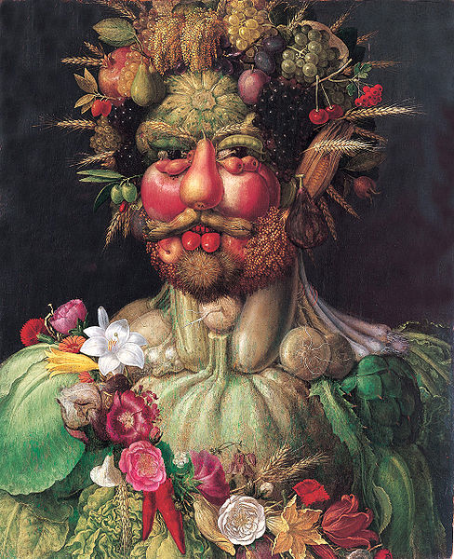  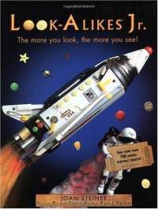  Inspired by the work of Guiseppe Archimboldo and the author Joan Steiner, both younger and older students can create self-portraits that draw relationships and similarities between different objects or symbols and one’s own facial features.  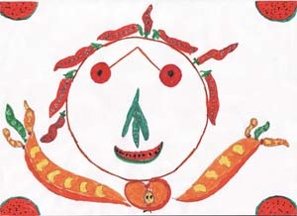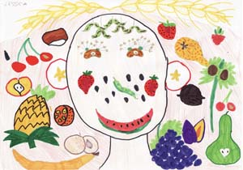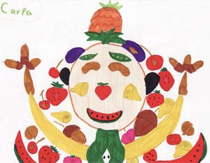  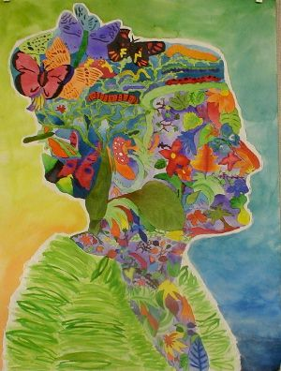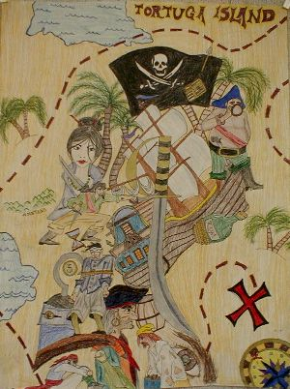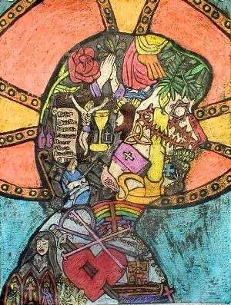  A personal analogy is created when a student identifies with the feelings and functions of an object. Students can creatively project themselves into the story or situation being depicted in a work of art, think about what it might be like to be in a particular landscape, or what it might feel like to be a particular object. This might be a nice introduction to talking about artworks and art criticism. You might prompt students by asking them, If you were the subject in this painting what would you see, hear, touch, taste and smell? What you be feeling if you were in this painting? Why might you be feeling this way?  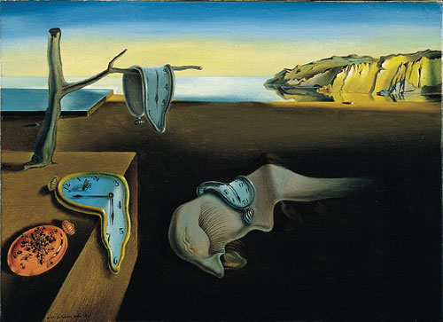  Salvador Dalí, Persistence of Memory, 1931  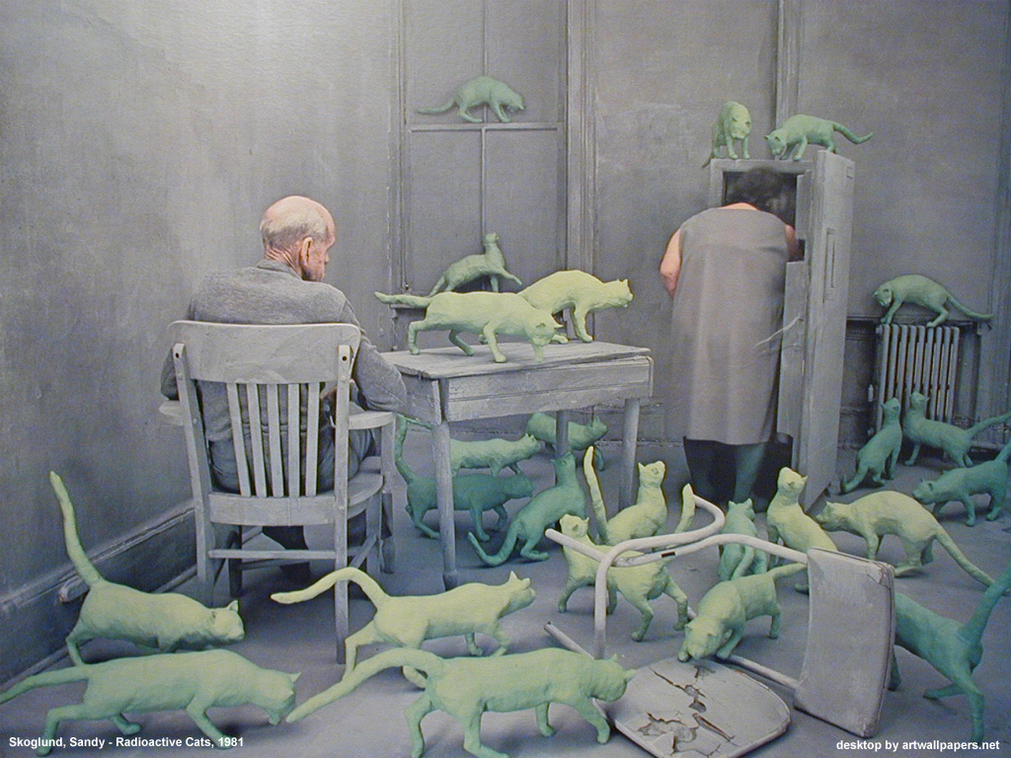  Sandy Skoglund, Radioactive Cats, 1981  Additional diverse artists that can be introduced through personal analogy include Robert Duncanson and Faith Ringgold, whose artworks lend themselves perfectly to storytelling. Students can talk about what it might feel like to be a person inside Duncanson’s landscape or to be part of Ringgold’s picnic.  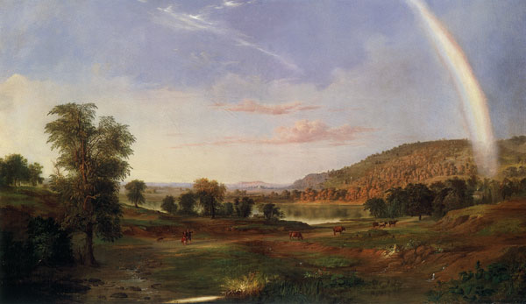  Robert Duncanson, Landscape with Rainbow, 1888  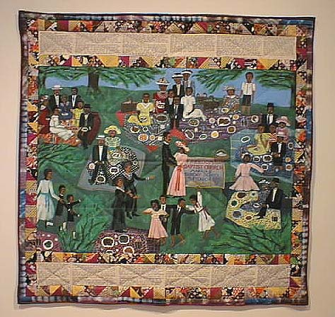  Faith Ringgold, Church Picnic, 1978  Not only can Students project themselves into the stories being told in paintings, they might also imagine what it might be like to be an object, like the apple in Magritte’s painting the listening room.  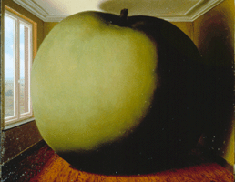  Rene Magritte, The Listening Room, 1952  In order to explore compressed conflict students could look at works in which the materials used are in contrast with the nature of the forms. For example, Meret Oppenheim’s fur lined teacup and saucer could inspire students to create other visual representations of compressed conflict, like this example of a fuzzy pompom-lined bowl.  Meret Oppenheim, Object, 1936
Supporting Student Learning (Scaffolding and Accelerating Learning for Different Ability Levels)
Advanced students can create more complex compositions by transforming a still life with multiple objects into a visual analog that explores all 3 visual languages.

WORK PERIOD  Releasing students to do the work | Step 5: Have students use the new information (Guided Practice )  Description of activities detailed in Step 4 (above)
CLOSING  Helping students make sense of their learning | Step 6: Make sure they can do it (Closure, Assessment, Evaluation Strategies)  Assessment:  Show students 3 new examples of each visual language and ask them to identify if the work is representational, abstract, or non-representational
Step 6: Make sure they can do it (Closure, Rubric, Product etc.)

Closure Activity:
Check artworks to rubric (See handout – Visual Language of Art)

Step 6: Make sure they can do it (Closure, Summarizing Strategy)

Students will look at each other’s artworks and talk about the choices they made.

Step 7: Have students practice at home (Independent Practice)

Non-representational artwork in response to music (sketchbook or journal) using media of choice.

