Action Research Final Report

Title: Arts Integration, Just Fun or Real Learning?

Research Team Leader: Ruth Rose, Art teacher,
Team Members:
Barbara Creider, Music teacher,
Pat Krauth, P. E. teacher,
Marsha Reyes, P.E. educational assistant

Location: Sunrise Elementary in the Las Cruces Public School District,
Las Cruces, New Mexico.
Participants: Grades 4 and 5
Multi-Year: Year One 2006-2007
Abstract: All students at a predominantly Hispanic Title I elementary school (grades 3-5) were given a week of arts-integrated instruction on a topic (measurement and the solar system) requested by homeroom teachers. Students learned about the topic through music projects, visual art projects, and movement projects. Pre- and post- tests of the fourth and fifth grade students showed their knowledge of the topic increased, sometimes significantly, as a result of the arts integrated instruction. Additional post-testing of fifth grade students after an interval of one month with no additional instruction resulted in higher scores than immediately following the week of instruction. Further investigation is needed to determine other subjects for which this approach would be fruitful and to determine how to optimize the effects of such learning.

Research Question: How will using an ARTS INTEGRATION approach to instruction affect short and long term retention of material learned by 4th and 5th grade students?

Description of Research Site:
Sunrise Elementary is located at the edge of Las Cruces, the second largest city in the state of New Mexico. Most of the area the school serves is rural. We serve students in grades 3, 4, and 5. There are 10 third grade classes, 10 fourth grade classes, and nine fifth grade classes. These numbers include one special education class in 3rd grade, two in fourth grade and one in fifth grade. The student population was 562 on the 120th day of the 2006-2007 school year. The school has a 30% student turnover rate within a year. The school was in School Improvement Year I during 2006-2007 because the Special Education students did not make Annual Yearly Progress in 2005-2006. The demographics of our students present a number of challenges. Eighty-five per cent of our children qualify for free lunch based on Federal poverty guidelines. Many of the children come from a background in which they grow up hearing and often speaking Spanish at home. Eighty-three percent of our students are classed as Hispanic, 1.6% are listed as Black, 15% White, and 0.5% Indian. Twenty-two per cent of our students are English Language Learners and 20% are in Special Education. We have a number of children who have family members who have died, are incarcerated, or are suffering from various forms of addiction. It is not unusual for our children to be the witnesses to or the victims of domestic violence.
Objectives:
We wish to document and then examine if an Arts based enrichment program is an effective way to learn. It is widely accepted that students learn better through multi-modal, hands on, activity based lessons in which students are permitted to construct knowledge based on their own direct experience with the materials/concepts. Story, song and dance have served as didactic tools in almost all cultures and have long been a part of the handing down of information from one generation to the next. Our experience told us that Arts Integration provides opportunities to learn and remember, especially for underserved students, but we wanted to be able to document and study the resulting data.
After running the Arts Integration program for a year (2005-2006), we were convinced that Music, Art and Physical Education were effective venues for children’s learning and that we could use our own disciplines to help students prepare for the standardized testing. We saw evidence of learning, the children seemed to be excited about what was happening, and the classroom teachers had nice things to say to us; but we had no evidence to prove that learning was taking place.

Methods and Materials:
The Arts Integration instruction at Sunrise Elementary School is in addition to the regular Art, Music and Physical Education programs in which the children already participate.
Three arts teachers (Art, Music and Physical Education) collaborate with homeroom teachers to develop topics for Arts Integrated instruction. The Arts teachers then design a week of interconnected lessons in Music, Art and Movement to teach the topic.
The topic is chosen from the grade level Standards & Benchmarks in Language Arts, Mathematics, Social Studies or Science. Each of the specialist teachers designs complementary lessons and experiences to present the topic using their own discipline. The specialists teach the chosen topic to the classes.
An individual homeroom meets with the Arts Integration staff during the school day for one hour each day for the period of one week. Since there are 25 homeroom classes at Sunrise so each class receives Arts Integrated instruction for one week during the school year. This week is structured to allow large group, small group, and individual learning experiences. The class meets together for an introduction day of instruction. At the end of the first day the students are divided into three small groups. During the next three days these small groups receive instruction from the specialists using Art, Music and Movement to explore the topic. At the end of the week, the children give a performance for themselves and their teacher demonstrating what they have learned.
The data collected included both pre-test and post-tests to measure what was learned and retained over time. In the fifth grade, the pre-test was administered during the first week of school. The post-test was distributed to classroom teachers on the Friday afternoon of the week of arts integration to be given the following Monday, and a second post-test was administered four weeks after the first post-test.
In the fourth grade, the pre-test was given in the week preceding the arts integration and the post-test was administered immediately following the arts integration unit. There was no second post-test.
In the fifth grade, we gave pre-tests and two post-tests spaced a month apart to 167 students. In the fourth grade we gave pre-tests and post-tests to 156 students.
Other data included still photos, videotaping of students working, student observations by arts integration teachers and classroom teachers, and student writing about the week. For 5th grade we have a photo record of masks created in art, all of the corrido verses created in music, and video footage of the activities in movement. For 4th grade, we have a photo record of the rose windows created in art, notation of the rhythms created in music and video footage of activities in music and in movement.

Observations and Conclusions:

Fourth Grade.
Our fourth graders received a unit on Measurement but received no parallel unit from the classroom teachers. The unit consisted of five days of the following activities. On day one, the students were divided into three groups named for three of the concepts we were focusing on, that being radius, diameter and circumference. The students walked these three concepts in a circle and then practiced doing the right ones when asked. They also spent time building and playing with marble mazes, as a hands-on experience with measurement and tracing a track. The music day consisted of learning about the mathematical relationships of whole, half, quarter, and eighth notes and then building four and eight beat rhythmic patterns with these notes, playing them and accompanying the recorder tune “Hot Cross Buns” with the rhythmic patterns created. The movement day consisted of building a clock face outside and walking off the minutes and hours as well as estimating distances in steps and walking the perimeters of geometric shapes. The art day consisted of studying symmetry and making rose windows out of paper circles. On the final day, students demonstrated what they had learned for the classroom teacher and answered questions about the concepts covered.
The data from the fourth grade classes showed clearly that the Arts Integration work we did was effective in helping the students learn. 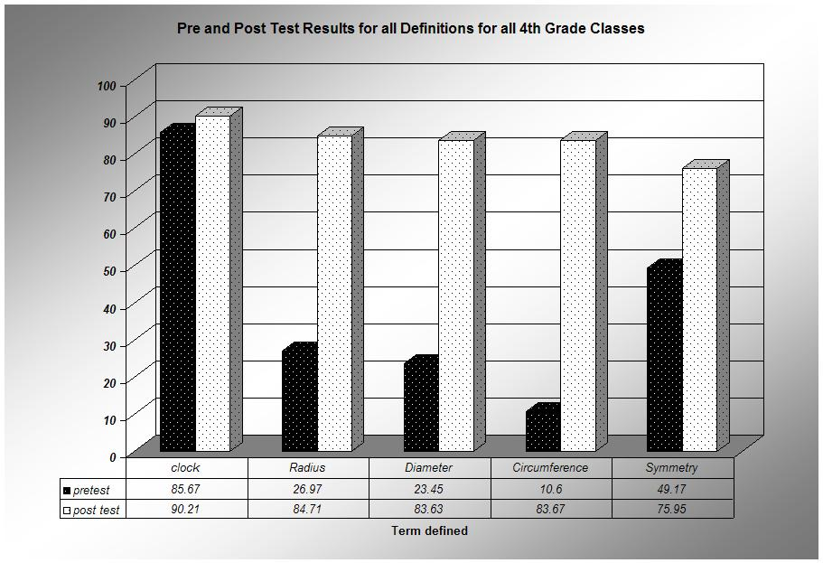
Our pre-test asked the students to tell the time on ten preprinted clock faces and then write definitions for the words Radius, Diameter, Circumference and Symmetry. This test was repeated after our unit on Measurement. As the chart above demonstrates, the most dramatic improvement came in the children’s ability to define the mathematical terms. The test of the ability to read an analog clock face was rather simple, with most of the questions asking children to tell half hours and hours, and we were surprised by how well most of the students did on the pre-test. This did not match up with our experience of actually seeing many children try unsuccessfully to read an analog clock face in the course of our teaching. The students reported being able to read the clock more confidently after the unit and the teachers also told us that they saw an improvement in the children’s accuracy after the unit.
Fifth Grade
The bulk of our data was collected from 5th graders. In this case, we had a pre- test that was given during the first week of school, a post-test that was given immediately after the Arts Integration unit and a second post-test that was given to teachers exactly one month later.
The 5th grade unit was focused on the Solar System. 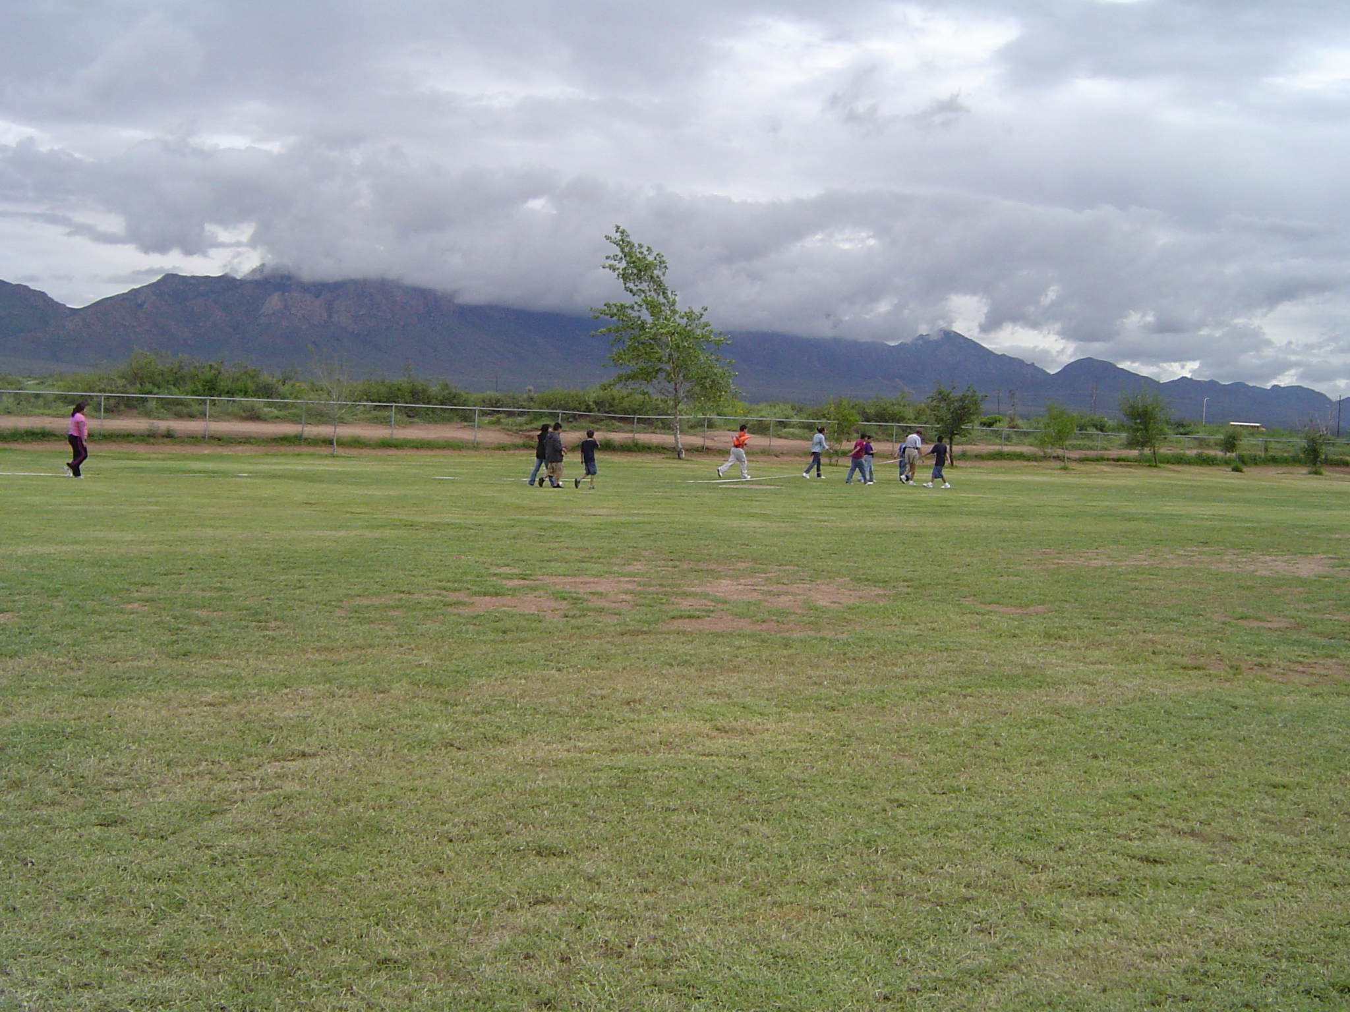 During the first day, the students studied the relative sizes and distances between the planets in the Solar System by examining small spherical objects which represented the sun and planets in the classroom and then going outside and walking the relative distances between these objects and placing safety cones at the orbits of each planet. During the music day, the students brought three facts about their planets and converted them into four line Corrido verses. During the arts day, the students learned about the mythological names and associations with the planets and made masks representing each planet. During the movement day, the students walked the orbits of the planets around the sun and learned that each planet’s orbit took a different length of time to walk. 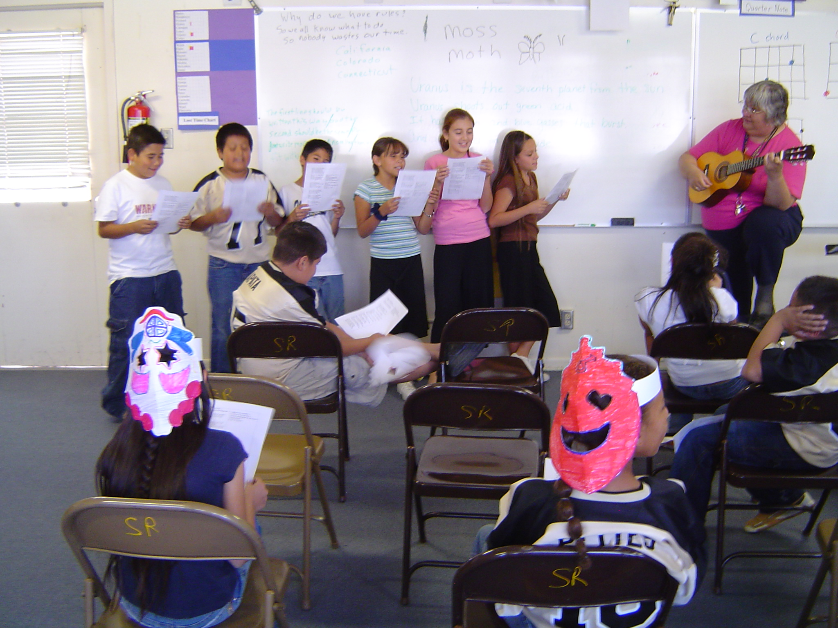 On the final day, the students sang the Corrido for their classroom teacher, explained the masks they had made, walked the orbits and answered questions about what they had learned.
These are the questions asked on our tests.
- What is a solar system?
- What is at the center of the solar system?
- How many planets are there?
- Name them.
- What is a moon?
- What is an orbit?
- What causes day and night?
- What causes the seasons?

With most of the eight classes, the homeroom unit was delivered during or before the Arts Integration unit, and one class received their homeroom unit after all the tests for this study had been administered. We charted each of these answers by class and also by question. There was clear evidence of learning in all cases. 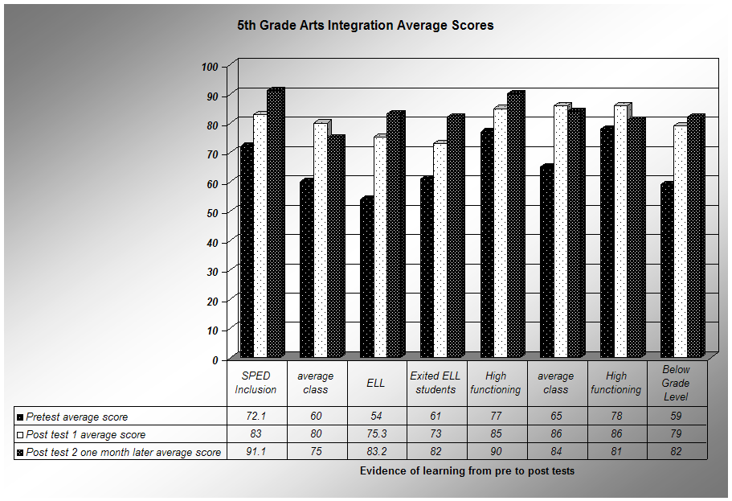The classes where the most improvement took place were the ELL class, SPED inclusion, and the lower functioning classes. The classes that contained fewer below grade functioning students showed less improvement, possibly because they already knew the material.
We were puzzled to see that the scores on the second post-test showed improvement over the scores on the first post-test in most cases. It may be that familiarity with the questions improved the answers or it may be that the students needed processing time to synthesize what they had learned, which we found to be an intriguing concept.
Students reported on their own learning and we documented this in the first post-test given immediately after the arts integration unit and again a month later in the second post-test. The students’ answers were insightful.

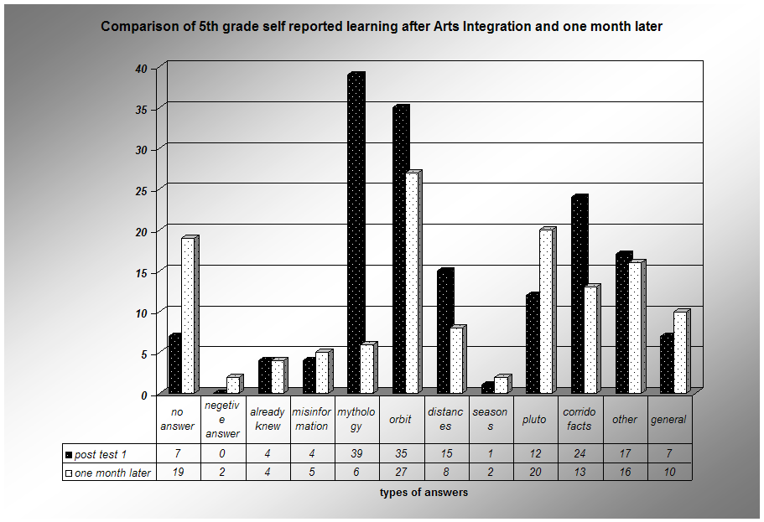

Immediately after the unit, the most students reported that the mythology information presented in Art was what stuck in their minds, with information about the orbits being the second most frequently reported. But by a month later, what they were most likely to mention was orbit, a topic that involved two of the movement activities. We were able to demonstrate that the biggest improvement in test scores came about on the orbit question, suggesting that movement was a powerful instructional tool. The first year of our research has given us ample documentation that real learning takes place during Arts Integration and is remembered well over time by the students.
Recommendations: We now have convincing data that Arts Integration is an effective tool for learning, and some idea of what types of learning work best. Our plans for next year are to focus the Arts Integration for all grades on Mathematics, as that is the area our school has selected for a major effort to improve test scores. We feel that we need a more thorough understanding of the classroom benchmarks and standards to be able to target our activities more directly to the performance deficits of the students in our school.

Personal Statement:
In Interest and Effort in Education, John Dewey established the thesis of progressivism and, therefore, of interdisciplinary studies:
“Our whole policy of compulsory education rises or falls with our ability to make school life an interesting and absorbing experience to the child. In one sense there is no such thing as compulsory education. We can have compulsory physical attendance at school; but education comes only through willing attention to and participation in school activities. It follows that the teacher must select these activities with reference to the child’s interests, powers, and capacities. In no other way can she guarantee that the child will be present.”

We have a great deal of anecdotal evidence that the reaction of the students to Arts Integration is very positive. Both in their writing about the week and in their statements to us, they repeatedly describe it is fun, a chance to play, and they express a desire to do more. The teachers report that the students are very excited about the week and say they are very impressed with the learning that takes place. Imaginative play is a form of art making. Much of what we do involves the manipulation or transformation of symbolic representations of the material we are attempting to teach. Because creativity and imagination are involved, as well as whole body movement, hands on manipulation and play, the students come away with a pleasurable sense of ownership of the concept.
Grace Nash, an Orff teacher, describes a four step process by which children learn in her book, Do It My Way, The Child’s Way of Learning:
The child’s four step learning process:
1. He expresses by imitation, echo or repetition that which he hears or sees.
2. He explores and extends this material. The student needs to find out what he can do with it, how it fits together and what it comes from.
3. He relates and creates, reorganizing the material into something of his own. It may be quite similar to or quite different form the original material, but it is his.
4. Literacy. Now he is ready to use written symbols to translate his experiences into abstract symbols, recognizing, relating and associating those symbols with that which he has experienced.

As teachers, too often we try to jump to literacy without allowing students to explore and extend the material through imitation, action and play. The result? The child remains in the fist step, imitation, and not attaining literacy.
Grace Nash, The Child’s Way of Learning.

Our effort to teach through Arts Integration attempts to take into account the learning styles of children.

State Benchmarks and/or Standards Addressed in Study:

4th grade
Standard 4 Measurement
Definition: Students will understand measurement systems and applications
Benchmarks and Standards to be addressed:
Fourth Grade Math Benchmark 2: Apply appropriate techniques tools and formulae to determine measurements
Performance Objective 1.
Estimate perimeters, areas of rectangles triangles and irregular shapes
Performance Objective 3
Estimate, measure and solve problems involving length, area, mass, time and temperature using appropriate standard units and tools.
Performance Objective 4
Identify common measurements of turns 90 degrees, 180 degrees, 360 degrees quarter turn.
Performance Objective 5
Compute elapsed time and make and interpret schedules.

5th grade
Science Standard III
Earth and Space Science
Students will: Understand the structure of the Earth, the Solar System and the Universe, the interconnections among them and the processes and the interactions of Earth’s systems.
Benchmark 1. (K-4) Students will: Know the structure of the solar system and the objects in the universe.
Benchmark 1. (5-8) Students will: Describe how the concepts of the energy, matter and force can be used to explain the observed behavior of the solar system of the universe and their structures.
Performance Standards
Students will: Describe the objects in the Solar System
Students will: Describe the Relationships among the Objects in the Solar System (relative distances, orbital motions)

NM Fine Arts Education Standards
1 Learn and develop the essential skills and technical demands unique to dance, music, theatre/drama, and visual art.
Visual art: (K-4)
A - Participate in the process of making art to understand the elements of art: line, shape, form, color and texture.
( 5-8) use art materials and techniques to solve specific problems and to enhance ideas)
B – Explore and become familiar with art materials and their related techniques
( 5-8 ) use of art materials and techniques by culturally diverse artists locally and globally
C – Use art materials in a safe and responsible manner
Music: explore through movement simple rhythm patterns; and identify basic rhythmic symbols including whole, half, quarter, and eighth notes, and the concepts of dotted notes and rests.

2 Use dance, music. Theatre/drama and visual art to express ideas
Visual Art: (K-4)
A –
( 5 – 8) apply elements of art and principles of design to communicate ideas
B - Know and use art to interpret personal ideas, feeling and experiences through visual form
(5-8) use subjects, themes and symbols when expressing ideas in art works
3 Integrate understanding of visual and performing art by seeking connections and parallels among art disciplines as well as all other content areas

Visual Art (K-4)
A – Explore similarities and differences between characteristics of the visual art and other art disciplines
(5-8) explore the characteristics of works in two or more art disciplines that share similar subject matter, historical periods or cultural context
B – Identify and apply connections between the visual art and other disciplines
( 5-8) show ways in which principles and subject matter of other disciplines are interrelated with visual art
Music--Students will recognize how all music elements are used in similar and distinctive ways in various arts; and explore and identify links among art disciplines as well as among other content areas.
4 Demonstrate an understanding of the dynamics of the creative process
Visual Art (K-4)
A (5-8) explore the influence of personal experience, imagination and the dynamics of culture to works of art
B develop appropriate methods of reflection and evaluation of art work
Music Students will:
improvise completion of a given rhythmic or melodic phrase; investigate a variety of sound sources for improvising short songs and instrumental pieces; and
Understand that there are multiple ways in which a phrase may be completed.

5 Observe, discuss, analyze and make critical judgments about artistic works.
Visual art (K-4)
B – Understand that there are different responses to specific artworks and respect those differences
C – Reflect upon and assess the characteristics and merits of one’s own artwork
6 Show increased awareness of diverse peoples and cultures through visual and performing art
Visual Art (K-4)
Music—Students will amplify and enhance cultural awareness of different ethnicities through related drama, poetry, dance, etc.; compare and contrast western and non-western music; and compare and contrast folk music with traditional and contemporary music.

7 Demonstrate knowledge about how technology and invention have historically influenced artists and offered new possibilities for expression
Visual Art (K-4)
A – Demonstrate an understanding of specific inventions that have influenced change in artists’ ability to create works of art
B – Use various technologies to create works of art
8 Contribute to communities by sharing expertise in dance, music, theatre/drama and visual art and by participating in the activities of cultural institutions
Visual Art (K-4)
C contribute to community culture by exhibiting art work

Bibliography

Janet R Barrett Interdisciplinary work and Musical Integrity Music Educators Journal v 87 no 5p 27-31 March 2001

Leon H Burton Interdisciplinary Curriculum,: Retrospect and Prospect Music Educators Journal Vol 87 no 5 p.17-21 66 March 2001.

Arthur K Ellis and Jeffrey T Fouts Interdisciplinary curriculum, the Research Base Music Educators Journal Volume 87 No 5 p 22-6 68 MR 2001

Jane Carol Manner Arts through the Curriculum Kappa Delta Pi Record 39 no. 1 fall 2002 pp 17-19

Jacob J. Mishook and Mindy R Kornhaber Arts Integration in an Age of Accountability Arts Education Policy Review 107 no. 4 March April 2006, pp 3-11.

Nick Rabkin and Robin Redmond The Arts Make a Difference Educational Leadership 63 no5 F 2006 60-4.

Sue Snyder Connection, Correlation and Integration. Music Education Journal Vol 87 p32-9, 70 March 2001.

Robert A Wiggins Interdisciplinary Curriculum: Music Educator Concerns Music Educators Journal vol 87 no 5 p40-4 March 2001

