Atlanta Public Schools
Office of Fine and Performing Arts

Grade 5 Visual Art
Performance Assessment Teacher Package

“Expressive Portrait in Oil Pastel or Tempera Paint and
Written Commentary”

Assessment Committee:
Stephany Walls, Nostacia Adams, Russell Kennedy, Pat Jackson, Jaymes Taylor, Cynthia Bair-Campbell
Mr. Raymond Veon,
Interim Director, Fine and Performing Arts
Project Director, ArtsAPS

Expressive Portrait (Oil Pastel or Tempera Paint)
The Task
Part 1: 4-6 class periods
Students are told that their local art gallery is loaning a Picasso portrait to another art gallery and that the curator of their local gallery has invited students to submit a portrait of their own to be considered as a replacement (note: their replacement painting can be in the style of Picasso or a style of their own choice, including their own personal style). Each student is to produce an expressive portrait using tempera or oil pastels that conveys two contrasting emotions (e.g., happiness/sadness). The portrait is to be painted/colored using a range of tints and shades of two complementary colors. The portrait is to be divided in half vertically (see template). On the right side of the painting the student is to use tints and shades of one complementary color on the face, and tints and shades of the other complementary color on the background. On the left side of the portrait the student is to reverse the placement of the tints and shades of the complementary colors. Facial features could be painted/colored in either complementary color.
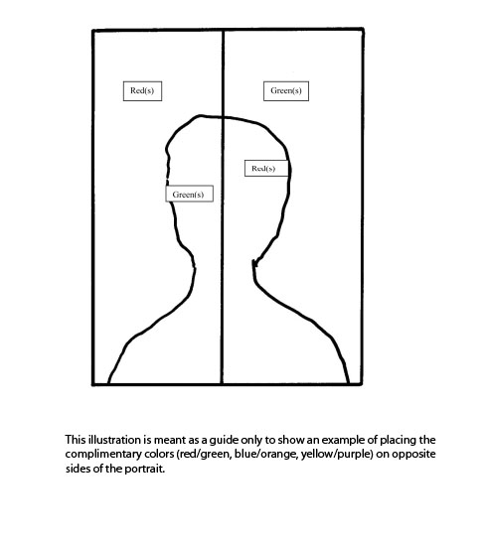

Illustration Source: Ontario Ministry of Education
Part 2: 1 class period
Students are to provide a written analysis of their work. They are to describe the intensity, value, and temperature of the complementary colors used, the contrasting emotions shown, and ways in which these emotions are conveyed by the colors chosen. Students are also to explain how the colors used reminded them of similar emotions they had experienced in their lives. Finally, they are to reflect on the ideas that informed their creative process and how this experience may influence their development as artists in the future.

Expectations
This task gives students the opportunity to demonstrate achievement of all or part of each of the expectations from the Georgia Performance Standards for the Visual Art for 5th Grade.

Prior Knowledge and Skills
To complete the task, students were expected to have some experience with, or some knowledge or skills related to, the following:
- Thumbnail sketches
- Primary and secondary colors as well as temperature (warm vs. cool), value (light vs. dark), and intensity (bright vs. dull) of color
- Warm and cool colors and their emotional impact (e.g., a warm color scheme may make people feel warmer)
- Mixing colors with oil pastels or tempera paint
- Proportion, distortion, exaggeration, substitution
- Looking at and talking about art (e.g., portraits and expressive pieces by various artists) analyzing their own pieces of art based on set criteria

Title: Expressive Portrait
Time Requirement: 4-6 lesson periods
Size: 9x12 inches

Concepts central to this task are the following:
There are three pairs of complementary colors.
Colors elicit emotion.
Each individual brings his or her own personal knowledge and experience to the interpretation of works of art.
Color, contrast, proportion, distortion, exaggeration, and/or substation can all be used to express ideas and emotions.
Oil pastel or tempera painting techniques.

Assessment and Evaluation
Please see the 4 Level Rubric on page 15.
Introduce the rubric to the students at the beginning of the exemplar task. Review the rubric with the students to ensure that each student understands the criteria and the descriptions for achievement at each level. Allow time for a thorough reading and discussion of the assessment criteria outlined in the rubric.

Minimum Requirements for Level 2:
To be considered a Level 2, the final portrait must meet the following set of threshold questions:
- Did the student follow the basic instructions (e.g. use of the template, etc.)
- Can the relationships between the major shapes be visually read as a portrait?
- Does it only use one set of complimentary colors?
- Does it show two different emotions?
- Does it have tints and shades?
- Is their evidence of distortion, exaggeration, or rearrangement of facial features to convey emotion?

Level 3:
Demonstrates BOTH an understanding of the task AND synthesis of two or more variables.
Level 4:
Demonstrates BOTH an understanding of the task AND synthesis of ALL of the variables identified above; visual evidence of innovation, integration of knowledge/skills beyond from other art learning or subject domains
Accommodations
Accommodations that are normally provided in the regular classroom for students with special needs should be provided in the administration of the exemplar task.

Materials and Resources Required
Students should be provided with the following materials:
-visual images, examples of portraits (Note: Please use the PowerPoint Resource Model for portrait examples)
-9 x 12" sheets of plain white paper
-oil pastels
-planning paper for thumbnail sketches
-newsprint/newspaper to cover desktops
-pencils (for the thumbnails and written portion of the task only)
-critical analysis sheets (see pages 15, 16, and 17 of this teacher packet)

References:
Georgia Performance Standards in the Visual Arts
National Standards for the Arts
Ontario Fine Arts Standards/Student Exemplars

Assessment Materials
(The following pages should be photocopied as
assessment materials for each student).

Task Rubric – Visual Arts, Grade 5 Expressive Portrait
First Name
Last Name
School
Art Teacher
Class
COMPOSITE (OVERALL) PERFORMANCE ASSESSMENTSCORE: 88 Possible Points
Level 1 (0-21 Points) ❐ Level 2 (22-43 Points) ❐ Level 3 (44-65 Points) ❐ Level 4 (66-88 Points) ❐

Meaning and Creative Thinking Score: Level 1 ❐ Level 2 ❐ Level 3 ❐ Level 4 ❐
Production Score: Level 1 ❐ Level 2 ❐ Level 3 ❐ Level 4 ❐
Contextual Understanding Score: Level 1 ❐ Level 2 ❐ Level 3 ❐ Level 4 ❐
Assessment and Reflection Score: Level 1 ❐ Level 2 ❐ Level 3 ❐ Level 4 ❐
Connections Score: Level 1 ❐ Level 2 ❐ Level 3 ❐ Level 4 ❐

DOMAIN: Meaning/Creative Thinking (Planning Matrix) 16Points Possible WEIGHTED DOMAIN
Level 4 = 4 points | Level 3 = 3 points | Level 2 = 2 points | Level 1 = 1 point | Enter Points Earned
A) makes 6 or more thumbnail sketches | makes 4-5 thumbnail sketches | makes all 2-3 thumbnail sketches | makes less than 2 thumbnail sketches
B) sketches reflect extensive experimentation and understanding of task (opposing emotions, exaggeration, distortion, and emphasis); takes risks, stretches and explores | sketches reflect evidence of experimentation and understanding of task; some evidence of taking risks, stretching and exploring | sketches are clear; limited experimentation and understanding of task is evident | sketches are illegible; no experimentation evident
C) 5 or more detailed ideas  and/or notes recorded | 3-4 detailed ideas recorded | ideas are recorded, but they are short | few or no ideas recorded
D) sketches/notes make 5 or more connections between task and personal experiences/feelings/ideas | makes 3-4 connections between task and personal experiences/feelings/ideas | makes 1 -2 connections between task and personal experiences/feelings/ideas | no connections to task evident
Meaning/Creative Thinking Total
SCORE: Level 1 ( 0-4 Points) ❐ Level 2 (4-7 Points) ❐ Level 3 (8-11 Points) ❐ Level 4 (12-16 Points) ❐

Rubric continued next page

DOMAIN: Production (Final Expressive Portrait) 24 Points Possible WEIGHTED DOMAIN
Criteria:
1. Reads as a Portrait
2.One set of Complimentary Colors plus black and white
3.Evidence of tints and shades used intentionally
4.Two different emotions
5. Evidence of exaggeration, distortion or rearrangement of facial features
Level 4 = 4 points | Level 3 = 3 points | Level 2 = 2 points | Level 1 = 0 or 1 point | Enter Points Earned
A) the relationships between the major shapes can be visually read as a portrait (e.g. a head on shoulders/upper body) in a way that reinforces another item from the minimum criteria and utilizes personal or innovative visual  elements | --the relationships between the major shapes can be visually read as a portrait in a way that reinforces another item from the minimum criteria | --the relationships between the major shapes can be visually read as a portrait | unclear whether major shapes constitute a portrait
B) two different emotions clearly visible in a way that reinforces another item from the minimum criteria and utilizes personal or innovative visual elements | --two different emotions clearly visible in a way that reinforces another item from the minimum criteria | --two different emotions clearly visible | unclear whether two different emotions are evident
C) uses only one set of complimentary colors plus black and white (no extra colors) in a way that reinforces another item from the minimum criteria and utilizes personal or innovative visual elements | --uses only one set of complimentary colors plus black and white in a way that reinforces another item from the minimum criteria | --uses only one set of complimentary colors plus black and white | uses more than one set of complimentary colors, black, and white
D) visual evidence that tints and shades used intentionally visible in a way that reinforces another item from the minimum criteria and utilizes personal or innovative visual elements | visual evidence that tints and shades used intentionally visible in a way that reinforces another item from the minimum criteria | visual evidence that tints and shades used intentionally | use of tints and shades not evident or their use is unclear
E) evidence of exaggeration , distortion, or rearrangement of facial features to convey emotion is evident in a way that reinforces another item from the minimum criteria and utilizes personal or innovative visual elements; takes risks, stretches and explores | evidence of exaggeration , distortion, or rearrangement of facial features to convey emotion is evident in a way that reinforces another item from the minimum criteria; some evidence of taking risks, stretching and exploring | evidence of exaggeration , distortion, or rearrangement of facial features to convey emotion | distortion, exaggeration, or rearrangement of parts not evident
F)clearly shows 2 emotions that can be read as contrasting emotions in a way that reinforces another item from the minimum criteria and utilizes personal or innovative visual elements | – clearly shows 2 emotions that can be read as contrasting emotions in a way that reinforces another item from the minimum criteria | – shows 2 emotions that can be read as contrasting emotions with limited effectiveness | demonstrates no or limited understanding of the concepts involved in producing an expressive portrait that shows contrasting emotions
G) follows basic instructions, all 6 minimum criteria present; clear evidence of 1-2 personal or innovative visual elements used in tandem with 1 or more of the 6 minimum criteria or the integration of knowledge/skills from other art learning or subject domains | --follows basic instructions, all 6 minimum criteria present ;clear evidence of 1-2 personal elements or innovative thinking; the presence of knowledge/skills from other art learning or subject domains | --follows basic instructions, all 6 minimum criteria present:, limited or questionable evidence of 1-2 personal elements or innovative thinking, there may be evidence of knowledge/skills from other art learning or subject domains | demonstrates no or limited understanding of basic instructions; 1-5 of the 6 minimum criteria present); no evidence of personal elements or innovative thinking
Production Total
DOMAINSCORE: Level 1 ( 0-5 Points) ❐ Level 2 (6-11 Points) ❐ Level 3 (12-17 Points) ❐ Level 4 (18-24 Points) ❐

DOMAIN: Contextual Understanding (Critical Analysis Question 1) 20 Points Possible
Level 4 = 4 points | Level 3 = 3 points | Level 2 = 2 points | Level 1 = 0 or 1 point | Enter Points Earned  **Category C Worth Double**
A) – 76-100% of written response uses appropriate and accurate vocabulary and art terminology | – 51% -75% of written response uses appropriate and accurate vocabulary and art terminology | –at least 50% of written response uses appropriate and accurate vocabulary and art terminology | – does not use or rarely uses appropriate vocabulary and art terminology
B) cites 5 or more art history and visual culture exemplars | –cites 3-4 art history and visual culture exemplars | – cites 1-2 art history and visual culture exemplars | – does not cite art history or visual culture exemplars
C) makes 5 or more connections between own work and exemplars | – makes 3 – 4 connections between own work and exemplars | – makes 1-2 connections between own work and exemplars | – does not connect own work to exemplars | ____ points x 2 =  ________
D) provides detailed description regarding visitors’ response by citing 3 or more examples and supports each statement with evidence | – provides detailed description regarding visitors’ response by citing 1-2 examples or evidence | – provides minimal description regarding how visitors might respond to their own artwork but uses short or undetailed sentences | –does not or provides limited description regarding how visitors might respond to their own artwork
Contextual Understanding Total
DOMAINSCORE: Level 1 ( 0-4 Points) ❐ Level 2 (5-9 Points) ❐ Level 3 (10-14 Points) ❐ Level 4 (15-20Points) ❐

DOMAIN: Assessment and Reflection (Critical Analysis Question 2) 20 Points Possible
Level 4 = 4 points | Level 3 = 3 points | Level 2 = 2 points | Level 1 = 0 or 1 point | Enter Points Earned
A.) Describes or identifies 2 emotions and explains the emotions depicted in the portrait citing 4 or more details and makes a connection between the colors used and emotions depicted. | Describes or identifies 2 emotions depicted in the portrait with sentences by citing 2-3 details. | Describe or identifies the 2 emotions depicted in the portrait with sentences. | Describes or identifies the emotions depicted in the portrait.
B.) Explanation of 4 or more connections between the portrayed emotions and the use of exaggeration, distortion, or rearrangement of portrait features. | –explanation of 2-3 connections between the portrayed emotions and the use of exaggeration, distortion, or rearrangement of portrait features. | – general explanation of the connection between the portrayed emotions and the use of exaggeration, distortion, or rearrangement of portrait features. | – explains the connection between portrayed emotions and the use of exaggeration, distortion, or rearrangement of portrait features. | ____ points x 2 =  ________
C.) Artistic choices are described and explained using sentences; provides supporting examples, rationales & evidence for each statement; answers the “what” and “why” of each choice; references the effect achieved by each choice and connects it to the task and the final product. | – artistic choices described and explained using sentences; provides examples, rationales & evidence for 1-2 statements; answers the “what” and “why” of each choice | – artistic choices described using short, repetitive, sentences; answers “what” and/or “why” of each artistic choice. | – artistic choices described using short, repetitive, sentences
Assessment and Reflection Total Points:____________
DOMAIN SCORE: Level 1 ( 0-4 Points) ❐ Level 2 (5-9 Points) ❐ Level 3 (10-14 Points) ❐ Level 4 (15-20Points)

DOMAIN: Connections (Critical Analysis Question 3) 8 Points Possible
Level 4 = 4 points | Level 3 = 3 points | Level 2 = 2 points | Level 1 = 0 or 1 point | Enter Points Earned
– makes 3 or more connections between performance task to personal experiences and/or connects how selected colors are used in other design contexts, also expresses additional connections related to other learning/life experiences. | – makes 3  connections between performance task to personal experiences and/or connects how selected colors are used in other design contexts | – makes 1-2 connections between performance task to personal experiences and/or connects how selected colors are used in other design contexts | – does not connect performance task to personal experiences or explain how colors are used in other design contexts
– all vocabulary and concepts employed are accurately used in written comments | – most of vocabulary and concepts employed are accurately used in written comments | – at least half of vocabulary and concepts employed are accurately used in written comments | – less than half of vocabulary and concepts employed are accurately used in written comments
Connections Total
DOMAINSCORE: Level 1 ( 0-2 Points) ❐ Level 2 (3-4 Points) ❐ Level 3 (5-6 Points) ❐ Level 4 (7-8 Points) ❐
TOTAL POINTS ALL DOMAINS

THUMBNAIL PLANNING MATRIX 1 of 2
1) Come up with three ideas for your expressive portrait. 2) Write down any ideas that you think of as you work. 3) Make three more thumbnail drawings for your portrait by experimenting with distortion, exaggeration, and emphasis; remember to write down your ideas! Make as many thumbnails and notes as you want; if you need more paper, ask your teacher.
Ideas: | Ideas: | Ideas:
Your Name: Your School:

THUMBNAIL PLANNING MATRIX 2 of 2 SHOWING DISTORTION, EXAGGERATION, & EMPHASIS
1) Come up with three ideas for your expressive portrait. 2) Write down any ideas that you think of as you work. 3) Make three more thumbnail drawings for your portrait by experimenting with distortion, exaggeration, and emphasis; remember to write down your ideas! Make as many thumbnails and notes as you want; if you need more paper, ask your teacher.
Ideas: | Ideas: | Ideas:
Your Name: Your School:

PART 2: CRITICAL ANALYSIS – Question 1
(ANSWERS TO EACH QUESTION TO BE RETURNED TO R. VEON)

The curator has asked you to respond to the following questions in order to your portrait considered for selection for the art gallery replacement. Please use one sheet of paper for each answer. Put your name, your school, your art teacher’s name, and your classroom teacher’s name on each sheet. Be sure to answer each part of every question. You may use the back of the paper.

Your Name: __________________________________________________________

Your School: _________________________________________________________

Your Art Teacher: _____________________________________________________

Your Classroom Teacher: _______________________________________________

When do you have art?
❐Once a week ❐Once every two weeks ❐Other (explain):

How long is your art class?
❐30 minutes or less ❐40 minutes or more

Question 1 (GPS: Contextual Understanding)

1. How is your portrait like the art of other artists you have studied? How is it different? How do you think visitors who see your work in a gallery or art show will respond to it?

PART 2: CRITICAL ANALYSIS – Question 2

Your Name: __________________________________________________________

Your School: _________________________________________________________

Your Art Teacher: _____________________________________________________

Your Classroom Teacher: _______________________________________________

Question 2 (GPS: Assessment and Reflection)

2. Describe the contrasting emotions you intend to show. How did you use exaggeration and/or distortion to show these emotions? Describe what you exaggerated and/or distorted. What else did you do in your portrait to show these emotions?

PART 2: CRITICAL ANALYSIS – Question 3

Your Name: __________________________________________________________

Your School: _________________________________________________________

Your Art Teacher: _____________________________________________________

Your Classroom Teacher: _______________________________________________

Question 3 (GPS: Connections)

3. Look at the colors you have used in your portrait to show contrasting emotions.
A. Describe the intensity, value, and temperature of the colors you used.
B. Explain how these colors remind you of emotions you have experienced in your life.
C. Do you ever see these colors used in other places (like toys, buildings, advertisements, in books or on clothes)? Why do you think they are used there?

TEACHER RESOURCE MATERIALS

Task Instructions

Introductory Activities
The pre-task is designed to review and reinforce the skills and concepts that students will be using in the exemplar task.
Pre-task 1: Looking Activity
1. Read the student scenario to the students and post it in the classroom. Tell them that the exemplar task will involve the use of the skills and concepts reviewed in the pre-tasks.
2. Post 8 1⁄2" x 11" sheets of red, blue, and yellow paper in the classroom. Place the colored sheets against a white background. Beside each colored sheet, post a piece of 8 1⁄2" x 11" white paper.
3. Divide the class into groups and instruct the students in each group to stare intently at one of the colored sheets for 30 seconds to one minute. Then have them look quickly at the white paper beside it.
4. Have the students, working in their groups, discuss what they see. Then have one student from each group report the group’s observations. (Note: When students look at the white paper after staring at a colored shape for an extended period of time, they will generally observe a ghost image of a colored “opposite” to the one they have stared at – e.g., a red ghost image is observed after staring at a green shape. These are complementary pairs of color: when one is placed beside the other, they both appear more intense. Complementary colors contrast with each other and therefore draw the viewer’s eye.)
5. List the students’ observations on the board.

Pre-task 2: Art Appreciation, Mood in Portraits
1. Display the visual images and portraits provided in the Grade 5 Performance Assessment PowerPoint, to be provided. Play two music audio clips to demonstrate contrasting moods/emotion; please use the files labeled ctm_06 and ctm_07 on the Music Thinking Strategies web page (see below). Show these images and re-play these clips as needed throughout this performance assessment.
Download music audio clips at: http://igniteart.weebly.com/music-thinking-strategies.html
2. Review terms such as portrait, expressive use of color, complementary colors, intensity (bright vs. dull), temperature (warm vs. cool), value (light vs. dark), tints and shades, exaggeration, and distortion. (See the Glossary below)
3. Brainstorm with the class possible contrasting emotions and record them on a chart. Post the chart in the classroom for future reference.
4. Analyze with the students one visual image or portrait, using the following suggested questions as a guide:
– Describe the colors the artist has used (i.e., hue, intensity, temperature, and value).
– Describe areas where complementary colors and tints and shades have been used.
– How does this piece of art make you feel?
– What concepts and/or techniques has the artist used to convey this emotion? For example, has the artist distorted, exaggerated, enlarged or rearranged parts to make an expressive painting?
– What does this picture remind you of?
NOTE: This is NOT a VTS lesson; however, the VTS lessons you have provided over the course of the year will help students with this activity.
5. Students practice using distortion, exaggeration, and rearranging facial features to convey emotion using the practice sheet provided in this Teacher Package. Students may take this sheet home; this sheet will not be turned in for marking.

Pre-task 3: Mixing Tints and Shades
1. Refer the students to Mixing Tints and Shades (Appendix A).
2. Instruct the students to choose one primary or secondary color and then to mix tints and shades by using the following instructions as a guide:
– Paint white in #1.
– Add a very small amount of the color to the white to create a tint for #2.
– Add a little more color to create a tint for #3.
– Add a little more color to create a tint for #4.
– Paint pure color in #5.
– Add a very tiny amount of black to the color to create a shade for #6.
– Add a very little more black to the color to create a shade for #7.
– Add a very little more black to the color to create a shade for #8.
– Paint black in #9.
3. Distribute white paper to each student. Tell the students to choose one of the following
colors – red, yellow, blue, orange, green, purple – and make three versions of that color by mixing it with grey. (Grey can be made by mixing black and white paint.) Ensure that all the colors are chosen. Share the results with the class.
4. Tell the students that they will be applying these techniques in the exemplar task.

Exemplar Task
Each student’s planning matrix/thumbnail sketches, painting (the expressive portrait) and the student’s completed answers to the three Critical Analysis questions are to be submitted for marking.
Part 1
1. Read the student scenario to the students again.
2. Discuss the task rubric with the students. Have them highlight or underline key words.
3. Discuss how features of the face may be enlarged or rearranged (e.g., with some features shown in frontal view, some in profile) to make an expressive painting. Students complete the planning matrix/thumbnail sketches by experimenting with various compositions and ways of exaggerating/distorting/rearranging facial features. Note: The thumbnails may be made in color using markers or colored pencils (but not oil pastels or paint). Students can write notes about the placement of colors (tints and shades) that show contrasting emotions. Students can also begin to prepare rough notes to justify choices made and explain connections with real-life experiences. This will help them with the critical analysis of their painting in part 2 of the exemplar task.
4. Instruct the students to paint (without drawing with a pencil first) the outline of the major shapes, using a brush or oil pastel and a color of their choice (one of their complementary colors).
5. Refer the students to the Expressive Portrait Color Placement Guide (see page 3) and
make sure that they understand how the complementary colors are to be placed on opposite sides of the portrait.
6. Direct the students to use a variety of tints and shades in their painting for both the background and foreground. Suggest that they blend colors in the background. Remind students that in each half of the painting the background color is to be the complementary color of the face. Demonstrate different brush strokes or oil pastel techniques.
7. Instruct the students to cover the entire page with paint/oil pastel so that no white space is exposed.

Part 2
1. When the paintings/oil pastels are finished, have the students complete the Critical Analysis, which has THREE major questions. Be sure students answer each sub-question in each major question.
2. Review with the students the following suggested components of a well-written response:
– using complete sentences
– explaining ideas with clarity
– providing examples
– using rich vocabulary, including art terminology
– addressing all parts of each question
– revising and editing the written response

DO NOT:
Do not include collage elements; follow directions explicitly.
Do not use other materials.
Do not change the size of the paper.

Part 2: 1 class period
1. When the oil pastel/paintings are finished, have the students complete the Critical Analysis.
2. Review with the students the following suggested components of a well-written response:
-using complete sentences
-explaining ideas with clarity
-providing examples
-using rich vocabulary, including art terminology
-addressing all parts of each question
-revising and editing the written response

Glossary
Balance: A principle of design. A feeling of balance results when the elements of design
are arranged to create the impression of equality in weight or importance.
Color: An element of design. Color is the particular hue that is seen when light is reflected off an object.
Complementary colors: Colors that are directly opposite each other on the color wheel (e.g., red and green, blue and orange, yellow and purple).
Cool colors: Colors that suggest coolness (e.g., blue, green, purple). These colors tend
to recede and appear smaller in an art work.
Distortion: Twisting or changing something out of shape.
Exaggeration: Making something (such as a facial feature) stand out, by making it more or less than it really is, e.g. larger, smaller, brighter, darker, prettier, uglier, etc.
Hue: The common name of a color (e.g., red).
Intensity: The brightness or dullness of a color. Pure color is the most intense; adding black or white will decrease its intensity.
Shade: A dark value of a color obtained by adding black to a pure color.
Temperature of color: Generally speaking, colors are either cool or warm.
Tint: A light value of a color obtained by adding white to a pure color.
Value: The lightness or darkness of a color.
Warm colors: Colors that suggest warmth (e.g., red, orange, yellow). These colors tend to come forward.

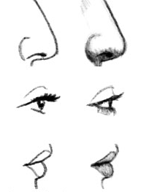

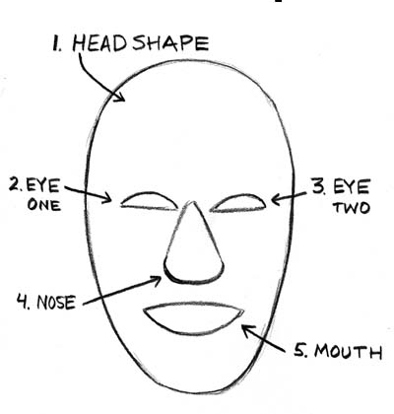

Practice exaggeration and distortion of different facial features by drawing in the boxes.

List of Visual Arts Teacher Resources

While preparing your 5th grade students for the Visual Arts assessments, use the following teacher resources:
- PowerPoint file created by fellow colleagues, Phil Alexander Cox, Allison Gardner and Raymond Veon;

- Play two music audio clips to demonstrate contrasting moods/emotion; please use the files labeled ctm_06 and ctm_07 on the Music Thinking Strategies web page (see below). Show these images and re-play these clips as needed throughout this performance assessment.
Download music audio clips at: http://igniteart.weebly.com/music-thinking-strategies.html

- Vocabulary/Concept List for 5th Grade Visual Arts Assessment

- Create an assessment materials folder for each student by instructing students to fold a 12”X18” piece of construction paper in ½ to insert all documents. Stapling the edges of the folder is optional.

Note: If Visual Arts teachers have other suggestions to add to this list of resources, please be prepared to share this information at our Professional Development meeting. This can be modified at a later date.

ARTIFACT ORDER
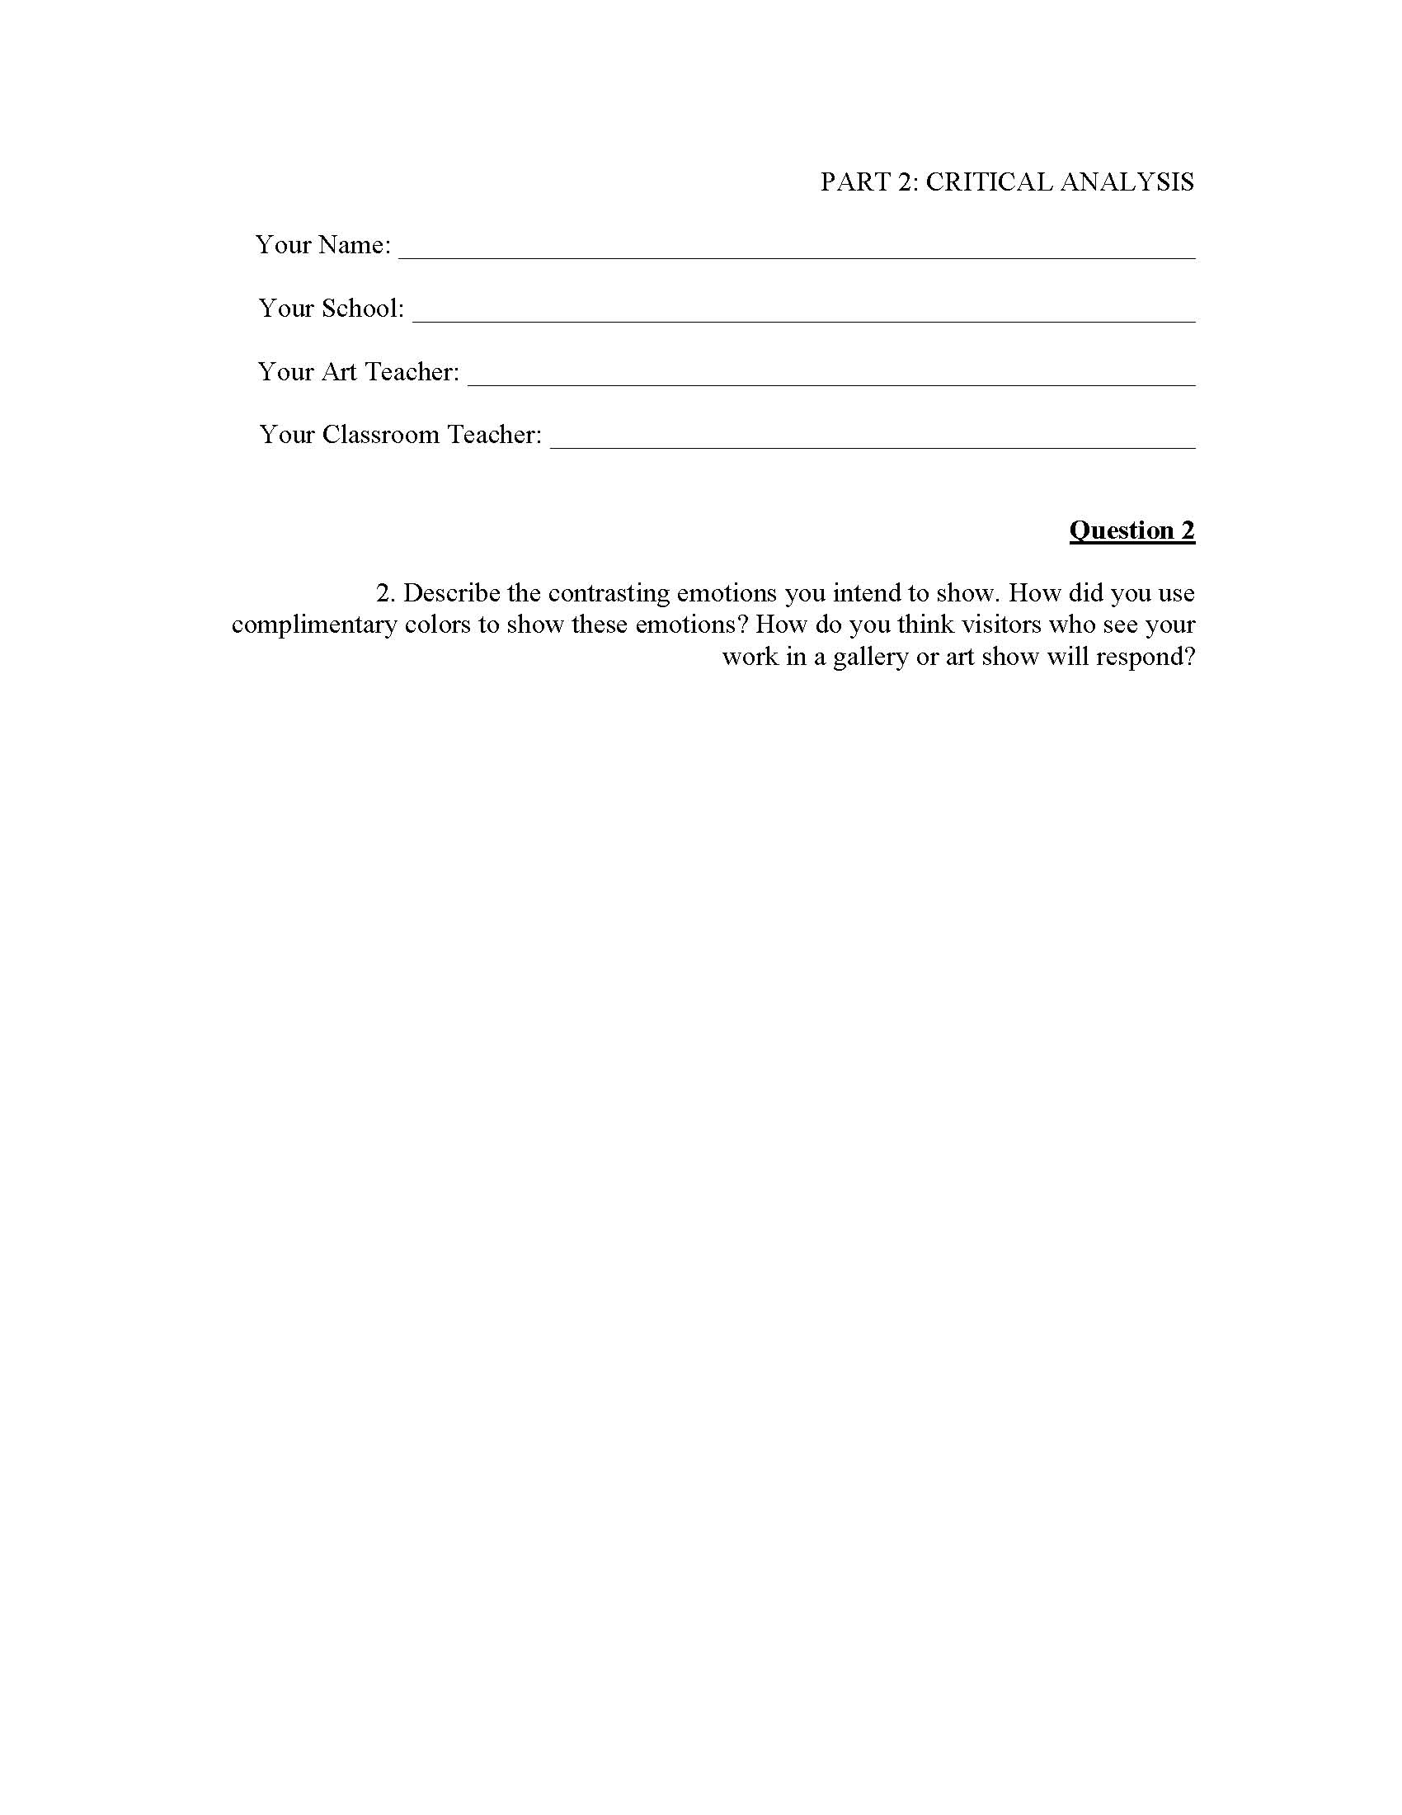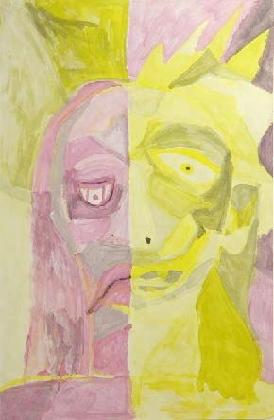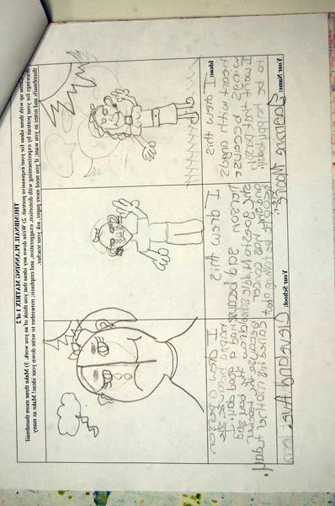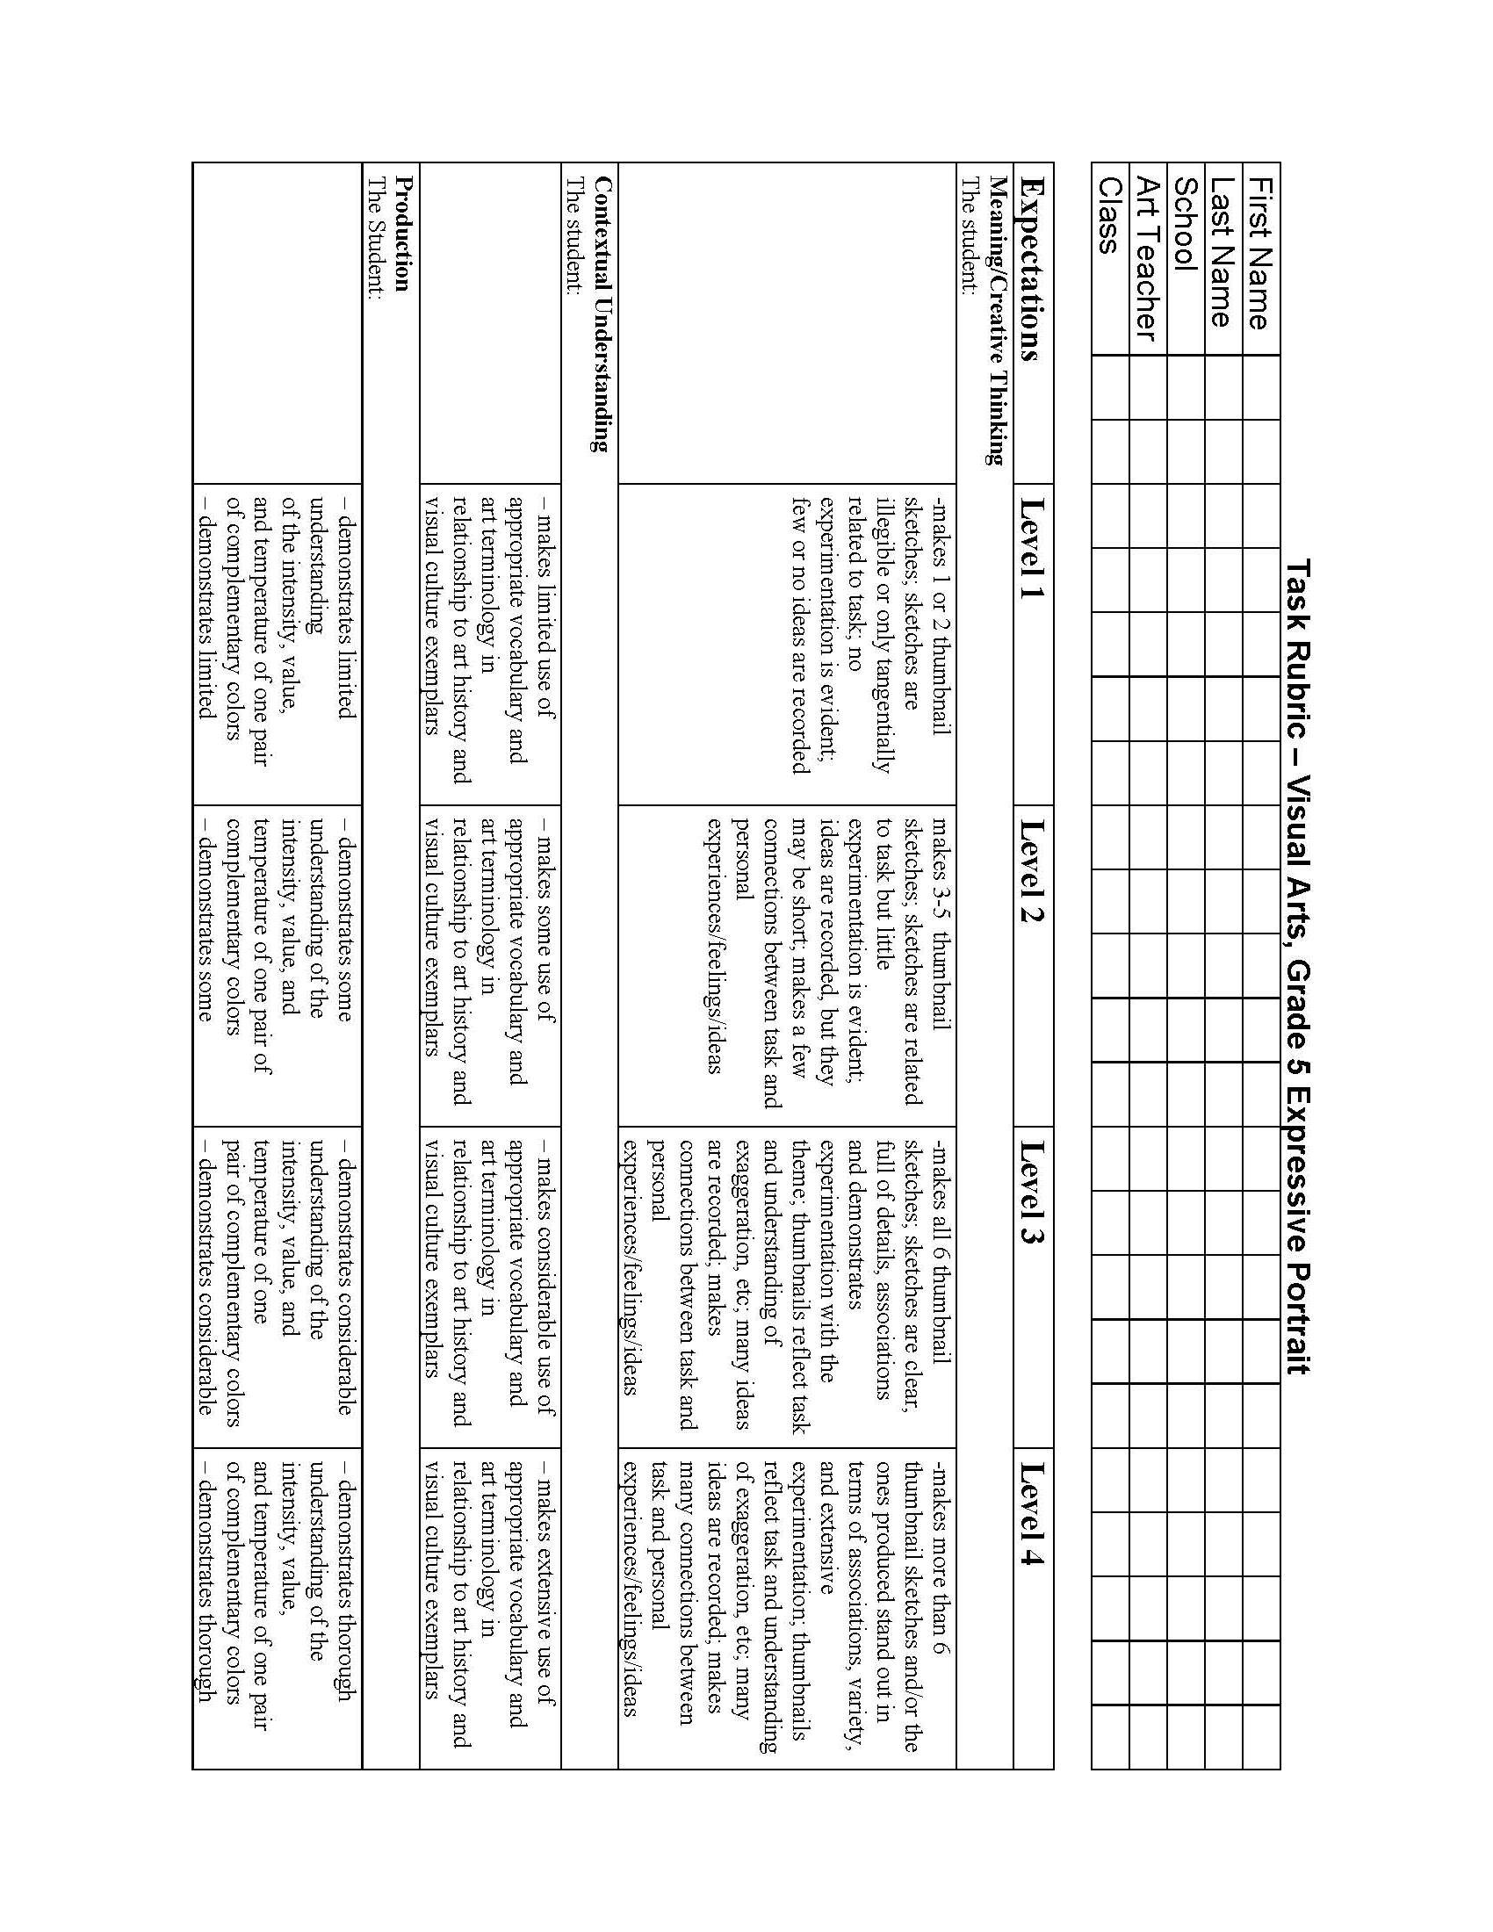
Teacher completes top Rubric

TOP:
1. Two Rubrics
  - One You Fill Out
  - One You Add Student Info Only—Judges Will Use This One

THEN
2. Thumbnails/Creative Planning Matrix

THEN
3. Actual Finished Artwork

LAST
4. Written Critical Reflection Answers

5th Grade Visual Arts Performance Assessment Teacher

Your Name: _____________________________________________________________

Your School(s): __________________________________________________________

Total years of teaching experience: _________ Total years in APS: ________
Highest degree earned: ___________ Colleges attended: ________________________
Other relevant experience: __________________________________________________
Have you participated in an ArtsAPS workshop? ___Yes ___ No
If so, when? ___2008-09 ___2009-10 ___2010-2011 (check all that apply)

Email: ___________________________ Phone: ________________________________

1. I feel the Visual Arts (VA) performance assessment was appropriate to the skill/knowledge level of my 5th grade students.
Strongly Disagree Moderately Disagree Slightly Disagree Slightly Agree Moderately Agree Strongly Agree
1 2 3 4 5 6
Comment:

2. The VA performance assessment addresses all major stages of the artistic process.
Strongly Disagree Moderately Disagree Slightly Disagree Slightly Agree Moderately Agree Strongly Agree
1 2 3 4 5 6
Comment:

3. The VA performance assessment addresses all major domains in the new GPS for the Visual Arts.
Strongly Disagree Moderately Disagree Slightly Disagree Slightly Agree Moderately Agree Strongly Agree
1 2 3 4 5 6
Comment:

4. The VA performance assessment instructions made clear what I was required to do.
Strongly Disagree Moderately Disagree Slightly Disagree Slightly Agree Moderately Agree Strongly Agree
1 2 3 4 5 6
Comment:

5. The VA performance assessment provides a clear and effective means of measuring both the visual arts knowledge and skill level of my students.
Strongly Disagree Moderately Disagree Slightly Disagree Slightly Agree Moderately Agree Strongly Agree
1 2 3 4 5 6
Comment:

On the back of this page, please clearly explain all other reflections, suggestions, or issues/problems encountered while administering this assessment and the means by which you overcame them.
Checklist
1. ALL STUDENTS ARE TO COMPLETE THE PERFORMANCE ASSESSMENT BY MAY 10th 2013.

Send ALL artifacts, answers to essay questions, final products and teacher feedback form via school mail to:

Raymond Veon,
Director, Fine and Performing Arts (int)
6th Floor, CLL
130 Trinity Ave.

2. ALL 5th grade classes are to take both the online assessment and the performance assessment.

3. You are sending ALL artifacts, planning matrices/thumbnail sketches, answers, and final portraits for ALL students in the selected class.

Checklist:
- My students have completed the online assessment
- All artifacts have been assembled in the order shown on page 3
- I have enclosed the brainstorming chart that I posted in class during the performance assessment
- I have enclosed at least two thumbnail planning matrix pages made by EACH student
- I have included the final product, an expressive portrait on 8 ½ x 11 paper, for EACH student
- I have enclosed the written answers to THREE critical analysis questions (see pages 12, 13 and 14 of this packet) for EACH student
- I have filled out the student information portions on TWO rubric forms for each student
- I have assessed each of my students using one of the above rubric forms and left the other one blank for the outside evaluator
- I have paper-clipped these two rubrics, the final portrait, the planning matrices, and the answers to the Critical Analysis questions together IN ORDER
- I have completed the Teacher Feedback Form
- I have separated all student work into four groups and labeled each group as follows: Level 1, Level 2, Level 3, Level 4
- In a SEPARATE envelope, I have enclosed other artifacts to demonstrate the impact of my art program on my students. Using school mail, mail all envelopes to Raymond Veon.
- Congratulations: You did it!

STUDENT VISUAL ART PERFORMANCE ASSESSMENT CHECKLIST:

Students, before you submit your completed packet to your teacher, use the list provided below to be certain that you have addressed all elements of the assessment.
Check your sketches and ask yourself, did I…
___ 1. Complete 6 or more sketches including as much detail as possible?
___ 2. Include 3 of 6 of my sketches showing exaggeration/distortion?
___ 2. Include as much information as possible in the note section about my artwork?
Check your expressive portrait and ask yourself, did I…
___ 1. Follow the basic instructions (e.g. use the template, etc.)?
___ 2. Check to see if the major shapes within my drawing can be read as a portrait (includes head, neck, and shoulders/upper portion of body)?
___ 3. Use one set of complimentary colors?
___ 4. Does my portrait show two different emotions that are opposite?
___ 5. Include tints and shades in my portrait?
___ 6. Use distortion, exaggeration, or rearrange facial features to show emotion?
Check your written responses and ask yourself, did I…
___ 1. Answer all of the questions using complete sentences?
___ 2. Did I think about how the questions relate to me personally?
___ 3. Did I offer as many examples as possible? (Examples of artists, artworks, media, art vocabulary, etc.)
Check the placement order of your materials to be certain that you have…
___ 1. Two (2) copies of the task rubric with your information filled in completely at the top
___ 2. Planning Matrix (Sketches and notes)
___ 3. Final Expressive Drawing/Painting
___ 4. Critical Analysis (Written Responses to Questions

