Atlanta Public Schools
Office of Fine and Performing Arts

Grade 5 Visual Art
Performance Assessment Student Package

“Expressive Portrait in Oil Pastel or Tempera Paint and
Written Commentary”

Assessment Committee:
Stephany Walls, Nostacia Adams, Russell Kennedy, Pat Jackson, Jaymes Taylor, Cynthia Bair-Campbell
Mr. Raymond Veon,
Interim Director, Fine and Performing Arts
Project Director, ArtsAPS

As a fifth grade artist, you are required to take this Fine Arts assessment to assess your Visual Arts education from grades K-5. This assessment contains three parts. You will be assessed on the following:
- How well you plan using your thumbnail planning matrix.

- How well you stretch yourself, take risks, and explore new and different ideas
3. How well you follow directions in drawing a portrait.
4. How well you respond to written answers, and include art vocabulary words to describe your answers.
As you are completing each part of this assessment, do your best to think carefully about your responses of sketching, note taking, drawing, and writing. You should answer all parts of each question using complete sentences. If you have a folder for your assessment materials, please keep them in the order shown on page 15.

Task Rubric – Visual Arts, Grade 5 Expressive Portrait
First Name
Last Name
School
Art Teacher
Class
COMPOSITE (OVERALL) PERFORMANCE ASSESSMENTSCORE: 88 Possible Points
Level 1 (0-21 Points) ❐ Level 2 (22-43 Points) ❐ Level 3 (44-65 Points) ❐ Level 4 (66-88 Points) ❐

Meaning and Creative Thinking Score: Level 1 ❐ Level 2 ❐ Level 3 ❐ Level 4 ❐
Production Score: Level 1 ❐ Level 2 ❐ Level 3 ❐ Level 4 ❐
Contextual Understanding Score: Level 1 ❐ Level 2 ❐ Level 3 ❐ Level 4 ❐
Assessment and Reflection Score: Level 1 ❐ Level 2 ❐ Level 3 ❐ Level 4 ❐
Connections Score: Level 1 ❐ Level 2 ❐ Level 3 ❐ Level 4 ❐

DOMAIN: Meaning/Creative Thinking (Planning Matrix) 16Points Possible WEIGHTED DOMAIN
Level 4 = 4 points | Level 3 = 3 points | Level 2 = 2 points | Level 1 = 1 point | Enter Points Earned
A) makes 6 or more thumbnail sketches | makes 4-5 thumbnail sketches | makes all 2-3 thumbnail sketches | makes less than 2 thumbnail sketches
B) sketches reflect extensive experimentation and understanding of task (opposing emotions, exaggeration, distortion, and emphasis); takes risks, stretches and explores | sketches reflect evidence of experimentation and understanding of task; some evidence of taking risks, stretching and exploring | sketches are clear; limited experimentation and understanding of task is evident | sketches are illegible; no experimentation evident
C) 5 or more detailed ideas  and/or notes recorded | 3-4 detailed ideas recorded | ideas are recorded, but they are short | few or no ideas recorded
D) sketches/notes make 5 or more connections between task and personal experiences/feelings/ideas | makes 3-4 connections between task and personal experiences/feelings/ideas | makes 1 -2 connections between task and personal experiences/feelings/ideas | no connections to task evident
Meaning/Creative Thinking Total
SCORE: Level 1 ( 0-4 Points) ❐ Level 2 (4-7 Points) ❐ Level 3 (8-11 Points) ❐ Level 4 (12-16 Points) ❐

Rubric continued next page

DOMAIN: Production (Final Expressive Portrait) 24 Points Possible WEIGHTED DOMAIN
Criteria:
1. Reads as a Portrait
2.One set of Complimentary Colors plus black and white
3.Evidence of tints and shades used intentionally
4.Two different emotions
5. Evidence of exaggeration, distortion or rearrangement of facial features
Level 4 = 4 points | Level 3 = 3 points | Level 2 = 2 points | Level 1 = 0 or 1 point | Enter Points Earned
A) the relationships between the major shapes can be visually read as a portrait (e.g. a head on shoulders/upper body) in a way that reinforces another item from the minimum criteria and utilizes personal or innovative visual  elements | --the relationships between the major shapes can be visually read as a portrait in a way that reinforces another item from the minimum criteria | --the relationships between the major shapes can be visually read as a portrait | unclear whether major shapes constitute a portrait
B) two different emotions clearly visible in a way that reinforces another item from the minimum criteria and utilizes personal or innovative visual elements | --two different emotions clearly visible in a way that reinforces another item from the minimum criteria | --two different emotions clearly visible | unclear whether two different emotions are evident
C) uses only one set of complimentary colors plus black and white (no extra colors) in a way that reinforces another item from the minimum criteria and utilizes personal or innovative visual elements | --uses only one set of complimentary colors plus black and white in a way that reinforces another item from the minimum criteria | --uses only one set of complimentary colors plus black and white | uses more than one set of complimentary colors, black, and white
D) visual evidence that tints and shades used intentionally visible in a way that reinforces another item from the minimum criteria and utilizes personal or innovative visual elements | visual evidence that tints and shades used intentionally visible in a way that reinforces another item from the minimum criteria | visual evidence that tints and shades used intentionally | use of tints and shades not evident or their use is unclear
E) evidence of exaggeration , distortion, or rearrangement of facial features to convey emotion is evident in a way that reinforces another item from the minimum criteria and utilizes personal or innovative visual elements; takes risks, stretches and explores | evidence of exaggeration , distortion, or rearrangement of facial features to convey emotion is evident in a way that reinforces another item from the minimum criteria; some evidence of taking risks, stretching and exploring | evidence of exaggeration , distortion, or rearrangement of facial features to convey emotion | distortion, exaggeration, or rearrangement of parts not evident
F)clearly shows 2 emotions that can be read as contrasting emotions in a way that reinforces another item from the minimum criteria and utilizes personal or innovative visual elements | – clearly shows 2 emotions that can be read as contrasting emotions in a way that reinforces another item from the minimum criteria | – shows 2 emotions that can be read as contrasting emotions with limited effectiveness | demonstrates no or limited understanding of the concepts involved in producing an expressive portrait that shows contrasting emotions
G) follows basic instructions, all 6 minimum criteria present; clear evidence of 1-2 personal or innovative visual elements used in tandem with 1 or more of the 6 minimum criteria or the integration of knowledge/skills from other art learning or subject domains | --follows basic instructions, all 6 minimum criteria present ;clear evidence of 1-2 personal elements or innovative thinking; the presence of knowledge/skills from other art learning or subject domains | --follows basic instructions, all 6 minimum criteria present:, limited or questionable evidence of 1-2 personal elements or innovative thinking, there may be evidence of knowledge/skills from other art learning or subject domains | demonstrates no or limited understanding of basic instructions; 1-5 of the 6 minimum criteria present); no evidence of personal elements or innovative thinking
Production Total
DOMAINSCORE: Level 1 ( 0-5 Points) ❐ Level 2 (6-11 Points) ❐ Level 3 (12-17 Points) ❐ Level 4 (18-24 Points) ❐

DOMAIN: Contextual Understanding (Critical Analysis Question 1) 20 Points Possible
Level 4 = 4 points | Level 3 = 3 points | Level 2 = 2 points | Level 1 = 0 or 1 point | Enter Points Earned  **Category C Worth Double**
A) – 76-100% of written response uses appropriate and accurate vocabulary and art terminology | – 51% -75% of written response uses appropriate and accurate vocabulary and art terminology | –at least 50% of written response uses appropriate and accurate vocabulary and art terminology | – does not use or rarely uses appropriate vocabulary and art terminology
B) cites 5 or more art history and visual culture exemplars | –cites 3-4 art history and visual culture exemplars | – cites 1-2 art history and visual culture exemplars | – does not cite art history or visual culture exemplars
C) makes 5 or more connections between own work and exemplars | – makes 3 – 4 connections between own work and exemplars | – makes 1-2 connections between own work and exemplars | – does not connect own work to exemplars | ____ points x 2 =  ________
D) provides detailed description regarding visitors’ response by citing 3 or more examples and supports each statement with evidence | – provides detailed description regarding visitors’ response by citing 1-2 examples or evidence | – provides minimal description regarding how visitors might respond to their own artwork but uses short or undetailed sentences | –does not or provides limited description regarding how visitors might respond to their own artwork
Contextual Understanding Total
DOMAINSCORE: Level 1 ( 0-4 Points) ❐ Level 2 (5-9 Points) ❐ Level 3 (10-14 Points) ❐ Level 4 (15-20Points) ❐

DOMAIN: Assessment and Reflection (Critical Analysis Question 2) 20 Points Possible
Level 4 = 4 points | Level 3 = 3 points | Level 2 = 2 points | Level 1 = 0 or 1 point | Enter Points Earned
A.) Describes or identifies 2 emotions and explains the emotions depicted in the portrait citing 4 or more details and makes a connection between the colors used and emotions depicted. | Describes or identifies 2 emotions depicted in the portrait with sentences by citing 2-3 details. | Describe or identifies the 2 emotions depicted in the portrait with sentences. | Describes or identifies the emotions depicted in the portrait.
B.) Explanation of 4 or more connections between the portrayed emotions and the use of exaggeration, distortion, or rearrangement of portrait features. | –explanation of 2-3 connections between the portrayed emotions and the use of exaggeration, distortion, or rearrangement of portrait features. | – general explanation of the connection between the portrayed emotions and the use of exaggeration, distortion, or rearrangement of portrait features. | – explains the connection between portrayed emotions and the use of exaggeration, distortion, or rearrangement of portrait features. | ____ points x 2 =  ________
C.) Artistic choices are described and explained using sentences; provides supporting examples, rationales & evidence for each statement; answers the “what” and “why” of each choice; references the effect achieved by each choice and connects it to the task and the final product. | – artistic choices described and explained using sentences; provides examples, rationales & evidence for 1-2 statements; answers the “what” and “why” of each choice | – artistic choices described using short, repetitive, sentences; answers “what” and/or “why” of each artistic choice. | – artistic choices described using short, repetitive, sentences
Assessment and Reflection Total Points:____________
DOMAIN SCORE: Level 1 ( 0-4 Points) ❐ Level 2 (5-9 Points) ❐ Level 3 (10-14 Points) ❐ Level 4 (15-20Points)

DOMAIN: Connections (Critical Analysis Question 3) 8 Points Possible
Level 4 = 4 points | Level 3 = 3 points | Level 2 = 2 points | Level 1 = 0 or 1 point | Enter Points Earned
– makes 3 or more connections between performance task to personal experiences and/or connects how selected colors are used in other design contexts, also expresses additional connections related to other learning/life experiences. | – makes 3  connections between performance task to personal experiences and/or connects how selected colors are used in other design contexts | – makes 1-2 connections between performance task to personal experiences and/or connects how selected colors are used in other design contexts | – does not connect performance task to personal experiences or explain how colors are used in other design contexts
– all vocabulary and concepts employed are accurately used in written comments | – most of vocabulary and concepts employed are accurately used in written comments | – at least half of vocabulary and concepts employed are accurately used in written comments | – less than half of vocabulary and concepts employed are accurately used in written comments
Connections Total
DOMAINSCORE: Level 1 ( 0-2 Points) ❐ Level 2 (3-4 Points) ❐ Level 3 (5-6 Points) ❐ Level 4 (7-8 Points) ❐
TOTAL POINTS ALL DOMAINS

THUMBNAIL PLANNING MATRIX 1 of 2
1) Come up with three ideas for your expressive portrait. 2) Write down any ideas that you think of as you work. 3) Make three more thumbnail drawings for your portrait by experimenting with distortion, exaggeration, and emphasis; remember to write down your ideas! Make as many thumbnails and notes as you want; if you need more paper, ask your teacher.
Ideas: | Ideas: | Ideas:
Your Name: Your School:

THUMBNAIL PLANNING MATRIX 2 of 2 SHOWING DISTORTION, EXAGGERATION, & EMPHASIS
1) Come up with three ideas for your expressive portrait. 2) Write down any ideas that you think of as you work. 3) Make three more thumbnail drawings for your portrait by experimenting with distortion, exaggeration, and emphasis; remember to write down your ideas! Make as many thumbnails and notes as you want; if you need more paper, ask your teacher.
Ideas: | Ideas: | Ideas:
Your Name: Your School:

PART 2: CRITICAL ANALYSIS – Question 1
(ANSWERS TO EACH QUESTION TO BE RETURNED TO R. VEON)

The curator has asked you to respond to the following questions in order to your portrait considered for selection for the art gallery replacement. Please use one sheet of paper for each answer. Put your name, your school, your art teacher’s name, and your classroom teacher’s name on each sheet. Be sure to answer each part of every question. You may use the back of the paper.

Your Name: __________________________________________________________

Your School: _________________________________________________________

Your Art Teacher: _____________________________________________________

Your Classroom Teacher: _______________________________________________

When do you have art?
❐Once a week ❐Once every two weeks ❐Other (explain):

How long is your art class?
❐30 minutes or less ❐40 minutes or more

Question 1 (GPS: Contextual Understanding)

1. How is your portrait like the art of other artists you have studied? How is it different? How do you think visitors who see your work in a gallery or art show will respond to it?

PART 2: CRITICAL ANALYSIS – Question 2

Your Name: __________________________________________________________

Your School: _________________________________________________________

Your Art Teacher: _____________________________________________________

Your Classroom Teacher: _______________________________________________

Question 2 (GPS: Assessment and Reflection)

2. Describe the contrasting emotions you intend to show. How did you use exaggeration and/or distortion to show these emotions? Describe what you exaggerated and/or distorted. What else did you do in your portrait to show these emotions?

PART 2: CRITICAL ANALYSIS – Question 3

Your Name: __________________________________________________________

Your School: _________________________________________________________

Your Art Teacher: _____________________________________________________

Your Classroom Teacher: _______________________________________________

Question 3 (GPS: Connections)

3. Look at the colors you have used in your portrait to show contrasting emotions.
A. Describe the intensity, value, and temperature of the colors you used.
B. Explain how these colors remind you of emotions you have experienced in your life.
C. Do you ever see these colors used in other places (like toys, buildings, advertisements, in books or on clothes)? Why do you think they are used there?

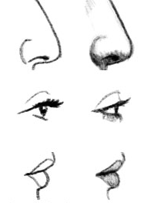

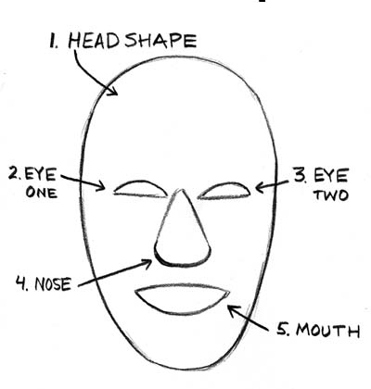

Practice exaggeration and distortion of different facial features by drawing in the boxes.

ARTIFACT ORDER
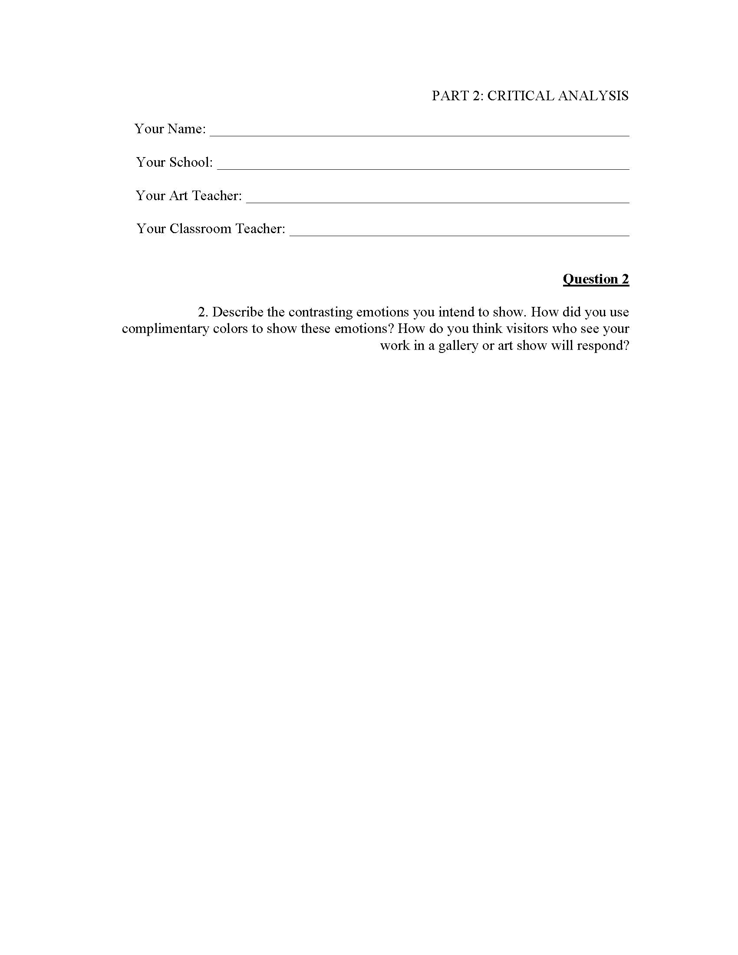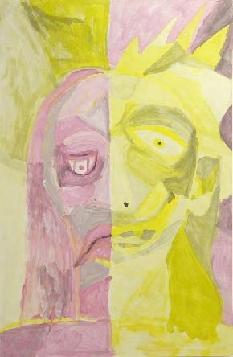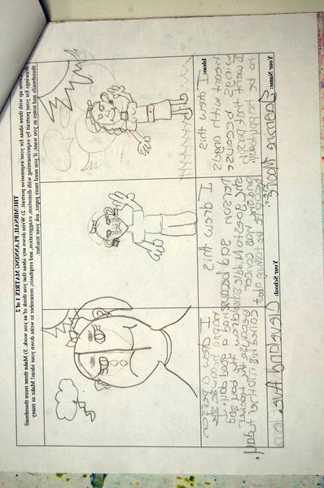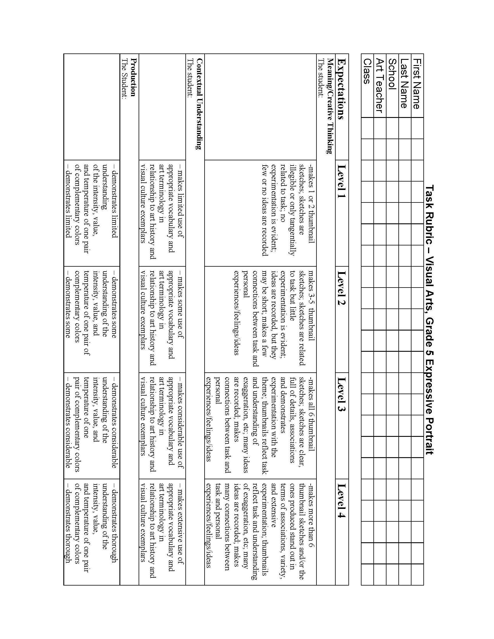
Teacher completes top Rubric

TOP:
1. Two Rubrics
  - One You Fill Out
  - One You Add Student Info Only—Judges Will Use This One

THEN
2. Thumbnails/Creative Planning Matrix

THEN
3. Actual Finished Artwork

LAST
4. Written Critical Reflection Answers

STUDENT VISUAL ART PERFORMANCE ASSESSMENT CHECKLIST:

Students, before you submit your completed packet to your teacher, use the list provided below to be certain that you have addressed all elements of the assessment.
Check your sketches and ask yourself, did I…
___ 1. Complete 6 or more sketches including as much detail as possible?
___ 2. Include 3 of 6 of my sketches showing exaggeration/distortion?
___ 2. Include as much information as possible in the note section about my artwork?
Check your expressive portrait and ask yourself, did I…
___ 1. Follow the basic instructions (e.g. use the template, etc.)?
___ 2. Check to see if the major shapes within my drawing can be read as a portrait (includes head, neck, and shoulders/upper portion of body)?
___ 3. Use one set of complimentary colors?
___ 4. Does my portrait show two different emotions that are opposite?
___ 5. Include tints and shades in my portrait?
___ 6. Use distortion, exaggeration, or rearrange facial features to show emotion?
Check your written responses and ask yourself, did I…
___ 1. Answer all of the questions using complete sentences?
___ 2. Did I think about how the questions relate to me personally?
___ 3. Did I offer as many examples as possible? (Examples of artists, artworks, media, art vocabulary, etc.)
Check the placement order of your materials to be certain that you have…
___ 1. Two (2) copies of the task rubric with your information filled in completely at the top
___ 2. Planning Matrix (Sketches and notes)
___ 3. Final Expressive Drawing/Painting
___ 4. Critical Analysis (Written Responses to Questions

