Four Measure Rhythm Soundtrack
- Look at the picture below and think about what is going on and what you might hear in this scene.
- Use what you know about music to consider the types of notes and rests, timbres, tempo, and dynamics that will work best for your composition.
- You will create a 4 measure rhythm pattern that goes with the picture and choose an instrument to use.
- Be creative and be sure to write down all of your ideas about creating this work!
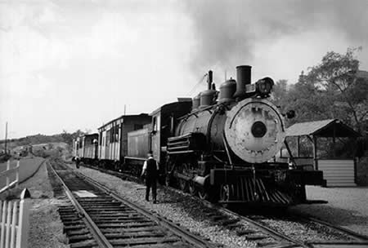

4. Another choice I’ve made is: __________.

I’m choosing this because:
___________________________________________________.
3. The tone color/timbre I’m using is
____________.

I’m choosing this because:
____________________________________________________.
2. My dynamic level is ________.

I’m choosing this because:
________________________________________________________________.
1. My tempo is ________.

I’m choosing this because:
_____________________________________________________________________________.

Check it!
- Did I use notes and rests?
- Did I put 4 beats in EACH measure?

Using musical notation, notate your rhythm pattern.
My 4-measure rhythm pattern:

4
4

Instrument: _______________________________

