Choose Your Scene
You will create a rhythm soundtrack for one of these pictures.
- Look at the pictures below.
- As a group choose one and describe what’s going on in the picture.
- Each student will create a 4 measure rhythm pattern that goes with the picture and choose an instrument.
- Use the Musical Planning Worksheet (pg. 2) to work out your musical ideas. Your group will plan how to put your rhythm patterns together.
- Use the Music Signs and Symbols chart for symbols, tempos, and dynamics to use in your composition.
- Get together with your group to plan your form (order of playing) by putting all rhythm patterns together.
- Practice playing your composition! Be flexible and creative!
- 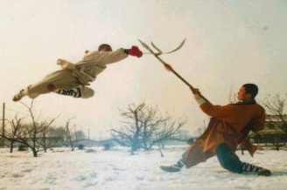
- 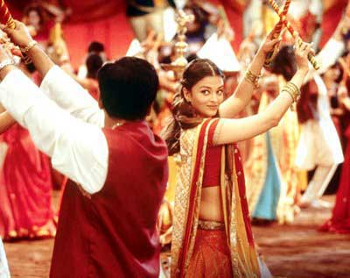 | - 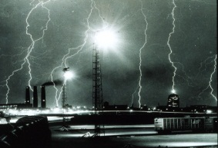
- 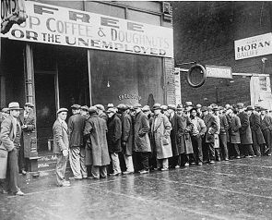 | - 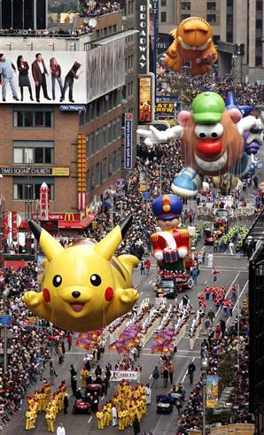

Musical Signs and Symbols
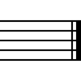  Double barline | 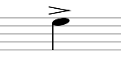 accent | 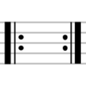 repeat signs | largo | andante | presto
crescendo | decrescendo | piano | forte | pianissimo | 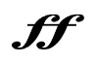  fortissimo

Form: MPW
Musical Planning Worksheet
The photo we chose (circle one):

1 2 3 4 5 6

4. Another choice I’ve made is: __________.

I’m choosing this because:
___________________________________________________.
3. The tone color/timbre I’m using is
____________.

I’m choosing this because:
____________________________________________________.
2. My dynamic level is ________.

I’m choosing this because:
________________________________________________________________.
1. My tempo is ________.

I’m choosing this because:
_____________________________________________________________________________.

Check it!
- Did I use notes and rests?
- Did I put 4 beats in EACH measure?

Using musical notation, notate your rhythm pattern.
My 4-measure rhythm pattern:

5.
4
4

Form: OGRS

Our Group’s Rhythm Soundtrack
Decide which students will be #1, #2, #3, #4
Each group member should write their rhythm patterns below.
Put a star by your conductor’s name.

We chose picture # _______

TITLE

6.
 | 4
Instrument | 4 |  |  |  | Student #1 Name
 | 4
Instrument | 4 |  |  |  | Student #2 Name
 | 4
Instrument | 4 |  |  |  | Student #3 Name
 | 4
Instrument | 4 |  |  |  | Student #4 Name

- Did your work change once your group put everything together? ________ Explain: _______________________________________________________________________________________________________________________________________________________________________________________________________________
Reflecting on Performance

Directions: Reflect on your individual work and your group’s completed soundtrack. Answer the following questions.

- The tone color/timbre we included was ________________________ because_____________________________________________________________________________________________________________________________________________________________________

- The tempo we chose was ____________because__________________ __________________________________________________________________________________________________________________

- The dynamic level we chose was _____________ because__________ __________________________________________________________________________________________________________________

- What was your favorite part of your composition? Why?
____________________________________________________________________________________________________________________________
____________________________________________________________________________________________________________________________

- Look at the picture your team chose. Explain how your tempo, dynamics, tone color/timbre choices helped reflect the picture?
________________________________________________________________________________________________________________________________________________________________________________________________________________________________________________________

